WEEK 3
Statistical Analysis & Predictive Modeling
Testing relationships and predicting daily ozone levels

Project detail | Value
Project | New York Air Quality Analysis using R
Dataset | airquality — R datasets package
Prepared by | Internship Project Submission
Study period | May to September 1973

A practical and reproducible study of daily air-quality conditions in New York.

Executive Summary
Week 3 tests the strongest visual relationship and builds a baseline predictive model. Ozone is the response; temperature, wind, and solar radiation are predictors. Complete observations are used so the outcome is never imputed during evaluation. The workflow includes a hypothesis test, reproducible 80/20 split, multiple regression, test metrics, and residual diagnostics.

1. Hypothesis
Hypothesis | Statement
H₀ | There is no linear relationship between temperature and ozone (ρ = 0).
H₁ | There is a linear relationship between temperature and ozone (ρ ≠ 0).

model_data <- airquality |>
na.omit() |> subset(select=c(Ozone,Solar.R,Wind,Temp))
cor.test(model_data$Temp,model_data$Ozone,method="pearson")
Result: Using 111 complete observations, r = 0.699 and p < 0.001. Reject H₀: warmer days are associated with higher ozone.

2. Train–Test Strategy
A deterministic 80/20 rule produces 89 training rows and 22 test rows. Every fifth complete row is held out, so the split reproduces identically without depending on software-specific random sampling.
test_index <- seq_len(nrow(model_data)) %% 5 == 0
train <- model_data[!test_index,]; test <- model_data[test_index,]
model <- lm(Ozone ~ Temp + Wind + Solar.R,data=train)

3. Regression Equation and Interpretation
Term | Estimate | Reading while other variables are fixed
Intercept | -48.950 | Mathematical baseline; not interpreted at impossible zero weather.
Temperature | 1.540 | Expected ozone change per 1°F increase.
Wind | -3.872 | Expected ozone change per 1 mph increase.
Solar radiation | 0.054 | Expected change per radiation unit.

Predicted Ozone = -48.950 + (1.540 × Temp) + (-3.872 × Wind) + (0.054 × Solar.R)

4. Evaluation on Unseen Data
pred <- predict(model,newdata=test)
RMSE <- sqrt(mean((test$Ozone-pred)^2))
MAE <- mean(abs(test$Ozone-pred))
R2 <- 1-sum((test$Ozone-pred)^2)/sum((test$Ozone-mean(test$Ozone))^2)
Metric | Result | Meaning
RMSE | 20.07 ppb | Typical error with large misses weighted more.
MAE | 17.24 ppb | Average absolute error.
Test R² | 0.581 | Variation explained relative to the test mean.
Full-data adjusted R² | 0.595 | Explanatory strength adjusted for three predictors.

Balanced interpretation: The model is a useful, transparent baseline, but its error is too large for high-stakes forecasting of individual days.

5. Diagnostics
par(mfrow=c(2,2))
plot(model)
# Check linearity, residual spread, normality, and influence.
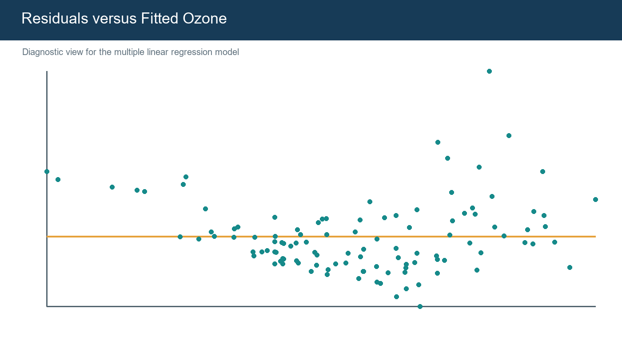
Figure 1. Residuals are centered around zero, but some high-ozone days remain difficult.
The diagnostic is broadly compatible with a first linear model, but large residuals and possible changing spread show that its assumptions are not perfect.

6. Strengths, Limitations, Improvements
Area | Assessment
Strength | Reproducible, interpretable, and evaluated on unseen data.
Limitation | Small sample from one city and one warm season.
Limitation | No emissions, humidity, lag, or location variables.
Improvement | Use repeated k-fold cross-validation.
Improvement | Test nonlinear terms, interactions, and tree-based methods.
Improvement | Use multiple years and time-based validation for forecasting.

7. Conclusion
The test confirms a strong temperature–ozone association. The regression combines three weather measures and obtains test RMSE 20.07 ppb and R² 0.581 on this fixed split. Diagnostics and limitations are reported so statistical significance is not overstated.

References
- R Core Team. R: A Language and Environment for Statistical Computing.
- R datasets package. airquality: New York Air Quality Measurements.
- Wickham, H. ggplot2: Elegant Graphics for Data Analysis.
- Rdatasets archive: https://vincentarelbundock.github.io/Rdatasets/

Portal Submission Description (200+ words)
This Week 3 report presents the statistical-analysis and predictive-modeling stage of my internship project using R. The project continues with the New York air-quality dataset and uses ozone concentration as the outcome variable. Temperature, wind speed, and solar radiation are selected as predictors because the earlier exploratory analysis and visualizations showed meaningful relationships with ozone. I first create a complete-case modeling dataset so that missing ozone values are not artificially imputed during model training or evaluation. A formal Pearson correlation test evaluates the null hypothesis that temperature and ozone have no linear relationship. The observed correlation is approximately 0.70, and the very small p-value provides strong evidence against the null hypothesis. For prediction, I use a reproducible 80/20 train–test split that holds out every fifth complete observation and fit a multiple linear regression model. The report includes the R code, estimated equation, coefficient interpretations, and evaluation on previously unseen test observations. Performance is discussed through RMSE, MAE, test R-squared, and adjusted R-squared rather than relying on one score. A residual-versus-fitted diagnostic plot is included to review model behavior and identify unusually large errors. I explain that the model captures an important part of ozone variation but should be treated as a transparent baseline rather than a perfect forecasting system. The report concludes with limitations and practical improvements, including repeated cross-validation, nonlinear terms, interaction effects, additional pollution variables, and a larger multi-year dataset. This gives a balanced interpretation of statistical significance, predictive usefulness, and uncertainty.
Use: Copy this section into the portal description field while uploading this Word file.

