WEEK 4
Comprehensive Data Analysis Report
From raw environmental observations to evidence-based conclusions

Project detail | Value
Project | New York Air Quality Analysis using R
Dataset | airquality — R datasets package
Prepared by | Internship Project Submission
Study period | May to September 1973

A practical and reproducible study of daily air-quality conditions in New York.

Executive Summary
This report integrates data preparation, exploratory analysis, visual communication, hypothesis testing, and predictive modeling. Across the project, hotter and less windy conditions are consistently associated with higher ozone. The regression provides a useful baseline, while residuals and test errors show that unusual peaks remain difficult to predict.
Central finding: Temperature has a strong positive relationship with ozone (r = 0.699); the complete-data baseline model explains about 60.6% of observed variation before adjustment.

1. Introduction
Air-quality measurements become useful only after they are checked, organized, interpreted, and communicated responsibly. This project asks which weather conditions are associated with ozone, how the pattern changes over summer, and how accurately a simple model can predict daily ozone.

2. Integrated Workflow
Stage | Work completed | Output
Week 1 | Audit, missing values, outliers, dates, factors, scaling | Analysis-ready data
Week 2 | Distribution, scatter, monthly and daily views | Visual narrative
Week 3 | Hypothesis test, split, regression, diagnostics | Evidence and metrics
Week 4 | Synthesis, implications, limitations | Final report

3. Data Preparation
The original data has 153 rows and six original variables. It contains 37 missing ozone and 7 missing solar-radiation values, with no duplicate rows. Median imputation supports descriptive work, while 111 complete observations are used for inference. Potential extreme readings are retained because they may represent real pollution events.
data(airquality)
colSums(is.na(airquality))
aq <- transform(airquality,
Date=as.Date(paste(1973,Month,Day,sep="-")))
model_data <- na.omit(aq[c("Ozone","Solar.R","Wind","Temp")])

4. Exploratory Results
Evidence | Result | Meaning
Temperature–ozone | r = 0.699 | Warmer days generally have higher ozone.
Wind–ozone | r = -0.612 | Windier days generally have lower ozone.
Solar radiation–ozone | r = 0.348 | Moderate positive association.
Distribution | Right-skewed | Several days have unusually high ozone.
Season | Mid-summer peak | July–August show the highest monthly averages.

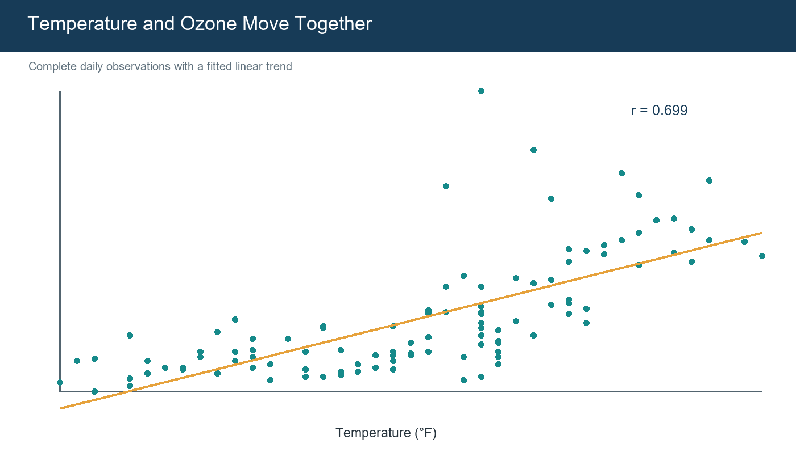
Figure 1. Strongest bivariate pattern in the project.
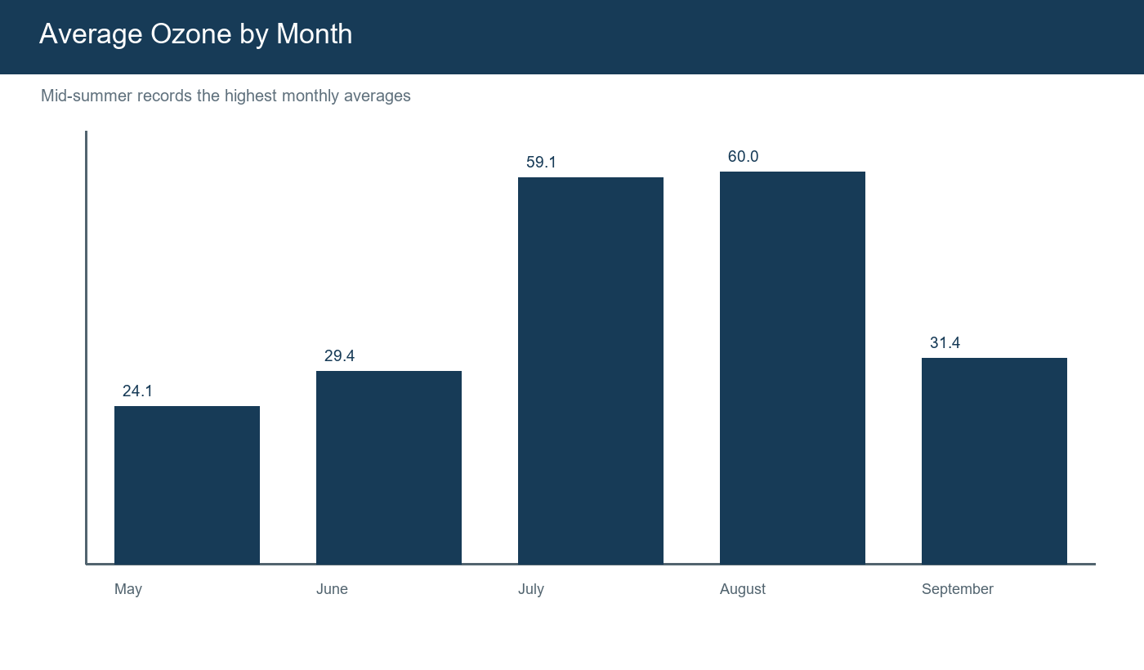
Figure 2. Monthly aggregation places the pattern in seasonal context.

5. Statistical and Predictive Results
The Pearson test gives r = 0.699 with p < 0.001, so the null hypothesis of no linear relationship is rejected. This supports association, not proof of causation. Multiple regression then combines temperature, wind, and solar radiation using every fifth complete observation as the reproducible test set.
Measure | Value
Training observations | 89
Test observations | 22
Test RMSE | 20.07 ppb
Test MAE | 17.24 ppb
Test R² | 0.581
Adjusted R² | 0.595

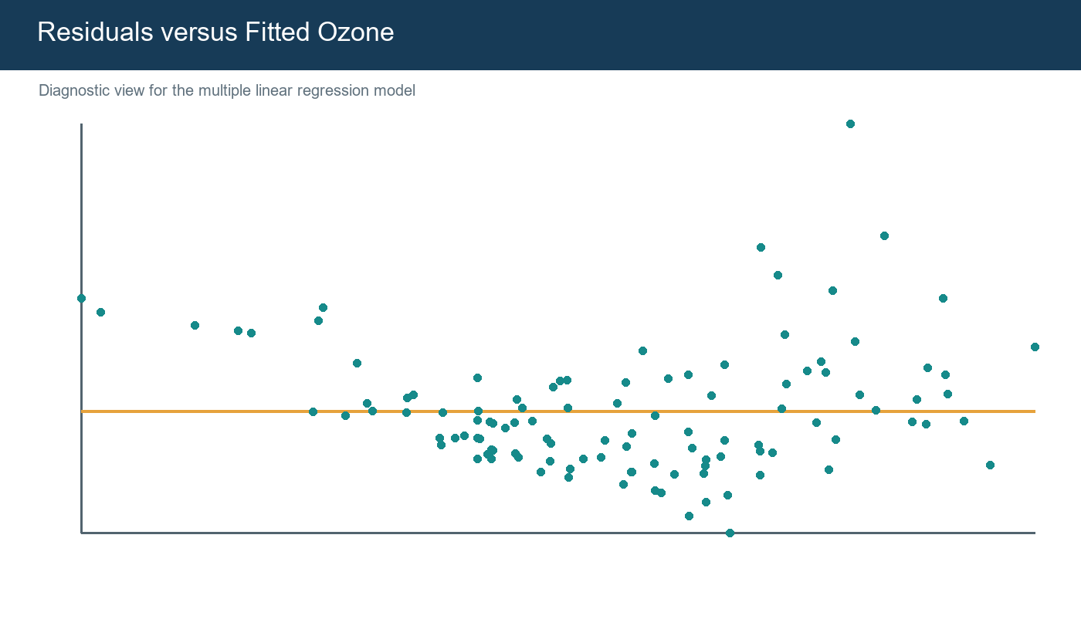
Figure 3. Diagnostics show a useful baseline with difficult high-ozone days.

6. Practical Implications
- Use sustained hot, calm weather as a screening signal for closer ozone monitoring.
- Present daily variation together with averages so short pollution episodes remain visible.
- Treat predictions as baseline risk estimates supported by observed monitoring.
- Do not replace regulatory measurements or environmental expertise with this small historical model.

7. Challenges and Lessons
Challenge | Response / lesson
Missing target values | Separated descriptive imputation from complete-case inference.
Extreme ozone days | Retained evidence and used diagnostics instead of automatic deletion.
Different audiences | Paired technical code with plain-language interpretations.
Risk of overclaiming | Separated correlation, significance, prediction, and causation.
Reproducibility | Maintained R code throughout all four stages.

8. Future Direction
- Expand across years, seasons, and monitoring locations.
- Add emissions, humidity, atmospheric pressure, and precursor pollutants.
- Compare linear regression with random forest and gradient boosting using repeated validation.
- Use time-based validation when the objective is future forecasting.
- Develop an R Shiny dashboard for interactive stakeholder communication.

9. Final Conclusion
The project develops a complete R workflow from raw data to clear findings. Weather measures contain useful information about ozone risk, particularly temperature and wind, but they do not fully explain extreme days. Stronger forecasting will require richer data, nonlinear methods, and repeated validation.

References
- R Core Team. R: A Language and Environment for Statistical Computing.
- R datasets package. airquality: New York Air Quality Measurements.
- Wickham, H. ggplot2: Elegant Graphics for Data Analysis.
- Rdatasets archive: https://vincentarelbundock.github.io/Rdatasets/

Portal Submission Description (200+ words)
This final report consolidates all four stages of my internship project into one complete data-analysis narrative using R. The project examines the New York air-quality dataset, which contains 153 daily observations of ozone, solar radiation, wind speed, and temperature between May and September 1973. The report begins with the project objective and data context, then summarizes the data-quality audit completed in Week 1. Missing values, duplicate checks, outlier detection, date creation, factor labeling, normalization, and the distinction between descriptive imputation and complete-case modeling are explained clearly. The visualization section integrates the most useful findings from Week 2, including the ozone distribution, the positive temperature–ozone relationship, seasonal differences, and daily fluctuations. The statistical section formalizes the strongest pattern through a Pearson correlation test and reports a correlation of approximately 0.70 with a p-value below 0.001. The predictive section documents an 80/20 train–test split and a multiple linear regression model using temperature, wind, and solar radiation. RMSE, MAE, R-squared, adjusted R-squared, and residual diagnostics are included so performance is evaluated honestly. The main conclusion is that hotter and less windy conditions are associated with elevated ozone, although simple weather variables cannot fully predict unusual pollution peaks. I also discuss practical monitoring implications, project limitations, challenges overcome, lessons learned, and future improvements such as multi-year data, additional atmospheric variables, repeated cross-validation, nonlinear models, time-based validation, and an R Shiny dashboard. Overall, the document demonstrates a complete and reproducible workflow that connects technical R analysis with clear, human-readable interpretation and responsible conclusions.
Use: Copy this section into the portal description field while uploading this Word file.

