B.Tech Computer Engineering
Semester – V

Advanced Python Lab

23CP301P

ACY: 2025-26



Name:Jayneel Mahival
Roll No:23BCP332

Submitted to
Dr. Azriel Henry
Department of Computer Engineering
School of Technology
Pandit Deendayal Energy University
Gandhinagar, Gujarat, India

November 2025

Index

Sr. No. | Experiment Title | Date | Page No.
1. | Text File Analysis for Product Reviews | 21/7/2025
2. | CSV File Handling and Basic Operations | 28/7/2025
3. | Railway Ticket Reservation System using Python | 4/8/2025
4. | Advanced Operations on CSV Files using pandas | 11/8/2025
5. | JSON Data Parsing and Manipulation | 18/8/2025
6. | Error and Exception Handling in Python Programs | 25/8/2025
7. | Implementing Logging Mechanisms in Python | 22/9/2025
8. | Image Processing using Python Libraries | 8/9/2025
9. | Basic Data Analysis using pandas and matplotlib | 29/9/2025
10. | Reading, Creating and Modifying PDF Files in Python | 13/10/2025
11. | User Management Automation System using Python Scripts | 27/10/2025
12. | Household Expenses Tracker using File and Data Handling | 3/11/2025

Experiment-1

Aim: To develop a Python script that reads multiple customer review files from a directory, extracts structured data using regular expressions, computes the average rating per product, identifies the top-rated products and writes a detailed summary to a text file.

Source Code:
import os
import re

INPUT_DIR = '../Data/input'
OUTPUT_DIR = '../Outputs/output_exp1'

os.makedirs(OUTPUT_DIR, exist_ok=True)

c_id_pattern = r'^[A-Za-z0-9]{6}$'
p_id_pattern = r'^[A-Za-z0-9]{10}$'
date_pattern = r'^\d{4}-\d{2}-\d{2}$'
rating_pattern = r'^[1-5]$'

ans = []
invalid = 0
valid = 0
prod_sums = {}
prod_counts = {}

for file in os.listdir(INPUT_DIR):
if file.endswith('.txt'):
path = os.path.join(INPUT_DIR, file)
try:
with open(path, encoding='utf-8') as f:
for line in f:
line = line.strip()
if not line:
continue
parts = re.split(r'\s+', line, 4)

if len(parts) < 5:
invalid += 1
continue

c_id, p_id, review_date, review_rating_str, review_text = parts
if not re.match(c_id_pattern, c_id) or not re.match(
p_id_pattern, p_id) or not re.match(
date_pattern, review_date) or not re.match(
rating_pattern, review_rating_str):
invalid += 1
continue

try:
review_rating = int(review_rating_str)
except ValueError:
invalid += 1
continue

prod_sums[p_id] = prod_sums.get(p_id, 0) + review_rating
prod_counts[p_id] = prod_counts.get(p_id, 0) + 1
valid += 1
ans.append(
(c_id, p_id, review_date, review_rating, review_text))
except Exception as e:
print(f"Error reading {path}: {e}")

total_processed = valid + invalid
prod_avg = {pid: prod_sums[pid] / prod_counts[pid] for pid in prod_sums}
top_3 = sorted(prod_avg.items(), key=lambda x: (-x[1], -prod_counts[x[0]]))[:3]

summary_path = os.path.join(OUTPUT_DIR, 'summary.txt')
with open(summary_path, 'w', encoding='utf-8') as out:
out.write(f"Total reviews processed: {total_processed}\n")
out.write(f"Total valid reviews: {valid}\n")
out.write(f"Total invalid reviews: {invalid}\n")
out.write("\nTop 3 products by average rating:\n")
out.write("Product_ID\t | \tAverage\n")
for pid, avg in top_3:
out.write(f"{pid}\t->\t{avg:.2f}\n")

Output:
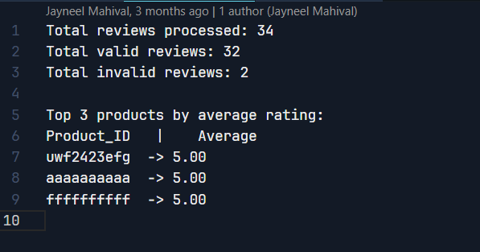

Experiment – 2

Aim: To write a Python program that reads student grades from a CSV file, calculates the average score for each student, and writes the result into a new CSV file. The program will demonstrate effective CSV file manipulation and the use of functions for modular and reusable code.

Code:
import csv
import os

def calculae_avg(data):
avg = round(sum(data) / len(data), 2)
return avg

INPUT_DIR = '../Data/students.csv'
OUTPUT_DIR = '../Outputs/output_exp2'
os.makedirs(OUTPUT_DIR, exist_ok=True)

def main():
main_data = []
with open(f'{INPUT_DIR}', mode='r') as f:
csvReader = csv.DictReader(f)
for line in csvReader:
student_avg = {}
maths_marks = line['Maths']
science_marks = line['Science']
english_marks = line['English']

data = [float(maths_marks), float(science_marks), float(english_marks)]
student_avg['Name'] = line['Name']
student_avg['Average'] = calculae_avg(data)

main_data.append(student_avg)

fields = ['Name', 'Average']
grades_csv = os.path.join(OUTPUT_DIR, 'student_average_grades.csv')
with open(grades_csv, 'w', newline='') as f:
csvwriter = csv.DictWriter(f, fieldnames=fields)
csvwriter.writeheader()
csvwriter.writerows(main_data)

if __name__ == "__main__":
main()

Output:
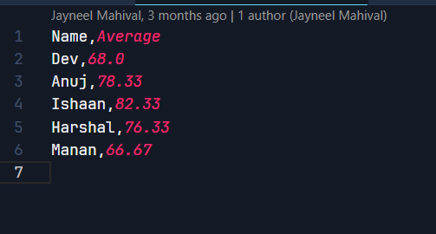

Experiment - 3

Aim: To implement a Python program that simulates a basic railway ticket reservation system by loading train and passenger data from CSV files, checking seat availability, booking tickets, updating train data, calculating fare, and generating reports.

Code:
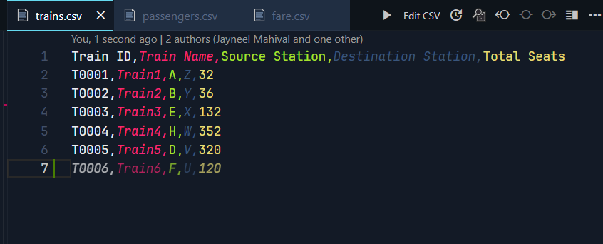
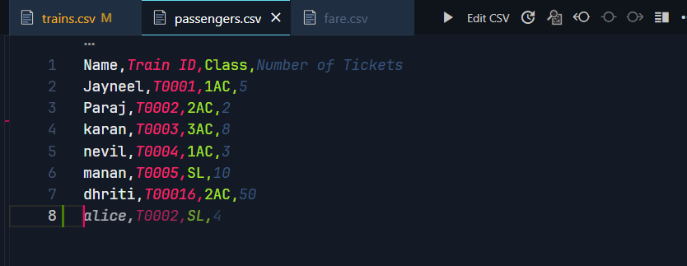
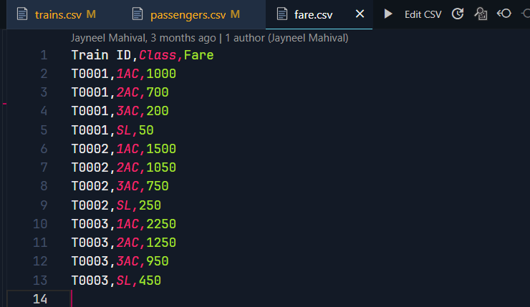
import csv
import os

TRAINS_FILE = "../Data/trains.csv"
PASSENGERS_FILE = "../Data/passengers.csv"
FARE_FILE = "../Data/fare.csv"
OUTPUT_DIR = "../Outputs/output_exp3"
os.makedirs(OUTPUT_DIR, exist_ok=True)

def load_trains():
trains = {}
with open(TRAINS_FILE, 'r', encoding='utf-8') as f:
reader = csv.DictReader(f)
for row in reader:
trains[row['Train ID']] = {
'Train Name': row['Train Name'],
'Source': row['Source Station'],
'Destination': row['Destination Station'],
'Total Seats': int(row['Total Seats'])
}
return trains

def load_fares():
fares = {}
with open(FARE_FILE, 'r', encoding='utf-8') as f:
reader = csv.DictReader(f)
for row in reader:
train_id = row['Train ID']
train_class = row['Class']
fare_amount = int(row['Fare'])
fares[(train_id, train_class)] = fare_amount
return fares

def load_passengers():
passengers = []
with open(PASSENGERS_FILE, 'r', encoding='utf-8') as f:
reader = csv.DictReader(f)
for row in reader:
passengers.append({
'Name': row['Name'],
'Train ID': row['Train ID'],
'Class': row['Class'],
'Tickets': int(row['Number of Tickets'])
})
return passengers

def book_tickets(trains, fares, passengers):
revenue = {}
passenger_costs = []

for p in passengers:
name = p['Name']
train_id = p['Train ID']
t_class = p['Class']
tickets = p['Tickets']

if train_id not in trains:
print(f"Error: Invalid Train ID '{train_id}' for passenger {name}")
continue

if (train_id, t_class) not in fares:
print(
f"Error: Fare for Train {train_id} Class {t_class} not found for {name}"
)
continue

available = trains[train_id]['Total Seats']
if tickets > available:
print(f"Error: Not enough seats for {name} on train {train_id}")
continue

trains[train_id]['Total Seats'] -= tickets
booking_fare = tickets * fares[(train_id, t_class)]
revenue[train_id] = revenue.get(train_id, 0) + booking_fare
passenger_costs.append(
(name, train_id, t_class, tickets, booking_fare))
print(
f"Booking confirmed for {name} on {trains[train_id]['Train Name']} ({t_class}) - Fare: ₹{booking_fare}"
)

return revenue, passenger_costs

def generate_reports(trains, revenue, passenger_costs):
with open(f"{OUTPUT_DIR}/report1_trains.csv", 'w', newline='', encoding='utf-8') as f:
fieldnames = ["Train ID", "Train Name", "Source", "Destination", "Seats Available"]
writer = csv.DictWriter(f, fieldnames=fieldnames)
writer.writeheader()
for tid, details in trains.items():
writer.writerow({
"Train ID": tid,
"Train Name": details['Train Name'],
"Source": details['Source'],
"Destination": details['Destination'],
"Seats Available": details['Total Seats']
})

with open(f"{OUTPUT_DIR}/report2_revenue.csv", 'w', newline='', encoding='utf-8') as f:
fieldnames = ["Train ID", "Total Revenue"]
writer = csv.DictWriter(f, fieldnames=fieldnames)
writer.writeheader()
for tid, rev in revenue.items():
writer.writerow({
"Train ID": tid,
"Total Revenue": rev
})

with open(f"{OUTPUT_DIR}/passenger_costs.csv", 'w', newline='', encoding='utf-8') as f:
fieldnames = ["Passenger Name", "Train ID", "Class", "Tickets", "Total Fare"]
writer = csv.DictWriter(f, fieldnames=fieldnames)
writer.writeheader()
for name, tid, t_class, tickets, fare in passenger_costs:
writer.writerow({
"Passenger Name": name,
"Train ID": tid,
"Class": t_class,
"Tickets": tickets,
"Total Fare": fare
})

def main():
trains = load_trains()
# print(trains)
fares = load_fares()
passengers = load_passengers()
revenue, passenger_costs = book_tickets(trains, fares, passengers)
generate_reports(trains, revenue, passenger_costs)
print("Reports generated successfully.")

if __name__ == "__main__":
main()

Output:
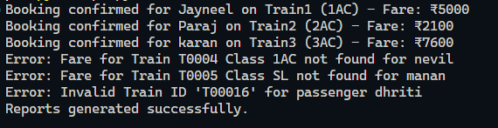
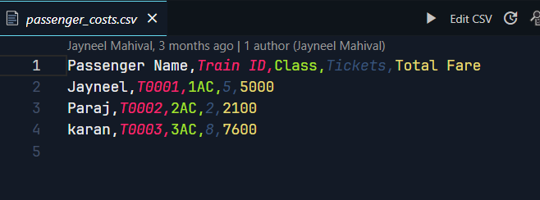
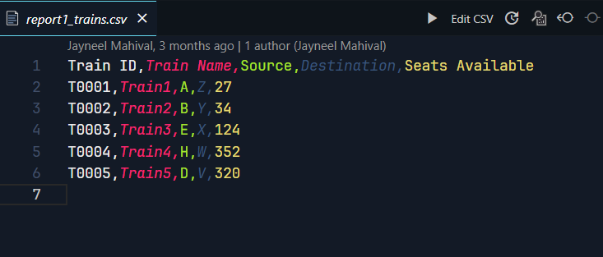
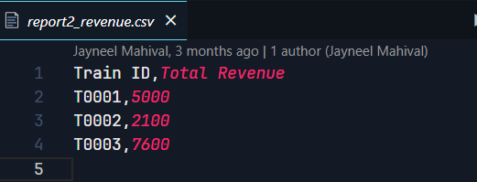

Experiment - 4

Aim: To develop a Python program that processes sales data stored across multiple CSV files, calculates the total and average monthly quantity sold per product, identifies the top 5 bestselling products and generates a summary report in CSV format.

Code:
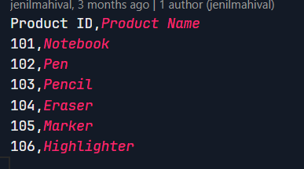
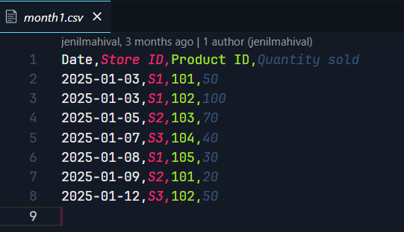

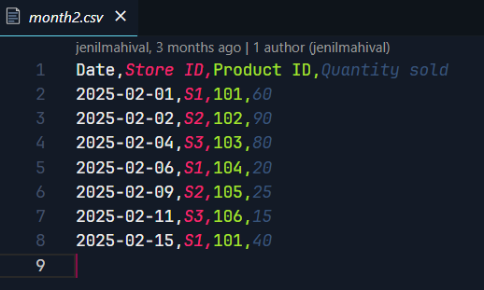

import os

import pandas as pd

def process_sales_data(root_dir):
product_names_path = os.path.join(root_dir, "Data/product_names.csv")
product_names_df = pd.read_csv(product_names_path)
product_dict = dict(zip(product_names_df["Product ID"], product_names_df["Product Name"]))

sales_data = {}
months = set()

for dirpath, _, filenames in os.walk(root_dir):
for file in filenames:
if file.endswith(".csv") and file != "product_names.csv":
file_path = os.path.join(dirpath, file)

df = pd.read_csv(file_path)

if not {"Date", "Product ID", "Quantity sold"}.issubset(df.columns):
continue

df["Month"] = pd.to_datetime(df["Date"]).dt.to_period("M")
months.update(df["Month"].unique())

for _, row in df.iterrows():
pid = row["Product ID"]
qty = int(row["Quantity sold"])
sales_data[pid] = sales_data.get(pid, 0) + qty

num_months = len(months)
summary_data = []
for pid, total_qty in sales_data.items():
avg_qty = total_qty / num_months if num_months > 0 else 0
pname = product_dict.get(pid, "Unknown Product")
summary_data.append([pid, pname, total_qty, round(avg_qty, 2)])

summary_df = pd.DataFrame(summary_data, columns=[
"Product ID", "Product Name", "Total Quantity Sold", "Average Quantity Sold per Month"
])

summary_df.sort_values(by="Total Quantity Sold", ascending=False, inplace=True)
top5_df = summary_df.head(5)

output_path = os.path.join(root_dir, "Outputs/sales_summary.csv")
summary_df.to_csv(output_path, index=False)

print("\nTop 5 Best-Selling Products:")
print(top5_df.to_string(index=False))

if __name__ == "__main__":
process_sales_data("..")

Output:
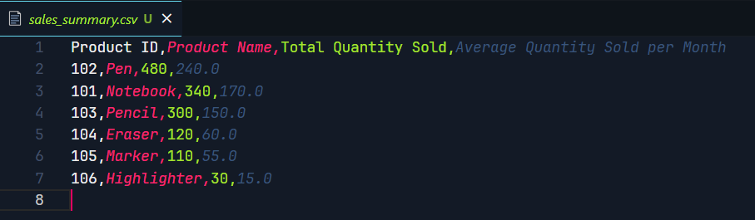

Experiment - 5

AIM: To develop a Python program that reads and analyses structured JSON files containing COVID-19 data across multiple countries, computes summary statistics, identifies extreme cases, and generates a consolidated report.

CODE:
Input file:
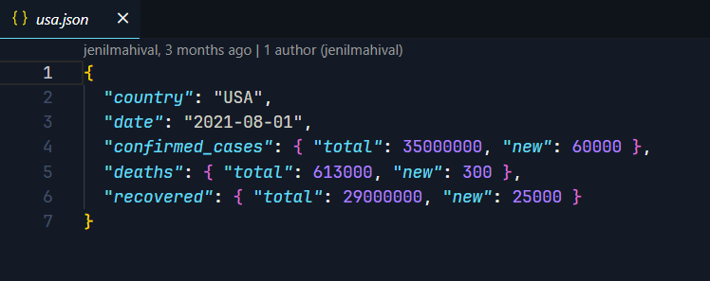
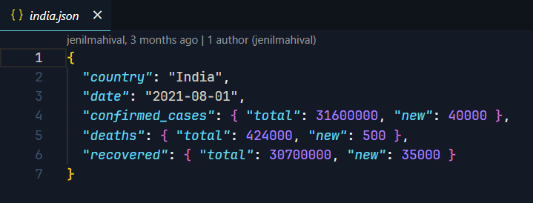
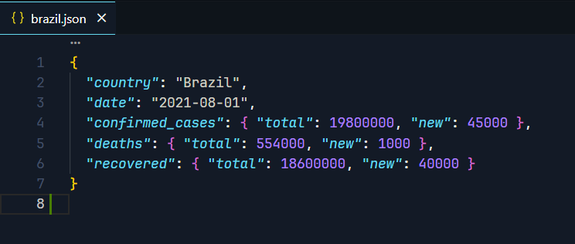
Source code:
import os
import json

base = "../Data/Covid/"
covid_data = []

for root, _, files in os.walk(base):
for file in files:
if file.endswith(".json"):
file_path = os.path.join(root, file)
try:
with open(file_path, "r", encoding="utf-8") as f:
data = json.load(f)
covid_data.append(data)
except Exception as e:
print(f"Error reading {file_path}: {e}")

print(f"Total JSON files read: {len(covid_data)}")

total_confirmed_cases = 0
total_deaths = 0
total_recovered_cases = 0
total_active_cases = 0

country_stats = {}

for data in covid_data:
country = data["country"]
confirmed = data["confirmed_cases"]["total"]
deaths = data["deaths"]["total"]
recovered = data["recovered"]["total"]

if country not in country_stats:
country_stats[country] = {
"total_confirmed": 0,
"total_deaths": 0,
"total_recovered": 0
}

country_stats[country]["total_confirmed"] += confirmed
country_stats[country]["total_deaths"] += deaths
country_stats[country]["total_recovered"] += recovered

with open("../Outputs/covid_summary.json", "w", encoding="utf-8") as f:
json.dump(country_stats, f, indent=4, ensure_ascii=False)
print(country_stats)

Output:
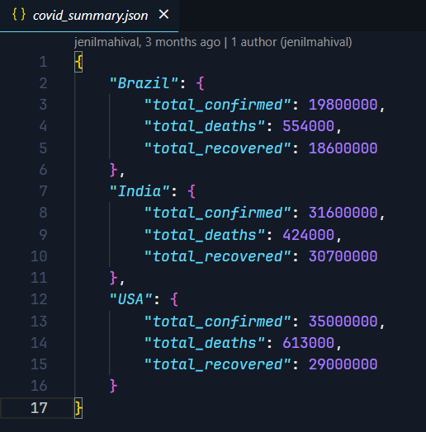

Experiment - 6

Aim: To build a robust Python-based text processing tool that can read input from a user-specified file, process the content, and write results to an output file using exception handling mechanism to ensure fault tolerance and graceful error reporting.

Code:
from collections import defaultdict
from wordcloud import WordCloud
import matplotlib.pyplot as plt

class InvalidData(Exception):
def __init__(self, message="Invalid data found in the file"):
self.message = message
super().__init__(self, message=message)

try:
with open("input.txt", "r") as file:
for line in file:
ls = line.split(" ")
except FileNotFoundError:
print("please give a valid input file")

try:
word_freq = defaultdict(int)
for word in ls:
for letter in word:
if(word.isnumeric() and letter.isdigit()):
word_freq[letter] += 1
elif(letter.isdigit()):
raise InvalidData
else:
word_freq[letter] += 1

except InvalidData as e:
print(f"Caught a custom error: {e.message}")

with open("input.txt", "r") as file:
t = file.read()

mc = WordCloud(width=500, height=300, background_color="white").generate(t)

plt.imshow(mc)
plt.show()

print(len(ls))
print(word_freq)

Output:
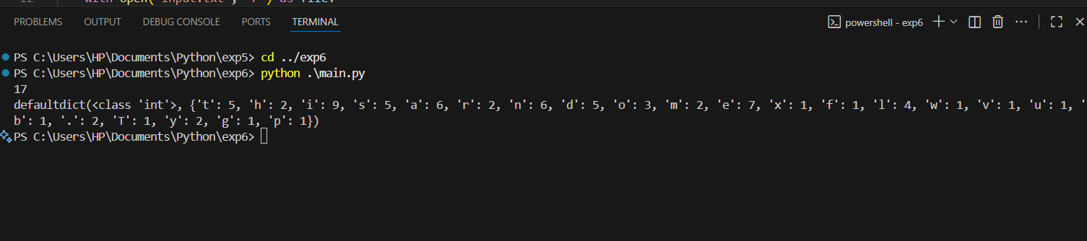

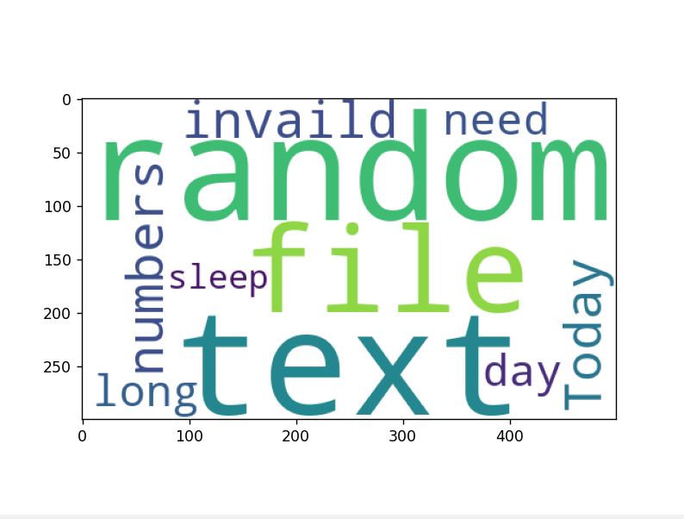

Experiment - 7

Aim: To analyze a Python-based project. Identify potential points for logging and implement dummy code with logging at key places such as function calls, exception handling, input/output operations, and loops for debugging and monitoring purposes.

Code:
import logging

def add(a,b):
return a+b

def sub(a,b):
return a-b

def mul(a,b):
return a*b

def div(a,b):
if b==0:
logging.error("Error:: Division by zero")
return None
return a/b

if __name__ =="__main__":

logging.basicConfig(
filename="calculator.log",
level=logging.INFO,
format="%(asctime)s - %(levelname)s - %(message)s",
)
flag = True
while(flag):
print("1. Add 2. Subtract 3.Multiply 4.Divide 5.Quit")
choice = int(input("Enter the choice:"))
if choice == 5:
break
flag = False
try:
if choice==1:
a=int(input("Enter the first number: "))
b=int(input("Enter the second number: "))
logging.info("Performing addition of two numbers::")
print(add(a, b))
elif choice ==2:
a=int(input("Enter the first number: "))
b=int(input("Enter the second number: "))
logging.info("Performing subtraction of two numbers::")
print(sub(a, b))
elif choice == 3:
a=int(input("Enter the first number: "))
b=int(input("Enter the second number: "))
logging.info("Performing multiplication of two numbers::")
print(mul(a, b))
elif choice == 4:
a=int(input("Enter the first number: "))
b=int(input("Enter the second number: "))
logging.info("Performing division of two numbers::")
print(div(a, b))
else:
print("Enter a valid number")
logging.info("Please enter a valid number:: ")
except ValueError:
print("Invalid Value type:: ")
except Exception as e:
print(f"Error occured :: {e}")

Output:

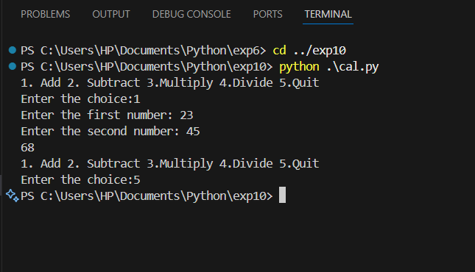

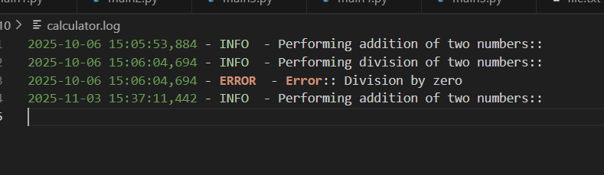

Experiment - 8

Aim: To develop a Python program that performs various image processing operations including loading, displaying, manipulating images, and analyzing image histograms.
Code:
from PIL import Image, ImageFilter, ImageEnhance
import matplotlib.pyplot as plt
import sys

IMAGE_FILE = "spotify2.png"

try:
with Image.open(IMAGE_FILE).convert('RGB') as img:
print(f"Successfully loaded '{IMAGE_FILE}'.")
print(f"Original mode: {img.mode}, Original size: {img.size}")

print("Displaying original image...")
img.show(title="Original Image")

print("Performing image manipulations...")

blurred_img = img.filter(ImageFilter.GaussianBlur(radius=5))
blurred_img.show(title="Gaussian Blur")

edges_img = img.filter(ImageFilter.FIND_EDGES)
edges_img.show(title="Edge Detection")

w, h = img.size
resized_img = img.resize((w // 2, h // 2))
resized_img.show(title="Resized (50%)")

bright_img = ImageEnhance.Brightness(img).enhance(1.8)
bright_img.show(title="Increased Brightness")

contrast_img = ImageEnhance.Contrast(img).enhance(1.5)
contrast_img.show(title="Increased Contrast")

grayscale_img = img.convert('L')
grayscale_img.show(title="Grayscale")

print("Calculating and displaying histogram...")

histogram = img.histogram()

r_hist = histogram[0:256]
g_hist = histogram[256:512]
b_hist = histogram[512:768]

plt.figure(figsize=(12, 6))
plt.suptitle('Color Histograms', fontsize=16)

plt.subplot(1, 3, 1)
plt.title("Red Channel")
plt.plot(r_hist, color='red')
plt.xlabel("Pixel Value")
plt.ylabel("Frequency")
plt.xlim([0, 256])

plt.subplot(1, 3, 2)
plt.title("Green Channel")
plt.plot(g_hist, color='green')
plt.xlabel("Pixel Value")
plt.xlim([0, 256])

plt.subplot(1, 3, 3)
plt.title("Blue Channel")
plt.plot(b_hist, color='blue')
plt.xlabel("Pixel Value")
plt.xlim([0, 256])

plt.tight_layout(rect=[0, 0.03, 1, 0.95])
plt.show()

except FileNotFoundError:
print(f"Error: The file '{IMAGE_FILE}' was not found.")
print("Please make sure the image file is in the same directory as the script.")
except Exception as e:
print(f"An error occurred: {e}")

Output:
(Original photo)


(Gaussian Blur)
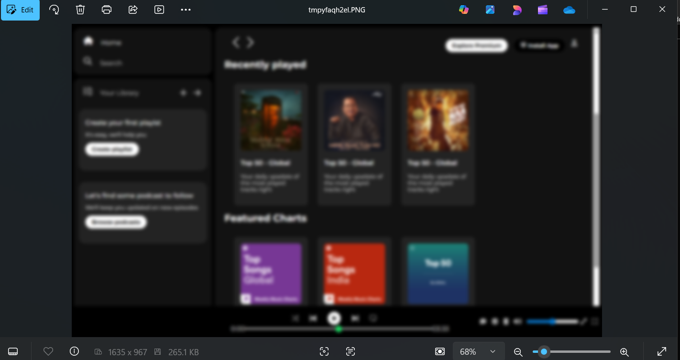

(Edge Detection)
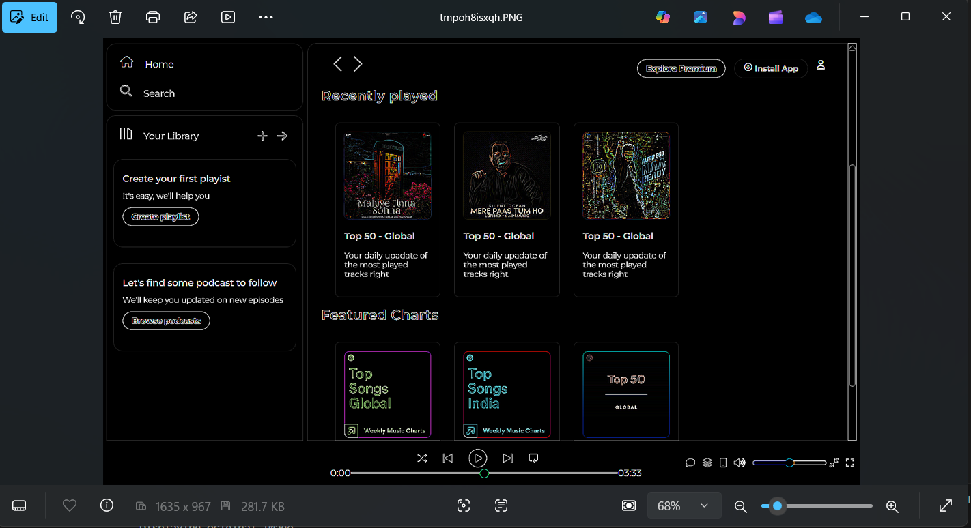

(Resize Image)
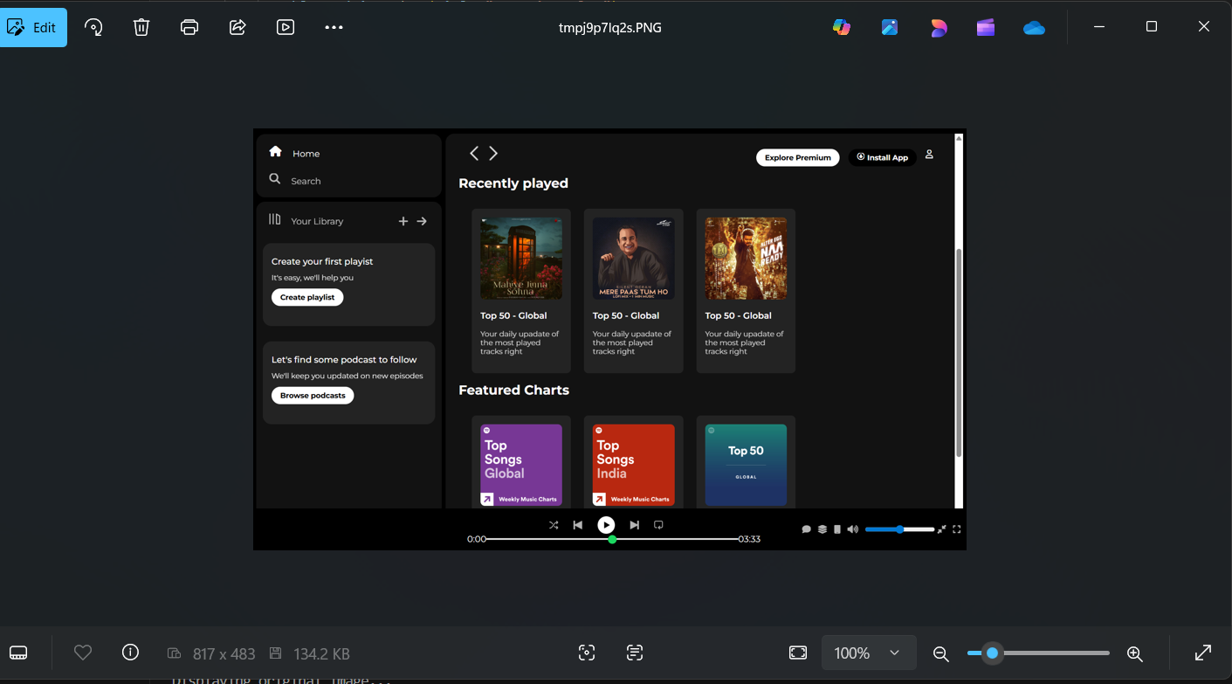

(Brightness)


(Contrast)


(Grayscale)
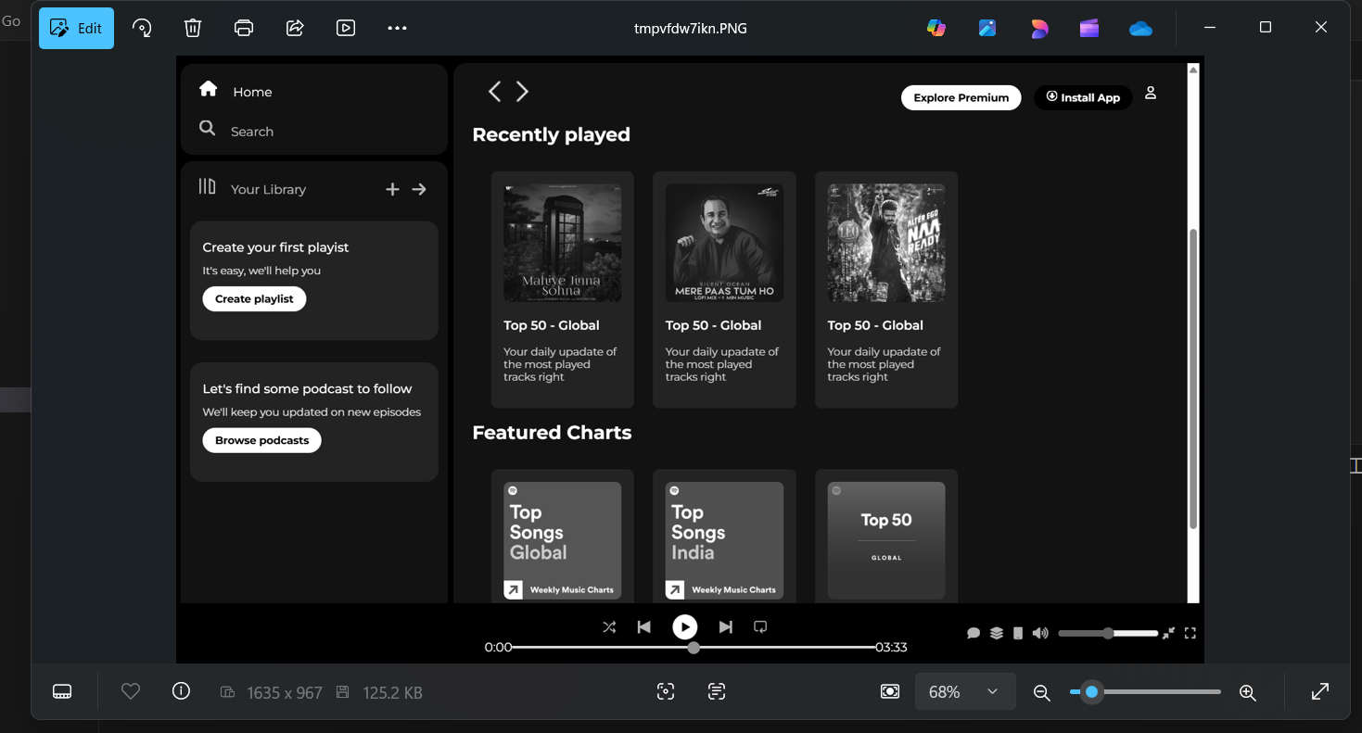

(Histogram)
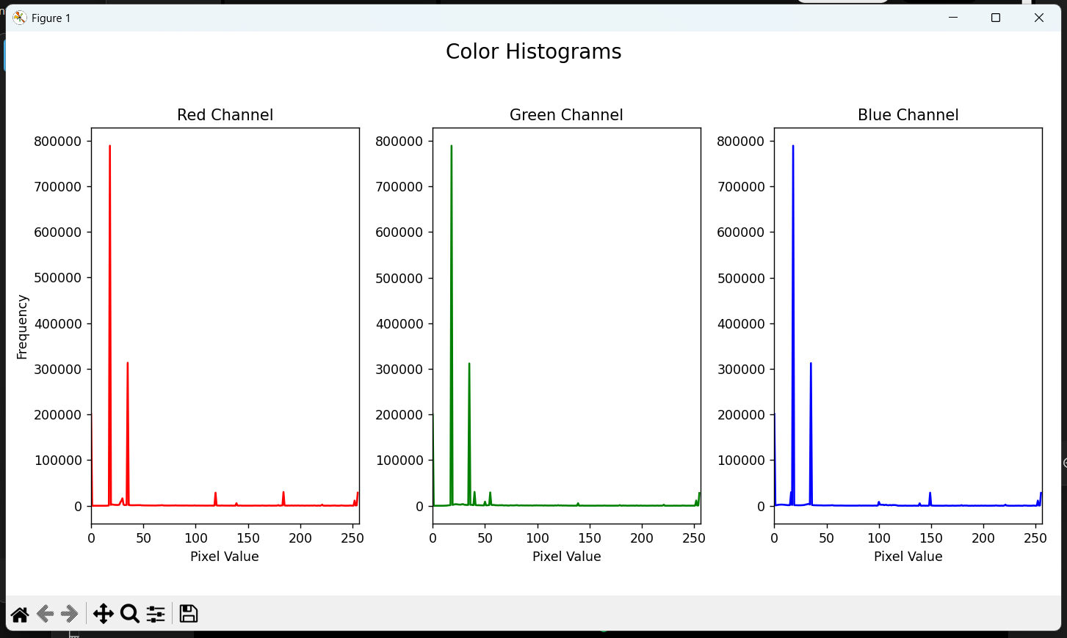

Experiment - 9

Aim: To analyze customer transaction data and segment customer based on their shopping behaviour using data analysis and clustering techniques in Python.
Code:
import pandas as pd
import numpy as np
from datetime import datetime
import kagglehub
import os

print("Downloading dataset from Kaggle...")
try:
dataset_path = kagglehub.dataset_download("puneetbhaya/online-retail")
file_name = None
for item in os.listdir(dataset_path):
if "retail" in item.lower() and (
item.endswith(".csv") or item.endswith(".xlsx")
):
file_name = item
break

if file_name is None:
raise FileNotFoundError(
"Could not find the main transaction file (csv or xlsx) in the downloaded directory."
)

file_path = os.path.join(dataset_path, file_name)

if file_name.endswith(".csv"):
df = pd.read_csv(file_path, encoding="unicode_escape")
elif file_name.endswith(".xlsx"):
df = pd.read_excel(file_path)

except Exception as e:
print(f"An error occurred during download or loading: {e}")
print(
"Please ensure you have a valid Kaggle API key configured and the file exists."
)
exit()

print(f"Data Loaded from: {file_path}")
print("Initial Data Check (First 5 Rows):")
print(df.head())
print("-" * 70)

df["Sales"] = df["Quantity"] * df["UnitPrice"]

df.dropna(subset=["CustomerID"], inplace=True)
df["CustomerID"] = df["CustomerID"].astype(int)

df = df[(df["Quantity"] > 0) & (df["UnitPrice"] > 0)]

date_col = "InvoiceDate" if "InvoiceDate" in df.columns else "InvoiceDate"
df[date_col] = pd.to_datetime(df[date_col])

NOW = df[date_col].max() + pd.Timedelta(days=1)

customer_data = (
df.groupby("CustomerID")
.agg(
Recency=(date_col, lambda x: (NOW - x.max()).days),
Frequency=("InvoiceNo", "nunique"),
Monetary=("Sales", "sum"),
TotalItemsPurchased=("Quantity", "sum"),
Last_Purchase_Date=(date_col, "max"),
)
.reset_index()
)

customer_data.rename(columns={"Monetary": "Total Amount Spent"}, inplace=True)

customer_data["Average Purchase Value"] = (
customer_data["Total Amount Spent"] / customer_data["Frequency"]
)

print("Customer Segmentation Features (First 5 Rows):")
print(customer_data.head())
print("-" * 70)

print("Descriptive Statistics for Segmentation Features (Task 3):")
stats = (
customer_data[["Total Amount Spent", "TotalItemsPurchased", "Recency", "Frequency"]]
.describe()
.T
)
print(stats)

Output:
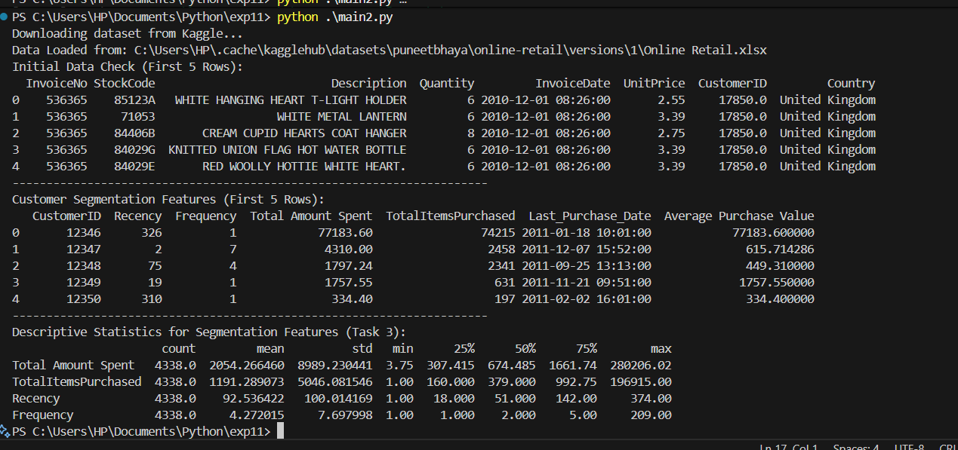

Experiment - 10

Aim: To analyze customer transaction data and segment customers based on their shopping behaviour using data analysis and clustering techniques in Python.

Code:
import csv
import os
from datetime import datetime
from reportlab.lib.pagesizes import A4
from reportlab.pdfgen import canvas
from PyPDF2 import PdfMerger

input_file = "orders.csv"
output_folder = "invoices"

if not os.path.exists(output_folder):
os.makedirs(output_folder)

def create_invoice(order):
order_id = order["Order ID"]
customer_name = order["Customer Name"]
product_name = order["Product Name"]
quantity = int(order["Quantity"])
unit_price = float(order["Unit Price"])
total_amount = quantity * unit_price
date = datetime.now().strftime("%d-%m-%Y")

filename = f"{output_folder}/Invoice_{order_id}.pdf"
c = canvas.Canvas(filename, pagesize=A4)
width, height = A4

c.setFont("Helvetica-Bold", 18)
c.drawCentredString(width / 2, height - 50, "Invoice")

c.setFont("Helvetica", 12)
c.drawString(50, height - 100, f"Invoice Number: {order_id}")
c.drawString(50, height - 120, f"Date of Purchase: {date}")
c.drawString(50, height - 160, f"Customer Name: {customer_name}")
c.drawString(50, height - 200, f"Product Name: {product_name}")
c.drawString(50, height - 220, f"Quantity: {quantity}")
c.drawString(50, height - 240, f"Unit Price: ₹{unit_price:.2f}")
c.drawString(50, height - 260, f"Total Amount: ₹{total_amount:.2f}")

c.setFont("Helvetica-Oblique", 10)
c.drawString(50, 80, "Thank you for shopping with us!")

c.save()
return filename

pdf_files = []

with open(input_file, newline="", encoding="utf-8") as csvfile:
reader = csv.DictReader(csvfile)
for row in reader:
pdf_path = create_invoice(row)
pdf_files.append(pdf_path)
print(f"Generated: {pdf_path}")

merger = PdfMerger()
for pdf in pdf_files:
merger.append(pdf)

merged_filename = "All_Invoices.pdf"
merger.write(merged_filename)
merger.close()

print(f"\n All invoices merged into {merged_filename}")

Source File:
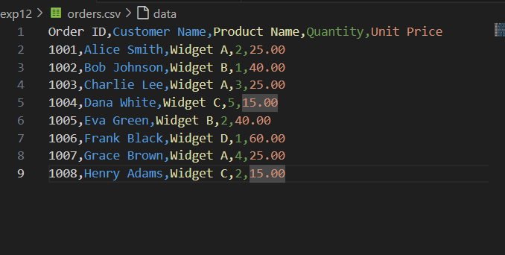

Output:

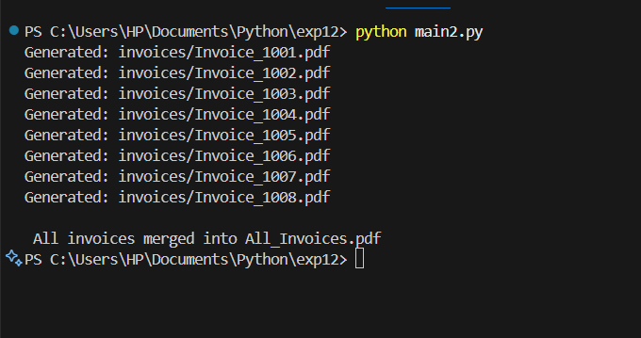

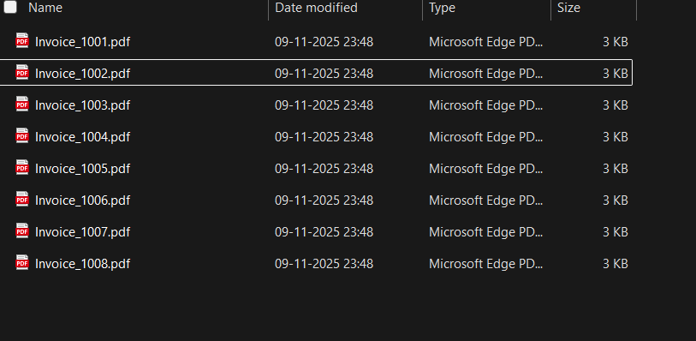

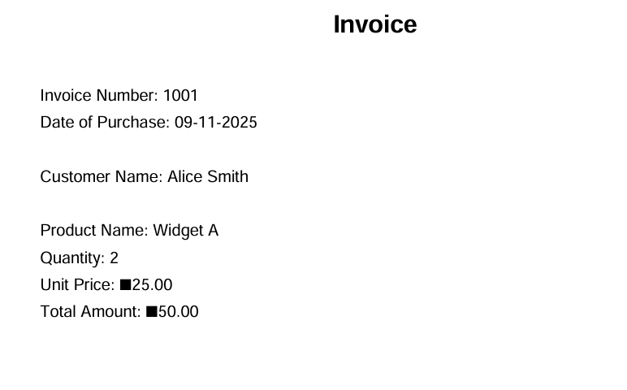

Experiment - 11

Aim: To develop a secure command-line user management system that allows users to register and log in, with all user credentials stored securely using hashed password in a local file.

Code:
import json
import pathlib
import bcrypt

logged_in = False
current_user = None
DATABASE = pathlib.Path.cwd() / "Data" / "db.json"

def display_option():
print("\n---- Welcome to User Management System ----")
print("1. Login")
print("2. Register")
print("3. Exit")
try:
n = int(input("Enter Your Choice: "))
return n
except ValueError:
return 0

def display_home(user: str):
print(f"\n--- Dashboard ---")
print(f"Welcome back, {user}!")
print("1. Logout")
try:
return int(input("Enter your choice: "))
except ValueError:
return 0

def main():
global logged_in, current_user

DATABASE.parent.mkdir(exist_ok=True)

while True:
if not logged_in:
choice = display_option()

if choice == 1:
try:
with open(DATABASE, "r", encoding="utf-8") as f:
data = json.load(f)
except (FileNotFoundError, json.JSONDecodeError):
print("\n[Error] No users registered. Please register first.")
continue

username = input("Enter Username: ")

user_account = next((user for user in data if user.get('username') == username), None)

if user_account:
pwd = input("Enter Password: ")
stored_hash = user_account.get('password').encode('utf-8')

if bcrypt.checkpw(pwd.encode("utf-8"), stored_hash):
print("\nLogin successful!")
logged_in = True
current_user = username
else:
print("\n[Error] Incorrect password.")
else:
print("\n[Error] Username doesn't exist.")

elif choice == 2:
try:
with open(DATABASE, "r", encoding="utf-8") as f:
data = json.load(f)
if not isinstance(data, list): data = []
except (FileNotFoundError, json.JSONDecodeError):
data = []

while True:
username = input("Enter Username: ")
if any(u.get('username') == username for u in data):
print("\n[Error] Username already exists. Please try another.")
else:
break

while True:
pwd = input("Enter Password: ")
confirm_pwd = input("Confirm Password: ")
if pwd == confirm_pwd:
break
else:
print("\n[Error] Passwords didn't match. Please try again.")

hashed_pw = bcrypt.hashpw(pwd.encode("utf-8"), bcrypt.gensalt(6))
user = {
'username': username,
'password': hashed_pw.decode('utf-8')
}

data.append(user)
with open(DATABASE, "w", encoding="utf-8") as f:
json.dump(data, f, indent=4)

print(f"\nUser '{username}' registered successfully! Please log in.")

elif choice == 3:
print("Exiting...")
break
else:
print("\n[Error] Invalid choice. Please try again.")

else:
choice = display_home(str(current_user))
if choice == 1:
print(f"Logging out {current_user}...")
logged_in = False
current_user = None
else:
print("\n[Error] Invalid choice.")

if __name__ == "__main__":
main()
Output:

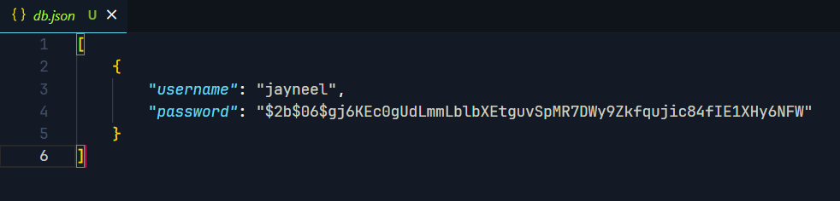
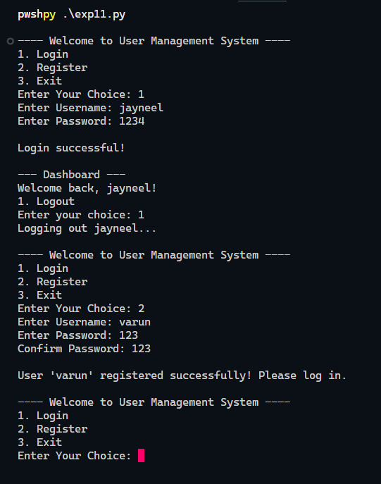

Experiment - 12

Aim: To develop a Python-based household expense tracker that supports data entry, analysis, categorization, budget management, and visual reporting through CSV handling and plotting libraries.

Code:
import csv
import os
import shutil
from datetime import datetime

import matplotlib.pyplot as plt
import pandas as pd

FILENAME = "expenses.csv"
BACKUP_FILE = "expenses_backup.csv"

def log_expense():
print("\n=== Log a New Expense ===")
name = input("Enter your name: ")
date = input("Enter date (YYYY-MM-DD): ")
description = input("Enter expense description: ")
amount = float(input("Enter amount spent: "))
category = input("Enter category (e.g., Groceries, Utilities, Entertainment): ")

file_exists = os.path.isfile(FILENAME)

with open(FILENAME, "a", newline="", encoding="utf-8") as file:
writer = csv.writer(file, quoting=csv.QUOTE_ALL)
if not file_exists:
writer.writerow(["Name", "Date", "Description", "Amount", "Category"])
writer.writerow([name, date, description, amount, category])
print("Expense logged successfully!\n")

def analyze_expenses():
if not os.path.exists(FILENAME):
print("No expenses found.")
return

df = pd.read_csv(FILENAME)
print("\n=== Expense Analysis ===")
total_by_person = df.groupby("Name")["Amount"].sum()
print("\nTotal Expenses by Family Member:")
print(total_by_person)

avg_daily_expense = df.groupby("Date")["Amount"].sum().mean()
print(f"\nAverage Daily Household Expense: ₹{avg_daily_expense:.2f}\n")

def plot_expense_trends():
if not os.path.exists(FILENAME):
print("No expenses found.")
return

df = pd.read_csv(FILENAME)
df["Date"] = pd.to_datetime(df["Date"])
df.sort_values("Date", inplace=True)
df_grouped = df.groupby("Date")["Amount"].sum().cumsum()

plt.figure(figsize=(10, 5))
plt.plot(df_grouped.index, df_grouped.values, marker="o", linestyle="-", color="b")
plt.title("Expense Trends Over Time")
plt.xlabel("Date")
plt.ylabel("Cumulative Expenses (₹)")
plt.grid(True)
plt.tight_layout()
plt.show()

def expense_report():
if not os.path.exists(FILENAME):
print("No expenses found.")
return

df = pd.read_csv(FILENAME)
df["Date"] = pd.to_datetime(df["Date"])
df["Month"] = df["Date"].dt.strftime("%Y-%m")

print("\n=== Monthly Expense Report ===")
total_by_person = df.groupby(["Month", "Name"])["Amount"].sum()
print("\nTotal Expenses per Member per Month:")
print(total_by_person)

category_breakdown = df.groupby("Category")["Amount"].sum()
print("\nExpense Breakdown by Category:")
print(category_breakdown)

monthly_expenses = df.groupby("Month")["Amount"].sum()
monthly_expenses.plot(kind="bar", color="teal", figsize=(8, 4))
plt.title("Monthly Expense Comparison")
plt.xlabel("Month")
plt.ylabel("Total Expenses (₹)")
plt.tight_layout()
plt.show()

def manage_budget():
if not os.path.exists(FILENAME):
print("No expenses found.")
return

df = pd.read_csv(FILENAME)
categories = df["Category"].unique()

print("\n=== Set Monthly Budgets ===")
budgets = {}
for cat in categories:
budgets[cat] = float(input(f"Enter budget for {cat}: ₹"))

spent = df.groupby("Category")["Amount"].sum()
print("\n=== Budget Report ===")
for cat in budgets:
spent_amt = spent.get(cat, 0)
remaining = budgets[cat] - spent_amt
print(f"{cat}: Spent ₹{spent_amt:.2f} / Budget ₹{budgets[cat]:.2f}")
if remaining < 0:
print(f"Over budget by ₹{-remaining:.2f}!")
else:
print(f"Remaining budget: ₹{remaining:.2f}")
print("-" * 40)

def backup_data():
if not os.path.exists(FILENAME):
print("No expense data found to back up.")
return
shutil.copy(FILENAME, BACKUP_FILE)
print("Data backup created successfully!\n")

def restore_data():
if not os.path.exists(BACKUP_FILE):
print("No backup file found.")
return
shutil.copy(BACKUP_FILE, FILENAME)
print(" Data restored successfully!\n")

def main():
while True:
print(
"""
========= Household Expense Tracker =========
1. Log a new expense
2. Analyze expenses
3. View expense trends
4. Generate monthly report
5. Manage budget
6. Backup data
7. Restore data
8. Exit
"""
)
choice = input("Enter your choice (1-8): ")

if choice == "1":
log_expense()
elif choice == "2":
analyze_expenses()
elif choice == "3":
plot_expense_trends()
elif choice == "4":
expense_report()
elif choice == "5":
manage_budget()
elif choice == "6":
backup_data()
elif choice == "7":
restore_data()
elif choice == "8":
print("Exiting... Goodbye!")
break
else:
print("Invalid choice! Try again.\n")

if __name__ == "__main__":
main()

Output:
