Game Design Document

Fill up the following document

1. Write the title of your project.

Hungry Zombies

1. What is the goal of the game?

The goal of the game is to protect the Playing charater from zombies that are trying to attack it. This will be done by shooting the zombie and killing them.

1. Write a brief story of your game.

The game is about a person who is a survivor of the zombie apocalypse. He has gathered gun from here and there and is now fighting a Horde of zombies coming towards him. We need to protect the person by shooting the zombies. The Playing character will get three lifes and when all the reviving turns will finish, your game will end.

1. Which are the playing characters of this game?

* Playing characters are the ones who respond to the user based on the input from the user.
* Cars, monkeys, dinos, wizards, etc., are the playing characters in the game.

|  |  |  |
| --- | --- | --- |
| Number | Character Name | What can this character do? |
| 1 | Hero | Shoot the zombies |

1. Which are the Non-Playing Characters of this game?

* Non-Playing characters are the ones that don't have an action or behavior when the user interacts with the game.
* Hurdles, stones, bananas, coins, etc., are non-playing characters in the game.

|  |  |  |
| --- | --- | --- |
| Number | Character Name | What can this character do? |
| 1 | Zombie 1 | Attack the Hero |
| 2 | Zombie 2 | Attack the Hero |
| 3 | Zombie 3 | Attack the Hero |
| 4 | Zombie 4 | Attack the Hero |
| 5 | Zombie 5 | Attack the Hero |
| 6 | Zombie 6 | Attack the Hero |
| 7 | Zombie 7 | Attack the Hero |
| 8 | Zombie 8 | Attack the Hero |

Draw your imagination of this game. What does this game look like?

* Draw the game either on your computer or on paper.
* Add images of the game scenes to show each of the playing and non-playing characters at least once.

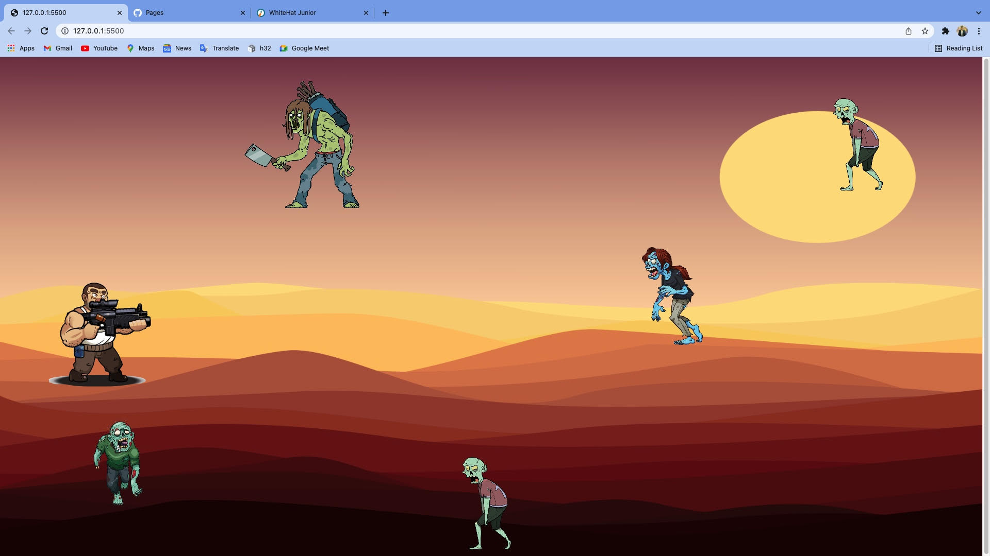

6.How do you plan to make your game engaging?

For making my game more engaging , I will first of all set a target audience (8-16years). I will add different levels in the game , which will increase the difficultly level, So that the game becomes more interesting. For making it engaging I will add different types of backgrounds which will automatically change according to the time in real life.There will be 3 lives given to PC(playing character), so that there is equality in the game.