COMP64012015-2016S1 Assignment 5
Minpath Due: November 22, 2015

Given an m by n matrix of integers (m <= 10, n <= 99), write a program which finds a path of minimal weight. A path begins anywhere in column 1 and consists of a sequence of steps ending in column n. A step consists of going from column j to column j+1 in an adjacent row, moving horizontally or diagonally. The first and last rows of the matrix are considered adjacent, i.e., the matrix ‘wraps’ so that it represents a horizontal cylinder. The weight of a path is the sum of the numbers in each of the n cells visited. For example, two matrices are shown below with the minimal path illustrated:

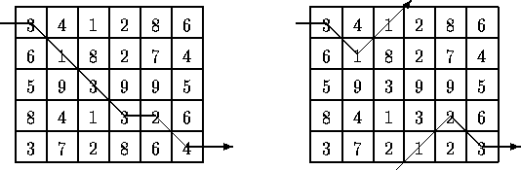
Input: The first line of data contains m and n in that order. This is followed by m x n integers; the numbers in the matrix in row major order. Integers on a line are separated by one or more spaces. An integer can be positive, negative or zero. You may assume that the weight of a path is small enough to be stored in an integer variable.

Output: The first line contains the weight of a minimal path and the second contains the path. The path consists of a sequence of n integers specifying the rows that constitute the minimal path. If there is more than one minimal weight path, any one will be acceptable.

Sample input
5 6
3 4 1 2 8 6 6 1 8 2 7 4
5 9 3 9 9 5 8 4 1 3 2 6
3 7 2 8 6 4

Sample output
16
1 2 3 4 4 5

