Classification Of Coronavirus using XCeption Model & Transfer Learning

*Abstract*—AI has been playing a big role on a variety of platforms. We are trying to put forward a model for the classification of a coronavirus dataset. The dataset contains chest radiology images of normal and pneumonia patients. The main aim is to simplify the process to produce an efficient dataset for the training of models to detect coronavirus infections. The final output will be an efficient result with a high level of accuracy that is obtained after the evaluation of the model is complete.

Keywords—Covid-19, Xception Model, CNN, Transfer Learning, Confusion Matrix, Classification, Image Data, Neural Networks

# Introduction

Coronavirus or Covid-19 as it’s more commonly known is a very contagious and life threatening virus which belongs to the family of SARS-CoV-2 viruses. This virus is spread by way of respiratory routes which mostly includes water droplets, air particles and aerosols. Getting infected with Covid-19 results in many complications, chief among which is pneumonia. Pneumonia is mostly caused by inflammation of an individual's lungs due to prolonged exposure to Covid-19. The symptoms are mostly visible after 14 days from the date of initial contraction. There are many methods of identification of Covid-19 which include a lateral flow test, PCR test, Imaging, Coding, Pathology, etc. The most notable ways to defend yourself from this virus is by wearing a face mask and maintaining good respiratory hygiene.This paper explains the process of Transfer Learning using Xception Model Classification on the dataset of Covid-19. We have 5800 images of covid-19 x-ray scans of patients to help to train the model to better identify the individuals who have contracted Covid-19. By using Transfer Learning, we are able to reuse a pre-trained model on a totally different problem which helps us save a lot more time. This provides a much more efficient output than would normally be generated by other models.

Literature Survey

The article (Donges, 2019) suggests that Transfer Learning uses the knowledge that it has gained from training with one model to train another model. Transfer Learning can be greatly exploited as the knowledge gained from one operation can be generalised and utilised for another operation. The main idea is that knowledge can be procured and used in another task which has similar preliminary conditions as the previous task. This means instead of the process being started from the beginning, it would continue from where it left off. Transfer Learning is mostly used in NLP and computer vision tasks which mostly include sentimental analysis which involves a high amount of computational power. It is considered to be more of a design methodology rather than a machine learning technique. It seems to work quite well in combination with neural networks which demand a large amount of data as well as computational power. The topic of transfer learning commands that much knowledge or data for that matter is transferred from a terminated task where the model was trained onto a new task and that this knowledge could vary depending on the data and the problem in general. This method provides a great deal of benefits, the most popular being the ability to save large amounts of time, an increased performance in neural networks and being non-demanding when it comes to large amounts of data. This is one place where transfer learning outperforms the rest.

This article (Fabien, 2019) suggests that Xception is a deep convoluted neural network which was developed by researchers from Google. A convolution could also be understood as an Inception module with a large number of towers where inception modules are replaced by depthwise separable convolutions. The data first passes through the entry point, it then passes through the middle flow which is iterated over eight times and finally passes through the exit flow. XCeption is often considered as an efficient architecture which often relies on two different points being Depthwise Separable Convolution and Shortcuts between Convolution blocks respectively. The Depthwise Separable Convolutions is considered as an alternative to the classical methods of evolution which is usually considered to be much more efficient in regards to computation time. To summarise, Xception models are known to be very expensive to train but overall are an exceptional improvement when it comes to Inception models. The Transfer Learning usually brings about a part of the solution when it comes to adapting algorithms to perform certain tasks.

# Dataset

Several publicly available medical repositories were utilized to acquire and analyze chest X-ray radiography (CXR) images for this study. Allen Institute for AI created and examined these repositories along with the Chan Zuckerberg Initiative, Georgetown University's Center for Security and Emerging Technologies, Microsoft Research, and the National Library of Medicine, in coordination with the White House Office of Science and Technology Policy. In particular, the dataset included in this study contains 8474 2D X-ray images of the posteroanterior chest. The study included 415 of these images. There were 5179 cases of COVID-19 disease, as well as 2880 cases of non-COVID-19 infected pneumonia acquired in the community.

# Methodology:

This paper explains the classification of coronavirus datasets using Transfer Learning and Xception Model in order to produce a much more efficient result. We will be using Python to import numpy, seaborn, matplotlib, pandas, tensorflow and keras libraries into our environment.

NumPy is a scientific computation library that is built upon the Python programming language and gets imported into the environment at the start of each program. Seaborn is a type of data-visualisation library that is built-in the Python language that gives seaborn the alias of sns during the process of being imported into the environment. Matplotlib is a plotting library which is a component of Python programming language which is considered as an extension to NumPy as it too contains numerical mathematical extensions. Pandas is an open source module in Python programming language that contains a variety of high performance and easy-to-use data structures as well as the tools to perform data analysis. Tensorflow is another free and open source library that is available in python and is mostly used in artificial intelligence and machine learning. Keras is another open source software library in python which provides a python interface for the implementation of artificial neural networks.

Data Loading and Inspection

We are loading the csv file into the dataframe to implement the task for processing data from the dataset. Two example images for two classes are produced which depict the level of progression of pneumonia in the patient.

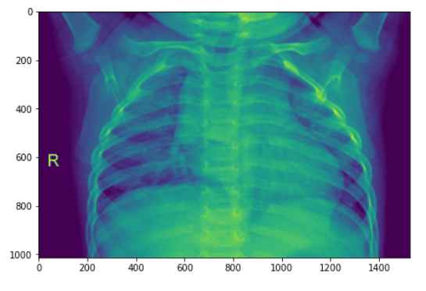

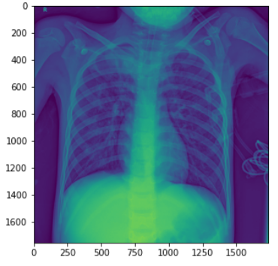

Data preprocessing

This step involves the transformation of basic or raw data from a dataset contained in a csv file to a more understandable or readable format. The images are read though the generators before the process of model definition begins.

Model definition

This stage involves the application of transfer learning using Xception Model within the limits of ImageNet weights.

Model training and evaluation

After the process of training the model has been completed, the result will depict a test set that includes precision, recall, f1-score, and support for the classification of image scans of patients having pneumonia and those without. Finally a heatmap confusion matrix is generated using the results to finalise true values and false values.

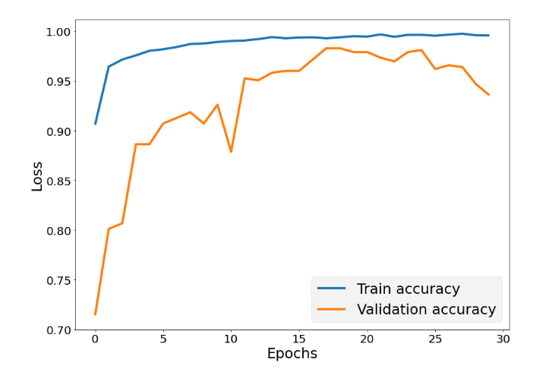

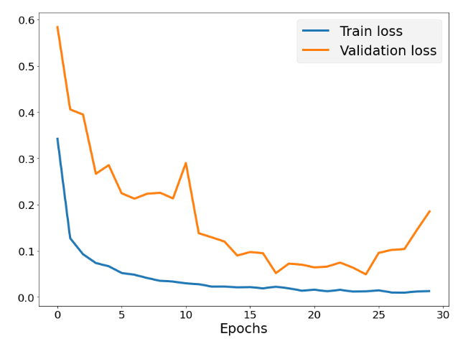

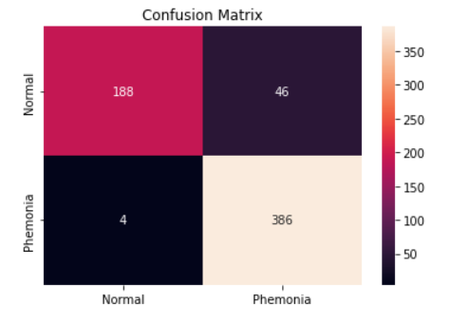

# Results and Future Work

In this paper, a number of new approaches are presented and investigated to assist in the development of a deep learning CNN model for detecting and classifying disease-associated samples in healthcare settings. Images of X-rays of chest X-rays of COVID-19 patients. According to the results of this study, preprocessing of the input image data can result in better input image data that can be used for the development of deep learning models. In order to apply the transfer learning method of learning, these procedures include the removal of irrelevant regions, the normalization of contrast-to-noise ratios, and the generation of pseudo-colour images to be fed into the three channels of CNN models. Moreover, the reported high classification performance of the model is promising, providing a solid base for further optimization of deep learning models for the detection of COVID-19 cases and evaluating their robustness and performance, by utilizing large data sets.

##### References

1. Vitalab.github.io. 2017. *Xception: Deep Learning with Depthwise Separable Convolutions*. [online] Available at: <https://vitalab.github.io/article/2017/03/21/xception.html#:~:text=The%20Xception%20Architecture%20In%20short%2C%20the%20Xception%20architecture,at%20one%20extreme%20of%20the%20spectrum%20described%20above.> [Accessed 25 April 2022].
2. Donges, N., 2019. *What Is Transfer Learning? Exploring the Popular Deep Learning Approach.*. [online] Built In. Available at: <https://builtin.com/data-science/transfer-learning> [Accessed 25 April 2022].
3. Heidari, M., Mirniaharikandehei, S., Khuzani, A., Danala, G., Qiu, Y. and Zheng, B., 2020. Improving the performance of CNN to predict the likelihood of COVID-19 using chest X-ray images with preprocessing algorithms. *International Journal of Medical Informatics*, 144, p.104284.
4. Heidari, M., Mirniaharikandehei, S., Khuzani, A., Danala, G., Qiu, Y. and Zheng, B., 2020. Improving the performance of CNN to predict the likelihood of COVID-19 using chest X-ray images with preprocessing algorithms. *International Journal of Medical Informatics*, 144, p.104284.
5. Zoabi, Y., Deri-Rozov, S. and Shomron, N., 2021. Machine learning-based prediction of COVID-19 diagnosis based on symptoms. *npj digital medicine*, *4*(1), pp.1-5.
6. Pinter, G., Felde, I., Mosavi, A., Ghamisi, P. and Gloaguen, R., 2020. COVID-19 pandemic prediction for Hungary; a hybrid machine learning approach. *Mathematics*, *8*(6), p.890
7. Abdulkareem, A.B., Sani, N.S., Sahran, S., Alyessari, Z.A.A., Adam, A., Abd Rahman, A.H. and Abdulkarem, A.B., 2021. Predicting COVID-19 based on environmental factors with machine learning. *Intelligent Automation and Soft Computing*, pp.305-320.
8. Fabien, M., 2019. *XCeption Model and Depthwise Separable Convolutions*. [online] Available at: <https://maelfabien.github.io/deeplearning/xception/#the-limits-of-convolutions> [Accessed 25 April 2022].