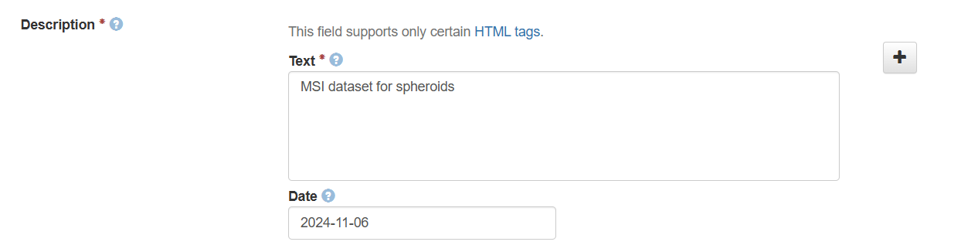
For the date, there should be a dropdown menu, format is not clear

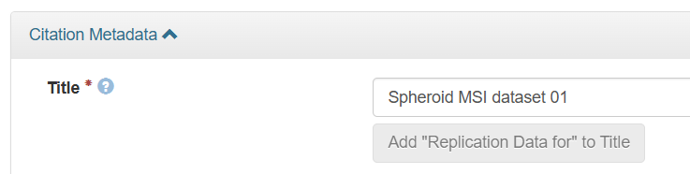
What is the replication data for button?

Equipment: first vendor then instrument
Acquisition type: drop down menu is wrong
Surface type should be editable (other)
Calibration type should allow multiple options
Microtome should be renamed to “sectioning device” with list of options
Thickness -> section thickness (typo in um)
Scan: add scanner options: aperio, confocal, IR, etc...
Laser diameter -> laser spot size (um x um)
Laser power: incomplete, more information needed: fluency and attenuation
Spatial res -> raster step size (distance between laser spots)
Processing: is this Before RAW data processing post acquisition or after? we need to add instrument data processing as “data reduction” with options: centroid, continuous, %value, etc...
Sample source: needs revision and reposition
Substructure when entering metadata
Sample sub-type is not clear, could be “Additional Notes” or Comments about samples.

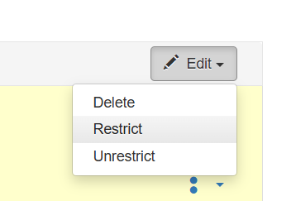what does restrict mean?

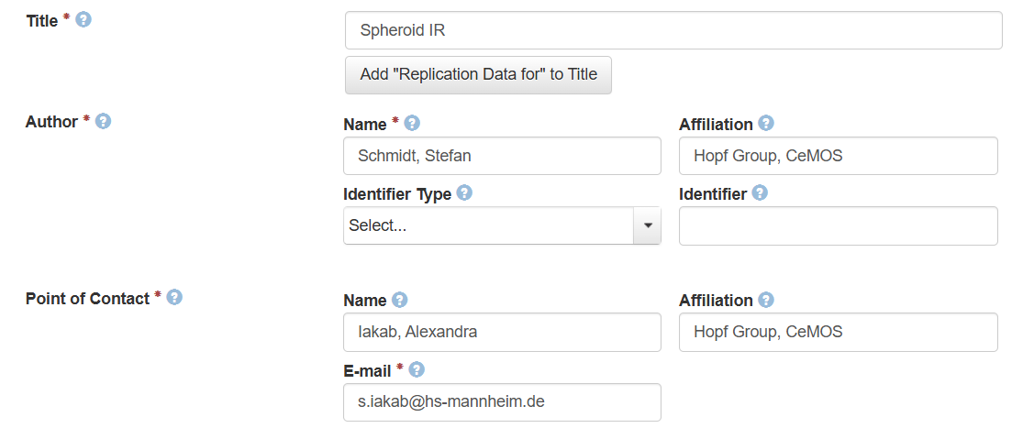
Drop down with all members of CeMOS

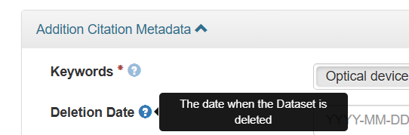
Keywords are not enough, we need more options or editable field
Deletion date is unclear

IR data
Acquisition mode: with options: FTIR, QCL-IR
Acquisition type options should be reflexion, transmission, ATR
Minimum Wavelength should be wavenumber
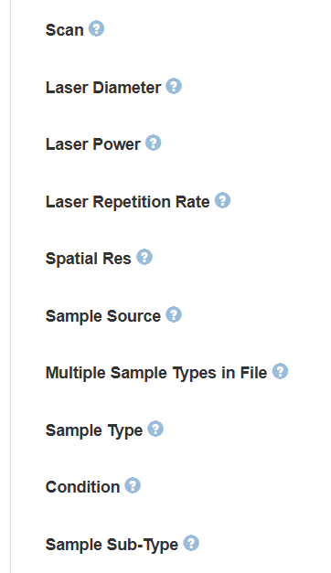
These options are irrelevant for IR, need to be reworked into: objective or NA, scan mode (single wavenumber, sweep scan, discrete scan), spectral resolution
Background correction: yes/no (with option to add description)
Other people should receive a notification even if they don’t have an account, if they are the contact person of the dataset

