Status:
Done
Pending
Must be discussed
- For the date, there should be a dropdown menu, format is not clear
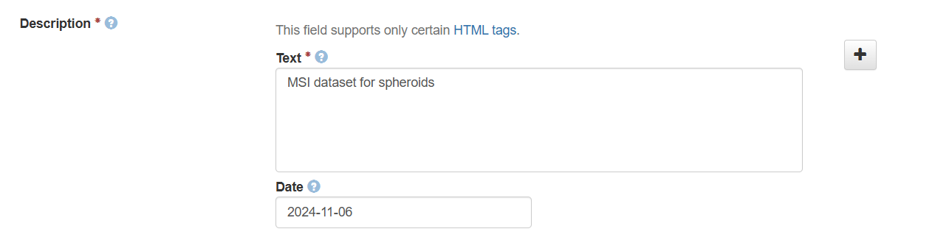
Not possible but only date format is allowed. Otherwise dataset can not be saved.

- What is the replication data for button?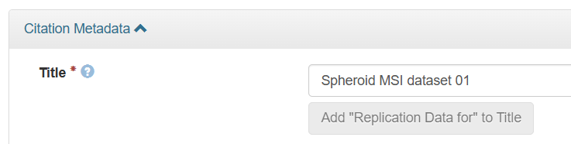
https://dataverse.org/best-practices/replication-dataset
in the dataset form, click the "Replication Data for" button to add this text to the title, making it clear to other researchers that this dataset can be replicated
- Equipment: first vendor then instrument
Consecutive dropdowns are not possible. Update equipment dropdown to vendor – instrument?
must be updated in Metadata (XLSX file)
- Acquisition type: drop down menu is wrong
must be updated in Metadata (XLSX file)
What must be updated?
- Surface type should be editable (other)
Not possible inside the drop down. Solution: additional field Other Surface?
- Calibration type should allow multiple options
must be updated in Metadata (XLSX file)
- Microtome should be renamed to “sectioning device” with list of options
must be updated in Metadata (XLSX file), list with options must be provided
cryostat, microtome, other
- Thickness -> section thickness (typo in um)
must be updated in Metadata (XLSX file)
- Scan: add scanner options: aperio, confocal, IR, etc...
must be added to Metadata (XLSX file), list with options must be provided
Added Scannertype after, because Scan was already present
- Laser diameter -> laser spot size (um x um)
list with options must be provided
5, 10, 20, 50, 100, 200, other
- Laser power: incomplete, more information needed: fluency and attenuation
must be added to Metadata (XLSX file) list of options or free text?
- Spatial res -> raster step size (distance between laser spots)
must be updated in Metadata (XLSX file)
- Processing: is this Before RAW data processing post acquisition or after? we need to add instrument data processing as “data reduction” with options: centroid, continuous, %value, etc...
Must be discussed by you; if required list with options or free text? Field name must be provided
Append additional field for %reduced and other
This is duplicate to data type?
- Sample source: needs revision and reposition
As additional fields?

Substructure when entering metadata
add sample and instrument section to Metadata (XLSX file); must classify what belongs to which
- Sample sub-type is not clear, could be “Additional Notes” or Comments about samples.
must be added to Metadata (XLSX file)
- what does restrict mean?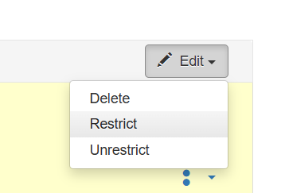
When you restrict a file it cannot be downloaded unless permission has been granted.
If you restrict any files in your dataset, you will be prompted by a pop-up to enter Terms of Access for the data. This can also be edited in the Terms tab or selecting Terms in the “Edit” dropdown button in the dataset. You may also allow users to request access for your restricted files by enabling “Request Access”.

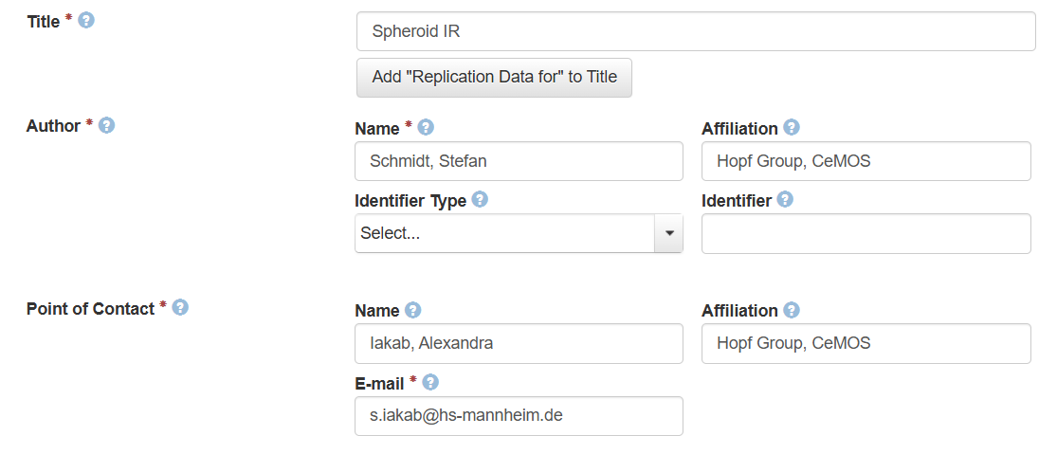
- Drop down with all members of CeMOS
not sufficient, must be updated every time a new employee comes to cemos
if central hosted, the Hochschule won’t support such work-intensive metadata
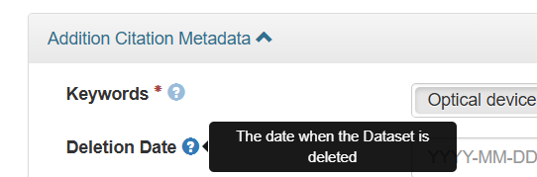
- Keywords are not enough, we need more options or editable field
List must be provided or change to Dataverse Keyword field which uses free text, must be discussed by you
Send mail for list of current keywords
- Deletion date is unclear
For sensitive data that needs to be deleted or for deletion after 10 years
Warning must be added to Metadata (XLSX file)
IR data
- Acquisition mode: with options: FTIR, QCL-IR
must be updated in Metadata (XLSX file), list with options must be provided
- Acquisition type options should be reflexion, transmission, ATR
must be updated in Metadata (XLSX file), list with options must be provided
- Minimum Wavelength should be wavenumber
must be updated in Metadata (XLSX file)

- These options are irrelevant for IR, need to be reworked into: objective or NA, scan mode (single wavenumber, sweep scan, discrete scan), spectral resolution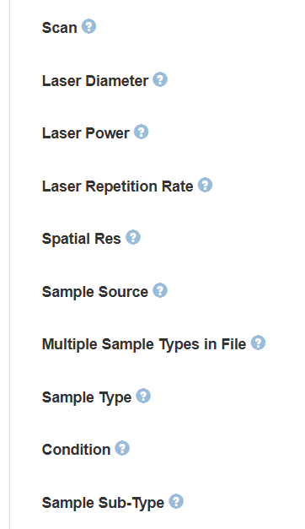
must be removed from Metadata (XLSX file)
- Background correction: yes/no (with option to add description)
Background correlation and correlation description field must be added in Metadata (XLSX file)
- Other people should receive a notification even if they don’t have an account, if they are the contact person of the dataset
Not possible only the creating person is the owner and get creation notification. But if somebody clicks on contact in the dataset the person even without an account get an email.

