Status:
Done
Pending
Must be discussed

- Spelling: sinGLE" wavenumber
Corrected spelling

- Spelling: AdditioNAL citation metadata
Corrected spelling but not sure whether to actually included this metadata block.

- Should additional citation metadata be removed for citation keywords?
Ask Alexandra again

- Sectioning device - model number is missing (Alexandra will take care about the model numbers and send it to you)
Added sectioning device to sample information metadata block and included device names.
- other sectioning device field is missing
Should not be missing. It is in the metadata.

- field missing: Scanner device (Aperio, Tissue scout,) and type/model number is missing
Added to metadata block sample information and included device names.

- MALDI:
"%Reduction" needs to be "data reduction" y/n with additional field of how many %
Daty type: there we also have %Red. its doubled, also appears in processing
Renamed to data reduction, added yes/no dropdown, removed duplicate reduced_processing_msi

- Make "sample information" as a separate global field like IR and MALDI and reduce sample prep in the IR and MALDI fields.
IR: It will only have: "sample notes"
MALDI: It will have: "wash" , "matrix type", "matrix instrument" and "sample notes"
Created new metadata block sample information and reduced sample preparation in IR and MALDI metadata block.

- besides "wash" there should be a fied with "on-tissue digestion" yes/no/trypsin/PNGase/other
and add a field for "incubation"
Added on-tissue digest with metadata block.

- Tissue treatment (y/n): "wash", "on-tissue digest" and "incubation", "staining" and "derivatization" and subfields
Added tissue treatment with dropdown, on-tissue digest with dropdown and incubation with dropdown, staining with dropdown and free text and derivatization with dropdown and free text to MALDI metadata block.
Incubation is pending due to missing info.

- semicolons missing
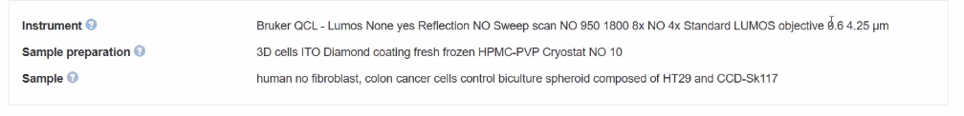
Due to structuring into instrument, sample preparation and sample. Without parent metadata they would be displayed in sperate lines.

