Python Major Project – Documentation and Project Design Portfolio

Sam Magri

3D-DASH
GitHub Repository Link: https://github.com/HyperVoidal/3D-DASH/tree/main
  - A remastering of hit 2013 game ‘Geometry Dash’ in a 3D medium

Project Summary
3D-Dash is a remaster of the 2013 side-scrolling platformer known as ‘Geometry Dash’ created by Robert ‘RobTop’ Topala. The original game features a square shaped player traversing through a series of levels littered with various obstacles in order to reach an end goal and switch to the next level.
Similar to the design of the game’s inspiration, 3D-Dash will feature a cuboid individual that progresses linearly through a series of levels through the act of platforming by various means. However, it’s variance comes from its application of the 3D medium rather than the original game’s 2D environment. While both games feature the player being locked into a constant forward momentum in order to maintain the pace and music of the game, this recreation will apply the 3rd dimension to the player character, thus requiring individuals to consider the game on a deeper level and with more forethought to an action at any given moment.
With various mechanics to leverage the environment, including a five-lane switching system, jumping, gravity changes and other means of traversal, players will need to think critically about situations as they arise in order to successfully traverse the environment without colliding with obstacles such as walls that otherwise forcefully restart the level.

Table of Contents
Sam Magri 1
3D-DASH 1
Project Summary 1
Problem Statement 4
Target Audience/Users 4
Proposed Features 4
Functional Proposed Components 4
Nonfunctional Proposed Components 4
Potential components 5
Technologies / Tools 5
Method / Approach 5
Major Anticipated Challenges 6
Project Timeline Overview 7
Solution Modelling 8
Context Diagram 8
Data Flow Diagrams 9
Structure Chart 11
UML Class Diagram 11
IPO Chart 13
Data Dictionary – Example Player Associated Variables 14
Communication Plan 17
Production and Implementation 18
Development Process 18
Key Features Developed 19
Version Control Summary 23
Testing and Evaluation 23
Test Cases and Results 24
Entity rendering system 24
Collision System 25
Menu Entity Deloading 27
Level Loading and Implementing for Linear Pathing 28
FPS Testing and Optimisations 29
Feedback Discussions 31
Discussion with Tester Simon 31
Discussion with Tester Arseniy 31
Evaluation Against Requirements 31
Improvements and Future Work 33
Client Feedback and Reflection 34
Summary of Client Feedback 34
Personal Reflection 35
Appendix 36
GitHub Repository Link: 36
Brainstorming List 10/06/25 (Digitised for Convenience): 36
Example Code Snippet – The Update Function 37

Problem Statement
In the gaming environment of today, many programs struggle to define a fast-paced environment while also incorporating aspects of quick-action problem solving and reaction time. 3D-Dash’s focus, and the focus of similar games, (i.e. Geometry Dash), consider the player’s enjoyment of a fast-paced environment, balanced with the difficulty of navigating a situation in an unconventional or previously unconsidered way.
Challenging the player to think ‘outside the box’ in a shortened time window may lead to frustration in the moment, but ultimately allows for further freedom of self-expression, especially in the 3d medium where players are capable of discovering multiple routes to a solution that was significantly less obvious. Thus, 3D-Dash allows for self-expression through on-the-fly problem solving, a medium that is underused in the gaming market.

Target Audience/Users
3D-Dash naturally taps into the market of people previously interested in the Geometry Dash title and its various subprojects (i.e. Geometry Dash World, SubZero, etc), as part of its connection to the platformer genre. Despite my own lack of skill in 3D design as a result of this being my first project, the three dimensions provided by my model of the game allow for a higher level of fast paced action while also giving room for those with less skill in reaction time to enjoy the game.
Stemming from my level design philosophy of scaling difficulty over the course of both a level and the progression of the game as a whole, different portions of the game will thus cater to different skill levels, simultaneously decreasing the barrier for entry while raising the ceiling for skill expression in the game. As a result, the target audience will involve all skill levels of those interested in the platformer genre.

Proposed Features

Functional Proposed Components
- Five-lanes of interconnected routes to progress, creating a fully 3D environment that allows for quick thinking and problem solving to move past complex obstacles
- Manoeuvrable camera that is capable of adjusted orientation to view different angles, as well as provide new perspectives as the player traverses.
- Multiple varied levels with different mechanics and traversal systems to ensure interesting and flexible gameplay
- Autosaved high-score system that tracks your best attempts in each level
- High degrees of player customisation and personal decision applications, allowing for individuality in progression and expression.

Nonfunctional Proposed Components
- Fluid, smooth animations that ensure the player easily understands information and is capable of interpreting level components with ease.
- Player character customization systems, such as adjusting the object of use, changing colours, or even different textures and patterns, that are similarly saved to the player’s file
- Intuitive player and viewport control scheme that functions with multiple types of devices and keyboard layouts.
- Vibrant effects that change the way each level looks with pulsating lighting cand graphics

Potential components
- Invigorating custom-designed music that matches up with in-game movements and provides an extra layer of interest to the design of the levels.
- Unlockable game features for finding secrets within or completion of levels, allowing for further replayability in the game.

Technologies / Tools
The proposed systems for this project are subject to change based on desired implementation of features, but the current systems for this project are:
- Python 3.10x – 3.12x
- Ursina 3D Rendering Layer (boilerplate systems for Panda3D)
  - Panda 3D Rendering Engine
- Blender 3D Graphics Design
- Various audio editing and compositing tools including:
  - Audacity
  - MuseScore Studio
  - MuseHub
  - Bandlab
While it is currently nonessential to confirm the target hardware specifications, I will aim to allow the project to be playable on almost all consumer-available devices, with low-spec CPU and a minimum of two gigabytes of RAM.

Method / Approach
My work within this project will be structured similarly to a fully structured Agile workflow, complete with proper testing and feedback from ‘hired’ gameplay testers, as well as simulated launches to ensure the game is in a proper state for submission and completion.
Requirements and Analysis will be the first to be conducted, including this project proposal as part of my own research. In this project, the main requirements will be specified by my own research into the target market, including critical reviews of platformer genres to find commonly desired components and pre-existing similar products from which I will observe common tropes and design elements to utilise. I will also be conducting an analysis of my own capabilities and that of the engine I have chosen to develop with, in their respective ability to achieve certain imagined goals.
Designing the project itself will be especially documented, including references to my inspiration and potential avenues for further development should time allow for it. Designing the project will happen multiple times throughout the project but many of my own considerations will be developed at the beginning, preceding any proper development of the systems. Later design activities will be more focused on individual features based on user feedback, as well as my own availability and workload overall.
Implementation of designed features will be conducted first with attempts at various components of the engine I assigned, in order to determine the capabilities to be addressed within the project itself, without relying too heavily on needing a finished product. Later development progress will be through the collective of systems I have designed, and in a significantly more structured format that utilizes important OOP principles, especially that of Inheritance and Polymorphism in order to optimise and improve the functionality of the game itself.
Testing and implementation/development components will be repeatedly occurring over the process of ‘sprints’, being individually set ranges of the timeline in which that is the primary focus of the development of the project. Testing systems will involve not only the isolation and confirmation of different critical components, but also testing the entire program as a whole and confirming my findings with short Q/A tests by ‘hired’ helpers who have experience in game design or gameplay systems.
Maintenance and mock launches will also be included as repeating cycles at the end of development sprints and during testing phases through tests of packaging and release systems (e.g. how the system handles conversion to an .exe file for release), as well as further functionality tests from both me and any in-person testers I find. I especially insist upon finding other people to help test, as despite my own qualifications for gameplay testing, different people will have different ideas for different situations, and my own experience in developing the game has the potential to cloud my own ability to notice flaws.

Major Anticipated Challenges
The primary expected difficulties of this project are expected to arise in three specific areas, as detailed below. My understanding of these points was defined by a series of rapid tests and early programming sprints designed as part of my feasibility study into the capabilities of the software systems I was planning on testing.
Firstly, the progression of my knowledge within the 3D medium thus requires me to understand the Ursina systems on a deep level in order to execute my level of customisation to the program. From basic testing since starting the writing process of this project proposal, it has already been found that I must design my own movement and collision for the player character, rather than using a preset system, as a result of my more complicated movement and camera mechanisms. Sorting the finer details of this system, especially in collision interactions between the models I plan on importing, will be a significant difficulty, and managing the creation of my own system of mesh interactions for complex models will be a difficult process.
The second expected challenge for this project lies in the music system. My plans for the creation and integration of music are heavily based on the original Geometry dash’s systems, where music is synchronized to certain actions and jumps within each of the levels. In this area, it becomes rather difficult to have my own version of this, as I cannot simply create an in-game framework due to the logistical limitations of my own time, the 3d medium, and the Ursina engine. Thus, I need to utilise the modelling software I was considering (blender) and systematically consider where the player will be at certain points in the song and link it to the progression of the level during construction.
The third challenge I will no doubt find within this project is the adoption of a variety of new mediums outside of my normal areas. In previous projects, I was primarily focused on 2D games or assistive software, so I have extremely limited experience within the 3D medium, aside from my previous experience with Blender software and modelling. Furthermore, I have almost zero experience in making music using computer-based technology and will thereby need to teach myself the systems in order to design my own music to work with the levels (as I will ensure the minimum usage of free/stolen asset use).
Within all of these issues remains the core problem of learning and understanding the intricacies behind the newer mediums I am pursuing. Resolving these issues and maintaining my personal mental state through these challenges will require, above all, proper time management and personal restraint to avoid constantly following new ideas and getting wrapped up in unreasonably intricate detailing. Rapid prototyping and testing will be extremely helpful as well, enabling me to quickly explore multiple ideas and understand their feasibility over the longer time period of the term.

Project Timeline Overview
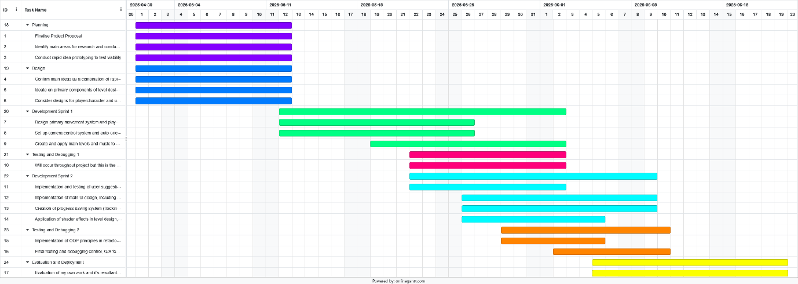In case this is too difficult to read, I have attached a link to a google drive file. It contains the full Gantt chart image, two excel files (one with the full Gantt chart table and one with a summarised version) and a file with the .Gantt extension that is able to be imported into a site like THIS LINK in order to be interpreted into the full Gantt chart with dropdown sequencing and full name explanations.
 (Where to import the .gantt folder on the site)
DRIVE FOLDER LINK (Automatically set to share to anyone with the link)

Solution Modelling

Context Diagram
The context diagram identifies the Level 0 processes of the 3D-Dash system, with the primary components of player input, internal logic, graphical output, and the main storage database that comprises all of the sub-databases. (LINK TO EXCALIDRAW FILE)
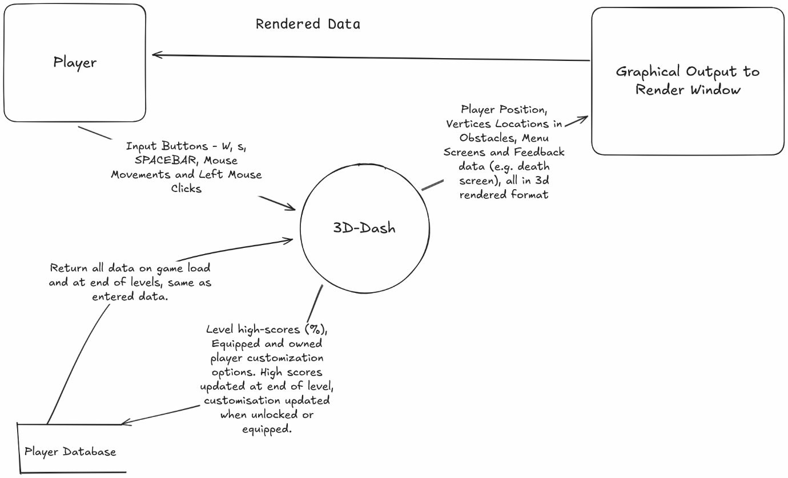

Data Flow Diagrams
The Level 1&2 Data Flow Diagrams explore the subroutines present within the Level 0 Context Diagram, allowing for greater context in the input and output processing. Each Level 2 is referential to a different component of the Level 1 DFD. In order: Main Menu System, Level Select System, Player Customisation Menu, Main Gameplay Loop. (LINK TO EXCALIDRAW FILE) 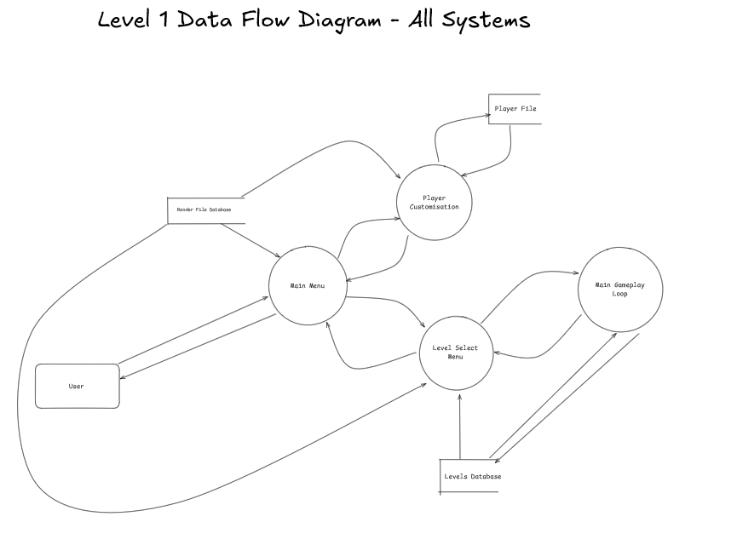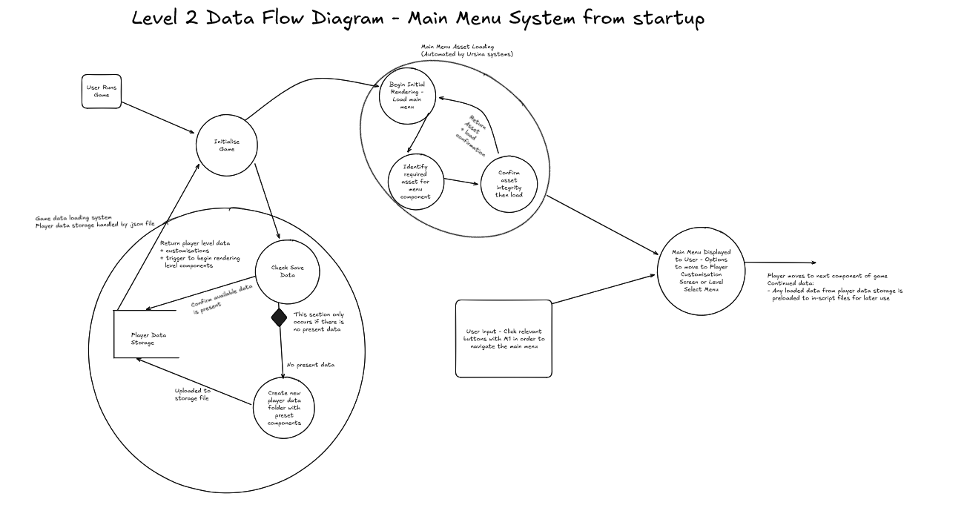
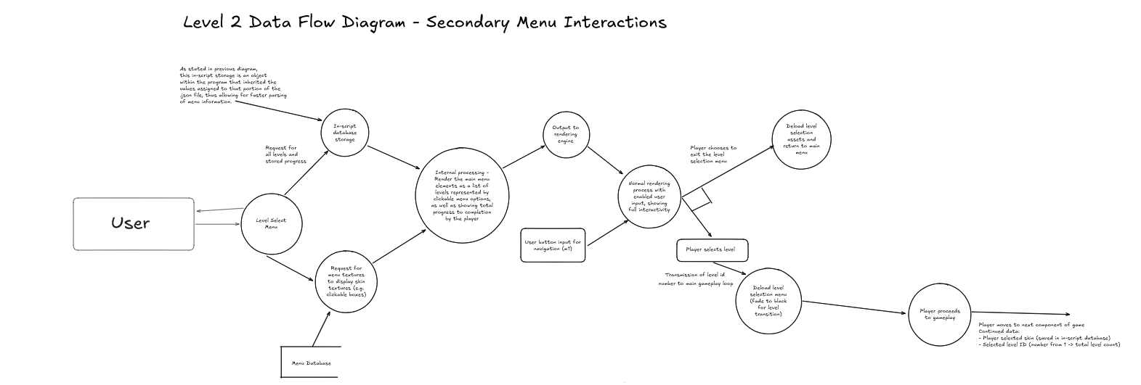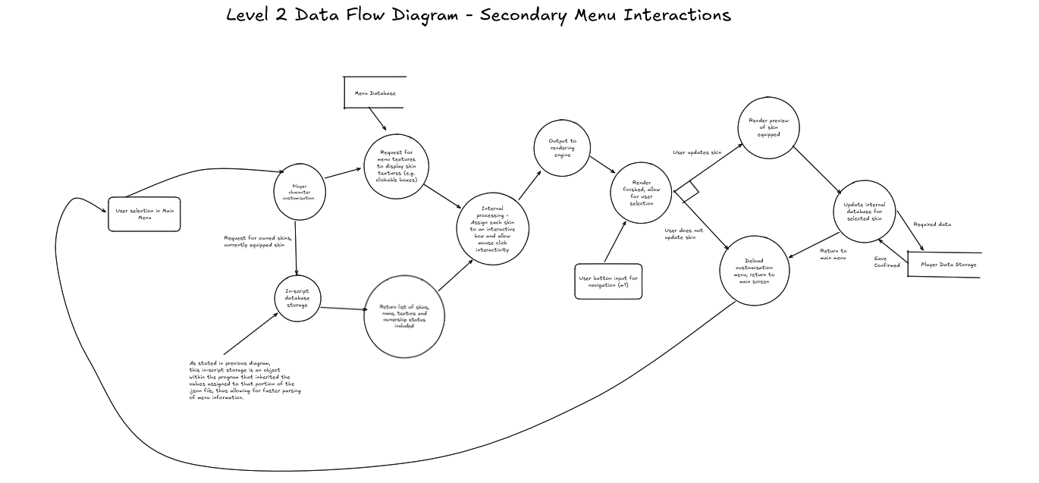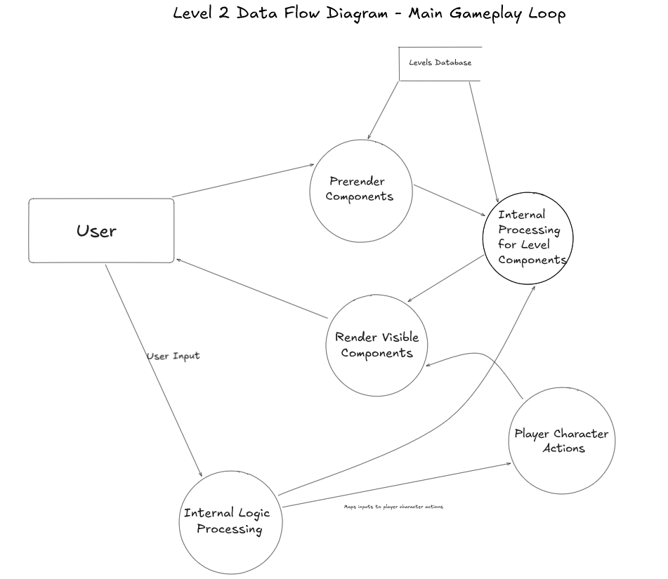

Structure Chart
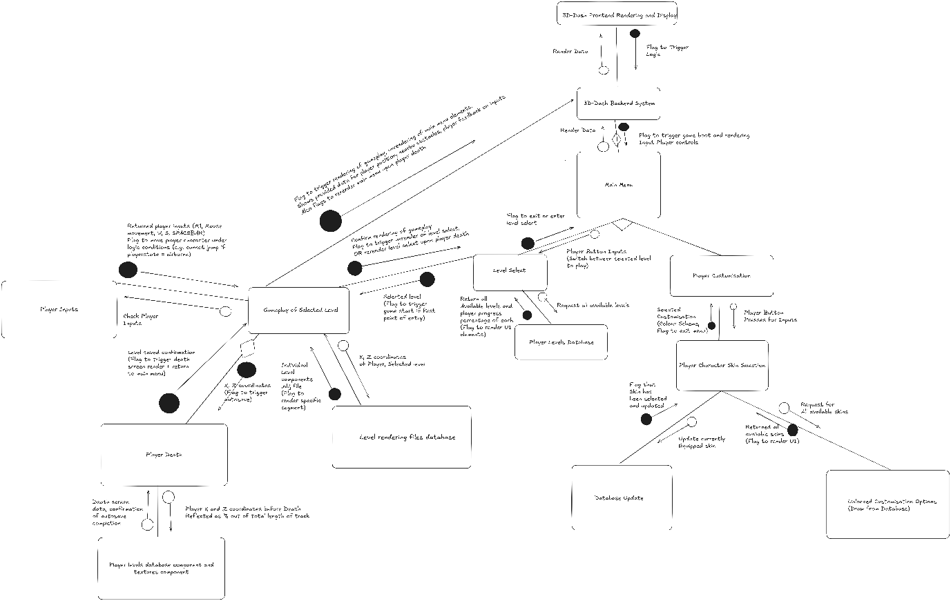
The structure chart displays the subroutines of the program, displaying its primary components in player access, decision logic, and menu switches. (LINK TO EXCALIDRAW FILE)

UML Class Diagram
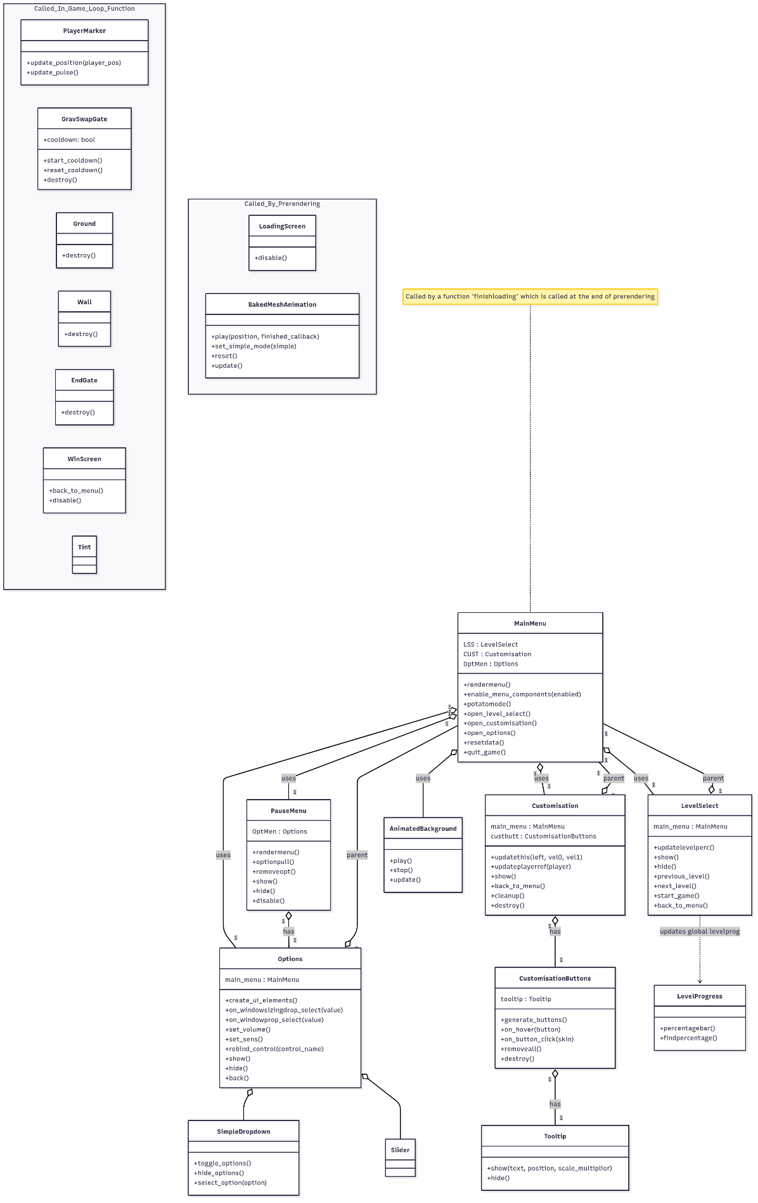
Link to online view (with high res scaling): https://www.mermaidchart.com/app/projects/3945c876-1bf4-47b2-9b15-b1db41f02879/diagrams/80fbd272-7139-4f6e-8ea4-12a1d13d94ab/version/v0.1/edit

IPO Chart
The IPO chart lists the primary processes related to individual inputs, displaying the processes that comprise the primary logic of the game.
Input | Process | Output
Player Keyboard Inputs – A, D, Spacebar  (During level gameplay only)  As a result of the implemented key remapping options in the menu, these could be assigned to any button. For clarity, however, I have left the default settings as references. | Interpret player movement to allow for navigation of the 3D space | ‘A’ triggers the player character to shift one lane to the left  ‘D’ triggers the player character to shift one lane to the right.  (Both are from a player character viewpoint, not the player’s camera)  ‘Spacebar’ triggers the player character to jump a short distance into the air and then fall back down.  W and S lane-switches are able to happen in-air. Jumping is only possible from a grounded state.
Mouse Button 1 (Left mouse button, M1), mouse movements in all directions.  (During level gameplay only) | Interpret camera movements based on inputs, wherein the camera is dependent on mouse inputs only | Pressing M1 activates the camera orienting mode, upon which mouse movements allow for user manipulation of the camera location relative to the player character. Releasing M1 returns the camera view to its original position.
Player Mouse1 (left mouse) input  (All menus) | Interpret mouse clicks to menu navigation functionality | Menu buttons are all controlled by pressing the mouse1 input in order to interact with them and thus conduct actions such as level select, character customisation, and all other menu interactions.
Individual level loading – input of level number | Select all appropriately named segments of the level, load singular portions to x and y coordinates of player (every 20m x means one segment of level) | Level components are loaded based on player position, wherein the only visible components are the surface loaded under the player and the component directly in front of them
Game Tick Loops – One frame references one tick | Update game state once every game tick. Game Tick Loop is separate from frames per second and is kept to 60 updates per second in order to ensure parity between devices. | Renders all entities, vertices and collision points, checks collision between registered entities and checks pressed input buttons.
Boxcast Collision Detection | Detect and respond to where a collision is likely to happen by casting a small invisible box to collide with objects first and thus detect if a player would collide with an object. | Main floor collision detection checks whether the player should be on top of collision by projecting directly below. Tertiary collision detection confirms that the player isn’t clipping into an object and bypassing the first check.  Death collision detection determines whether the player has run into a wall.
Menu and external control inputs (r, esc, tab)  (In-game only) | Interpret player keyboard inputs for tertiary actions that are theoretically nonessential to gameplay | Pressing R triggers the player death and instant restart  Escape closes the game and quits to desktop  Tab opens the pause menu

Data Dictionary – Example Player Associated Variables
Variable | Data Type | Size/Format | Description | Example | Validation
Velocity | Integer | 1+ digits | The velocity variable identifies the vertical speed of the player at a given exact time. It adds to the player.y variable when necessary and can be inherited by other values | Jumping at any time sets the velocity to 15, thus applying the jump height of the time modifier multiplied by the velocity of 15 | Can be any number of digits at any time, set to negative, positive or 0.
Gravity | Constant Integer | 3 digits max | The gravity variable identifies the gravitational acceleration of the player towards the downward direction. Gravity applies at all times regardless of player position, only stopping once the is_grounded variable is enabled. | Starting the game sets an initial gravity of 39.2 to be applied throughout the game. This value does not change at any point. | Cannot be blank or null. Can be zero, negative or positive theoretically, but must be set to 0 to apply downwards force.
Is_grounded | Boolean | True/False | Identifies whether the player is on the ground. If enabled, the player is automatically snapped to the nearby collision. | When the player’s hitbox collides with a SAFEGROUND entity, the is_grounded variable is set to true | Cannot be any value other than True or False
Move_x | Constant | 2 digits max | Move_x is a collision detection variable that applies a speed of 0.1 to the playercharacter before any player input is registered, allowing for short-range collision pre-checks while the player is moving. If the player collides with a wall obstacle not set to kill them, Move_x automatically moves the player | Move_x is set to 0.1 currently at the start of the game | Cannot be changed during the game, should remain the same after initialisation at game start.
Player.x | Float | 10 digits max | The player’s position on the X coordinate of the 3D environment | 32.10234153 | Must be either positive, negative or 0.
Player.y | Float | 10 digits max | The player’s position on the Y coordinate of the 3D environment | 128.2341242 | Must be either positive, negative or 0.
Player.z | Float | 10 digits max | The player’s position on the Z coordinate of the 3D environment | 9241.234123 | Must be either positive, negative or 0.
Scale | Float | 3 digits max | The player character’s scale value, that defines how much the hitbox, model, and textures should be stretched from their initial import values to the environment on any combination or quantity of X, Y, and Z values. | 2.25 | Must be positive. No other constraints. Can change during gameplay.
Model | Object/String | Preset object called by string or an imported .obj file | The player character’s assigned model that dictates initial sizing before scale is applied, as well as the given components of its design | “Cube”, “Sphere”, “Model.obj” | Must be either a string or a list of different object files including .obj, .blend, .stl and more
Texture | Object/string | Preset colour or texture called by a string or an imported image texture file | The player model’s texture. Is not mandatory and can either be left blank to leave texturing to the model object, or filled to use a different texture | “color.black”, “color.white”, “fish.png” | Can be either null, a preset colour, or an image texture, including .png files

Communication Plan
The primary help for this project will be situated in playtesting and A/B testing features of the game through a series of different components that I need to ensure are functional for each of the given users. These tests aim to encompass the different experiences faced by players who are new to the game and unaware of any internal mechanics, thus making them unequipped to solve internal issues and more likely to relay problems or perceived problems to me.
The first phase of my testing is as a component of the two development sprints outlined in my Gantt chart. Information-heavy features will need to be tested by a variety of new players to ensure compatibility with people and results should be tallied and scored based on feedback. I will be in the same room as the tester, recording project feedback as notes and later work with those notes to devise solutions to problems found. I have a team of 7 testers who I will use sparingly for the main components to determine ratings for four main elements of my project:
- Playability / Ease of use
- Requirement for directions
- Visual aesthetics and design
- Controls and Handling
Feedback will primarily be verbal, with further progression from verbal feedback involving user modelling of how they would prefer a certain system to appear, from which I will extrapolate their feedback into a theoretically improved model, test It myself against my own criteria and design goals for the game, and then reintegrate based on feedback from the other testers as well.
Ultimately, my system of communication aims to incorporate user feedback into the project with enough functionality to allow for ease of use and user experience improvements. A common piece of feedback I’ve found in my previous projects from minimal beta testing is that instructions and directions in the game are too difficult to properly understand, and pacing of level progress is too swift. This, I have attributed to my own failure to properly test mid-development; and my own skill at my game results in a misattribution of new player skill. This is also a component of the reasoning as to my decision to design multiple levels rather than a singular demonstration level as it will allow for more diverse feature sets while maintaining project guidelines and playability.

Production and Implementation

Development Process
My solution was approached through a system of rapid prototyping designed to build on top of existing features consistently and create example designs that could accomplish specific tasks, ultimately chaining ideas to form the finished product. This was best explained by the ‘Next tasks’ GitHub commit system I implemented, leaving notes to myself for the next items to complete where each individual commit had some new playable addition or set of additions designed to provide a somewhat completed experience each time. These changes occasionally adjusted at different points to provide varying gameplay experiences, but they were all centred around the main ideas of the game outlined in the planning stage.
The only variance from this pattern was during particularly complex problems, wherein multiple commits were made to swap between devices and test different ideas to verify the importance of given changes. Particularly during the floor collision detection problem timeframe in the late first development sprint and the menu entity loading/unloading function errors that would cause memory leaks in the early second development sprint.
My primary intention during development was to create ‘blueprint’ functions and classes that could be applied to a variety of scenarios within the game in accordance with OOP principles of inheritance and polymorphism, as well as leveraging capabilities of the Ursina class and control of the visual output to apply encapsulation and abstraction of noncritical data to the user, such as entity counts and FPS that is normally visible in the developer viewpoint. Each blueprint function and class were applicable to multiple scenarios, including classes such as Tooltip() and SimpleDropdown() designed for multi-use scenarios within the menu, and Tint() classes taking colour and duration arguments to allow for multiple applications even though I never had more than one main one.
This system was also how I designed and implemented my Json system, which actively controls the main game logic by influencing what levels are included in the game and what customisation options are player available. Updating the level_data.json file to have five levels instead of four will automatically implement a level 5 into the next game launch and immediately integrate a Level5.obj file if it can find one on player selection. Similarly, the customisation menu adjusts its size and row icon density depending on how many skins are present in the Json file. By avoiding hardcoding systems, it allows for a higher degree of flexibility within the development process and makes successive updates to non-internal logic significantly easier for me to implement. These systems are also backed by a player-proofing system to avoid internal errors, including a missing texture skin that applies if the game cannot load a selected player skin, and a Json file restoration system that rebuilds the .Json files from a backup within the game itself. Implementing these systems ensures a more stable development environment while also providing an adaptive system that can resolve internal errors effectively.
The game’s design philosophy is that of adaptive learning. Players learn new mechanics through logical thinking and understanding of the main game systems. The tutorial is the levels themselves, using systems such as colour-coding the starting lanes to show how the player can move laterally and introducing the gravity swapping system in Level 3 as a gimmick to prepare players for the heavier integration in Level 4. Utilising more subtle gameplay introduction systems ensures that my main philosophy is achieved, being to create an environment where logical thinking needs to be applied in quick succession without creating an environment that feels wholly unfair.

Key Features Developed
The core features of the game are encapsulated within the main classes and functions of the game, namely the Prerendering, MainMenu, Options, Customisation, LevelSelect, map rendering functions, update and game_logic_step functions.
The Prerendering function handles the primary asset loading that commits the important components of animations to the memory of the computer, reducing file asset loading when the components are required for the game. Prerendering ensures that midrange computers are able to properly render data to avoid frame drops, higher end computers can run the game with little effort and lower end computers can open the game for long enough to enable the potato mode and let their players run the game properly.
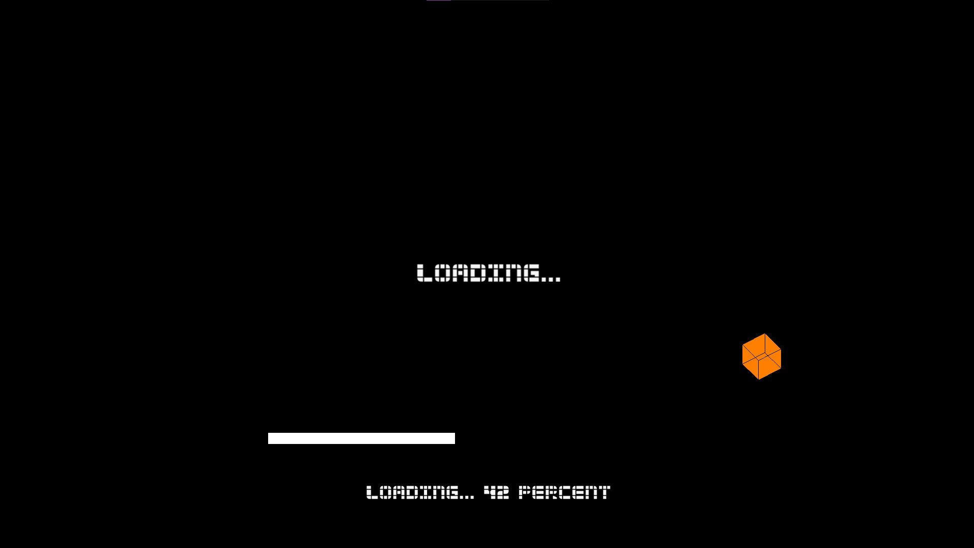
A screenshot of the loading screen and it’s processes. The orange cube is set to whatever skin the player has selected and jumps around the screen as the game loads assets to keep the attention of the player during loading.
The MainMenu class, expectedly, controls the menu switching system that allows access to the secondary components, as well as housing the first major menu animation for the game, being the synthwave-style tunnel effect, I created within blender and then exported as image files. This is the first major animation affected by the potato mode due to its larger file size for rendering, despite how effectively it can be rendered. The main menu also handles asset loading and unloading for the main clickable level components, ensuring that no entity leaks are caused within the system and maintaining effective button layouts to ensure the player has proper access to all buttons.
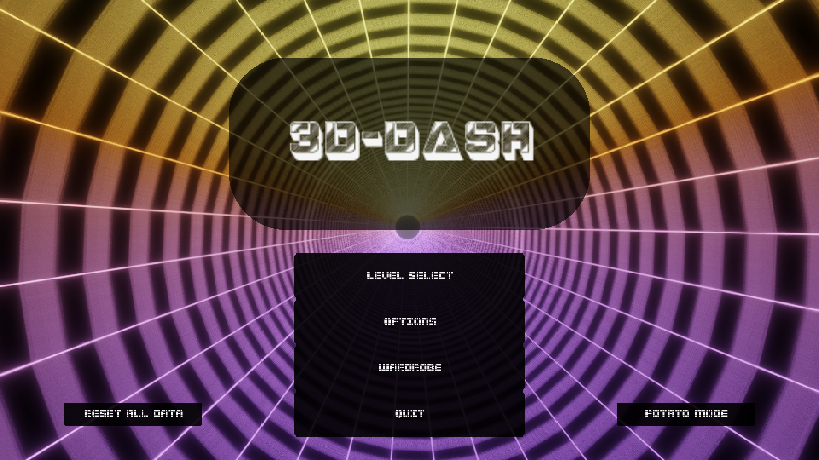
A screenshot of the main menu. The background tunnel effect is animated within the game to provide an interesting visual to the player’s experience. Buttons are self-explanatory
The Options class allows players more control over internal game aspects, acting as the main opening of the abstraction process wherein players can control volume, camera sensitivity, window size and settings, as well as reassigning buttons. This allows for a higher degree of control over the game. The options menu was also the first component I implemented that allowed for integrated file storage and retrieval within the game, allowing players to save their preferences across multiple playing sessions and reset them when necessary.
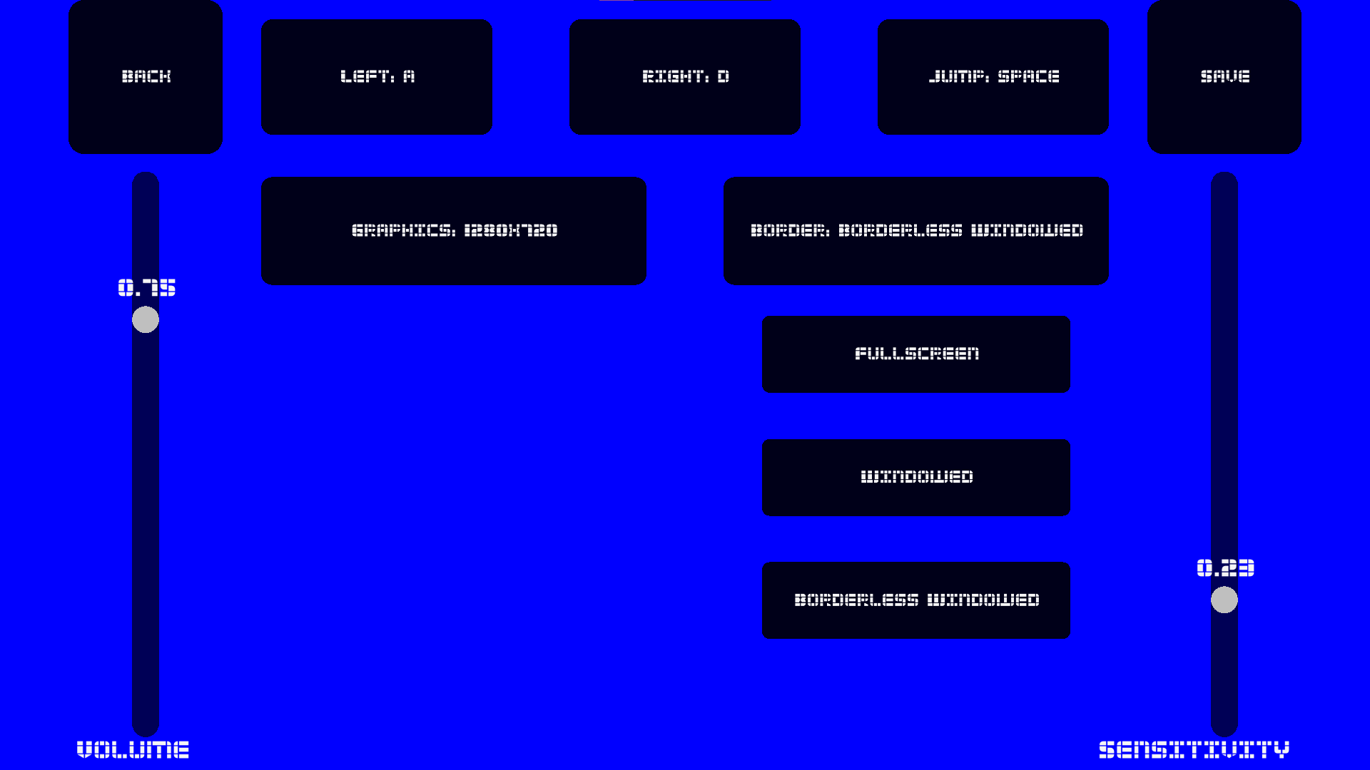
A screenshot of the options menu, displaying the main enterable buttons. The middle top three are the input key changers, ‘save’ inserts all data into the .Json file, volume and sensitivity are display sliders and graphics and border controls are dropdown menus that create smaller entry buttons as shown.
Levelselect incorporates the Json file of level_data to create a scrolling series of screens depicting each of the levels and the player’s progress within them, capping at 100% once the player has finished the entire level. The Json file controlling levelselect is imported as a list and each of the arrows increase or decrease the number selection for the list’s name, displaying the level’s number assigned and a unique colour variable for each one.
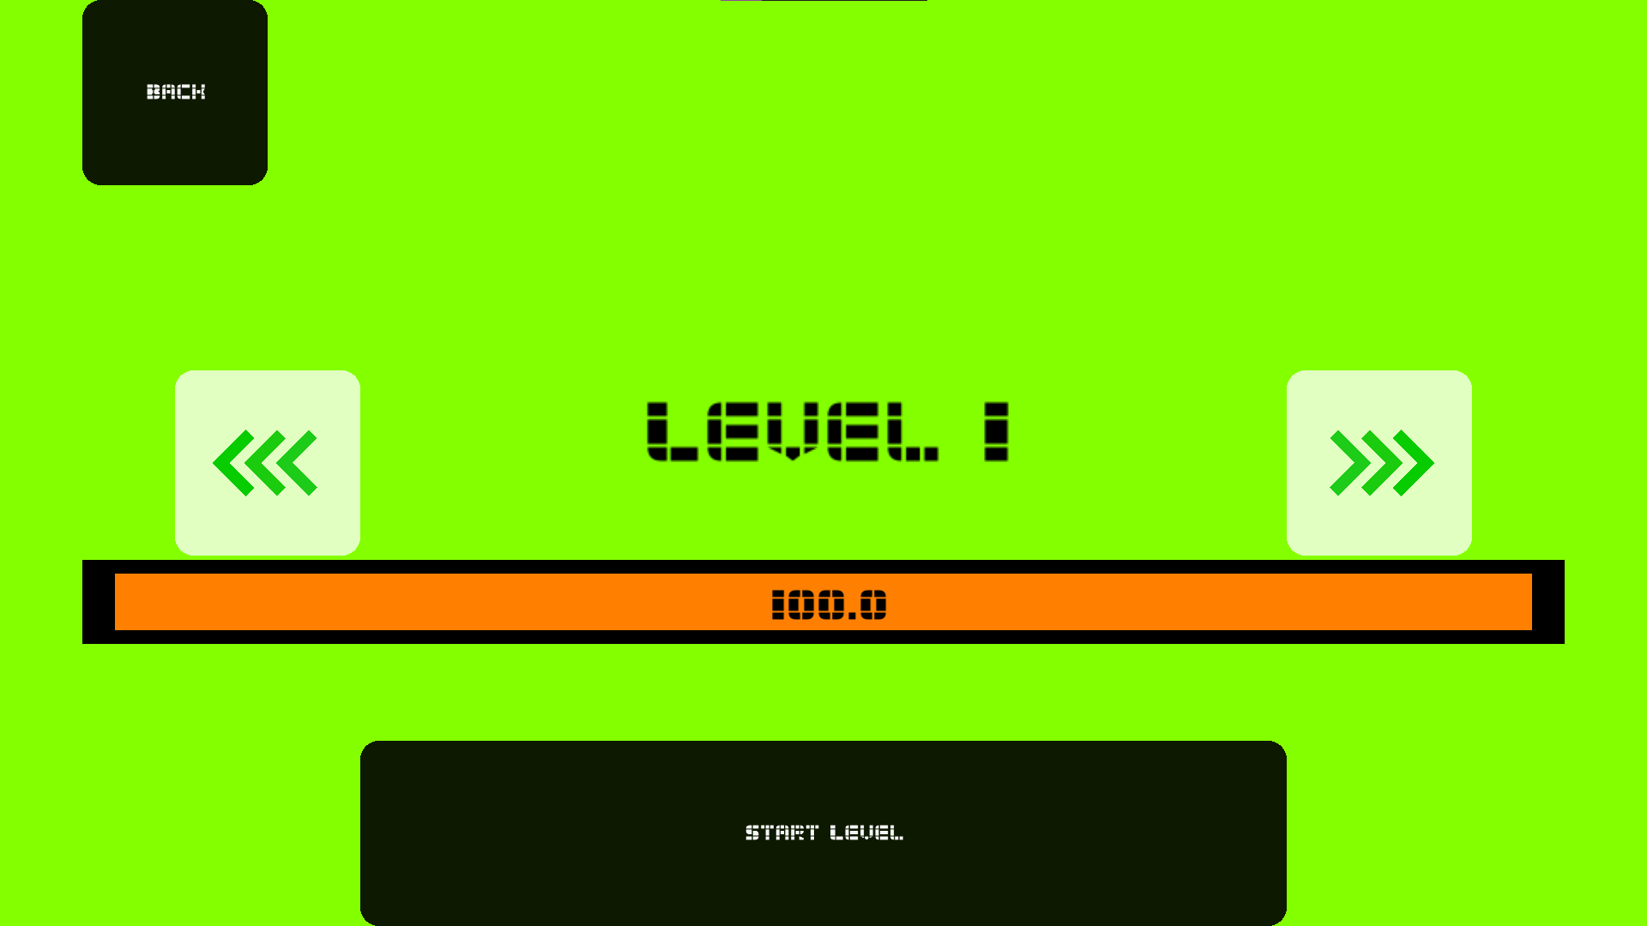
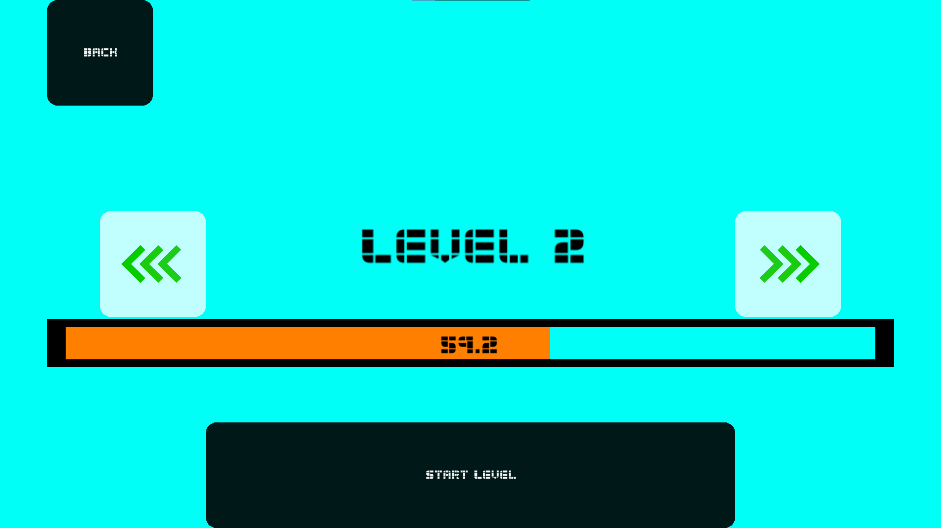
Two examples of the levelselect screen. Colours are assigned to the background sequentially, allowing for limitless expansion, and level names appear as adjusted versions of the names in the .Json file. Arrow controls allow switching between levels and the display for level length passed is shown in the percentage and the orange bar display.
Selecting the level triggers the loading of the object file with the same name, with the naming system allowing for a smoother and less frustrating selection process. First, the ground and wall classes identify the starting platform that displays the main starting point of the level. Levels then are loaded first through the calcpoints() function which rotates and positions the level to appropriately map to the static location just past the starting platform, and renderMap() loads the level itself as a mesh entity, defining its shader display and other related components before the level is loaded. EndGates() defines the end of the level using data inherited from calcpoints(), same with gravitygates(), though that also depends on the list of levels and coordinates where gravity swap gates should be placed. This process order is essential to the game’s functionality, as each class and function integrates with each other to chain important processes in loading and preparing the map for player spawn and comprise the setup to the internals of the main gameplay loop.
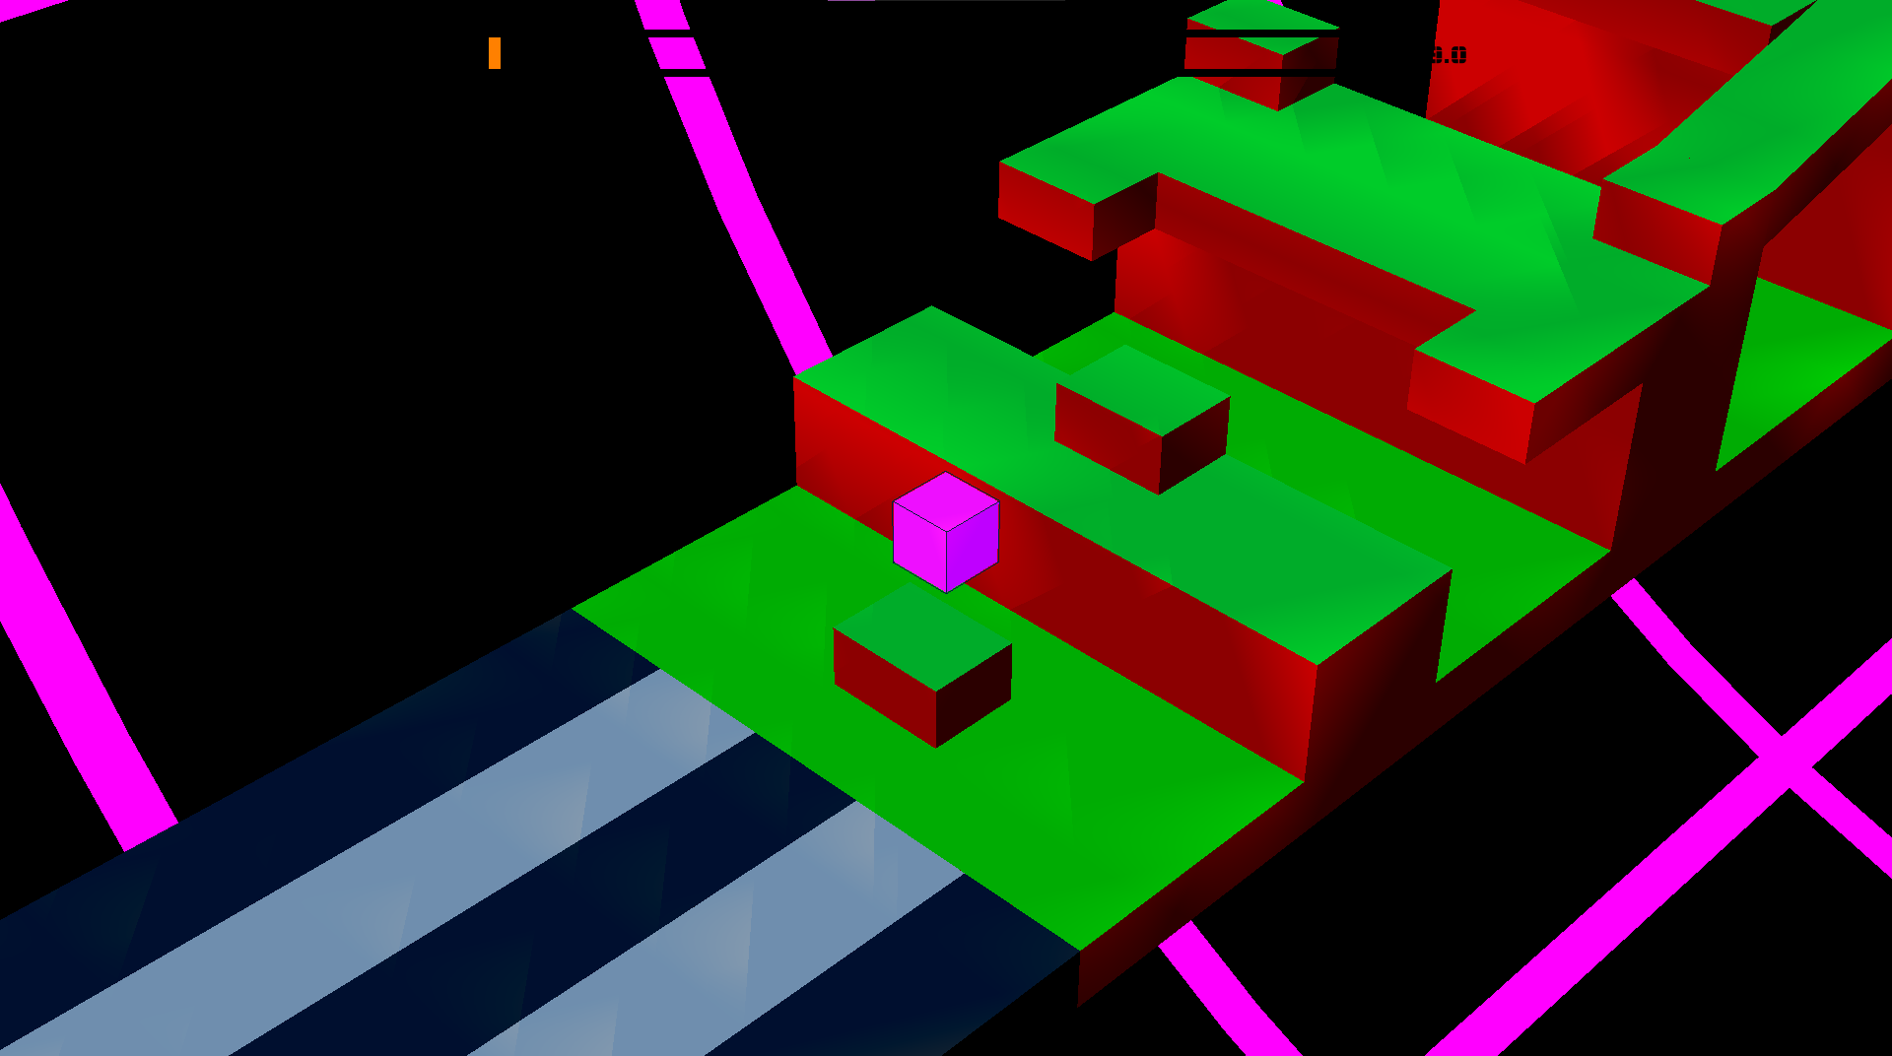
A showcase of the main gameplay within a level (namely Level2), displaying the conjoin between the main level (green and red) and the starting platform (white and black). The attached level is created through blender (see appendix) and inserted into the level through the applied functions of calcpoints() and renderMap().
The update and game_logic_step functions are the most critical components to the game itself, comprising the main game logic for the gameplay loop. Within the update function is an initialiser for the game_logic_step function that ensures the number of logic updates per second is limited to exactly 60, in equal ratio, ensuring that logic such as player movement and jump velocity is equalised between devices. Game_logic_step also controls the boxcast hitbox definitions and collision checking, allowing for proper detection of solid ground for the player to stand on, detection of collision to walls, and determining when the player passes through a gravity swapping gate or an end-level gate. See further information in the Appendix
Each of these features comprises a crucial aspect of the game by directly enabling player control and capability within the environment. Each component identifies the primary system of player interaction through button controls, keyboard inputs and visual feedback, comprising the primary internal functions of the game. Secondary functions such as animation, sounds and extra visual effects, as well as extra options such as the Wardrobe menu are less important to the game itself as the system can function without them, however they provide extra visual polish and player customisability that enables improved player enjoyment.

Version Control Summary
Version control summary is available on my GitHub repository, and each individual commit has a description designed to sum arise the basic intentions and ideas behind each of the changes, as well as the possible next steps for myself to work with for each section. The link is in the appendix and at the opening page of the document.

Testing and Evaluation
Testing was primarily conducted through a series of ‘waves’, with breaks after each major development (approximately every 3-4 GitHub commits) to test individual components both by myself and by requested testers.
Internal testing was primarily conducted through chained print statements to show individual data regarding different level components, allowing for more flexibility and personal understanding in how data progressed through the inherited function chains. Isolated Unit tests combined with Integration tests were more commonly applied during difficult bugs to resolve, wherein
The aspects of individual gameplay skill shared between play testers ultimately provided a variety of experiences that a new player may have. More experienced players would find more advanced routes, challenging me to work with more intricate systems of player expression, while newer players provided a fresh perspective in optimising the starter user experience to allow for a natural progression of gameplay skill. This provided significant assistance in usability testing and access understanding, resulting in a drastically improved new player experience and a myriad of new mechanics designed for returning players to test out and change their routes to new systems.
I also applied principles of regression testing to ensure that my program could handle the changes made with each successive update. This was especially important within a volatile work environment created by the AGILE method that resulted in frequent internal bugfixes. While most were cleaned up during development and pointed out by play testers, the remaining bugs were caught by my next principles of acceptance testing, allowing me to revise the entire codebase to test for bugs in a more comprehensive manner, leveraging play testers, my own knowledge of mechanics and various printout statements to clean up my logic and avoid any bugs I could find. This can be seen as the last phase of uploads and commits to the GitHub, wherein Bugfix patch #1, 2,3, and the extra hotfixes, ultimately resulted in a significantly improved game experience from its buggier state beforehand.
Load testing also provided significant improvements to the program, namely in an understanding of how much of a system impact the program created. Using the discrepancy in processing power between my laptops and pc, I was able to test the device on multiple systems and with varying levels of processing power; from higher-end 32gb ram devices with high-functioning CPUs to midrange, consumer-level 8gb ram on a work computer, to even smaller loads using virtual machines to simulate as low as 4gb of total system ram and a CPU from 2012. This provided a highly accurate metric data to allow me to understand the main problem areas of the program through Ursina’s entity and fps display, ensuring I could target problem areas for improvement, ultimately leading to the development of the ‘potato mode’ – effective for lower end devices in alleviating harder tasks and disabling heavy animations - and utilising various rendering tactics to improve the load efficiency of the game’s processes.

Test Cases and Results

Entity rendering system
Test ID | Description | Expected Result | Actual Result | Pass/Fail
TC01-InitRender | Testing initial rendering capabilities via integration of inbuilt native entities within the Ursina renderer – testing rotations, transformations and movements. | Buttons assigned to keyboard allow for direct control over camera movements and the singular object cube floating in space. Arrow keys control lateral camera movement, mouse controls camera rotation, and WASD keys enable cardinal direction movement of the object, with C and V controlling height | Buttons assigned to keyboard allow for direct control over camera movements and the singular object cube floating in space. Arrow keys control lateral camera movement, mouse controls camera rotation, and WASD keys enable cardinal direction movement of the object, with C and V controlling height | Pass
TC02-InitRender | Importing blender models as substitutes for native rendered Ursina objects; applying textures based on different files to understand rendering system better. | Object should import similar or identically to the modelled donut and have the assigned texture from the export .mtl file referenced in the .obj file export. | Donut object renders properly and assigns textures as requested. However, the incredibly high polygon count of the model reduces the rendering speed of the game down to >10fps, resulting in massive frame drops and errors | Pass  This test reveals significantly more about the processing power of my own computer and Ursina’s base handling of large-poly objects.
TC03-InitRender | Rendering menu items such as buttons and key inputs and parsing values from selections | Integration of Quad and Button objects in player controls, unlocking the mouse showcase and enabling clickable menu buttons. | Menu struggles to deload its rendered entities, but actual interactions are entirely possible and return values or call functions on request. | Pass but with extra connotations for later projects

Collision System
Test ID | Description | Expected Result | Actual Result | Pass/Fail
TC01-Collision | A first test to see if the player is able to properly collide with the floor objects created natively in the Ursina engine | Player lands on top of the floor object and stops falling once collision is achieved | Player lands on top of the floor object and stops falling once collision is achieved | Pass
TC02-Collision | Testing integration of Blender models in attaching player hitbox using the SimpleHitbox entity identifier within Ursina | Player lands on top of the floor of the object and stops falling once they collide with a physical aspect of the map | Player is situated on top of the map, just above an invisible bounding box that determines the furthest points of the model. | Fail
TC03-Collision | Test #2 for integration of blender models by applying the mesh modifier rather than the simple hitbox to be more effective in rendering and handling complex collision | Player lands on top of physical components of the floor and remains stationary after collision. | Player falls directly through the map components and fully through the playable area. Hitboxes reveal an oddly arranged map hitbox that seems adjusted in an odd way; this hitbox seems to be unable to be edited or moved | Fail
TC04-Collision | Test #3 for integration of blender models – testing new ideas for adjusting the hitbox size using the player’s inbuilt collision detection | Player lands on top of physical components of the floor and remains stationary after collision. | Player falls directly through the map components and fully through the playable area. Hitbox shows no change despite stretching out the map size drastically. | Fail
TC05-Collision | Test model changes by using the FirstPersonPerspective prefab by Ursina themselves and then piloting an ‘editorcam’ to parent to the player to act as the third person viewpoint. Application of unit testing and then integration testing, before using recursive testing to determine effect on other variables. | Player lands on top of physical components of the floor and remains stationary after collision. | Player correctly interacts with the main map; however, camera controls are compromised, and the inbuilt movement system is entirely dismantled. Player has lost all expected controls. Further testing reveals that these movement errors are essentially prebaked and unresolvable by conventional means. | Fail by proxy
TC06-Collision | Apply final possibility – utilising the boxcast function to create a secondary hitbox from the player that makes changes to itself and the player hotbox, hopefully allows for proper detection through raytraced vertex detection | Player lands on top of physical components of the floor and remains stationary after collision. Controls are no longer compromised. | Player lands on top of physical components of the floor and remains stationary after collision. Controls are no longer compromised. | Pass

Menu Entity Deloading
Test ID | Description | Expected Result | Actual Result | Pass/Fail
TC01-BuLD | Button controls being loaded and unloaded when necessary – removing visible components, destroying colliders and disabling hitboxes to improve lag | All buttons are deloaded and become invisible upon leaving the assigned screen | Buttons are not deloaded and their hitbox does not disappear. They overlay on top of the requested entities of the menu the player would interact with and cause overlay errors since hitbox and collider are still present | Fail
TC02-BuLD | Visibility removal handling, applied through unit testing in a separate file to unload requested entities | All buttons are deloaded and become invisible upon pressing the “clear buttons” button | All buttons are deloaded and become invisible upon pressing the “clear buttons” button | Pass
TC03-BuLD | Integration of unit tested file functionality into the more complex structure of the game menus | All buttons are deloaded and become invisible upon leaving the menu with the ‘back’ button. | Buttons are visibly deloaded and cannot be pressed but remain ‘present’ in system memory, slowly adding to the entity count and creating RAM leaks | Fail
TC04-BuLD | Full application of button system into removal and reloading for unloading/loading systems | All buttons are deloaded and become invisible upon leaving the menu with the ‘back’ button. Opening the given menu will reload the buttons and return them to functionality within the scene. | All buttons are deloaded and become invisible upon leaving the menu with the ‘back’ button. Opening the given menu will reload the buttons and return them to functionality within the scene. | Pass  This is referenced as the “Zero Day” flaw in the GitHub commits

Level Loading and Implementing for Linear Pathing
Test ID | Description | Expected Result | Actual Result | Pass/Fail
TC01-LL | Testing the initial capability of the engine to render and reposition meshes and thus provide a stable ground | Map renders in expected position as rotation (X, Y, Z) should theoretically be 0, as does position, and player should collide properly with map | Map renders with 90 degrees of southward rotation, shifted 20 meters away from the player. Teleporting the player on top of the map shows its hitbox is working properly, however. | Fail  Is a good learning experience however – shows that blender model locations in the constructor have effects on the model location in-game
TC02-LL | Testing proper blender map locations to balance map rendering | Map renders in expected position and rotation by adjusting the values in blender to negatives of rendered values in the engine. Colliders should still be enabled | Map renders with its exact midpoint (set to midpoint on the blender model) at the necessary location. Rotation is still -90 degrees and the map’s colliders are functional | Fail  The map’s location in the constructor is important, and I need to translate rotation via the map itself. The midpoint is a singular coordinate point on the map so I will need to calculate half the map length and shift it backwards by that amount
TC03-LL | Testing rotation and movement of the blender model | Map renders in expected position and rotation by adjusting the values in blender to negatives of rendered values in the engine and applying a rotation to the map. Colliders should still be enabled | Map visually renders in the appropriate position and rotation, with the start points aligned. However, collision is somehow entirely disabled. | Fail  Reveals important information – vertex locations are not rotated in the same way as the visual appearance and just turn 90 degrees rather than rotating around the midpoint axis, causing the collision detection to fail.
TC04-LL | Testing lateral rotation using trigonometric calculations for proper displacement. | Map vertices are moved through trigonometric principles to emulate a rotation around the midpoint axis of exactly 90 degrees. | Map regains its collision in all locations through a reproduceable function that relies on the geometry of the map itself rather than hardcoded values. Vertices are rotated properly, and all other map visual locations are shown. | Pass  This is stored in the calcPoints() function and is reproduceable for all necessary maps, as long as their blender model midpoint is the direct middle of the map.

FPS Testing and Optimisations
Test ID | Description | Expected Result | Actual Result | Pass/Fail
TC01-FPS | Testing quantity of frames per second in the update() function as well as ensuring that the game_logic_step() function retains 1/60th second update window | Maintains a minimum of 60fps on both PC and Laptop with differing specifications, game_logic_step retains 1/60th timeframe | Reaches 144fps on PC and appropriate timeframe of game logic, laptop maintains steady 50fps in menus and drops to 10fps during heavy loads such as animation and level rendering | Fail  The intention was to measure low end hardware; high end is a benchmark or a warning of catastrophically bad optimisations
TC02-FPS | Prerendering systems to provide a more effective loading system and ensure better fps | Maintains a minimum of 60fps on both PC and Laptop with differing specifications, game_logic_step retains 1/60th timeframe | PC reaches the same 144fps (Ursina fps limit with vSync enabled, besides 288fps). Laptop maintains 50fps throughout loading screens and drops to 20 during death animation. | Fail  This has provided helpful context for rendering options, but without using frustratingly painful optimisation techniques like back face culling, the laptop cannot properly exceed this fps without trimming or outright removing heavy loading tasks.
TC03-FPS | Determining and applying appropriate optimisations based on rise in fps from addressing problem areas found as which parts of the game dropped the FPS the most. Changes applied through a ‘potato mode’ that disables or replaces certain mechanics. | FPS should increase during menu animations and loading, as well as during the basic gameplay. This should only change for the low-end laptop as the PC reaches Ursina’s 144fps vSync cap. | FPS increases during menu animations as the menu is now a blue screen cover rather than an actual animation. Normal rendering in-game is improved by removal of shaders. FPS during death animation drops significantly as expected, but everything else reaches or exceeds the 60fps expectation | Pass  However, there is still work to be done; the death animation is incredibly choppy and difficult for low-end devices to load.
TC04-FPS | Applying further culling and removal of heavy loading items to improve FPS for lower end devices, incorporated into the ‘potato mode’ – remove the death animation and replace with a cartoon style compress effect using Ursina native systems rather than object loading. | FPS should maintain at the usual 60 frames per second on all devices as an absolute minimum, with little variation or frame drops that cause the choppy animation effect. | FPS maintains at 60 during the death animation and during all other components of the menu, while on low end device. PCs maintain 144 or higher. | Pass

Feedback Discussions

Discussion with Tester Simon
  - (During development process – direct inspiration for better depth perception through the colour scheme)
[Sam] “What would you say was the most effective feature of the game?”
[Simon] “Definitely the level progression, it felt more beginner friendly but increased the difficulty relatively well. I did get stuck a few times, but it felt more like a challenge than a chore.”
[Sam] “Were there any primary issues you struggled with during gameplay?”
[Simon] “It might just be my old eyes, but depth perception was a big struggle; it was hard to determine the difference between different floor heights and walls.”
[Sam] “I’ll take that into account, thank you. And I’ll be sure to let you know when I need your help next.”

Discussion with Tester Arseniy
  - (After multiple game completions and while the game was in its final phases)
[Arseniy] “So what were the struggles in your ga- “
[Sam] “No, no I’m asking the questions”
[Sam] “What would you say were the most effective features of the game?”
[Arseniy] “Definitely the control switch. My favourite control scheme is windows, f1 and f12 as key binds. In that order.”
[Sam] “So would you say that the personalisation and customisability is your favourite aspect? Did you have any suggestions for improvements to it?”
[Arseniy] “I believe allowing for a larger controller scheme and maybe also a custom skin maker and maybe switching the colour maps for the levels? Oooh and maybe also a level designer in the game itself.”
[Sam] “What was your main frustration with the game, if there was one?”
[Arseniy] “Camera controls. The controls are wonky at best and completely random at a midpoint. At worst, your camera feels disjointed during the zoom-in animation. Also, potato mode makes my eyes bleed, and I hate the menu theme music. Victory theme is fine, but I’d prefer if it was the final fantasy victory music. Also, the gravity gates are annoying because of the animation that disjoins the camera from the player for a moment.”
[Sam] “I’ll take that into account, thank you. And I’ll be sure to let you know when I need your help next.”

Evaluation Against Requirements
My own requirements for the game were based on the functional and nonfunctional requirements listed in the project proposal. Thus, I combined my ideas from the functional and nonfunctional requirements in addition to my internal definitions for a ‘proper’ game in the Development Process, leading to a list of components for the game and their conceptual design necessities.
- Playability / Ease of use
Player learning speed is shown through the beta testers to increase exponentially, with the speed of exponential increase in direct proportion to previous experience with similar games and simply gaming experience in general. Play tester Arseniy was able to quickly pick up the controls of the game and apply discovered nuances to learn how the game functioned and how to read ahead of the initial locations using the camera. Comparatively, play tester Simon showed slower progress as a result of his lack of gaming experience, but was still able to work through each of the levels within a proper time and without showing genuine frustration towards the game experience.
Player convenience was prioritized through my functionality of the .Json file storage that allowed for players to save preferences and level progress, ultimately preserving the saved state of the game between multiple playthroughs as per my functional requirement.
Animations were limited but ultimately provided context to the players to ensure that they had more of an understanding of their gameplay – namely in the death animation. The main menu animation provided more of a visual flair to the game than anything else but still maintained my requirements for player context and enjoyment of visual aspects through animated components within my functional requirements.
Player skill at the game evolved properly with the game itself and seemed to be generally well-matched to the level design as new features were found between levels. Growth of personal performance was shown to require short jumps in understanding between levels but generally improved at an appropriate rate. Thus, I find the ease of use of the game operations to be appropriate; providing a challenging experience that keeps players engaged without providing too heavy of a frustrating experience.
- Requirement for directions
The game itself is shown to be relatively easy for players to understand. The simplistic controls listed in the options menu, as well as the limited actual functionality of buttons allows for a lowered barrier to entry while also enabling a higher skill ceiling for player expression during the experience. This also aligns with my overarching idea for a ‘logic puzzle’ style experience within a faster-paced medium. Play testers showed that learning the controls was frustrating at first, unless they initially chose to explore the options menu wherein their understanding of the game quickly evolved.
Overall, initial impressions of the game required little directions; only those with severely lacking game experience had trouble understanding the control scheme, but this was more an issue with their own ability to mentally process button presses into in-game movements, not a problem with the provided skill requirements to start.
- Visual aesthetics and design
The visual aesthetics of the game are generally effective but limited in their graphical fidelity by my need to provide a low-specification requirement and the effective limitations of the Ursina engine. My best explanation of this is in the simple animation ability of the game, with nearly no posing controls, a limited movement control within the python IDE and an inability to import prerendered object animations from software such as blender, instead requiring a constant object replacement to simulate animation via the equivalent of a flipbook animation with .obj files.
Sound inclusions provided some assistance in this, such as explosion animation sounds and button clicking sounds to reduce the limited and blocky appearance of the level components, as predicted and expected in my nonfunctional requirements.

Overall, while the visual design was as effective as I could hope to make it with the tools I was applying, the game ultimately was unable to live up to my expectations for graphical fidelity, lacking features I hoped to add such as more expressive shaders, animations and lighting controls.
- Controls and Handling
The main control scheme of the game was designed to match with common control systems in other games, matching the A and D keys to the common left and right movements within the First Person Shooter (FPS) genre, and the spacebar as a common jump key from the original Geometry Dash. Noting concerns of players that certain keys felt ‘more comfortable’ than others, I elected to design a key rebinding system that saved to a .Json file storage, allowing players to customise their in-game experiences through the controls as well. This aligned with my requirements within the functional requirements component as it provided the expected control scheme by catering to the largest audience, as well as allowing for player customisation to provide a more effective experience.
Handling of the game seems relatively helpful. The controls are intentionally unique and jumpy to allow for last-minute decision making and the camera system is intentionally changed from the usual orbit controls in order to force players to learn and become more familiar with a system that can provide helpful context with the right knowledge. I’ve shown in a file located in ‘old stuff’ folder that has the proper orbital mechanics as a normal game, and I personally found it to be too simplistic and not as intentionally limiting to the player viewport. The enforced camera controls I provided allow me to ‘hide’ components of the level as secrets for players to find or provide new angles to alternate routes that require more observation from the player.
Ultimately, my control scheme and camera handling are designed in accordance with the functional and nonfunctional requirements to provide an experience that is both intuitive and adaptable, while also maintaining imposed limitations to allow for a challenging experience and environment of the game. These systems ultimately work in tandem to enhance the ‘logical processing’ side of my game, ensuring a more consistent requirement for player skill expression and observational capability.

Improvements and Future Work
While the game itself is in a theoretically ‘complete’ state as per my functional and nonfunctional requirements, as well as player experience criteria, components of the game itself had to be trimmed, cut or entirely scrapped as a result of the experienced limitations of time, knowledge, and choice of tools.
The most important component I would consider if I had the capability to take extra time and improve the game is to entirely scrap my usage of the Ursina engine. While it was helpful to apply my own capabilities in designing and building the game and its mechanics in the more familiar environment of python, Ursina itself is highly limiting and frankly terrible at its singular purpose of 3D rendering. Its graphical libraries are adequate at best, it’s menu and buttons systems are unintuitive and clunky, and the options for lighting and graphical effects are limited. Furthermore, my own ability to create such systems from scratch is limited by Ursina too, with frustrating locational controls, difficulties with higher processing power requirements, and the failure of its system to work within a multithreaded environment that ultimately limited my capabilities within the potential of the game. This resulted in the failure of me to adhere to my nonfunctional requirement of shading and lighting effects besides a simple texturing change and ultimately caused my project to increase significantly in processing power requirements.
My second improvement would be to lengthen the levels and provide a further set of skins and levels to ensure a more enjoyable experience within the game. Before settling on the four main levels and mechanics, I had a large system of ideas derived from brainstorming that would have provided significantly more enjoyable content to the game (see appendix for brainstorming ideas list), however the presence of time constraints unfortunately resulted in a series of compromises that reduced the overall quality of the game. If these ideas had the time to develop and be implemented, I have no doubt that the game would display a significantly higher level of polish and player engagement.

Client Feedback and Reflection

Summary of Client Feedback
Client feedback followed a generally positive trend, providing important feedback based on components of the game I requested they test and stating a generally positive gameplay experience. Bugs were charted in a list of things to patch stored in a note file across computers and accessed during each update, with play testers’ advice and noted bugs being added separately to the list.
After the completion of the game, client feedback was almost entirely positive, with the only heavily noted criticisms being that of depth perception issues and camera control issues. While Camera control was intentionally limited by the game to force a more logical thinking route, the depth perception issue was a significant issue that I attempted to remedy multiple times to no success. Attempting shader application resulted in extremely taxing processing requirement increases, with the only compromise being a reduction in quality to the point of complete ineffectiveness, providing interesting visual flair but ultimately doing little to improve player depth perception. The second remedy was retexturing the level models to use darker colours for lower components and shade sides differently from fronts. While this was helpful, the depth perception issues remained still. With extra time I likely could have remedied this issue through adaptive normal modelling in blender or working out the processing issues in the shader engine, however in its current state it remains exceptionally playable.
The game’s visual and UI designs were foundationally dependent on user feedback; gaining metric data through A/B and unit testing to ensure that player adaptability to the menu system was effective as possible. Retesting user metrics after production revealed that players were able to navigate menus easily, and with limited issue in finding important components and identifying locations to navigate to.
The gameplay of the levels was found to be relatively effective in building player skill to provide a steep but fair learning curve to the game. The progression of object clutter, essential mechanics and required execution of complex movement was intended to slowly scale throughout the levels, allowing for a player progression of skill, and this was largely shown to be true among the final testers. “Arghh, this one’s really hard… no, no one more try, I can do this.” While some components were difficult for players to progress with, namely the middle part of Level 3 and the start of Level 1, the game overall offered a unique challenge that built player skill in a way that avoided internal frustration and ensured a functional player experience.
Audio and visual feedback was limited at best but remained valuable to gain information on. Multiple final testers returned that they had been ‘jumpscared’ by the death sound at the start, prompting me to lower the volume multiplier for the explosion sound effect, but otherwise criticism was largely joking, with a few complaints that the music was ‘shit’ contrasted by a variety of comparisons to 80s synthwave and sci-fi music theming, which was the exact sense I aimed to portray. Visual results were relatively positive too, with the only complaint being a lack of overall animation, namely in the player’s lateral movement. While this was considered early in development, I ultimately decided that an animation would need to be exceedingly subtle to not distract players while also maintaining instantaneous left and right movement, and with the apparent failure to apply proper graphical fidelity by Ursina’s renderer, I found that it would be more time, energy, and graphically efficient to avoid any further animations.

Personal Reflection
Leveraging my available time to improve the game in smaller, prototype style tests rather than constantly advancing a singular point with specific tasks was no doubt the most effective strategy. Prioritisation of required tasks from my determined lists of things to do accelerated my production process by a large margin as it allowed me to finish important features quickly and leave room for less effective designs or more painful problems to be considered over longer periods of time for their potential solutions and requirements.
While optimisations to workflow could certainly have been made, and my decision at the beginning to use the Ursina engine within python was certainly a costly mistake, I believe that the logical requirements of my development processes has resulted in a far better learning experience and a much more effective display of my capabilities than a conventional engine.
I’ve found that the game seems well-suited to my criteria, with limited player difficulties and a considerable amount of praise for its enjoyability. While I personally can still see areas for improvement, these areas were ultimately gated by significant time sinks or entirely limited by the engine itself. I have no doubt I will continue to work on this game in my own time to polish more and provide more available features to players, however I find the game to be in an acceptable and complete state for submission at the time of writing, and I believe (and hope) that the play testers would feel the same.

Appendix

GitHub Repository Link:
https://github.com/HyperVoidal/3D-DASH/tree/main

Brainstorming List 10/06/25 (Digitised for Convenience):
- Gravity Flipping
  - Some kind of gate e.g. purple/green block?
  - Lowered alpha to avoid obscuring gameplay
  - Flips gravity exactly 180 degrees, camera should flip similarly to emphasize change but not enough to return game to exactly normal
  - Applies by the same gate for both switches, allows for replicable controls that avoids unnecessary repetition in design; proves OOP principles
  - Maybe some kind of special rotation for Y axis normalisation instead of X axis, e.g. 90-degree flip?
    - Different colours for differentiation
      - One colour rotates map 90 degrees, another 180 degrees.

- Custom skin uploads? Allow players to natively apply their own images to the cube
  - Potential file pathing issues, may need to require players to add the textures to game files
- Animated skins to allow for more interesting ideas?
  - Could cause loading/rendering issues for lower end pcs
  - May also cause collision errors due to constant texture/model reloading since Ursina is awful in texture hotswapping
- Levels incorporate music
  - Background ambience?
  - Music sync to required jumps
    - Would be incredibly difficult to figure out some kind of timing because of all the possible jumps
- Alternate cube modes?
  - Flying ship that reduces gravity based on how long the player holds
  - Flappy bird?
  - Jump key also rotates gravity by 90 or -90 degrees
  - Camera orients to have player as front and centre and mouse movements control y and z position?
  - Forced orthogonal perspective for memorisation testing?
- Obstacle design improvements
  - Kill cones
  - Swinging axes
  - Lasers?
- Shader lighting effects
  - Raytracing on maps?
  - Potential gamemode where map has complete darkness and landing a jump provides a brief light flash?
- Platformer controls with unlocked camera movements? Allow for further map exploration and planning in a ‘ghost mode’ so players can familiarize themselves with the levels and plan over a longer time period if they are having troubles with level navigation
  - Practice mode?

Example Code Snippet – The Update Function
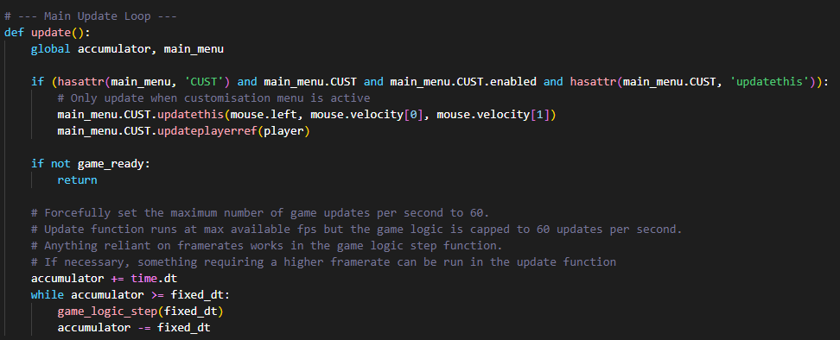
Game updates in Ursina are unable to be capped or be given a maximum limit, the engine simply updates as much as necessary. Thus, I created an alternative system that calls ‘game_logic_step()’ (Where actually important things happen like player movement updates) in order to circumvent the issue and gain more control. Since it’s at exactly 60 updates per second at all times, varied situations like player movement that previously updated on a frame basis instead is now constant by the 60-tick mechanism.
The only exception to this is the customisation menu, since the game_logic_step only runs during player gameplay, so any update requirements outside of the game – in this case, rotating the player reference cube in the wardrobe menu by clicking and dragging with the mouse – is handled without the 60 tick limit, since accuracy is nowhere near as important as in gameplay.

