Usage Instructions:
+ This card Library is designed for displaying cards from my card game.
+ To make a new card, create a class than implements the Card interface, and set its stats and information as variables.
+ To display a card, call the displayCard() function from within that card, inputting: SPD, name, HP, textbox, LVL, part of speech, and DMG. The order is the same as it appears on the card, left to right, top to bottom.
+ The title and part of speech automatically center on the card, and the textbox automatically wraps.
The final output should look like this:
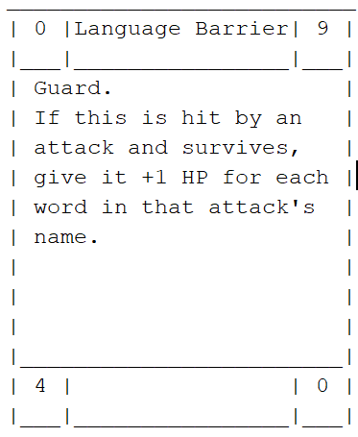

Usage Examples:
You can modify the display to work for cards from your own game or display custom Realms cards you make.
How to add this library as a dependency in a Java project:
- This Library is made for Java 21.
- Add this to your pom.xml file’s dependencies:
<dependency>
<groupId>com.mycompany</groupId>
<artifactId>java-card-library</artifactId>
<version>1.0.0</version>
</dependency>
- Then, add this the pom.xml’s repositories:
<repository>
<id>github</id>
<url>https://maven.pkg.github.com/Hypercube34/javaCardLibrary</url>
</repository>
- Run “$mvn install” on your command line or “Clean and Build” in NetBeans.
Links:
Repository
Package

