THE UNIVERSITY OF BIRMINGHAM
College of Engineering and Physical Sciences

Mechanics 1

Tutorial Sheet - 3

1. An effectively rigid bar is suspended from three wires and carries a vertical force of 10 kN, as shown in the diagram. All three wires are of the same length, have the same cross-sectional area and are made from the same material - and thus have the same Young's Modulus.

2
m
2
m
1
m
A
B
C
10
kN

Note that a real bar cannot, in fact, be perfectly rigid - but it may be assumed in this case that curvature of the bar due to bending is negligibly small compared with elastic extensions of the wires. Thus, the bar may deflect and rotate, but can be assumed to remain a perfectly straight line.

What are the tensile forces in the wires?

Ans : T_{A} = 2.105 kN, T_{B} = 3.158 kN, T_{C} = 4.737 kN

2. A steel column in a building frame, 7.5m long, is fully fixed against movement at its top and bottom, as shown in the diagram. Two vertical forces, each of 20 kN are applied at a point 4.5m above the base of the column.
P
Q
R
20
kN
20
kN
3.0
m
4.5
m

The column has uniform cross-sectional area (A) and Young's Modulus (E).

What are the axial forces in the upper (PQ) and lower (QR) sections of the column?

Ans : T_{PQ} = +24 kN, T_{QR} = -16 kN

3. A composite beam has been developed which uses two materials. The beam geometry and the material properties are given below. Details of the bar and the materials are given below. Determine the forces in the two components.

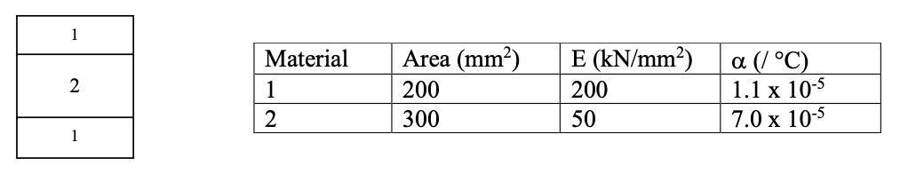

The beam was manufactured at a temperature of 20C and will be used in an environment with a temperature range of -10°C to 40°C. What is the range of temperature-induced stresses that the two component materials may experience whilst the beam is in service?

Ans : Material 1 = -96.6 N/mm² to 64.4 N/mm² Material 2 = -42.9 N/mm² to 64.4 N/mm²

4. An extruded aluminum beam section has the dimensions shown in the diagram.

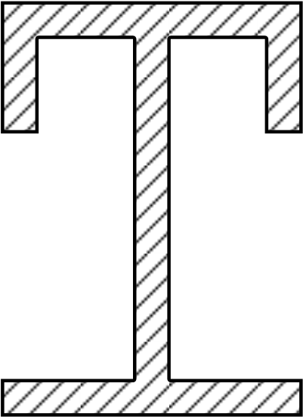

55
55
70
5
5
y
_
G
5
20
5
5

Locate the centroid of the section, and find the second moment of area about a horizontal axis passing through the centroid.
Ans: y = 36.07 mm, I = 1.018 _{x} 10⁶ mm ⁴

5.What is the second moment of area about its base of an equilateral triangle of side b?
b
G

b

A regular hexagon, of side b, is formed from six equilateral triangles. What is the second moment of area about an axis passing through the centroid and parallel to one of the sides?
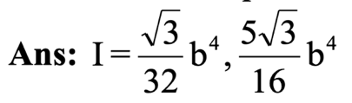

6. simply supported beam of 5.0m span carries a uniformly distributed load of intensity 12kN/m on its full length. Clearly (as a result of the symmetry, if for no other reason), the vertical reactions at the ends are each 30kN.
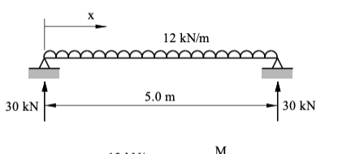
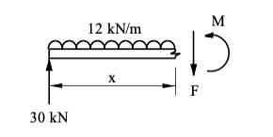
(a) By 'cutting' the beam at distance x from the left-hand end, and considering equilibrium of the section to the left of the 'cut', find expressions for the internal shear force (F) and bending moment (M) in terms of x

(b) Plot graphs of F and M for 0 ≤ x ≤ 5 and find the largest shear force and bending moment in the beam.

Ans : Fmax = 30 kN, Mmax = 37.5 kNm

