Week 4 – Shear and Bending Moment Diagrams
4.1 Learning Outcomes
In this lecture we will learn how to determine the internal forces (i.e. shear and moments) in continuous beam elements which is a fundamental step for design.

4.2 Introduction
Members that are slender and support loadings that are applied perpendicular to their longitudinal axis are called beams. In general beams are long, straight bars having a constant cross-sectional area. Beams are often classified as to how they are supported. For example, simply supported beam is pinned at one end and roller supported at the other end; a cantilevered beam is fixed at one end and free at the other; and an overhanging beam has one or both of its ends freely extended over the supports.
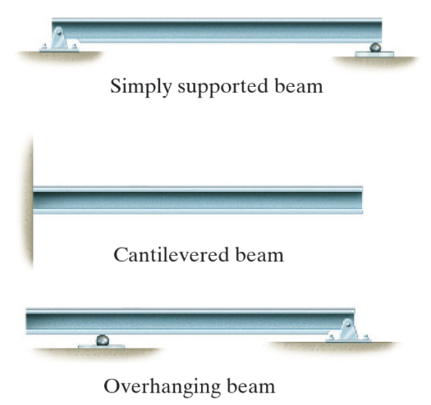

Beams are considered among the most important of all structural elements. They are used to support the floor of a building, the deck of a bridge, the wing of an aircraft, or the axel of an automobile. Many of the bones of the body act as beams.

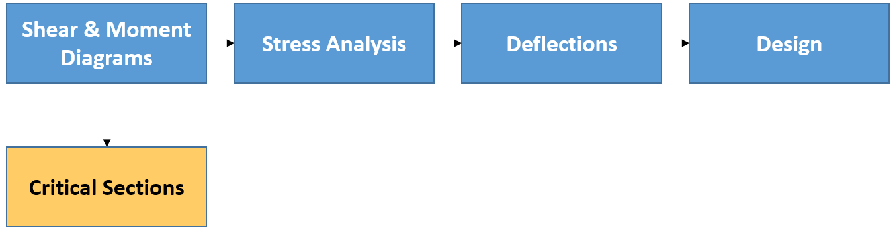
Because of the applied loadings, beam develop an internal shear force and bending moment that, in general, vary from point to point along the axis of the beam. In order to properly design a beam it becomes important to determine the maximum shear and moment in the beam. We do this by drawing the shear and bending moment diagrams.

4.3 Beam Sign Convection
The positive directions for shear force (V) and bending moments (M) are as follows: the distributed load acts upward on the beam, the internal shear force causes a clockwise rotation of the beam segment on which it acts, and the internal moment causes compression in the top fibres of the segment such that it bends the segment so that in holds water. Loadings that are opposite to these are considered negative.


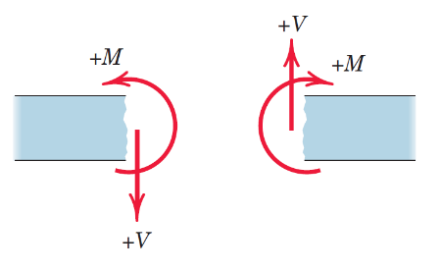
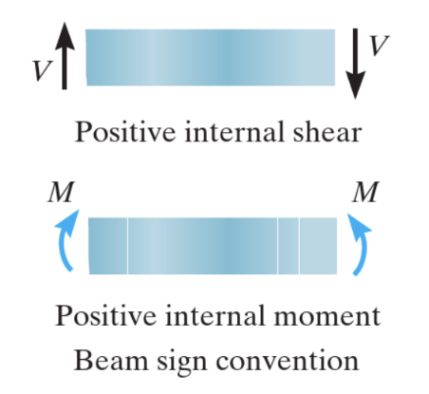
Positive shear
Positive moment

4.4 Procedure for Analysis
The shear and moment diagrams for a beam can be constructed using the following procedure.
- Determine all the reactive forces
- Establish an x, y coordinate system
- Section the beam between
  - concentrated forces
  - couple moments
  - where the distributed loading is continuous
- Be sure V and M are shown acting in their positive sense , in accordance with the sign convention
- The shear V is obtained by summing forces perpendicular to the beam’s axis.
- The moment M is obtained by summing moments about the sectioned end of the segment.
- Generally it is convenient to show the shear and moment diagrams below the free-body diagram of the beam.

4.5 Introductory Examples
Example 1
Consider a simply supported beam of span L, carrying a concentrated load P at its mid-point.
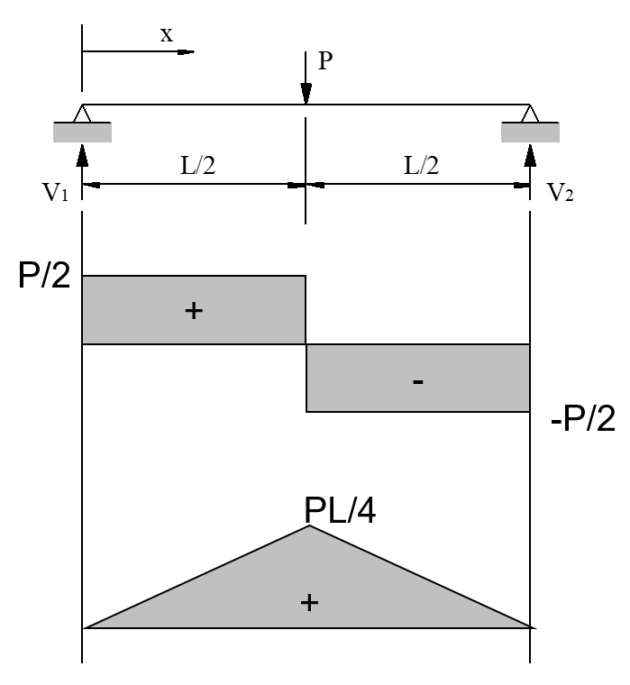
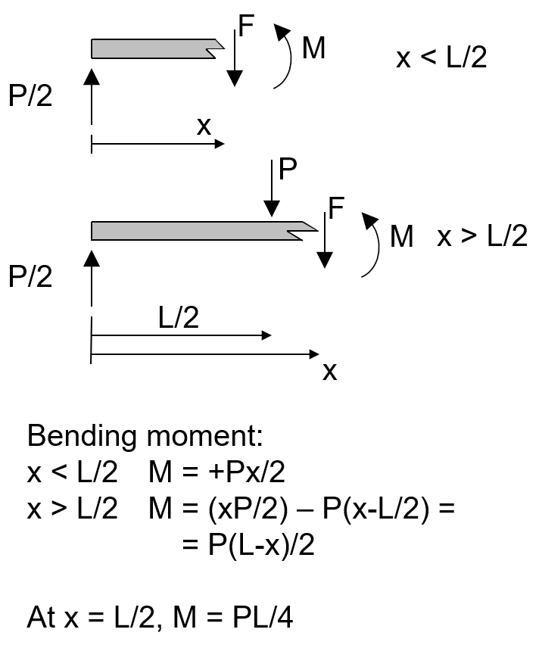
Example 2
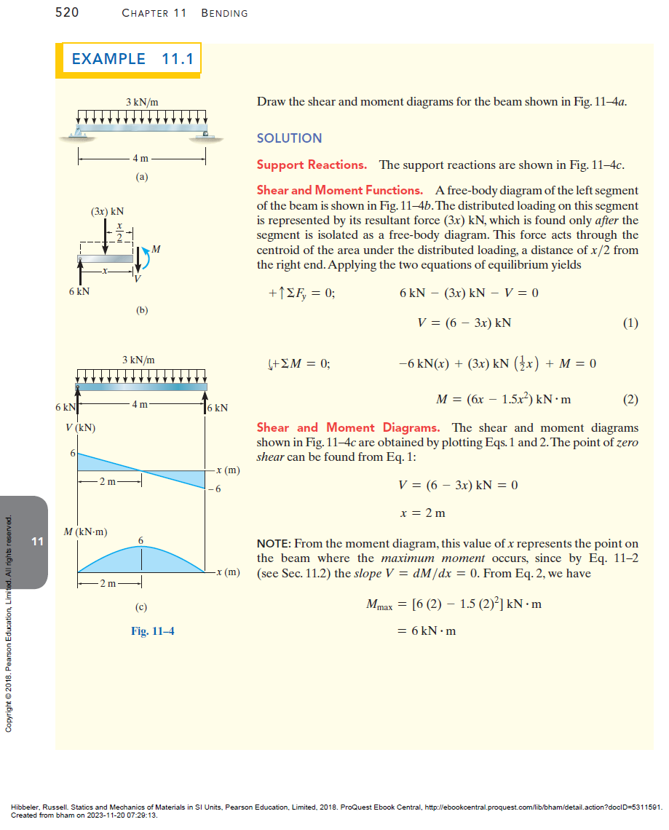

4.6 Practice in Classroom
Consider a simply supported beam of span L, carrying a uniformly distributed load w per unit length.
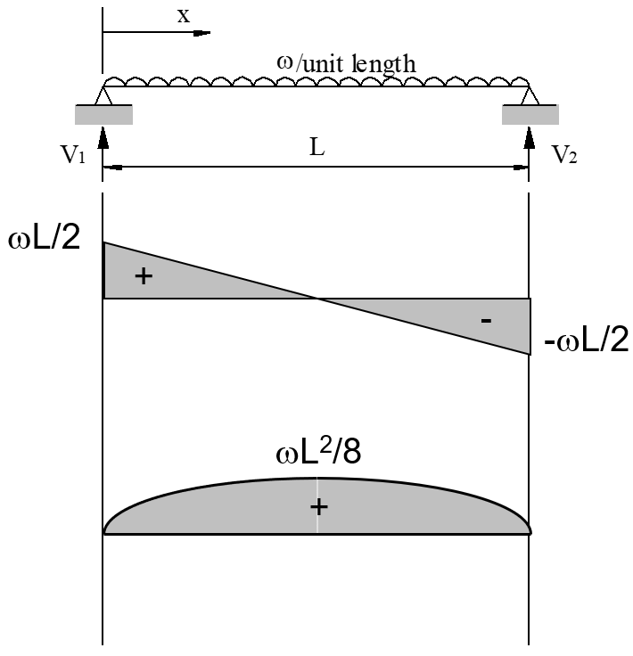
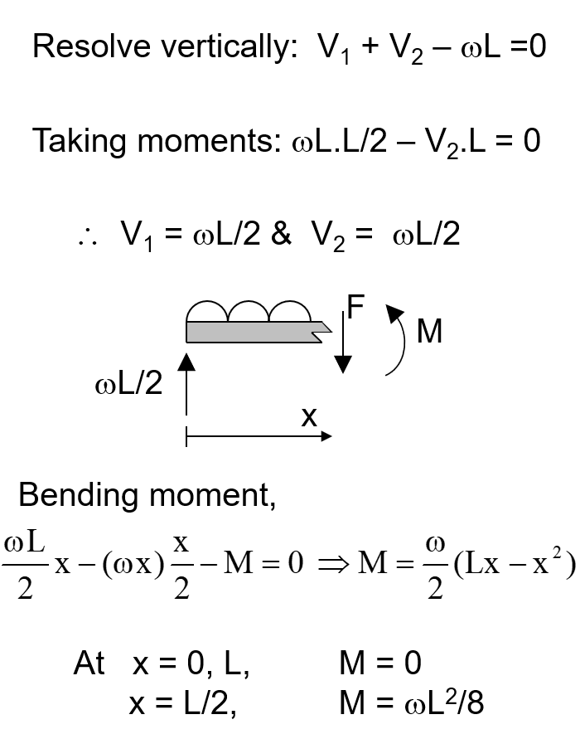
4.7 Test Yourself
Draw the shear force and bending moment diagram for the beam below.
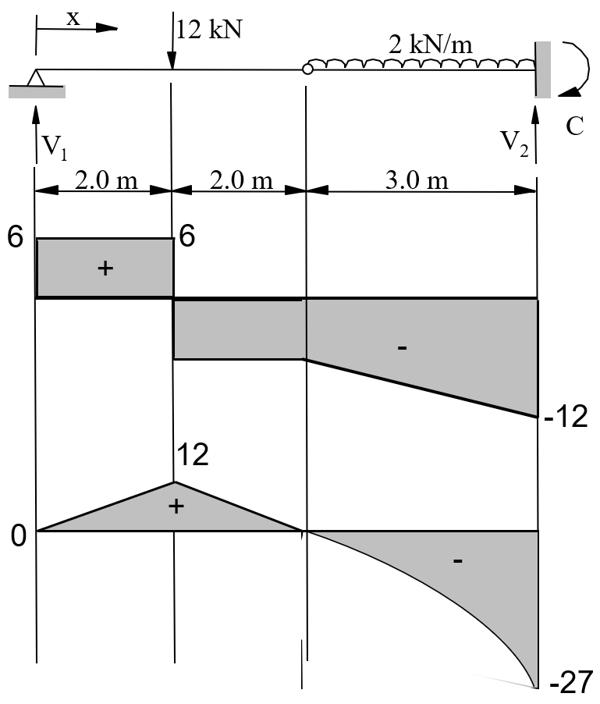
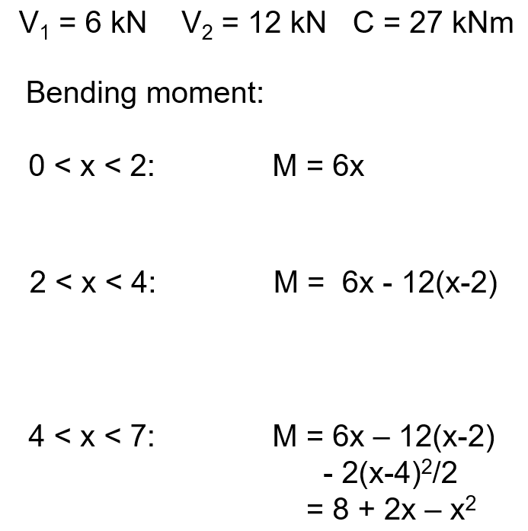

4.8 Further Reading
These topics are covered in section 11.1 (Shear and Moment Diagrams, Chapter 11, Section 1) in the Statics & Mechanics of Materials textbook (5th Edition, 2018).

