

**NATIONAL UNIVERSITY - HO CHI MINH CITY**

**UNIVERSITY OF SCIENCE**



**Majors: Information Technology - High Quality**

**Group Project - CS162 - CS10002 - 22CLC06**

**Project Topic:**

**A Course Management System**

School Year: 2022 – 2023

**-------------------**

***Preface***

Our group would like to extend our most sincere and heartfelt appreciation to the esteemed teachers of the **Programming Techniques** course at the **University of Science**. We are grateful for the opportunities that teachers provided for us and our fellow students to engage in a stimulating group project that has further enriched our passion for learning, as we sought out resources to gain valuable knowledge and experience, which has proven to be beneficial not only for our group but also for every individual in the **Programming Techniques** class.

We would also like to express our deepest gratitude to our esteemed teachers, Mr. **Nguyễn Lê Hoàng Dũng** and Mr. **Hồ Tuấn Thanh**, for their exceptional guidance and unwavering support. Their insight instruction, patient mentorship, and genuine care have enabled us to complete our project with the highest degree of professionalism.

Ultimately, we would like to acknowledge and thank our dear friends for their support and encouragement throughout the learning and project implementation process.

Recognizing that our project may have room for improvement, we humbly welcome any feedback from our teachers or friends to further enhance our work.

In closing, we wish to extend our sincere appreciation and respect to our esteemed teachers for their valuable contributions to our academic and personal growth. We wish our teachers good health, continued success, and fulfillment in all of your endeavors.

**Thank you sincerely for teachers and friends support and guidance!**

**Group Project**

**BCRSystem**

***Teacher’s Feedback***

…………………………………………………………………………………………………………………………………………………………………

………………………………………………………………………………………………………………………………………………………………….

………………………………………………………………………………………………………………………………………………………………….

………………………………………………………………………………………………………………………………………………………………….

………………………………………………………………………………………………………………………………………………………………….

………………………………………………………………………………………………………………………………………………………………….

………………………………………………………………………………………………………………………………………………………………….

………………………………………………………………………………………………………………………………………………………………….

………………………………………………………………………………………………………………………………………………………………….

………………………………………………………………………………………………………………………………………………………………….

………………………………………………………………………………………………………………………………………………………………….

………………………………………………………………………………………………………………………………………………………………….

………………………………………………………………………………………………………………………………………………………………….

………………………………………………………………………………………………………………………………………………………………….

………………………………………………………………………………………………………………………………………………………………….

………………………………………………………………………………………………………………………………………………………………….

………………………………………………………………………………………………………………………………………………………………….

………………………………………………………………………………………………………………………………………………………………….

………………………………………………………………………………………………………………………………………………………………….

………………………………………………………………………………………………………………………………………………………………….

………………………………………………………………………………………………………………………………………………………………….

………………………………………………………………………………………………………………………………………………………………….

**Teacher Teacher**

**Nguyễn Lê Hoàng Dũng Hồ Tuấn Thanh**

***Table of Contents***

**Introduction 4**

• Students work in this project: 4

• Subject – Instructors/Teachers: 5

• Summary of contents related to project: 5

• Group Evaluation: 5

• Video demo of project: 5

**Contents 6**

❖ Data Storage of our project source code 6

❖ Data Storage of our project source code 6

❖ Structure of our project source code 6

❖ References Source code/Something else 6

# 

# ***Introduction***

## Students work in this project:

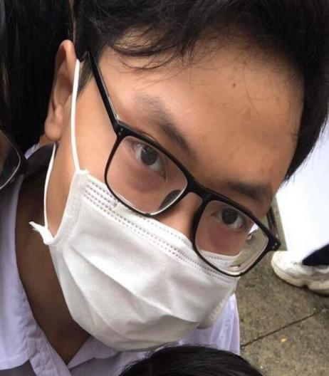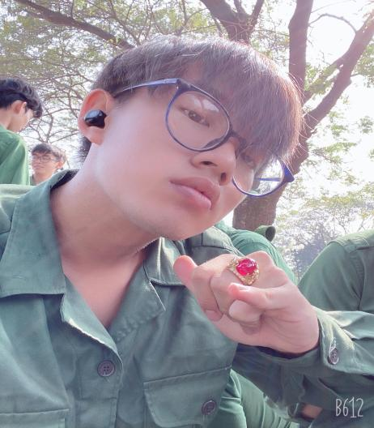

**20127095** - Vũ Lê Trọng Văn **22127432** - Đặng Thanh Tú

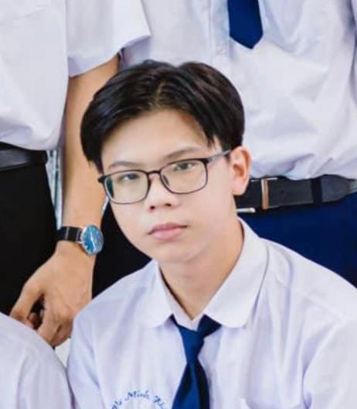

**22127213** - Võ Minh Khôi **22127148** - Nhâm Đức Huy

## 

## Subject – Instructors/Teachers:

- Subject: Programming Techniques

- Instructor/Teacher: **Nguyễn Lê Hoàng Dũng**

- Instructor/Teacher: **Hồ Tuấn Thanh**

## Summary of contents related to project:

- Telling about the project …. (Doing later after finishing the project)

## Group Evaluation:

|  |  |  |  |  |
| --- | --- | --- | --- | --- |
| Numerical Order | Student Code | Student Name | Completion Level | Note |
| 1 | 22127213 | Võ Minh Khôi | 100% | - |
| 2 | 22127148 | Nhâm Đức Huy | 100% | - |
| 3 | 22127432 | Đặng Thanh Tú | 100% | - |
| 4 | 20127095 | Vũ Lê Trọng Văn | 100% | - |

## Video demo of project:

- Link video demo:

“ <https://www.youtube.com/channel/UC_vMFU1bHtroD3qtdLOCxHg> ”

# *Contents*

## **Introduction to Project**

## **Data Storage of our project source code**

## Structure of our project source code

## References Source code/Something else

1. : ….
2. : .…
3. : ….
4. : ….