This is a group project. It is worth 20 points.
Create a graph class that stores a linked list of nodes, representing a directed graph. Create graph, node, and edge classes to implement the graph.
Your program will take as input a file containing node names and links. Each line in the file will contain the name of a node, a node connected to it, and the distance. Names may be repeated for additional links. Example:
Program07a.txt  A B 10  A D 5  A E 10  D C 4  D F 4  C B 8  C F 3  F C 2  F E 8 | 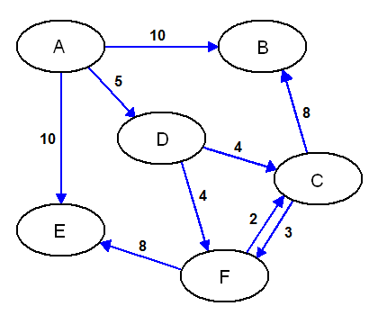
Test your program with these code and data files:
https://markbowman.org/231/Program07.zip
You may not change the Main.cpp file. You will need to create all the other code files.
Your data structure should read in a data file to construct the graph, search for and move to a node, then do both a depth-first, and breadth-first traversal of the graph from that node.
All data elements should be private. It will help to declare the graph container class as a friend to the lower classes. Use these functions to display the contents of the graph.
Due Apr 28 6:00pm (5 pts)
Hand in a copy of the Graph.h, Node.h, and Edge.h files, with the complete declarations for the graph, node, and edge classes. For each class function, provide the declaration and which member of your group assigned to write it. Do not attach function definitions. These files should be formatted using the course standards.
Due May 5 4:00pm (10 pts)
Hand in a copy of the code, and a sample run for each of the input files to demonstrate that your program and functions work correctly. Your project will be graded on its functionality and the readability of the code, including comments

May 5 Class Presentation (5 pts)
Your group will make a short presentation to the class to explain how the data structure is implemented. Be prepared to use the screen projector to display your code and sample runs, and answer questions about your project.

Sample Output
Enter file name: Program07a.txt

S)how, M)ove, D)epth, B)readth, P)ath, Q)uit: S

Node A
Edge B 10
Edge D 5
Edge E 10

Node B

Node D
Edge C 4
Edge F 4

Node E

Node C
Edge B 8
Edge F 3

Node F
Edge C 2
Edge E 8

S)how, M)ove, D)epth, B)readth, P)ath, Q)uit: M
Enter node: A

Node A
Edge B 10
Edge D 5
Edge E 10

S)how, M)ove, D)epth, B)readth, P)ath, Q)uit: D

Depth List
----------------
A B D C F E

S)how, M)ove, D)epth, B)readth, P)ath, Q)uit: M
Enter node: D

Node D
Edge C 4
Edge F 4

S)how, M)ove, D)epth, B)readth, P)ath, Q)uit: B

Breadth List
----------------
D C F B E

S)how, M)ove, D)epth, B)readth, P)ath, Q)uit: Q

Thank you!

Extra Credit (5 pts)
Implement the greedy shortest edge first method described in class to find a path from a start node to a destination node.
Sample Output
Enter file name: Program07a.txt

S)how, M)ove, D)epth, B)readth, P)ath, Q)uit: S

Node A
Edge B 10
Edge D 5
Edge E 10

Node B

Node D
Edge C 4
Edge F 4

Node E

Node C
Edge B 8
Edge F 3

Node F
Edge C 2
Edge E 8

S)how, M)ove, D)epth, B)readth, P)ath, Q)uit: P
Enter start node: A
Enter finish node: E

Path
----------------
A to D = 5
D to C = 4
C to F = 3
F to E = 8
Total = 20

S)how, M)ove, D)epth, B)readth, P)ath, Q)uit: P
Enter start node: A
Enter finish node: B

Path
----------------
A to D = 5
D to C = 4
C to F = 3
F to E = 8
No path found

S)how, M)ove, D)epth, B)readth, P)ath, Q)uit: Q

Thank you!

