

***Operating systems Lab Work***

***Practical 9***

***Name :Shrey Vyas***

***Batch:F-1***

***Roll Number:22BCE335***

**9A**

**Code:**

#include <stdio.h>

#include <stdlib.h>

#include <sys/types.h>

#include <unistd.h>

int main()

{

    printf("Initial id=%d", getpid());

    int id1 = fork();

    int id2 = fork();

    int id3 = fork();

    printf("Printing three fork function\n");

    int id1, id2, id3;

    id1 = fork();

    id2 = fork();

    id3 = fork();

    if (id1 < 0 || id2 < 0 || id3 < 0)

    {

        printf("Fork failed\n");

        return;

    }

    else if (id1 == 0 && id2 == 0 && id3 == 0)

        printf("Child process 1: My PID is %d, my parent's PID is %d\n", getpid(), getppid());

    else if (id1 == 0 && id2 > 0 && id3 > 0)

        printf("Child process 2: My PID is %d, my parent's PID is %d\n", getpid(), getppid());

    else if (id1 > 0 && id2 == 0 && id3 > 0)

        printf("Child process 3: My PID is %d, my parent's PID is %d\n", getpid(), getppid());

    else if (id1 > 0 && id2 > 0 && id3 == 0)

        printf("Child process 4: My PID is %d, my parent's PID is %d\n", getpid(), getppid());

    else if (id1 == 0 && id2 == 0 && id3 > 0)

        printf("Child process 5: My PID is %d, my parent's PID is %d\n", getpid(), getppid());

    else if (id1 > 0 && id2 == 0 && id3 == 0)

        printf("Child process 6: My PID is %d, my parent's PID is %d\n", getpid(), getppid());

    else if (id1 == 0 && id2 > 0 && id3 == 0)

        printf("Child process 7: My PID is %d, my parent's PID is %d\n", getpid(), getppid());

    else

        printf("Parent process: My PID is %d\n", getpid());

        return 0;

}

**Output:**

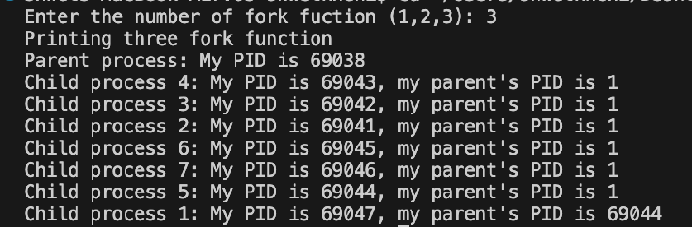

**9B**

**Code:**

#include <stdio.h>

#include <string.h>

int main() {

    FILE *file;

    char filename[] = "prac9b.txt"; // Change this to your file's name

    char line[256];

    char word[100];

    printf("Enter the word to find:");

    scanf("%s",&word);

    file = fopen(filename, "r");

    if (file == NULL) {

        printf("Error opening file %s\n", filename);

        return 1;

    }

    int i=1;

    int count=0;

    while (fgets(line, sizeof(line), file)) {

        if (strstr(line, word) != NULL) {

            printf("%d | %s\n",i,line);

            count++;

        }

        i++;

    }

    printf("The count of occurences are %d",count);

    fclose(file);

    return 0;

}

**Output:**

