MLOP’s
Deployment Scenarios
-Shrey Vyas

Aim of the Practical: The idea is to be able to fully understand the concepts of Nginx and regarding how, what and why’s of a webserver as well as a dev or prod server. These scenarios give a hand-on idea of how things must be done, and how nginx can actually be used in the Industry.

Various Deployment Scenarios to look in this demonstration:

1. Using Development Server
2. Using Production Server (Waitress)
3. Using Nginx + Waitress
4. Nginx + Waitress - Virtual Hosting (one server block (virtual server) serving multiple domains like example.com, api.example.com. Proxy pass to one application server. Only one App. The App should check the request.host to serve the correct home page. For Host to IP mapping on Windows, use file C:/Windows/System32/drivers/etc/hosts).
5. Nginx + Waitress. There is a different virtual server (server block) for example.com and api.example.com. Proxy pass to one application server. Only one App. The App should check the request.host to serve the correct home page. For Host to IP mapping on Windows, use file C:/Windows/System32/drivers/etc/hosts).
6. Nginx + Waitress. Two Separate Apps running on same Waitress but on different ports. One App is for example.com while the other for api.example.com. For Host to IP mapping on Windows, use file C:/Windows/System32/drivers/etc/hosts).
7. Nginx + Waitress. Two Separate Apps running on two different Waitress (on separate systems). One App is for example.com while the other for api.example.com. For Host to IP mapping on Windows, use file C:/Windows/System32/drivers/etc/hosts).
8. Support HTTPS. ( By the use of openssl tool to get the certificate and certificate key, that is, a dummy one)
9. Improve HTTPS implementation. (Use certificate from Trusted CA like https://letsencrypt.org/, https://www.godaddy.com/en-in/web-security/ssl-certificate, etc.)
10. Serve Static files efficiently.
11. Load balancing + sticky sessions in Nginx (Don't use Nginx Plus)

Commands for running the codes:
In the beginning, in scenarios 1 and 2, we will setup a dummy dev server and a dummy prod server, and from scenario 3 onwards, we would be configuring the different ways of using nginx server including configurations for static files, load balancing, https, sticky sessions and virtual hosting.
Running app servers:
Click on run, and for different apps to run at the same time, just open new terminals and run python <app-file-name>.py

Setting up nginx configurations:
By going to the directory /nginx-1.26.3/conf/nginx.conf file inside any scenario that you might want to run, and changing the configurations for the webservers that you want to set up, you can control the behaviour of nginx web server.

All the specific configuration changes have been given below in each of the scenarios

Running nginx server instances:
Open terminal and go inside the nginx-1.26.3 directory of the scenario that you want to run
Then run command nginx.exe and to stop you can run nginx -s stop (force stop) [or] nginx -s quit (graceful stop)
Run nginx -s reload to reload any configuration changes
If nginx doesn’t stop, it might occur due to child nginx processes that keep running on the same port, hence the configuration file doesn’t seem to work sometimes. In that case, just run command
taskkill /F /IM nginx.exe /T for killing all child processes called nginx.exe that are currently running.
/F – Force Terminate to force kill a process
/IM – Image name – to mention an argument for the name of the process that is supposed to be killed
/T – Kill all the child processes

After running this you can start nginx properly again and it will work
SCENARIO_1:
# This is going to be a simple dev server, hence
# No Waitres
# Inbound rules : 127.0.0.1

from flask import Flask, render_template
#render_template is a function that takes the path of the file as input and helps fetch the file and give it as a response
#Flask is a class that helps you to make an instance of the Class that does everything like listening to the port and so on

app=Flask(__name__)

@app.route("/") # @ specifies the endpoint
def welcome(): #specifies the function to run whenever we hit the endpoint
print(type(render_template("index.html")))
print(render_template("index.html"))
# return x
return render_template("index.html") #By default, render_template or even Flask organises things in templates/, and static/ and so on.
# Hence this by default works by looking at the templates folder, hence the name of the function
# WORKS WITH SOMETHING CALLED THE JINJA ENGINE

return
if (__name__=="__main__"): #So that this only runs directly and not as an imported class in some other code file
app.run(host="127.0.0.1",port=5000,debug=True) # This is for debug mode and AutoReload

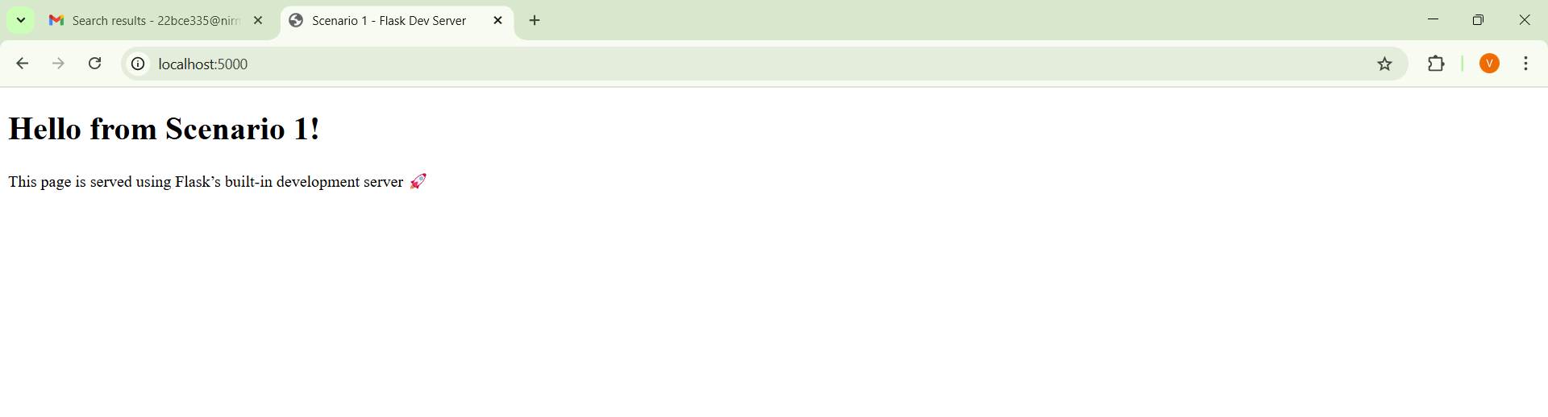

SCENARIO_2:

from flask import Flask, render_template
from waitress import serve

app=Flask(__name__)

@app.route("/")
def welcome_message():
return render_template("index.html")

if (__name__=="__main__"):
serve(app,host="0.0.0.0",port=5000)

#Note, the ip address of your laptop can be found using the ipconfig command on cmd, since it doesnt display the current IP

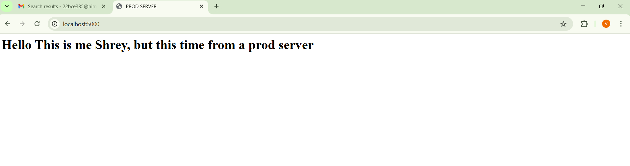

SCENARIO_3:

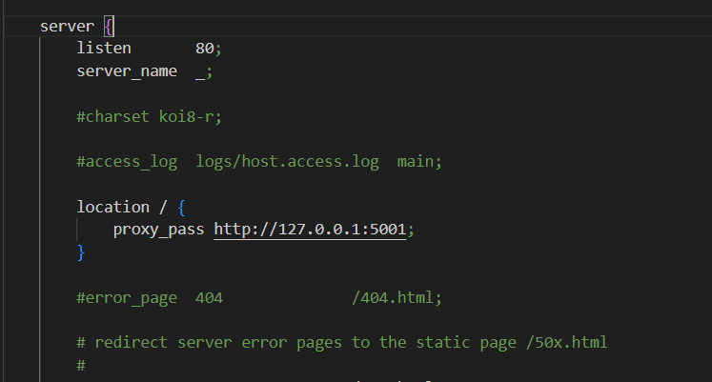
from flask import Flask, render_template
from waitress import serve

## REMEMBER THIS IS A NORMAL CASE OF NGINX - DEFAULT LISTENS ON 0.0.0.0 , YOU CAN HIT ON A PORT, AND MENTION PROXY PASSES ACCORDING TO THE ENDPOINTS
## THIS IS GOING TO BE A CASE WHERE DOMAIN NAMES ARE NOT USED YET, SO FOR LOCAL DEV IT CAN BE SET AS LOCALHOST AS SERVER_NAME IN NGINX CONF FILE
## OR IT CAN BE SET AS _, TO MATCH ALL THE DOMAIN NAMES AND ALLOW EVERYTHING

# Strange behaviour, when server_name localhost is applied and the port 80 is hit, it shouldnt be allowing to access the site from my phone, but it does allow, meaning it falls back to default server block for that port

app=Flask(__name__)

@app.route("/")
def welcome_message_from_prod_server():
print("The endpoint welcome message on the Prod Server has been hit.")

return render_template("index.html")

serve(app,host="127.0.0.1",port=5001)

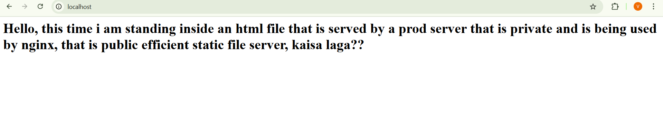

SCENARIO_4:
server {

#proxy_set_header Host $host; This is the only thing that is new.
listen 1400;
server_name my_site_1.com my_site_2.com;

#charset koi8-r;

#access_log logs/host.access.log main;

location / {
proxy_pass http://127.0.0.1:5005;
proxy_set_header Host $host;
}

from flask import Flask, render_template, request

from waitress import serve

app=Flask(__name__)

@app.route("/")
def my_thoughts_welcome_message():
if (request.host=="my_site_1.com"):
print("My_site_1_has_contacted")
return render_template("index.html")
if (request.host=="my_site_2.com"):
print("My_site_2_has_contacted")
return render_template("index.html")

return "Nothing found!!!!!!!"

if (__name__=="__main__"):
serve(app,host="127.0.0.1",port=5005)





SCENARIO_5:
server {

#proxy_set_header Host $host; This is the only thing that is new.
listen 1400;
server_name my_site_1.com;

#charset koi8-r;

#access_log logs/host.access.log main;

location / {
proxy_pass http://127.0.0.1:5006;
proxy_set_header Host $host;
}

server{
listen 1400;
server_name my_site_2.com;

location / {
proxy_pass http://127.0.0.1:5006;
proxy_set_header Host $host;
}
}

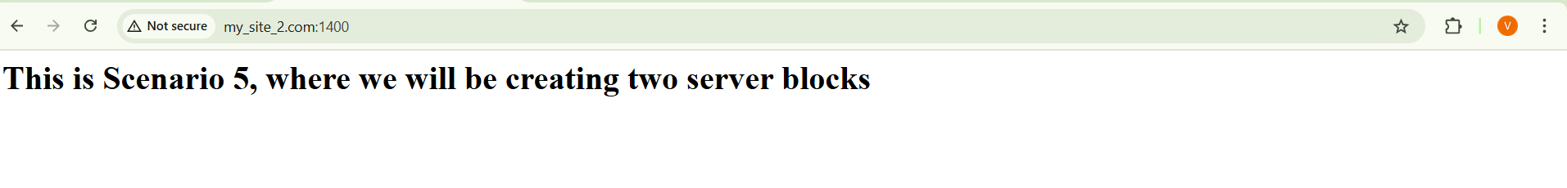


SCENARIO_6:
server {

#proxy_set_header Host $host; This is the only thing that is new.
listen 1400;
server_name my_site_1.com;

#charset koi8-r;

#access_log logs/host.access.log main;

location / {
proxy_pass http://127.0.0.1:5000;
}

server{
listen 1400;
server_name my_site_2.com;

location / {
proxy_pass http://127.0.0.1:5001;
}
}

from flask import Flask, render_template, request

from waitress import serve

app=Flask(__name__)

@app.route("/")
def welcome_mssg():
return render_template("index.html")

if(__name__=="__main__"):
serve(app,host="127.0.0.1",port=5000)

from flask import Flask, render_template, request

from waitress import serve

app=Flask(__name__)

@app.route("/")
def welcome_mssg():
return render_template("index2.html")

if(__name__=="__main__"):
serve(app,host="127.0.0.1",port=5001)



SCENARIO_7:
server{
listen 1400 default_server;
server_name _;
return 443;
}

server {

#proxy_set_header Host $host; This is the only thing that is new.
listen 1400;
server_name my_site_1.com;

#charset koi8-r;

#access_log logs/host.access.log main;

location / {
proxy_pass http://10.53.163.247:5001;
}

#error_page 404 /404.html;

# redirect server error pages to the static page /50x.html
#
error_page 500 502 503 504 /50x.html;
location = /50x.html {
root html;
}

# proxy the PHP scripts to Apache listening on 127.0.0.1:80
#
#location ~ \.php$ {
# proxy_pass http://127.0.0.1;
#}

# pass the PHP scripts to FastCGI server listening on 127.0.0.1:9000
#
#location ~ \.php$ {
# root html;
# fastcgi_pass 127.0.0.1:9000;
# fastcgi_index index.php;
# fastcgi_param SCRIPT_FILENAME /scripts$fastcgi_script_name;
# include fastcgi_params;
#}

# deny access to .htaccess files, if Apache's document root
# concurs with nginx's one
#
#location ~ /\.ht {
# deny all;
#}
}

server{
listen 1400;
server_name my_site_2.com;

location / {
proxy_pass http://10.53.163.45:5000;
}
}

server{
listen 1400;
server_name my_site_3.com;

location / {
proxy_pass http://10.53.163.154:5000;
}
}

SCENARIO_8:
server{
listen 1400 default_server;
ssl_certificate C:\Users\Dhwani\Desktop\Shrey\SEM-VII\MLOPs\Practicals\Deployment_Scenarios\Scenario_8\server.crt;
ssl_certificate_key C:\Users\Dhwani\Desktop\Shrey\SEM-VII\MLOPs\Practicals\Deployment_Scenarios\Scenario_8\server.key;
sl_protocols TLSv1.2 TLSv1.3;
ssl_ciphers HIGH;
server_name _;
return 443;
}

server {

#proxy_set_header Host $host; This is the only thing that is new.
listen 1400 ssl;

ssl_certificate C:\Users\Dhwani\Desktop\Shrey\SEM-VII\MLOPs\Practicals\Deployment_Scenarios\Scenario_8\server.crt;
ssl_certificate_key C:\Users\Dhwani\Desktop\Shrey\SEM-VII\MLOPs\Practicals\Deployment_Scenarios\Scenario_8\server.key;
ssl_protocols TLSv1.2 TLSv1.3;
ssl_ciphers HIGH;
server_name my_site_1.com;

#charset koi8-r;

#access_log logs/host.access.log main;

location / {
proxy_pass http://127.0.0.1:5000;
}

#error_page 404 /404.html;

# redirect server error pages to the static page /50x.html
#
error_page 500 502 503 504 /50x.html;
location = /50x.html {
root html;
}

# proxy the PHP scripts to Apache listening on 127.0.0.1:80
#
#location ~ \.php$ {
# proxy_pass http://127.0.0.1;
#}

# pass the PHP scripts to FastCGI server listening on 127.0.0.1:9000
#
#location ~ \.php$ {
# root html;
# fastcgi_pass 127.0.0.1:9000;
# fastcgi_index index.php;
# fastcgi_param SCRIPT_FILENAME /scripts$fastcgi_script_name;
# include fastcgi_params;
#}

# deny access to .htaccess files, if Apache's document root
# concurs with nginx's one
#
#location ~ /\.ht {
# deny all;
#}
}

server{
listen 1400 ssl;
ssl_certificate C:\Users\Dhwani\Desktop\Shrey\SEM-VII\MLOPs\Practicals\Deployment_Scenarios\Scenario_8\server.crt;
ssl_certificate_key C:\Users\Dhwani\Desktop\Shrey\SEM-VII\MLOPs\Practicals\Deployment_Scenarios\Scenario_8\server.key;
ssl_protocols TLSv1.2 TLSv1.3;
ssl_ciphers HIGH;
server_name my_site_2.com;

location / {
proxy_pass http://127.0.0.1:5001;
}
}


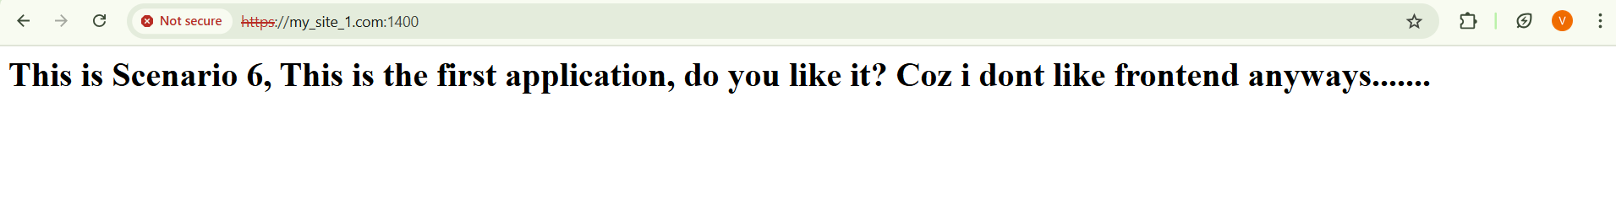

SCENARIO_9(NR):
SCENARIO_10:
location /static/ {
alias C:/Users/Dhwani/Desktop/Shrey/SEM-VII/MLOPs/Practicals/Deployment_Scenarios/Scenario_10/static/;
}

OR

location /static/ {
root C:/Users/Dhwani/Desktop/Shrey/SEM-VII/MLOPs/Practicals/Deployment_Scenarios/Scenario_10;
}

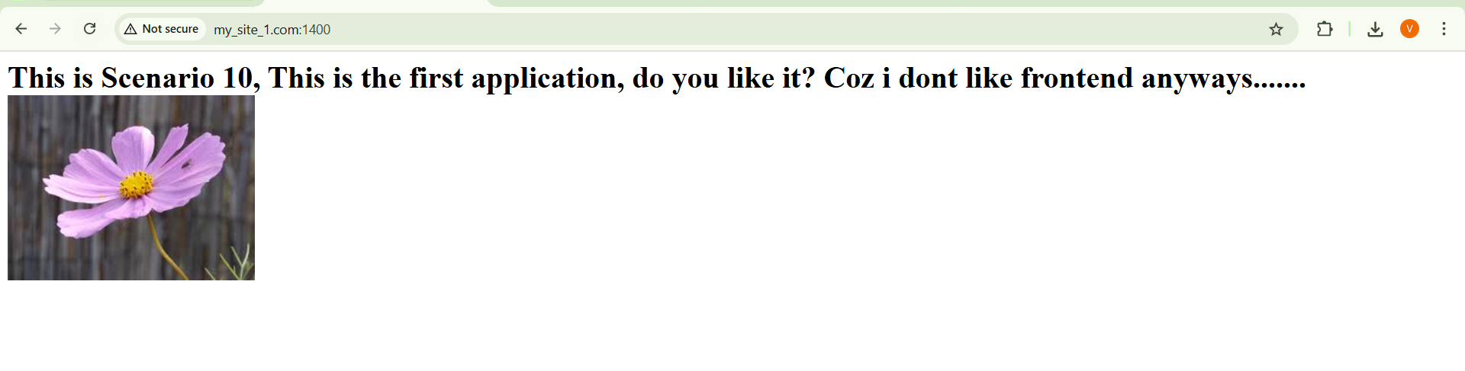
SCENARIO_11:
upstream my_waitress_servers{

ip_hash;
# least_conn;

server 10.65.49.45:5000;
server 10.65.49.154:5000;
server 127.0.0.1:5000;
}



Some of my extra notes for last min revesion hehe:
Development Server: Used during development for testing, debugging, and fast iteration. Focuses on speed, flexibility, and convenience. Supports auto reload so code changes apply immediately. Runs in debug mode with detailed error messages. Uses lightweight built-in development servers such as Flask app.run, Django runserver, or Node.js dev server. Provides detailed logs for debugging. Not meant to handle high traffic. Runs on localhost or a private IP. May include developer-only security features such as a debugger PIN.

Production Server: Used for real users in real environments. Focuses on stability, security, scalability, and performance. Uses proper servers such as NGINX or Apache along with WSGI or ASGI servers like Gunicorn, uWSGI, or Waitress. Optimized for high concurrency and traffic. Does not expose stack traces to users. Enforces security such as SSL or TLS, secure headers, and firewalls. Includes monitoring, logging, backups, and reliability measures. Runs on a public IP or domain and must remain reliably available.

IP Address Notes: 127.0.0.1 refers to the local device. 0.0.0.0 binds the server to all available network interfaces and allows access from external devices. Inbound firewall rules determine which IP addresses are allowed to access the server.

NGINX Notes: To kill all NGINX processes in Windows use: taskkill /F /IM nginx.exe /T. /F forces termination. /IM specifies the process name. /T kills child processes too. If multiple server blocks exist on the same port and the request does not match any domain name, NGINX selects and uses the first server block by default.

SSL and Certificate Notes: OpenSSL can be used locally to generate certificates for HTTPS. The process includes generating a private key (commonly a 2048 bit RSA key), creating a certificate signing request with domain information, and signing it. Production environments normally require a trusted certificate authority, but development environments can use self-signed certificates.

Load Balancing with NGINX: Use an upstream block to define multiple backend servers with their IP addresses or ports. Use the server directive for each backend entry. Optional features such as ip_hash can be used to create sticky sessions based on client IP.

