**Exercise-7 Financial Forecasting.**

* **Concept of recursion and how it can simplify certain problems:** Recursion is a programming technique where a function calls itself to solve a problem by breaking it down into smaller, more manageable subproblems. The function continues to call itself with modified inputs until it reaches a base case, which is a simple scenario that can be solved directly without further recursion.
* Key components of recursion:
* **Base case:** The condition that stops the recursion
* **Recursive case:** The part where the function calls itself with a modified input
* **How recursion simplifies problems:**

1. **Divide and Conquer:** Recursion allows us to break down complex problems into smaller, more manageable subproblems. This approach can make solving certain types of problems more intuitive and easier to understand.
2. **Elegant Solutions:** For some problems, recursive solutions can be much more concise and elegant than their iterative counterparts. This often leads to cleaner, more readable code.
3. **Natural fit for certain problems:** Some problems have a naturally recursive structure, such as tree traversals, fractals, or certain mathematical functions (e.g., factorial, Fibonacci sequence).
4. **Avoiding complex loop structures:** Recursion can sometimes eliminate the need for complex nested loops or intricate iterative logic.
5. **Backtracking algorithms:** Recursion is particularly useful in backtracking algorithms, where we need to explore multiple possibilities and undo choices**.**

This recursive solution is more concise and arguably more intuitive than an iterative approach using loops. However, it's important to note that while recursion can simplify certain problems, it's not always the most efficient solution. Recursive calls can consume more memory and potentially lead to stack overflow errors for very large inputs. In practice, the choice between recursive and iterative solutions often depends on the specific problem, performance requirements, and readability considerations.

* **Implementation process:**

The program is implemented using four main classes:

* ***FinancialForecasting*:** The main class that initializes the *UserInterface*.
* ***UserInterface*:** Manages user interactions and program flow.
* Implements a recursive menu system (*runMenu* method).
* Handles user input and delegates tasks to other classes.
* ***DataStorage*:** Manages data storage and retrieval.
* Uses *ArrayLists* to store values and growth rates.
* Implements recursive data display (*displayDataRecursive* method).
* ***ForecastCalculator*:** Performs financial calculations.
* Implements recursive future value calculation (*calculateFutureValueRecursive* method).
* Includes a recursive total growth calculation (*calculateTotalGrowthRecursive* method).
* 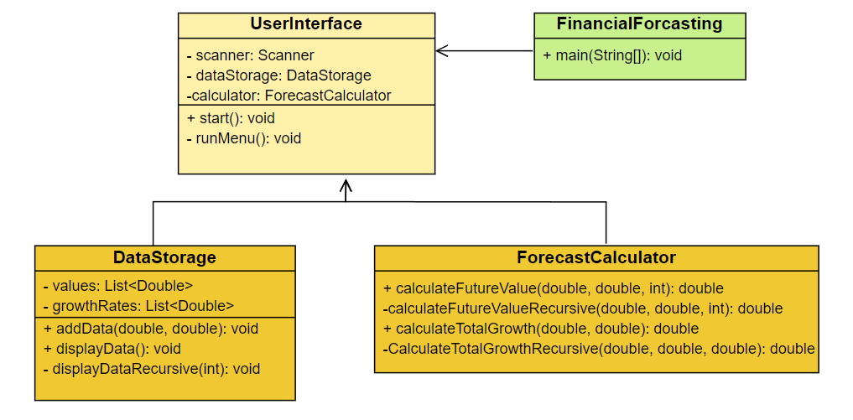**Class Diagram**
* **Class Diagram Explanation**
* ***FinancialForecasting:***
* This is the main class of the program.
* It has a single public static method: main(String[]).
* It's responsible for initializing the UserInterface.
* ***UserInterface :***
* This class manages user interactions and program flow.
* It has private fields:

1. **scanner**: Scanner - for user input
2. **dataStorage**: *DataStorage* - to manage data
3. **calculator**: *ForecastCalculator* - for calculations

* Key methods include:

1. **start():** void - initiates the program
2. **runMenu():** void - implements the recursive menu system

It interacts with both *DataStorage* and *ForecastCalculator*.

* ***DataStorage***:
* Manages the storage and retrieval of financial data
* Private fields:

1. *values*: List<Double> - stores initial values
2. *growthRates*: List<Double> - stores growth rates

* Key methods:

1. *addData(double, double):* void - adds new data
2. *displayData():* void - shows stored data
3. *displayDataRecursive(int):* void - recursive helper for display

* **ForecastCalculator**
* Performs financial calculations.
* Key methods:

1. *calculateFutureValue(double, double, int):* double - calculates future value
2. *calculateFutureValueRecursive(double, double, int):* double - recursive helper
3. *calculateTotalGrowth(double, double):* double - calculates total growth
4. *calculateTotalGrowthRecursive(double, double, double):* double - recursive helper

The arrows in the diagram show dependencies between classes. *UserInterface* depends on both *DataStorage* and *ForecastCalculator*, while *FinancialForecasting* only directly interacts with *UserInterface*.

**Time Complexity Analysis:**

a) **Menu System (UserInterface):**

* Time Complexity: O(n), where n is the number of menu interactions.
* Each menu interaction is O(1), but the recursion depth depends on how many times the user interacts with the menu.

b) **Data Display (DataStorage):**

* Time Complexity: O(n), where n is the number of stored data points.
* The displayDataRecursive method visits each data point once.

c**) Future Value Calculation (ForecastCalculator):**

* Time Complexity: O(n), where n is the number of years.
* The calculateFutureValueRecursive method makes n recursive calls, one for each year.

d) **Total Growth Calculation (ForecastCalculator):**

* Time Complexity: O(n), where n is proportional to the difference between the initial and target values.
* The number of recursive calls depends on how many 1% increments are needed to reach the target value.

Through this Financial Forecasting program, we can draw several important conclusions:

1. **Modular Design**: The program demonstrates the benefits of a modular design. By separating concerns into different classes (user interface, data storage, calculations), we create a more maintainable and extensible codebase.
2. **Recursive Problem Solving**: The program showcases how recursion can be applied to various aspects of software development, from user interfaces (menu system) to data processing (displaying data) and complex calculations (future value and total growth).
3. **Trade-offs in Recursive Solutions:** While recursion often leads to elegant and intuitive solutions, it also comes with potential drawbacks like increased memory usage and the risk of stack overflow for large inputs. This highlights the importance of considering optimization techniques.
4. **Flexibility in Financial Modeling**: The program provides a flexible framework for financial forecasting, allowing users to input various scenarios and calculate future values based on different growth rates.
5. **Data Management**: The DataStorage class shows how to manage and display data efficiently, illustrating basic principles of data structures.
6. **Algorithmic Complexity**: The time complexity analysis of the recursive algorithms (O(n) for most operations) demonstrates the importance of understanding algorithm efficiency, especially when dealing with potentially large datasets or long time horizons in financial forecasting.
7. **Optimization Opportunities**: The discussion on optimizations (memoization, tail recursion, iterative solutions) highlights the importance of continual improvement in software development, especially when dealing with computationally intensive tasks.
8. **Real-world Application**: This program serves as a practical example of how programming concepts (recursion, data structures, algorithms) can be applied to solve real-world problems in finance.

In conclusion, this Financial Forecasting program not only serves its primary purpose of performing financial calculations but also demonstrates key software development principles, the practical application of recursion, and the importance of considering both elegance and efficiency in algorithm design.

**The output of the program**

* 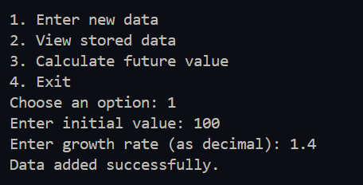Adding value and the growth rate
* 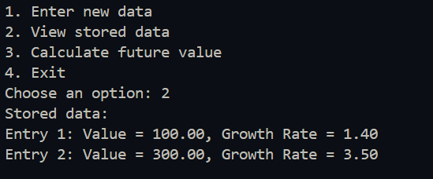View the values which are stored in the past

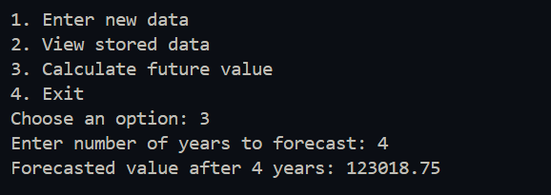

* Calculate the future values from the data