**Exercise 7: Packages**

* **Scenario 1:** Group all customer-related procedures and functions into a package.
* **Question:** Create a package ***CustomerManagement*** with procedures for adding a new customer, updating customer details, and a function to get customer balance.
* **Package Specification**: Defines the *CustomerManagement* package with procedures for adding and updating customers, and a function to get customer balance.
* **Package Body**: Implements the procedures to insert and update records in the *Customers* table, and the function to retrieve the balance.
* **Testing Procedures**: Executes PL/SQL blocks to test the *AddCustomer*, *UpdateCustomer*, and *GetCustomerBalance* methods.
* **Verification**: Outputs success messages and queries the Customers table to confirm the correct data modifications.

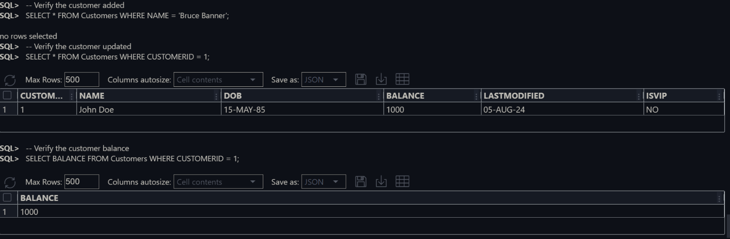Here is the Output of the code:

* **Scenario 2:** Create a package to manage employee data.
* **Question:** Write a package ***EmployeeManagement*** with procedures to hire new employees, update employee details, and a function to calculate annual salary.
* **Package Specification**: Defines the *EmployeeManagement* package with procedures for hiring and updating employees, and a function to calculate annual salary.
* **HireEmployee Procedure**: Implements the procedure to insert a new employee record into the *Employees* table.
* **UpdateEmployee Procedure**: Implements the procedure to update an existing employee's details in the *Employees* table.
* **CalculateAnnualSalary Function**: Implements the function to retrieve an employee's monthly salary and calculate the annual salary.
* **Testing Procedures**: Executes PL/SQL blocks to test the *HireEmployee*, *UpdateEmployee*, and *CalculateAnnualSalary* methods, outputting success messages and querying the Employees table to verify correct data modifications.

Here is the Output of the code:

* 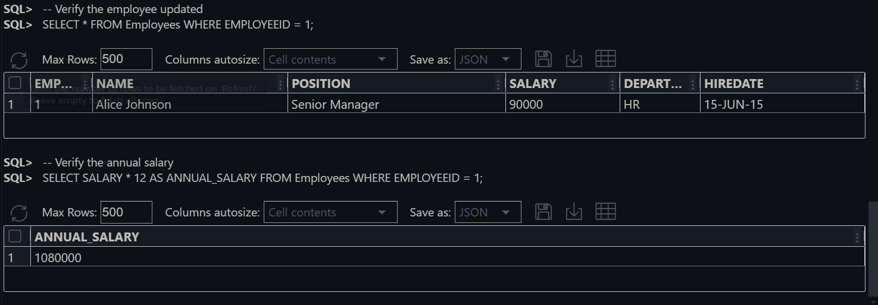**Scenario 3:** Group all account-related operations into a package.
* **Question:** Create a package ***AccountOperations*** with procedures for opening a new account, closing an account, and a function to get the total balance of a customer across all accounts.
* **Package Specification**: Defines the *AccountOperations* package with procedures for opening and closing accounts, and a function to get a customer's total balance across all accounts.
* **OpenAccount Procedure**: Implements the procedure to insert a new account record into the *Accounts* table.
* **CloseAccount Procedure**: Implements the procedure to delete an account record from the *Accounts* table.
* **GetTotalBalance Function**: Implements the function to calculate and return the total balance of a customer across all their accounts.

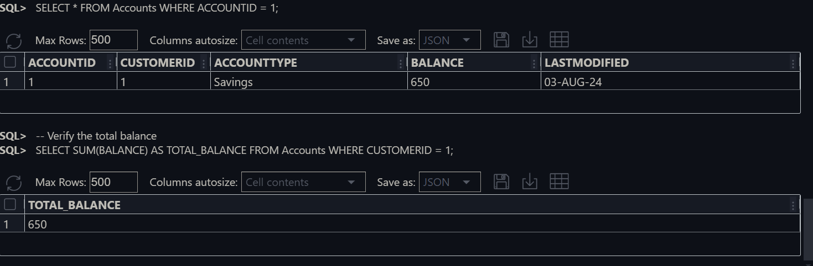Here is the output of the code: