**Functional Requirement Document for EMI CALCULATOR**

**Contents:**

1. Introduction 3
   1. Purpose 3
   2. Intended Audience 3
2. Functional Requirements 3
   1. Home Page 3
   2. Calculator Tabs 4
   3. EMI Calculation Functionality 5
   4. Result Display and Chart Visualization 5
   5. Responsiveness 6
3. Summary 6

**1. Introduction:**

The Functional Requirement Document (FRD) provides a detailed description of the functionality and behavior of the EMI Calculator web application. This document serves as a guide for the development team, testers, and stakeholders to understand how the system behaves and what users can expect.

**1.1 Purpose:**

The purpose of this document is to specify the functional requirements for a responsive and user-friendly EMI Calculator that allows users to calculate Equated Monthly Installments (EMI) for Personal, Home, and Car loans. The application computes EMI based on user input and provides a visual representation of principal and interest components.

**1.2 Intended Audience:**

* Development Team
* QA Team
* Business Analyst
* DB Team

**2. Functional Requirements:**

When the user types the URL <https://hyperstrom.github.io/EMI_Calculation/> it should navigate to the Home page of EMI Calculator website.

**2.1 Home Page:**

When the user opens the EMI Calculator website, the landing page displays the following sections:

* A header containing the logo and the application title “EMI Calculator.”
* A tab section with three clearly defined tabs:
  + Personal
  + Home
  + Car

Each tab corresponds to a different loan type, and clicking on a tab, switches the content displayed on the page accordingly.

(Home page screen is shown in the **Figure 1.1)**

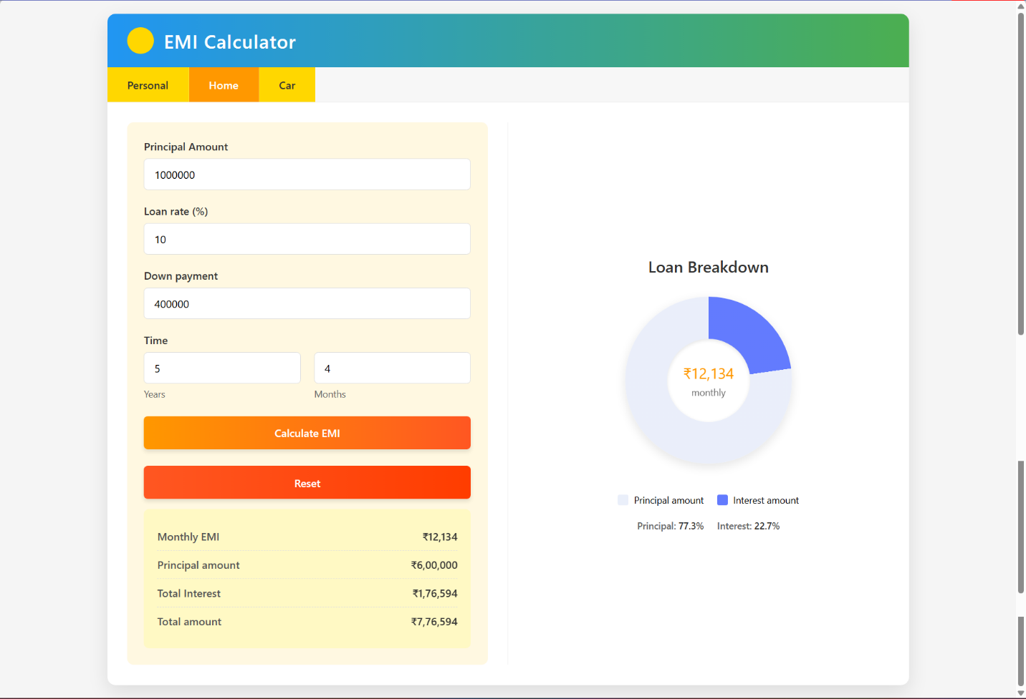

**Figure 1.1**

**2.2 Calculator Tabs:**

* Each tab should open a specific loan type calculator. All calculators should consist of:
  + Input fields:  
     - Principal Amount (required)  
     - Interest Rate (with min and max bounds depending on loan type)  
     - Loan Duration (Years and Months)  
     - Down Payment (only for Home and Car loans)
  + Action Buttons:  
     - Calculate EMI  
     - Reset
* Input validation should be implemented with specific messages for invalid inputs or exceeded time limits as shown below:

|  |  |  |  |
| --- | --- | --- | --- |
| **Input Field** | **Loan Type(s)** | **Validation Rules** | **Error Message** |
| **Principal Amount** | All (Personal, Home, Car) | * Must be a number * Must be > 0 | Principal must be greater than 0. |
| **Rate of Interest** | Personal | * Must be between 15% and 25% | Rate must be between 15% and 25%. |
| Home | * Must be between 10% and 15% | Rate must be between 10% and 15%. |
| Car | * Must be between 10% and 25% | Rate must be between 10% and 25%. |
| **Down Payment** | Home, Car | * Must be ≥ 0 * Must be ≤ Principal Amount | Down payment must be ≥ 0 and ≤ Principal amount. |
| **Years** | All | * Must be ≥ 0 (integer only) | Years of loan must be greater than or equal to 0. |
| **Months** | All | * Must be between 0 and 11 * If years = 0, months ≠ 0 | Months must be between 0 and 11.  If years is 0, months cannot also be 0. |
| **Loan Tenure** | Personal | * Max = 120 months (10 years) | Personal loan period cannot exceed 10 years. |
| Home | * Max = 360 months (30 years) | Home loan period cannot exceed 30 years. |
| Car | * Max = 84 months (7 years) | Car loan period cannot exceed 7 years. |

**2.3** **EMI Calculation Functionality:**

* On clicking the Calculate button, the application validates all inputs.
* EMI is calculated using the standard formula for fixed-rate loans.

Upon clicking **"Calculate EMI"**, the following logic is executed:

* **Loan Amount** = Principal − Down Payment (if applicable)
* **Monthly Rate** = (Annual Rate / 12) / 100
* **Total Months** = (Years × 12) + Months
* **EMI** = P × R × ( 1 + R )N / ( 1 + R )N − 1

Where:

P = Principal

R = Monthly Interest Rate

N = Number of Monthly Installments

* The output includes:  
   - Monthly EMI  
   - Principal Amount  
   - Total Interest Payable  
   - Total Amount Payable
* If invalid data is provided or required fields are empty, proper error messages are shown.

**2.4 Result Display and Chart Visualization:**

* The right section of the page shows the Loan Breakdown visualization.
* A dynamic donut-style pie chart shows the proportion of the principal and interest.
* The monthly EMI amount is shown at the center of the chart.
* The percentage split of principal and interest is displayed under the chart.

**2.5 Responsiveness**

* The layout is responsive and adapts to various screen sizes.
* On smaller devices, tabs stack vertically.
* Inputs are keyboard accessible.
* Placeholder texts and validation messages support clarity.

**3.1 Summary**

The EMI Calculator web application is a single-page, user-friendly interface for performing EMI-related computations. It incorporates robust input validation, tab-wise segmentation, and dynamic visual feedback to enhance usability and user engagement. This document shall serve as the primary reference for building, testing, and validating the EMI Calculator.