**NATIONAL UNIVERSITY OF COMPUTER AND EMERGING SCIENCES-FAST**

**KARACHI CAMPUS**



**COURSE INSTRUCTORS:**  
**Sir Danish Khan**

**Miss Erum Shaheen**

**DATABASE SYSTEMS**

**PROJECT REPORT**

**TECHNO CITY**

**(ELECTRONIC ITEMS MARKET VIEWER SYSTEM)**

**SECTION: BCS-6A**

**GROUP MEMBERS:**

**Shahzaib Khan (19K-0273)**

**Muhammad Ahmed (19K-1282)**

**Shahnawaz Farman (19K-1456)**

# PROJECT DESCRIPTION:

Our project is based on a scalable idea for capturing market trends by generating a grand view of product ranges present in the market (DBMS). Customer can easily view all the products present in any shop of the market. Whereas the sellers (product vendors) and companies can use customer’s views in order to induce trends to boost their sales accordingly.

# PROJECT BACK-GROUND & INSPIRATION:

We (customers) usually have to visit different electronic markets for searching a single product for a good price. Customers also needs to know the market trend in order to make a good decision and same goes for sellers and companies to know which product has more demand. So, our project is based on a website along with SQL database to store the product information, from where customers can get details.

# ER-DIAGRAM:

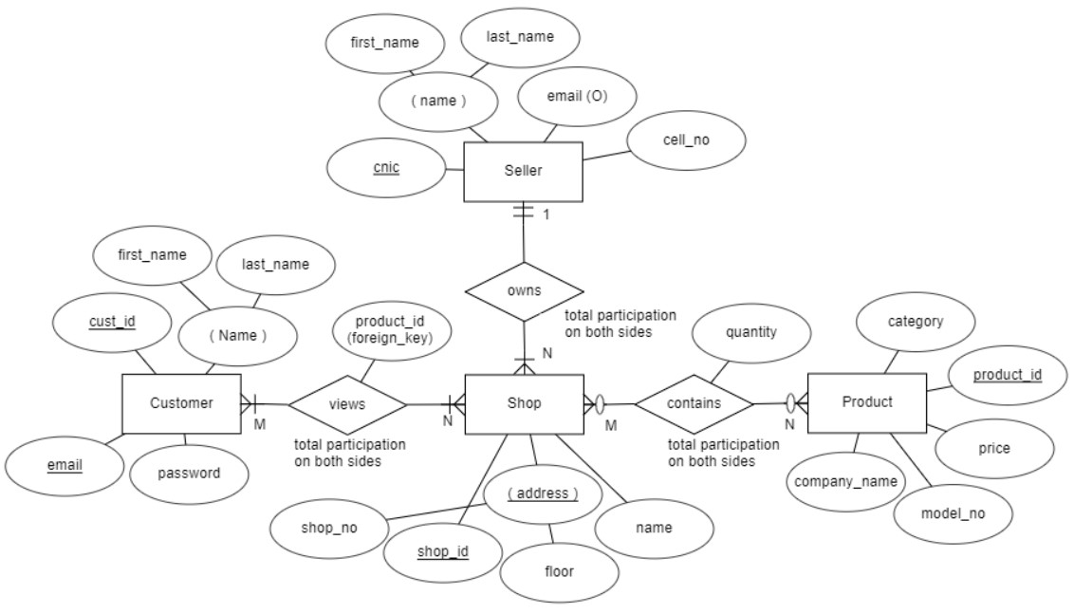

**PROJECT SNAPSHOTS & CODE BREAK-DOWN:**

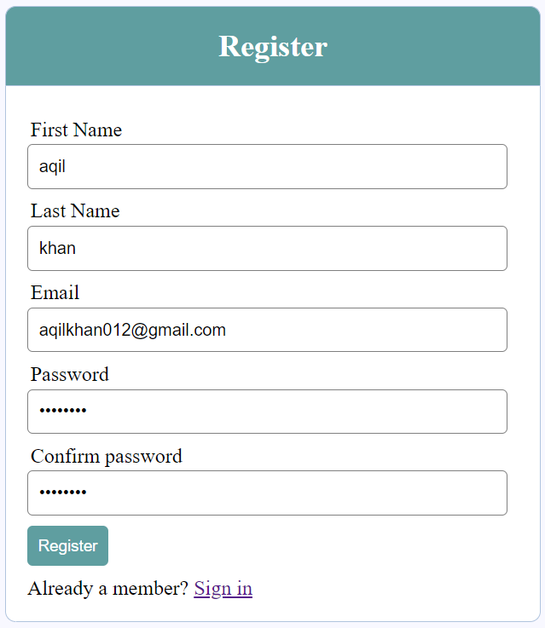

In this menu, if a customer is a new member, then he has to register first. The Information will be stored in Customer Table.

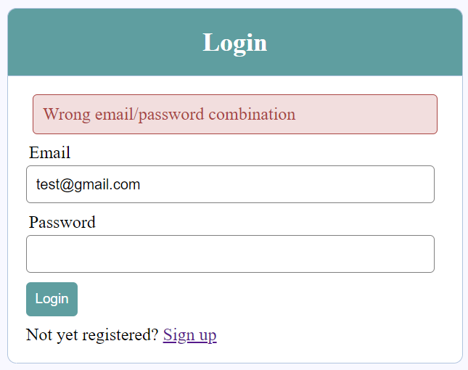

In this menu, if a customer is an existing member, then he can directly login into website. The Information will be verified from Customer Table.

**NOTE**: If the visitor/customer enters wrong info in any menu, it will be validated. So, that DBMS doesn’t have to handle it all by itself.

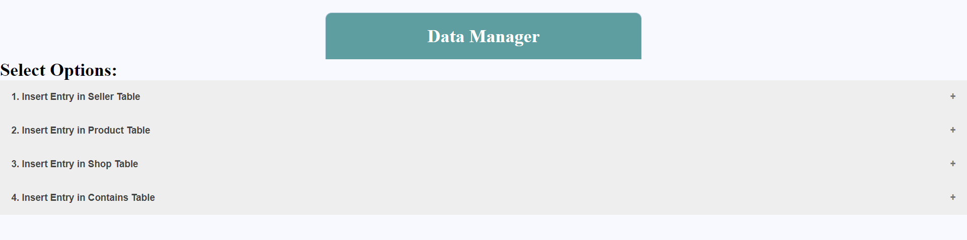

In this menu, only admin can insert data about Shops, their Owners and the Product ranges they have. The data is taken from fields and then back-end validates each field of the form. Afterwards, we verify the existing entity tuple in its respective table. And then finally, it inserts the data into that table if there are no errors.

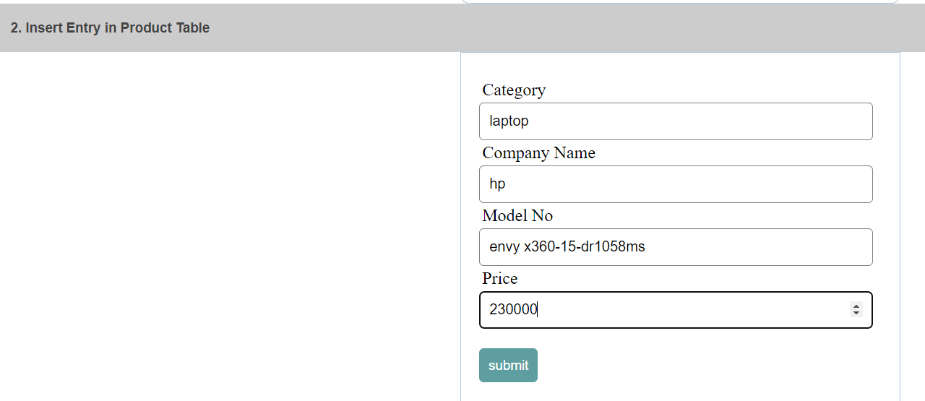

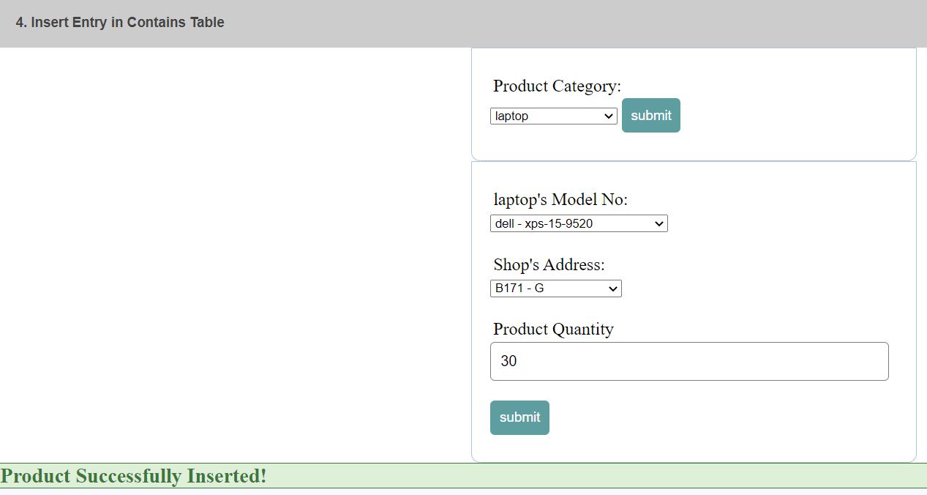

**NOTE**: In this menu, some tables also maintain foreign-key attributes. From above pic, we can see that ‘Contains’ Table is referring to the existing shops from ‘Shop’ table and their product ranges from Product table. And, based on this relation, we can easily mention or view any product’s quantity in that particular shop.