Software Design Specifications

POS Cashier System

Version: 01.00

Project/Course Code | CS3009
Supervisor | Miss Syeda Rubab Jaffar
Co Supervisor | N/A
Project Team | - Ahmed Sultan (21K-4938)  - Shahzaib Khan (19K-0273)
Submission Date | 28th July, 2024

Document History

Version | Name of Person | Date | Description of change
1.0 | Ahmed Sultan | 21/07/2024 | Document Created
1.0 | Ahmed Sultan | 21/07/2024 | Added Introduction & Design Considerations Sections
1.0 | Shahzaib Khan | 22/07/2024 | Added Class Diagram & Design Strategy Section
1.0 | Ahmed Sultan | 22/07/2024 | Completed Detailed System Design Section
1.0 | Shahzaib Khan | 23/07/2024 | Updated Design Strategy Section
1.0 | Shahzaib Khan | 24/07/2024 | Document Finalized

Distribution List

Name | Role
Miss Syeda Rubab Jaffar | Supervisor

Document Sign-Off

Version | Sign-off Authority | Project Role | Signature | Sign-off Date
1.0 | Ahmed Sultan | Group/Project Leader | N/A | 28/07/2024

Document Information

Category | Information
Customer | FAST-NU
Project | POS Cashier System
Document | Software Design Specification
Document Version | 1.0
Status | Final Draft
Author(s) | Ahmed Sultan, Shahzaib Khan
Approver(s) | Miss Syeda Rubab Jaffar
Issue Date | 28th July, 2024
Document Location | GCR (Google Classroom)
Distribution | Course Teacher

Definition of Terms, Acronyms and Abbreviations
[This section should provide the definitions of all terms, acronyms, and abbreviations required to interpret the terms used in the document properly. ]

Term | Description
ER | Entity Relationship
DD | Design Specification
POS | Point of Sales
HR | Human Resources
N/A | Not Applicable

Table of Contents

1 Introduction 5
1.1 Purpose of Document 5
1.2 Intended Audience 5
1.3 Document Convention 5
1.4 Project Overview 5
1.5 Scope 5
2 Design Considerations 6
2.1 Assumptions and Dependencies 6
2.1.1 Assumptions 6
2.1.2 Dependencies 6
2.2 Risks and Volatile Areas 6
2.2.1 Risks 6
2.2.2 Volatile Areas 6
3 System Architecture 7
3.1 System Level Architecture 7
3.2 Software Architecture [Class Diagram] 7
4 Design Strategy 8
5 Detailed System Design 9
5.1 Database Design 9
5.1.1 ER Diagram 9
5.1.2 Data Dictionary 10
5.2 Application Design 17
5.2.1 Sequence Diagram [Behavioral Model] 17
5.2.2 State Diagram 18
6 References 18
7 Appendices 18

Introduction

Purpose of Document
The purpose of this document is to provide a comprehensive overview of the POS (Point of Sale) Cashier System. It outlines the system's functionality, features, and requirements, ensuring a clear understanding of its operations and benefits. This document serves as a guide for developers, stakeholders, and end-users, detailing the design, implementation, and usage of the system to facilitate efficient and effective transaction management in retail environments.

For this Project, we have chosen structural design methodology for simplicity & time efficiency.

Intended Audience
This document is intended to be used by people who are involved in the creation of this project and its evaluation, namely team members and course instructor.

Document Convention
- Bold arial font, size 16 for headings
- Italic bold arial font, size 14 for sub-headings
- Arial font, size 12 for paragraphs

Project Overview
The POS Cashier System is a software application designed to streamline and manage retail transactions efficiently. It functions by processing sales, handling payments, managing inventory, and monitoring sales. The system typically includes features such as barcode searching & scanning, and receipt printing. The basic design approach involves a user-friendly interface for cashiers, and a robust backend for data management. By using Agile process for development, we will also ensure to incorporate user feedback to enhance functionality and usability, ensuring the system meets the dynamic needs of retail operations.

Scope
The POS cashier system requires employees to log in. Upon successful login, the system verifies the credentials and checks the employee's role, categorizing them as an admin, HR, or cashier. Admins have access to all pages, including employee, POS, transaction history, product, and customer pages. HR personnel can only access the employee page, while cashiers are restricted to the POS page. On the employee and product pages, there are tables for viewing, adding, editing, and deleting entries. The transaction page allows users to view and delete transactions. In the POS page, employees can input barcodes to add products to a cart, and the bill updates accordingly. Upon completing the transaction, employees need to enter customer details such as name, number, payment type, and amount.

Design Considerations

Assumptions and Dependencies

Assumptions
- The system will operate on hardware that meets the specified technical requirements.
- Users of the system have basic computer literacy and have received adequate training.
- The network infrastructure in the retail environment is reliable and secure.

Dependencies
- Compliance with relevant financial and data protection regulations.
- Availability of compatible peripheral devices such as barcode scanners, receipt printers, and cash drawers.

Risks and Volatile Areas

Risks
- Hardware Failures: Malfunctioning of POS devices, scanners, printers, or network equipment can disrupt operations.
- Data Breaches: Unauthorized access to sensitive customer and transaction data.

Volatile Areas
- Scalability: Ensuring the system can handle varying transaction volumes during peak times.
- Customer Support: Providing consistent and timely support to address any issues or queries from users.

System Architecture

System Level Architecture
N/A (since Component & Interface diagrams are not in syllabus)

Software Architecture [Class Diagram]
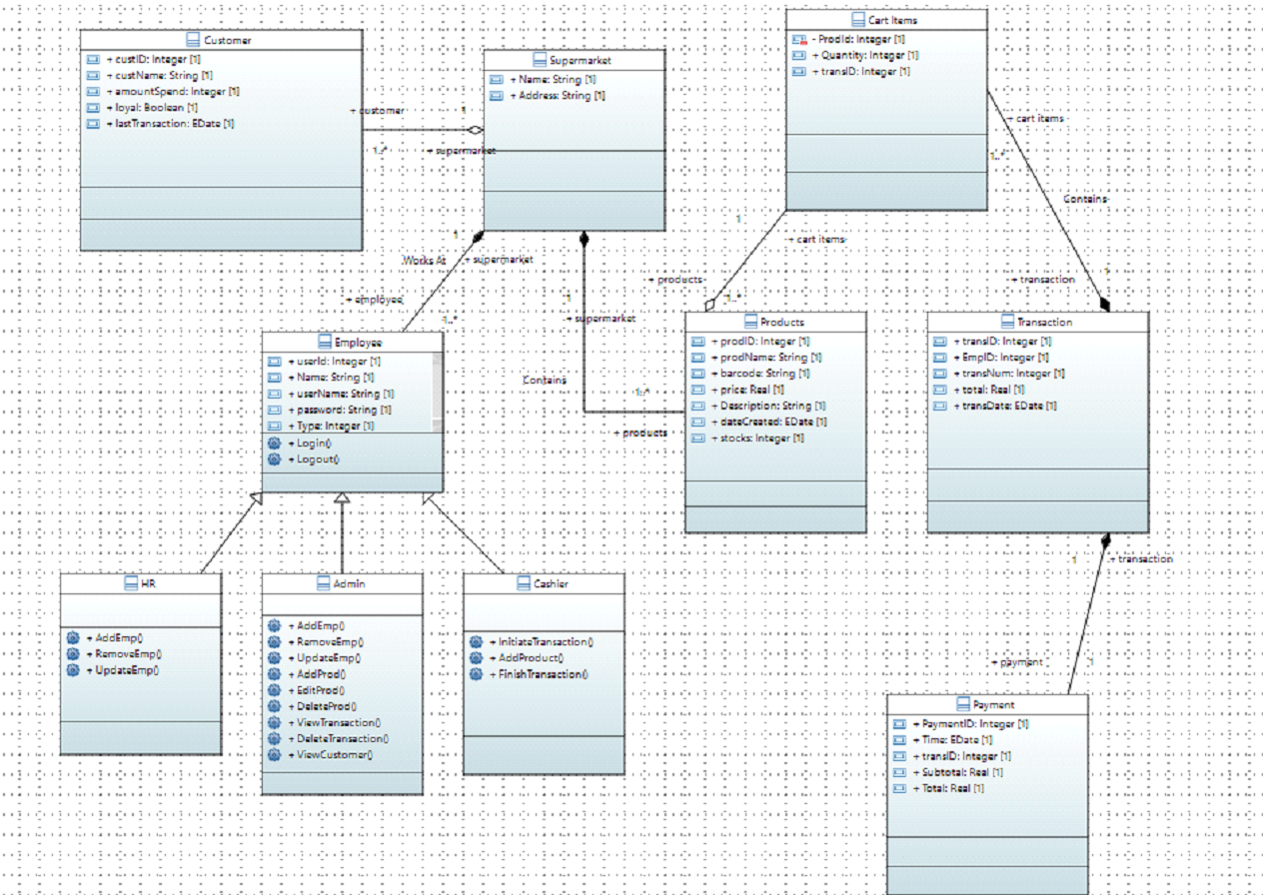

Design Strategy
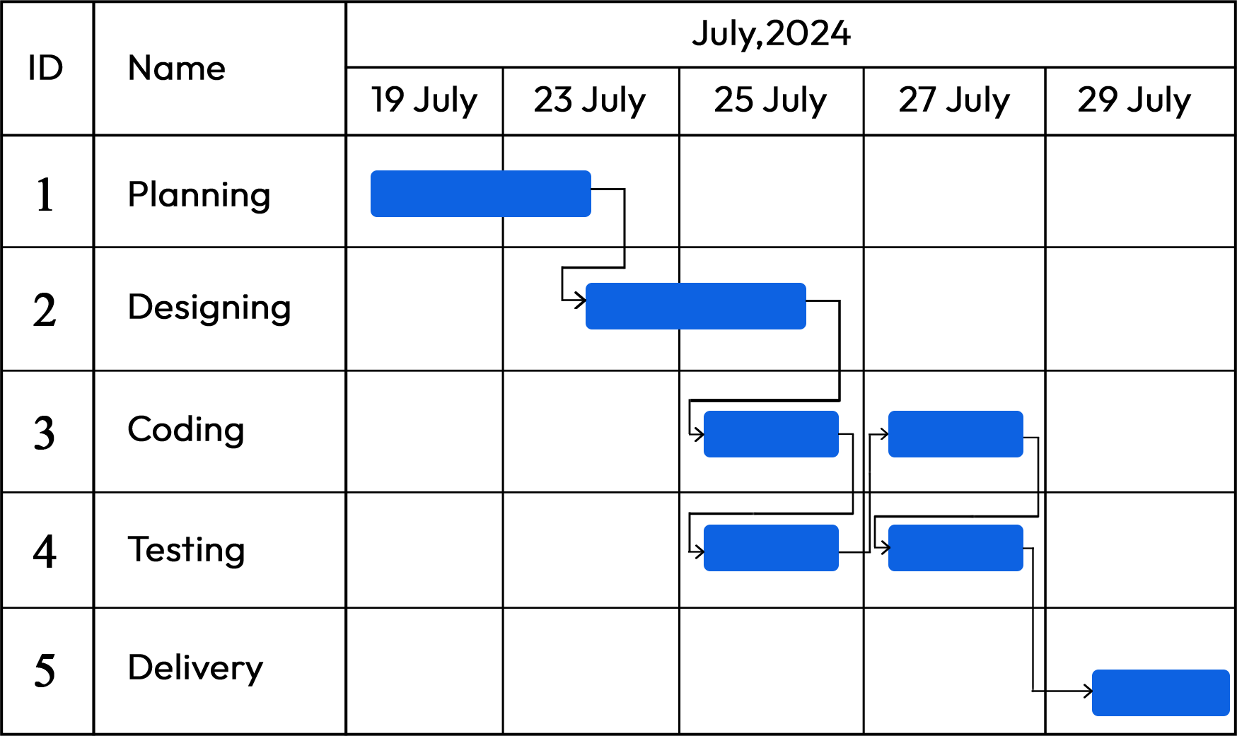

During the first 4 days, we collected the information related to our project and problem statement and designed a proposal which work as a groundwork of what our project will do and what technology will be used. Then the next 2 days diagrams were generated to get an idea of how our system will interact with different hardware, software and its user and what features it will provide. Next 2-3 days was the largest phase of coding where we setup work environments and database were built and connected using API to the frontend, testing was done simultaneously with coding where we used dummy data to test the code and debugged any errors and then the project was delivered.

Detailed System Design

Database Design

ER Diagram
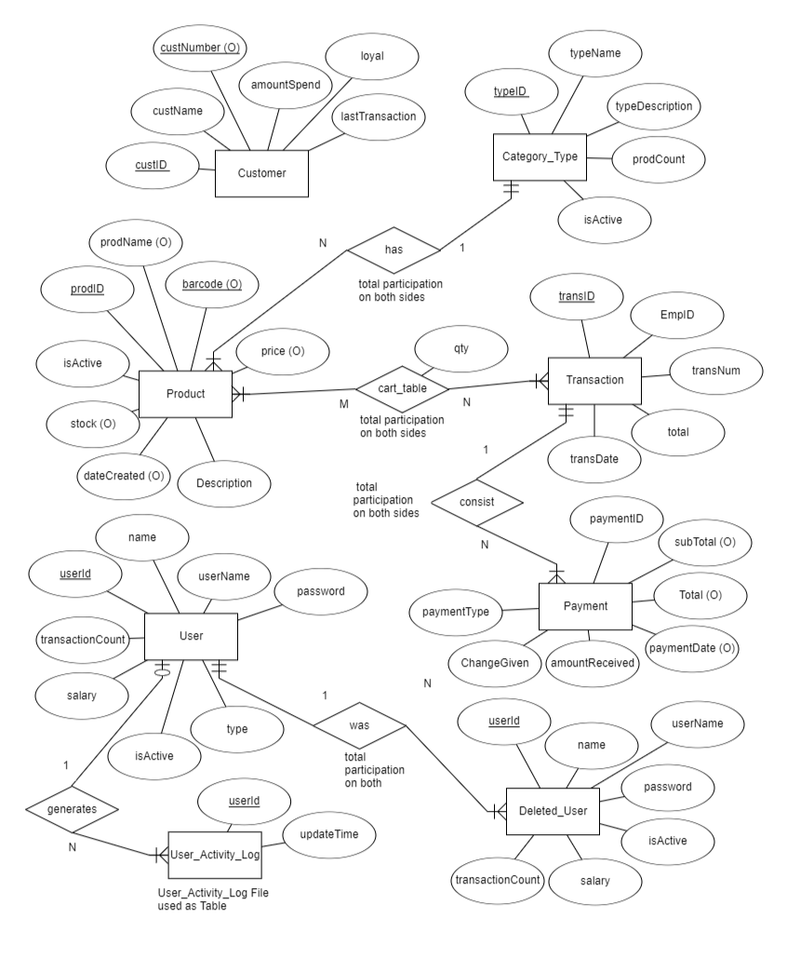

Data Dictionary

< Data 1>
Name |  | carttable
Alias |  | N/A
Where-used/how-used/ COntent Description |  | used in the POS section of the website where the transactions are recorded
Column Name | Description |  | Type | Length | Null able | Default Value | Key Type
TransID | ID of transacrtion |  | Integer | 11 bytes | No | None | PK
ProductID | Unique ID of product |  | Integer | 11 bytes | No | None
qty |  |  | Integer | 11 bytes | No | None

< Data 2>
Name |  | Customer
Alias |  | N/A
Where-used/how-used/ COntent Description |  | this is used in the pos section of the website when the customer details will be entered in order to make a transaction
Column Name | Description |  | Type | Length | Null able | Default Value | Key Type
custID | Unique ID of Customer |  | Integer | 11 bytes | No | None | PK
custName | Name of Customer |  | varchar | 255 bytes | No | None
custNumber | Phone Number of customer |  | varchar | 255 bytes | No | None
amountSpend | amount that is spent by the customer |  | varchar | 255 bytes | No
lastTransaction | date and time of the last transaction |  | datetime |  | No | Current_timestamp()

< Data 3>
Name |  | DeletedUsers
Alias |  | N/A
Where-used/how-used/ COntent Description |  | The users that were deleted will be shown in the employees section in the “EX employees data” section of the website
Column Name | Description |  | Type | Length | Null able | Default Value | Key Type
userID | Unique ID of user |  | Integer | 11 bytes | No | None
name | Name of user |  | varchar | 100 bytes | No | None
userName | username given to the user |  | varchar | 100 bytes | No | None
password | password of the user |  | varchar | 255 bytes | No | None
Type | what is the position of the user (HR,Cashier,  Admin) |  | integer | 11 bytes | No | None
isActive |  |  | tinyint | 1 byte | No | None
salary | salary of the user |  | varchar | 255 bytes | No | None
transactionCount | how many transactions have been done. |  | integer | 11 bytes | No | None

< Data 4>
Name |  | payment
Alias |  | N/A
Where-used/how-used/ COntent Description |  | when the payment will be made in the pos section the details will be recorded in the transactions section of the website
Column Name | Description |  | Type | Length | Null able | Default Value | Key Type
paymentID | the id of the payment of the transaction |  | Integer | 11 bytes | No | None | PK
transID | id of the transaction |  | Integer | 11 bytes | Yes | NULL
subTotal | sub total amoun t of the items without tax |  | varchar | 255 bytes | Yes | NULL
Total | total amount with tax addition |  | varchar | 255 bytes | Yes | NULL
paymentDate | Date of the payment of the transaction |  | date |  | Yes | current_timestamp()
amountReceived | payment amount received by the customer |  | varchar | 255 byte | No | None
ChangeGiven | the change given to the customer byu the cashier |  | varchar | 255 bytes | No | None
paymentType | type of payment either cash or credit |  | integer | 2 bytes | No | None

< Data 5>
Name |  | products
Alias |  | N/A
Where-used/how-used/ COntent Description |  | The detailed information of the products that can/will be added in or deleted from the products section of the website
Column Name | Description |  | Type | Length | Null able | Default Value | Key Type
prodID | the id of the product |  | Integer | 11 bytes | No | None | PK
prodName | Name of the product |  | varchar | 100 bytes | Yes | NULL
price | Price of the product |  | varchar | 100 bytes | Yes | NULL
Description | Description of the product |  | varchar | 110 bytes | No | None
dateCreated | Creation date of the product |  | date |  | Yes | Current_timestamp()
stocks | How much product is there |  | integer | 11 byte | Yes | NULL
barcode | barcode of the product |  | varchar | 110 bytes | Yes | NULL
typeID | id of the type of the product |  | integer | 11 bytes | No | None

< Data 6>
Name |  | Transaction
Alias |  | N/A
Where-used/how-used/ COntent Description |  | When the transaction is made, the details of the employee who made the transaction , the total price of the transaction and the date when the transaction is made will be recorded in the transactions category
Column Name | Description |  | Type | Length | Null able | Default Value | Key Type
transID | the id of the Transaction |  | Integer | 11 bytes | No | None | PK
EmpID | ID of the Employee |  | Integer 11 | 11 bytes | No | None
transNum | Number of the Transaction |  | varchar | 255 bytes | No | None
total | total price of the transaction |  | varchar | 255 bytes | No | None
transDate | Creation date of the transaction |  | timestamp |  | No | Current_timestamp()

< Data 7>
Name |  | Types
Alias |  | N/A
Where-used/how-used/ COntent Description |  | used while adding the product , the type category where the product will be in is to be mentioned
Column Name | Description |  | Type | Length | Null able | Default Value | Key Type
typeID | the id of the type |  | Integer | 11 bytes | No | None | PK
typeName | Name of the type |  | Integer | 11 bytes | No | None
typeDescription | description of the type |  | varchar | 255 bytes | No | None
prodCount | count of the product |  | varchar | 255 bytes | No | None
isActive |  |  | tinyint | 1 byte | No | None

< Data 8>
Name |  | updatelog
Alias |  | N/A
Where-used/how-used/ COntent Description |  | whatever process will be done in the website by any user , the updateLog will create each record of each step in the employees section in the “employee log” section
Column Name | Description |  | Type | Length | Null able | Default Value | Key Type
userId | the id of the user |  | Integer | 11 bytes | No | None
name | Name of the user |  | varchar | 100 bytes | No | None
userName | username given to the user |  | varchar | 100 bytes | No | None
password | Password of the user |  | varchar | 255 bytes | No | None
Type | positon of the user (HR, Admin, Cashier) |  | integer | 11 byte | No | None
isActive |  |  | tinyint | 1 byte | No | None
salary | salary of the user |  | integer | 255 bytes | No | None
transactionCount | how many transactions the user has done |  | integer | 11 bytes | No | None
updateTime | time the user made a transaction or did a process in the website |  | datetime |  | No | current_timestamp()

< Data 9>
Name |  | users
Alias |  | N/A
Where-used/how-used/ COntent Description |  | the record of the user which will be in the employee data section where a user details like name, password, position(type), and salary can be added deleted and edited
Column Name | Description |  | Type | Length | Null able | Default Value | Key Type
userId | the id of the user |  | Integer | 11 bytes | No | None | PK
name | Name of the user |  | varchar | 100 bytes | No | None
userName | username given to the user |  | varchar | 100 bytes | No | None
password | Password of the user |  | varchar | 255 bytes | No | None
Type | positon of the user (HR, Admin, Cashier) |  | integer | 11 byte | No | None
isActive |  |  | tinyint | 1 byte | No | None
salary | salary of the user |  | integer | 255 bytes | No | None
transactionCount | how many transactions the user has done |  | integer | 11 bytes | No | None

Application Design

Sequence Diagram [Behavioral Model]
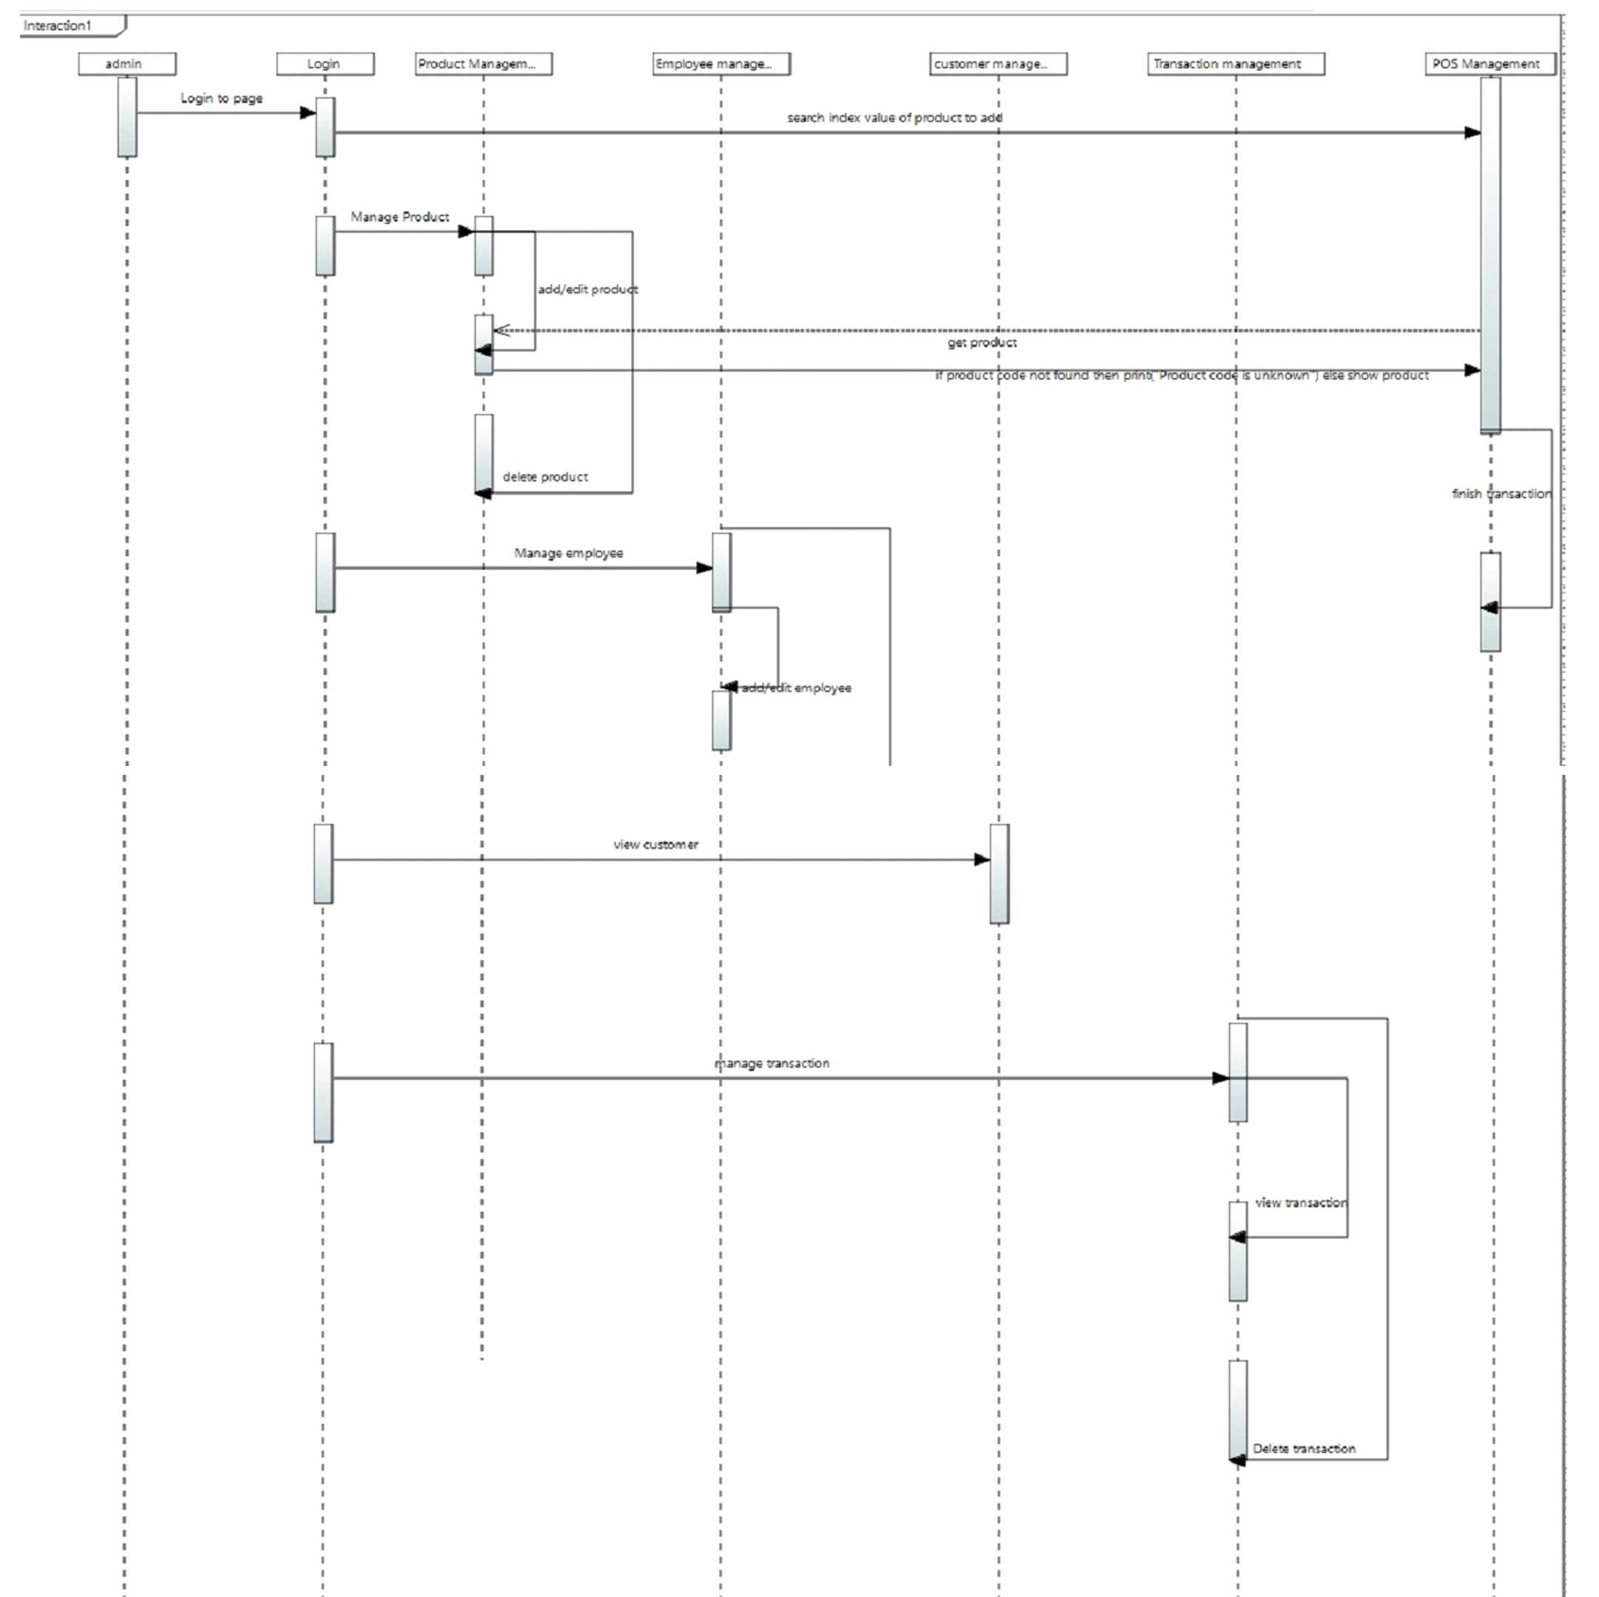

State Diagram
N/A (since state diagram isn’t included in our syllabus)

References
N/A

Appendices
N/A

