|  |  |  |  |  |  |  |  |  |  |  |
| --- | --- | --- | --- | --- | --- | --- | --- | --- | --- | --- |
| **Software Requirement Specifications**  **POS Cashier System**  **Version: 01.00**   |  |  | | --- | --- | | Project/Course Code | CS3009 | | Supervisor | Miss Syeda Rubab Jaffar | | Co Supervisor | N/A | | Project Team | * Ahmed Sultan (21K-4938) * Shahzaib Khan (19K-0273) | | Submission Date | 28th July, 2024 | |

**Document History**

[Not Complete. ]

|  |  |  |  |
| --- | --- | --- | --- |
| Version | Name of Person | Date | Description of change |
| 1.0 | Ahmed Sultan | 21/07/2024 | Document Created |
| 1.0 | Ahmed Sultan | 21/07/2024 | Added Non-functional requirements |
| 1.0 | Shahzaib Khan | 22/07/2024 | Added UseCase x.x.xx |
|  |  |  |  |
|  |  |  |  |
|  |  |  |  |
|  |  |  |  |

**Distribution List**

|  |  |
| --- | --- |
| **Name** | **Role** |
| Miss Syeda Rubab Jaffar | Supervisor |
|  |  |

**Document Sign-Off**

|  |  |  |  |  |
| --- | --- | --- | --- | --- |
| **Version** | **Sign-off Authority** | **Project Role** | **Signature** | **Sign-off Date** |
| 1.0 | Ahmed Sultan | Group/Project Leader | N/A | 28/07/2024 |
|  |  |  |  |  |

**Table of Contents**

1. Introduction 7

1.1. Purpose of Document 7

1.2. Intended Audience 7  
1.3 Abbreviations ………………………………………………………………………………………...7

1.4. Document Convention 7

2. Overall System Description 8

2.1. Project Background 8

2.2. Project Scope 8

2.3. Not In Scope 8

2.4. Project Objectives 8

2.5. Stakeholders 8

2.6. Operating Environment 8

2.7. System Constraints 8

2.8. Assumptions & Dependencies 8

3. External Interface Requirements 9

3.1. Hardware Interfaces 9

3.2. Software Interfaces 9

3.3. Communications Interfaces 9

4. Functional Requirements 10

4.1. Functional Hierarchy 10

4.2. Use Cases 10

4.2.1. [Title of use case] 10

5. Non-functional Requirements 11

5.1. Performance Requirements 11

5.2. Safety Requirements 11

5.3. Security Requirements 11

5.4. User Documentation 11

6. References 12

7. Appendices 13

1. **Introduction**

* 1. **Purpose of Document**

The purpose of this document is to provide a comprehensive overview of the POS (Point of Sale) Cashier System. It outlines the system's functionality, features, and requirements, ensuring a clear understanding of its operations and benefits. This document serves as a guide for developers, stakeholders, and end-users, detailing the design, implementation, and usage of the system to facilitate efficient and effective transaction management in retail environments.

* 1. **Intended Audience**

This document is intended to be used by people who are involved in the creation of this project and its evaluation, namely team members and course instructor.

**1.3 Abbreviations**

* 1. **Document Convention**
* Bold arial font, size 16 for headings
* Italic bold arial font, size 14 for sub-headings
* Arial font, size 12 for paragraphs

1. **Overall System Description**
   1. **Project Background**

The POS Cashier System is a software application designed to streamline and manage retail transactions efficiently. It functions by processing sales, handling payments, managing inventory, and monitoring sales. The system typically includes features such as barcode searching & scanning, and receipt printing. The basic design approach involves a user-friendly interface for cashiers, and a robust backend for data management. By using Agile process for development, we will also ensure to incorporate user feedback to enhance functionality and usability, ensuring the system meets the dynamic needs of retail operations.

* 1. **Project Scope**

The POS cashier system requires employees to log in. Upon successful login, the system verifies the credentials and checks the employee's role, categorizing them as an admin, HR, or cashier. Admins have access to all pages, including employee, POS, transaction history, product, and customer pages. HR personnel can only access the employee page, while cashiers are restricted to the POS page. On the employee and product pages, there are tables for viewing, adding, editing, and deleting entries. The transaction page allows users to view and delete transactions. In the POS page, employees can input barcodes to add products to a cart, and the bill updates accordingly. Upon completing the transaction, employees need to enter customer details such as name, number, payment type, and amount.

* 1. **Not In Scope**

N/A

* 1. **Project Objectives**

In the dynamic and competitive retail industry, the effective management of supermarket operations and point-of-sale (POS) transactions is crucial for ensuring seamless customer experiences, optimizing inventory, and maximizing overall operational efficiency. Existing systems often lack the comprehensive features required to address the evolving needs of modern supermarkets, such as:

**⦁ Inefficient Inventory Management**

**⦁ Limited Customer Engagement**

**⦁ Outdated POS System**

**⦁ Data Security Concerns**

**⦁ Ineffective Reporting and Analytics**

**⦁ Integration Challenges**

**⦁ Employee Productivity and Training**

**⦁ Customer Checkout Experience**

* 1. **Stakeholders**

Developers, Designer, SuperMarket Employees (Cashiers, HR, Admin etc)

* 1. **Operating Environment**

In a Computer, Mobile, Laptop or any other technological devices that can open websites.

* 1. **System Constraints**

This project is currently deployed using local host and is not up on a proper running server. Furthermore, the project is built as the project for Software Engineering course so the scope of the project currently is small. The web app is designed for foreigners so there will be a language barrier for users who don’t speak English.

* 1. **Assumptions & Dependencies**
* **Assumptions**

The assumption is that the project commenced in late July 2024. Therefore, employing UML diagrams, architectures, and design strategy phases becomes crucial to demonstrate a well-timed working strategy, ensuring systematic development. This approach aims to meet the client's (instructor's) requirement of deploying the project by the end of July**.**

1. **External Interface Requirements**
   1. **Hardware Interfaces**

N/A

* 1. **Software Interfaces**

N/A

* 1. **Communications Interfaces**

N/A

1. **Functional Requirements**
   1. **Functional Hierarchy**

|  |  |  |
| --- | --- | --- |
| **No.** | **Feature Name** | **Feature Description** |
| **1** | Login | Admin, HR and cashier have different credentials to login as admin has more access than HR and cashier and HR has more access then cashier. |
| **2** | Manage Products | products can be added , deleted and edited in the products section where when adding and editing, the barcode , type, Name, category and price is added/edited.  (only admin can do it) |
| **3** | Manage Product Type | Each product lies in a category/type (eg: Iphone lies in electronics, icecream lies in food/sweets), so type can be added edited and deleted here in the types section.  (only admin can do it) |
| **4** | Manage Employee Data | Employees can be added, deleted and edited (which includes there salay , username, password)  (only admin and HR can do it) |
| **5** | View Employee Logs | Whatever updates are done in the employee data will be shown with date and time of the process done.  (only admin and HR can view it) |
| **6** | View Customers details | The data of the customers who made transactions will be recorded in the customers section.  (only admin and HR can view it) |
| **7** | View Transactions | All the transactions made by any account will be stored in the transactions section. The time and date will be recorded too and each transaction will have a different record, it wont be added in the same account transaction.  (admin, HR and cashier can view it) |
| **8** | POS system | cashier system where we can search the products through the barcode, the price of the products customer wants will be added and a subtotal will be formed then after tax calculation the total price will be calculated. Then customer name and number will be added for record. |

* 1. **Use Cases**
     1. **[Title of use case]**

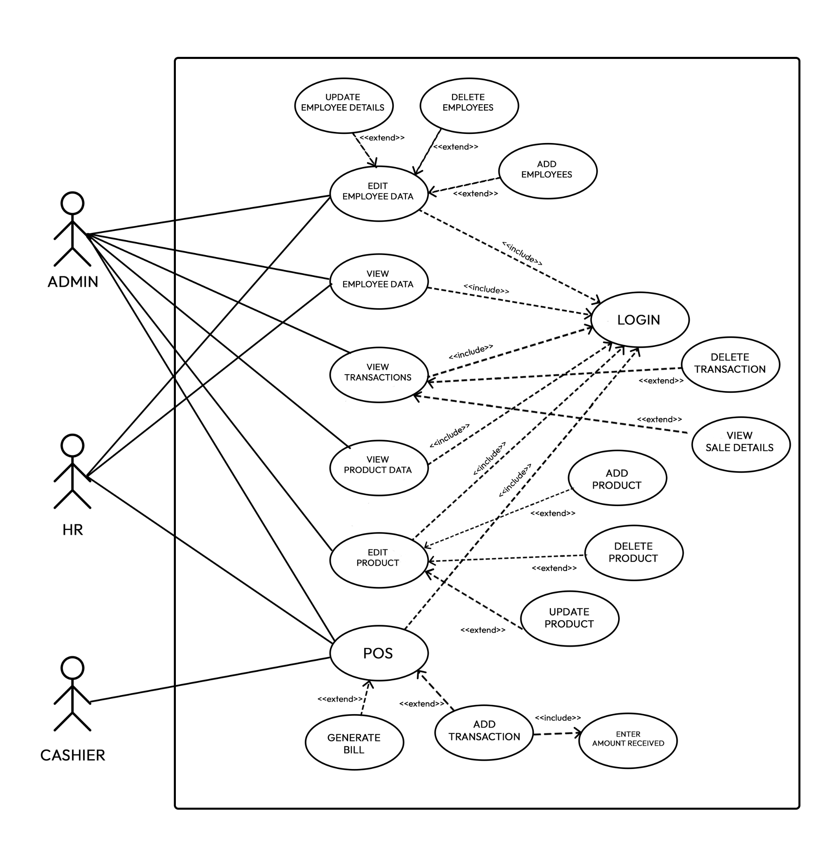

|  |  |  |  |  |
| --- | --- | --- | --- | --- |
| **<Use case Id: 1>** | | | | |
| **Use case Id:** | | 1 | | |
| **Actors:**  Admin | | | | |
| **Feature:** Manage Product in products section | | | | |
| **Pre-condition:** | | The information on the products to be added , edited should be available | | |
| **Scenarios** | | | | |
| **Step#** | **Action** | | | **Software Reaction** |
| **1.** | ADD product | | | a popup appears where we have to type barcode of the product, unit of the product, name of the product, which category the product lies in, the description fo the product and the price of hte product. |
| **2.** | DELETE product | | | a confirmation popup appears asking to continue and if not to continue then close. |
| **3.** | EDIT product | | | in edit product the same popup appears as in add product except the difference is that the previous information fo the product will be filled in the sections , it just needs to be edited. |
| **Alternate Scenarios:** Write additional, optional, branching or iterative steps. Refer to specific action number to ensure understandability. | | | | |
| **N/A** | | | | |
| **Post Conditions** | | | | |
| **Step#** | **Description** | | | |
| **1.** | The added product will be visible in the products section which only the admin can see | | | |
| **2.** | The product will be deleted and to add it again we will have to go through the add procedure. | | | |
| **3.** | The product details will be changed to the new ones | | | |
| **Use Case Cross referenced** | | | N/A | |

|  |  |  |  |  |
| --- | --- | --- | --- | --- |
| **<Use case Id: 2>** | | | | |
| **Use case Id:** | | 2 | | |
| **Actors:**  Admin | | | | |
| **Feature:** Manage Product type in type section | | | | |
| **Pre-condition:** | | The information on the type of the products to be added , edited should be available | | |
| **Scenarios** | | | | |
| **Step#** | **Action** | | | **Software Reaction** |
| **1.** | ADD type | | | a popup appears where we have to add the name and description of the type. |
| **2.** | DELETE type | | | a confirmation popup appears asking to continue and if not to continue then close. |
| **3.** | EDIT type | | | in edit type the same popup appears as in add type except the difference is that the previous information of the type will be filled in the sections , it just needs to be edited. |
| **Alternate Scenarios:** Write additional, optional, branching or iterative steps. Refer to specific action number to ensure understandability. | | | | |
| **N/A** | | | | |
| **Post Conditions** | | | | |
| **Step#** | **Description** | | | |
| **1.** | The added type will be visible in the type section which only the admin can see | | | |
| **2.** | The type will be deleted and to add it again we will have to go through the add procedure. | | | |
| **3.** | The type details will be changed to the new ones | | | |
| **Use Case Cross referenced** | | | N/A | |

|  |  |  |  |  |
| --- | --- | --- | --- | --- |
| **<Use case Id: 3>** | | | | |
| **Use case Id:** | | 3 | | |
| **Actors:**  Admin, HR | | | | |
| **Feature:** Manage Employee Data | | | | |
| **Pre-condition:** | | The information on the employees to be added , edited should be available | | |
| **Scenarios** | | | | |
| **Step#** | **Action** | | | **Software Reaction** |
| **1.** | ADD employee | | | a popup appears where we have to add the name, type(position of the employee), username, password and salary of the new employee. |
| **2.** | DELETE employee | | | a confirmation popup appears asking to continue and if not to continue then close. if deleted, the data will go in the exemployee data area in the employees section from where the employee can be rollbacked. |
| **3.** | EDIT employee | | | in edit type the same popup appears as in add employee except the difference is that the previous information of the employee will be filled in the sections , it just needs to be edited. |
| **Alternate Scenarios:** Write additional, optional, branching or iterative steps. Refer to specific action number to ensure understandability. | | | | |
| **N/A** | | | | |
| **Post Conditions** | | | | |
| **Step#** | **Description** | | | |
| **1.** | The added employee will be visible in the employee section. | | | |
| **2.** | The employee will be deleted and to add it again we will have to go to the exemployee data area in the employees section and rollback it. | | | |
| **3.** | The employee details will be changed to the new ones | | | |
| **Use Case Cross referenced** | | | N/A | |

|  |  |  |  |  |
| --- | --- | --- | --- | --- |
| **<Use case Id: 4>** | | | | |
| **Use case Id:** | | 4 | | |
| **Actors:**  Admin, HR | | | | |
| **Feature:** View Employee Logs | | | | |
| **Pre-condition:** | | N/A | | |
| **Scenarios** | | | | |
| **Step#** | **Action** | | | **Software Reaction** |
| **1.** | view employee | | | We can view the timeupdated of the employee details that were updated and what was updated. |
| **Alternate Scenarios:** Write additional, optional, branching or iterative steps. Refer to specific action number to ensure understandability. | | | | |
| **N/A** | | | | |
| **Post Conditions** | | | | |
| **Step#** | **Description** | | | |
| **1.** | N/A | | | |
| **Use Case Cross referenced** | | | N/A | |

|  |  |  |  |  |
| --- | --- | --- | --- | --- |
| **<Use case Id: 5>** | | | | |
| **Use case Id:** | | 5 | | |
| **Actors:**  Admin, HR | | | | |
| **Feature:** View Customer Details | | | | |
| **Pre-condition:** | | N/A | | |
| **Scenarios** | | | | |
| **Step#** | **Action** | | | **Software Reaction** |
| **1.** | view customer details | | | We can view the amount spent and last transaction date of the customer and there name and phone number |
| **Alternate Scenarios:** Write additional, optional, branching or iterative steps. Refer to specific action number to ensure understandability. | | | | |
| **N/A** | | | | |
| **Post Conditions** | | | | |
| **Step#** | **Description** | | | |
| **1.** | N/A | | | |
| **Use Case Cross referenced** | | | N/A | |

|  |  |  |  |  |
| --- | --- | --- | --- | --- |
| **<Use case Id: 6>** | | | | |
| **Use case Id:** | | 6 | | |
| **Actors:**  Admin, HR, Cashier | | | | |
| **Feature:** View Transactions | | | | |
| **Pre-condition:** | | N/A | | |
| **Scenarios** | | | | |
| **Step#** | **Action** | | | **Software Reaction** |
| **1.** | view Transactions | | | Can view the transaction ID, Emp Name who made the transaction, the price of the transaction, the date and the receipt of the products of the transaction. |
| **Alternate Scenarios:** Write additional, optional, branching or iterative steps. Refer to specific action number to ensure understandability. | | | | |
| **N/A** | | | | |
| **Post Conditions** | | | | |
| **Step#** | **Description** | | | |
| **1.** | N/A | | | |
| **Use Case Cross referenced** | | | N/A | |

|  |  |  |  |  |
| --- | --- | --- | --- | --- |
| **<Use case Id: 7>** | | | | |
| **Use case Id:** | | 7 | | |
| **Actors:**  Admin, HR, Cashier | | | | |
| **Feature:** POS | | | | |
| **Pre-condition:** | | N/A | | |
| **Scenarios** | | | | |
| **Step#** | **Action** | | | **Software Reaction** |
| **1.** | Search | | | We can search the products through barcode number to add in the bill. |
| **2.** | Add customer name and number | | | Add customer name and number to add for the record of the customer. |
| **3.** | Payment Type | | | Two options appear either pay by cash or credit. |
| **4.** | Finish Transaction | | | To complete the transaction a success prompt will appear. |
| **Alternate Scenarios:** Write additional, optional, branching or iterative steps. Refer to specific action number to ensure understandability. | | | | |
| **N/A** | | | | |
| **Post Conditions** | | | | |
| **Step#** | **Description** | | | |
| **4.** | The transaction will be recorded in the transaction section and the customer data will be recorded in the customer section and the employ transaction log will be updated in the log. | | | |
| **Use Case Cross referenced** | | | N/A | |

1. **Non-functional Requirements**
   1. **Performance Requirements**

The system is presently operational on a local host, limiting its usage to not many users. However, upon successful deployment, approximately 1000 users will be able to access the application and its features simultaneously. The app boasts an average response time or latency of 0.0275ms. Furthermore, it efficiently handles data in a precise and concise manner.

* 1. **Safety Requirements**

Potential property damage or a loss of credibility may occur if a user behaves aggressively towards the website. To prevent such incidents, user will have to rate their guests, enabling other users to assess the person's character and credibility before providing their property to them.

* 1. **Security Requirements**

There is a single access point as admin, HR and cashier are able to login through only one screen.

* 1. **User Documentation**

N/A

1. **References**

N/A

1. **Appendices**

N/A