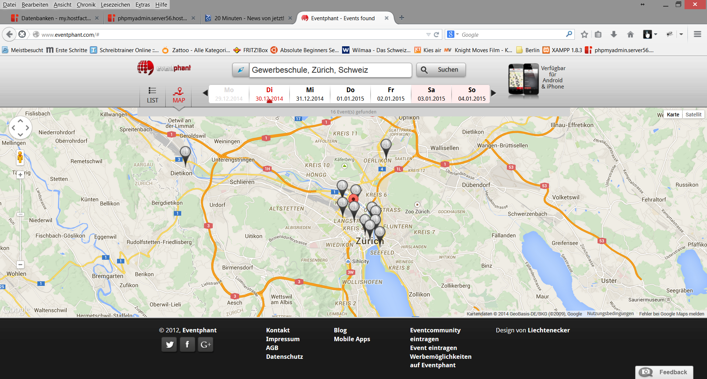
Eventphant GmbH
Freistädterstrasse 7, 4040 Linz, Austria
CEO Stephan Schober
Email: office@eventphant.com
Landesgericht Linz, FN 379804 k
Member of Wirtschaftskammer Österreich
Third-party licenses
Several fantastic pieces of free and open-source software have really helped get Eventphant to where it is today. A few require that we include their license agreements within our product. Consider it done. As we enjoy giving credit where it's due, we included the entire list below. This means you can not only see which software we've been using, but the terms of the licenses too. A big thanks from all of us at Eventphant to the smart people behind the fantastic programs listed. Rock on!
iOS
SBJSON
http://stig.github.com/json-framework/
Copyright (C) 2007-2010 Stig Brautaset. All rights reserved.
Redistribution and use in source and binary forms, with or without modification, are permitted provided that the following conditions are met:
- Redistributions of source code must retain the above copyright notice, this list of conditions and the following disclaimer.
- Redistributions in binary form must reproduce the above copyright notice, this list of conditions and the following disclaimer in the documentation and/or other materials provided with the distribution.
- Neither the name of the author nor the names of its contributors may be used to endorse or promote products derived from this software without specific prior written permission.
THIS SOFTWARE IS PROVIDED BY THE COPYRIGHT HOLDERS AND CONTRIBUTORS "AS IS" AND ANY EXPRESS OR IMPLIED WARRANTIES, INCLUDING, BUT NOT LIMITED TO, THE IMPLIED WARRANTIES OF MERCHANTABILITY AND FITNESS FOR A PARTICULAR PURPOSE ARE DISCLAIMED. IN NO EVENT SHALL THE COPYRIGHT OWNER OR CONTRIBUTORS BE LIABLE FOR ANY DIRECT, INDIRECT, INCIDENTAL, SPECIAL, EXEMPLARY, OR CONSEQUENTIAL DAMAGES (INCLUDING, BUT NOT LIMITED TO, PROCUREMENT OF SUBSTITUTE GOODS OR SERVICES; LOSS OF USE, DATA, OR PROFITS; OR BUSINESS INTERRUPTION) HOWEVER CAUSED AND ON ANY THEORY OF LIABILITY, WHETHER IN CONTRACT, STRICT LIABILITY, OR TORT (INCLUDING NEGLIGENCE OR OTHERWISE) ARISING IN ANY WAY OUT OF THE USE OF THIS SOFTWARE, EVEN IF ADVISED OF THE POSSIBILITY OF SUCH DAMAGE.
ASIHTTPRequest
http://allseeing-i.com/ASIHTTPRequest/
Copyright (c) 2007-2011, All-Seeing Interactive
All rights reserved.
Redistribution and use in source and binary forms, with or without modification, are permitted provided that the following conditions are met:
- Redistributions of source code must retain the above copyright notice, this list of conditions and the following disclaimer.
- Redistributions in binary form must reproduce the above copyright notice, this list of conditions and the following disclaimer in the documentation and/or other materials provided with the distribution.
- Neither the name of the All-Seeing Interactive nor the names of its contributors may be used to endorse or promote products derived from this software without specific prior written permission.
THIS SOFTWARE IS PROVIDED BY All-Seeing Interactive ''AS IS'' AND ANY EXPRESS OR IMPLIED WARRANTIES, INCLUDING, BUT NOT LIMITED TO, THE IMPLIED WARRANTIES OF MERCHANTABILITY AND FITNESS FOR A PARTICULAR PURPOSE ARE DISCLAIMED. IN NO EVENT SHALL All-Seeing Interactive BE LIABLE FOR ANY DIRECT, INDIRECT, INCIDENTAL, SPECIAL, EXEMPLARY, OR CONSEQUENTIAL DAMAGES (INCLUDING, BUT NOT LIMITED TO, PROCUREMENT OF SUBSTITUTE GOODS OR SERVICES; LOSS OF USE, DATA, OR PROFITS; OR BUSINESS INTERRUPTION) HOWEVER CAUSED AND ON ANY THEORY OF LIABILITY, WHETHER IN CONTRACT, STRICT LIABILITY, OR TORT (INCLUDING NEGLIGENCE OR OTHERWISE) ARISING IN ANY WAY OUT OF THE USE OF THIS SOFTWARE, EVEN IF ADVISED OF THE POSSIBILITY OF SUCH DAMAGE.
MKNetworkKit
https://github.com/MugunthKumar/MKNetworkKit
MKNetworkKit is licensed under MIT License Permission is hereby granted, free of charge, to any person obtaining a copy of this software and associated documentation files (the "Software"), to deal in the Software without restriction, including without limitation the rights to use, copy, modify, merge, publish, distribute, sublicense, and/or sell copies of the Software, and to permit persons to whom the Software is furnished to do so, subject to the following conditions:
The above copyright notice and this permission notice shall be included in all copies or substantial portions of the Software.
THE SOFTWARE IS PROVIDED "AS IS", WITHOUT WARRANTY OF ANY KIND, EXPRESS OR IMPLIED, INCLUDING BUT NOT LIMITED TO THE WARRANTIES OF MERCHANTABILITY, FITNESS FOR A PARTICULAR PURPOSE AND NONINFRINGEMENT. IN NO EVENT SHALL THE AUTHORS OR COPYRIGHT HOLDERS BE LIABLE FOR ANY CLAIM, DAMAGES OR OTHER LIABILITY, WHETHER IN AN ACTION OF CONTRACT, TORT OR OTHERWISE, ARISING FROM, OUT OF OR IN CONNECTION WITH THE SOFTWARE OR THE USE OR OTHER DEALINGS IN THE SOFTWARE.
Reachability
Copyright (c) 2011, Tony Million.
All rights reserved.
Redistribution and use in source and binary forms, with or without
modification, are permitted provided that the following conditions are met:
- Redistributions of source code must retain the above copyright notice, this list of conditions and the following disclaimer.
- Redistributions in binary form must reproduce the above copyright notice,this list of conditions and the following disclaimer in the documentation and/or other materials provided with the distribution.
THIS SOFTWARE IS PROVIDED BY THE COPYRIGHT HOLDERS AND CONTRIBUTORS "AS IS" AND ANY EXPRESS OR IMPLIED WARRANTIES, INCLUDING, BUT NOT LIMITED TO, THE IMPLIED WARRANTIES OF MERCHANTABILITY AND FITNESS FOR A PARTICULAR PURPOSE ARE DISCLAIMED. IN NO EVENT SHALL THE COPYRIGHT HOLDER OR CONTRIBUTORS BE LIABLE FOR ANY DIRECT, INDIRECT, INCIDENTAL, SPECIAL, EXEMPLARY, OR CONSEQUENTIAL DAMAGES (INCLUDING, BUT NOT LIMITED TO, PROCUREMENT OF SUBSTITUTE GOODS OR SERVICES; LOSS OF USE, DATA, OR PROFITS; OR BUSINESS INTERRUPTION) HOWEVER CAUSED AND ON ANY THEORY OF LIABILITY, WHETHER IN CONTRACT, STRICT LIABILITY, OR TORT (INCLUDING NEGLIGENCE OR OTHERWISE) ARISING IN ANY WAY OUT OF THE USE OF THIS SOFTWARE, EVEN IF ADVISED OF THE POSSIBILITY OF SUCH DAMAGE.
Pull2Refresh
Plancast
Created by Leah Culver on 7/2/10.
Copyright (c) 2010 Leah Culver
Permission is hereby granted, free of charge, to any person obtaining a copy of this software and associated documentation files (the "Software"), to deal in the Software without restriction, including without limitation the rights to use, copy, modify, merge, publish, distribute, sublicense, and/or sell copies of the Software, and to permit persons to whom the Software is furnished to do so, subject to the following conditions:
The above copyright notice and this permission notice shall be included in all copies or substantial portions of the Software.
THE SOFTWARE IS PROVIDED "AS IS", WITHOUT WARRANTY OF ANY KIND, EXPRESS OR IMPLIED, INCLUDING BUT NOT LIMITED TO THE WARRANTIES OF MERCHANTABILITY, FITNESS FOR A PARTICULAR PURPOSE AND NONINFRINGEMENT. IN NO EVENT SHALL THE AUTHORS OR COPYRIGHT HOLDERS BE LIABLE FOR ANY CLAIM, DAMAGES OR OTHER LIABILITY, WHETHER IN AN ACTION OF CONTRACT, TORT OR OTHERWISE, ARISING FROM, OUT OF OR IN CONNECTION WITH THE SOFTWARE OR THE USE OR OTHER DEALINGS IN THE SOFTWARE.
APPIRater
Copyright (c) 2010, Arash Payan
All rights reserved.
Permission is hereby granted, free of charge, to any person obtaining a copy of this software and associated documentation files (the "Software"), to deal in the Software without restriction, including without limitation the rights to use, copy, modify, merge, publish, distribute, sublicense, and/or sell copies of the Software, and to permit persons to whom the Software is furnished to do so, subject to the following conditions:
The above copyright notice and this permission notice shall be included in all copies or substantial portions of the Software.
THE SOFTWARE IS PROVIDED "AS IS", WITHOUT WARRANTY OF ANY KIND, EXPRESS OR IMPLIED, INCLUDING BUT NOT LIMITED TO THE WARRANTIES OF MERCHANTABILITY, FITNESS FOR A PARTICULAR PURPOSE AND NONINFRINGEMENT. IN NO EVENT SHALL THE AUTHORS OR COPYRIGHT HOLDERS BE LIABLE FOR ANY CLAIM, DAMAGES OR OTHER LIABILITY, WHETHER IN AN ACTION OF CONTRACT, TORT OR OTHERWISE, ARISING FROM, OUT OF OR IN CONNECTION WITH THE SOFTWARE OR THE USE OR OTHER DEALINGS IN THE SOFTWARE.
RSOAuthEngine
Created by Rodrigo Sieiro on 12/11/11.
Copyright (c) 2011 Rodrigo Sieiro . All rights reserved.
Permission is hereby granted, free of charge, to any person obtaining a copy of this software and associated documentation files (the "Software"), to deal in the Software without restriction, including without limitation the rights to use, copy, modify, merge, publish, distribute, sublicense, and/or sell copies of the Software, and to permit persons to whom the Software is furnished to do so, subject to the following conditions:
The above copyright notice and this permission notice shall be included in all copies or substantial portions of the Software.
THE SOFTWARE IS PROVIDED "AS IS", WITHOUT WARRANTY OF ANY KIND, EXPRESS OR IMPLIED, INCLUDING BUT NOT LIMITED TO THE WARRANTIES OF MERCHANTABILITY, FITNESS FOR A PARTICULAR PURPOSE AND NONINFRINGEMENT. IN NO EVENT SHALL THE AUTHORS OR COPYRIGHT HOLDERS BE LIABLE FOR ANY CLAIM, DAMAGES OR OTHER LIABILITY, WHETHER IN AN ACTION OF CONTRACT, TORT OR OTHERWISE, ARISING FROM, OUT OF OR IN CONNECTION WITH THE SOFTWARE OR THE USE OR OTHER DEALINGS IN THE SOFTWARE.
Facebook
Copyright 2010 Facebook
Licensed under the Apache License, Version 2.0 (the "License"); you may not use this file except in compliance with the License. You may obtain a copy of the License at
http://www.apache.org/licenses/LICENSE-2.0
Unless required by applicable law or agreed to in writing, software distributed under the License is distributed on an "AS IS" BASIS, WITHOUT WARRANTIES OR CONDITIONS OF ANY KIND, either express or implied. See the License for the specific language governing permissions and limitations under the License.
DejalActivityView
Please see the "Dejal Open Source License" web page for more information.
Attribution is required, but a non-attribution license is also available.
http://www.dejal.com/developer/license/
Copyright (c) 2002-2012 Dejal Systems, LLC. All rights reserved.
Redistribution and use in source and binary forms, with or without modification, are permitted provided that the following conditions are met:
- Redistributions of source code must retain the above copyright notice, this list of conditions and the following disclaimer.
- Redistributions in binary form must reproduce the above copyright notice, this list of conditions and the following disclaimer in the documentation and/or other materials provided with the distribution.
THIS SOFTWARE IS PROVIDED BY THE COPYRIGHT HOLDERS AND CONTRIBUTORS "AS IS" AND ANY EXPRESS OR IMPLIED WARRANTIES, INCLUDING, BUT NOT LIMITED TO, THE IMPLIED WARRANTIES OF MERCHANTABILITY AND FITNESS FOR A PARTICULAR PURPOSE ARE DISCLAIMED. IN NO EVENT SHALL THE COPYRIGHT HOLDER OR CONTRIBUTORS BE LIABLE FOR ANY DIRECT, INDIRECT, INCIDENTAL, SPECIAL, EXEMPLARY, OR CONSEQUENTIAL DAMAGES (INCLUDING, BUT NOT LIMITED TO, PROCUREMENT OF SUBSTITUTE GOODS OR SERVICES; LOSS OF USE, DATA, OR PROFITS; OR BUSINESS INTERRUPTION) HOWEVER CAUSED AND ON ANY THEORY OF LIABILITY, WHETHER IN CONTRACT, STRICT LIABILITY, OR TORT (INCLUDING NEGLIGENCE OR OTHERWISE) ARISING IN ANY WAY OUT OF THE USE OF THIS SOFTWARE, EVEN IF ADVISED OF THE POSSIBILITY OF SUCH DAMAGE.
Android
twitter4j
http://twitter4j.org/en/index.html Copyright 2007 Yusuke Yamamoto
Licensed under the Apache License, Version 2.0 (the "License");
you may not use this file except in compliance with the License.
You may obtain a copy of the License at
http://www.apache.org/licenses/LICENSE-2.0
Unless required by applicable law or agreed to in writing, software
Distributed under the License is distributed on an "AS IS" BASIS,
WITHOUT WARRANTIES OR CONDITIONS OF ANY KIND, either express or implied.
See the License for the specific language governing permissions and
limitations under the License.
Twitter4J includes software from JSON.org to parse JSON response from the Twitter API. You can see the license term at The JSON License.
Android Mapviewballoons
Author: Jeff Gilfelt
The code in this project is licensed under the Apache Software License 2.0.
Copyright (c) 2012 readyState Software Ltd.
https://github.com/jgilfelt/android-mapviewballoons

