**Smart Water Level Monitoring System**

**A Thesis**

**Presented to**

**The College of Computer Studies**

**DR. AURELIO MENDOZA MEMORIAL COLLEGES**

**Ipil, Zamboanga Sibugay**

**In Partial Fulfillment of the**

**Requirements for the Degree**

**Bachelor of Science in Information Technology**

**Rolan John Benitez**

**Roald M. Dela Cruz**

**Crischelle Z. Carreon**

**Kenn Mark T. Villanueva**

**2022**

**Chapter 1**

**THE PROBLEM AND ITS SCOPE**

**Introduction**

According to data posted on the UN website in 2022, they observed decreasing trends in vulnerability to floods and droughts, which are encouraging due to effective risk management. Between 1980-1989 and 2007-2016, global human and economic vulnerability decreased approximately 6.5- and 5-fold, respectively. However, the effects of floods and droughts continue to be severe and growing in many parts of the world. Due to anticipated increases in the frequency and intensity of floods and droughts3, climate change will almost probably intensify their consequences. For a 2 °C average temperature increase, flood economic loss is predicted to treble globally7 and drought economic damage to triple in Europe8.

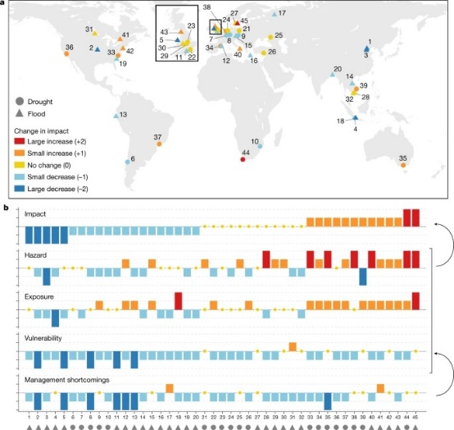The purpose of risk management is to reduce the impact of events through modification of the hazard, exposure and/or vulnerability: according to United Nations (UN) terminology9, disaster risk management is the application of disaster risk reduction policies and strategies to prevent new disaster risk, reduce existing disaster risk and manage residual risk, contributing to the strengthening of resilience against, and reduction of, disaster losses.

Location of flood and drought paired events coloured according to changes in impact and their indicators of change.

**A**, Location of flood and drought paired events (n = 45). Numbers are paired-event IDs.

**B**, Indicators of change, sorted by impact change. Impact is considered to be controlled by hazard, exposure and vulnerability, which are exacerbated by risk management shortcomings. Maps of the paired events coloured according to drivers and management shortcomings are shown in Extended Data

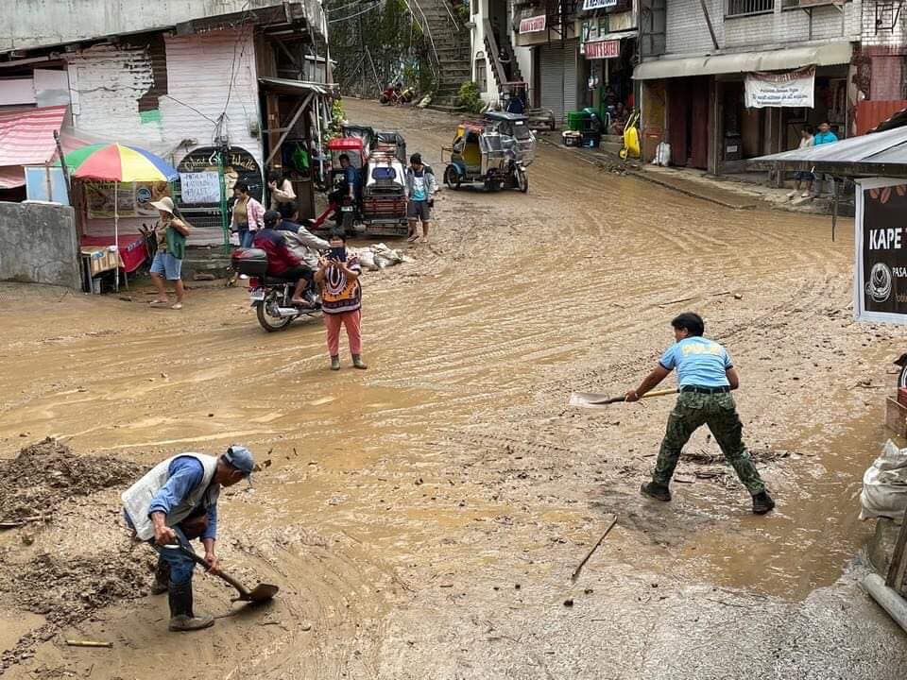In the month of July 2022, authorities reported one person died and homes and buildings were destroyed after a heavy rain caused a landslide, previously flooding was reported in Zamboanga del Sur province where 35,984 people were affected on July 5th. Around the same time over 1,206 people were affected by floods in Cebu and Negros Oriental Provinces. Flooding and landslides struck parts of in Ifugao, Benguet and Mountain Provinces in Cordillera Administrative Region (CAR) from 7th of July affecting 3,166 people, injuring 6 and damaging 1,048 houses.

Floods in Banaue, Ifugao. Philippines, July 2022. Photo: Government of Ifugao Province

Most floods that cause catastrophic damages and causing casualties, injuries and destruction of infrastructures are from a nearby river where the water rises and overflows and causes nearby debris to be swept along and blocks the waterway resulting in further overflow and wrecks nearby habitat especially in rural communities where the infrastructures aren’t built to withstand a flood or any natural disaster.

[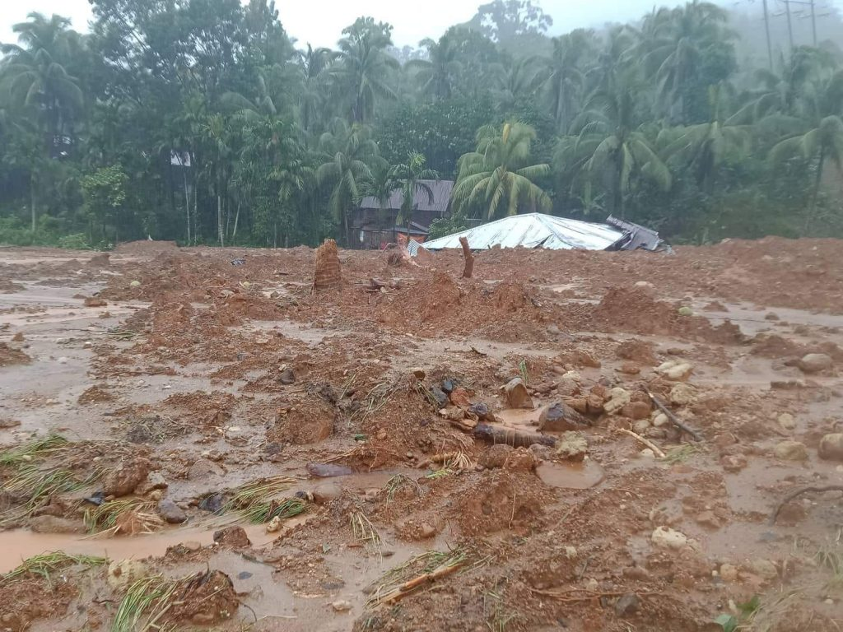](https://floodlist.com/wp-content/uploads/2022/04/Floods-and-mudslides-damages-in-Baybay-City-province-of-Leyte-Eastern-Visayas-Philippines-April-2022.jpg) The National Disaster Risk Reduction and Management Council (NDRRMC) in the Philippines has confirmed that 75 people have lost their lives as a result of floods and mudslides following heavy rainfall from Tropical Storm Megi (Agaton). A further 28 people are reported missing. The vast majority of the fatalities occurred in Eastern Visayas Region, in particular in villages around Baybay City in the province of Leyte. NDRRMC said 920,727 people have been affected and 162,467 people displaced and staying in emergency accommodation centres.

Floods and mudslides caused fatalities and severe damage in Barangay Bunga, Baybay City, province of Leyte, Eastern Visayas, Philippines, April 2022. Photo: Adrian Ostan Real, SK Chairperson

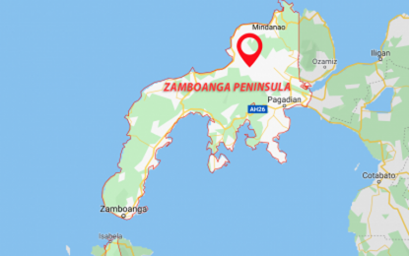In 2021, Flash floods spawned by a low pressure area (LPA) coupled with an intertropical convergence zone (ITCZ) inundated 37 villages and displaced over 2,000 households across the Zamboanga Peninsula. Landslides were also recorded in three barangays in the Zamboanga Sibugay province, Office of Civil Defense (OCD) Regional Director Ramon Ochotorena said in an interview Thursday. Of the 37 affected barangays, 16 are in seven towns of Zamboanga Sibugay; 11 in three towns of Zamboanga del Sur; seven in Siocon, Zamboanga del Norte; three in Zamboanga City. Ochotorena said 1,811 households were affected by the flash flood in Molave, Zamboanga del Sur, following torrential rains since Wednesday night. The other two towns affected by flood in Zamboanga del Sur are Dinas and Tambulig. “We are continuously monitoring the situation in different parts of the region,” Ochotorena said. He said some 150 households were displaced in the seven flooded barangays in Siocon, Zamboanga del Norte. No casualties were reported so far.

Google map of the Zamboanga Peninsula

ZAMBOANGA SIBUGAY, Philippines – Waist-level flashfloods forced more than 2,000 residents to leave their homes in 13 barangays of Kabasalan, Zamboanga Sibugay, Friday evening, December 22.

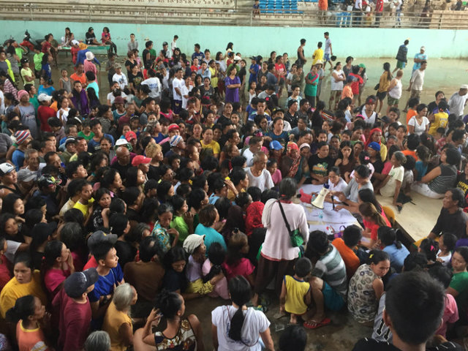Caused by heavy rain and wind due to Tropical Storm Vinta, an uprooted tree-trunk hit and damaged a flood-mitigating dam in Barangay Goodyear, according to the Local Disaster Reduction Management Office of Kabasalan. (READ: [Death toll from Tropical Storm Vinta rises to 30](https://www.rappler.com/nation/192078-tropical-storm-vinta-death-toll-20171223))

RELIEF EFFORTS. Evacuees at Poblacion, Kabasalan Gymnasium line up as they receive their relief food packs from the local municipal government

This caused the sudden rise of flood waters in at least 10 barangays, including the Poblacion, Bangkal, Sanghayan, F.L. Peña, Salipyasin, Cainglet, Sta Cruz, Dipala, Conception, Sininan, Canasan, and T. Danda.

Based on initial reports, Vinta caused heavy flooding, ["wiped out" houses](https://www.rappler.com/nation/192074-flashflood-wipes-out-village-tubod-lanao-del-norte-vinta), and displaced [thousands of residents](https://www.rappler.com/move-ph/issues/disasters/192067-hundreds-davao-city-residents-evacuate-river-overflows)across different provinces in Mindanao. (READ: [Marawi City, Lanao del Sur under state of calamity due to Vinta)](https://www.rappler.com/move-ph/issues/disasters/192076-marawi-city-lanao-del-sur-province-state-calamity-vinta)

 Installing Smart Water Level Monitoring System that utilizes Internet of Things (IOT) and SMS technologies can increase safety and awareness in a community that was close to a water channel or a water canal, river that flows from the mountains towards the sea is very important as it not only warns people but also gives them time to prepare for a natural calamity like flash floods, although flooding is normal but what comes along with it is the threat of mudslides, which are extremely dangerous. Floods are a danger if you fall and get swept along with it and get injured amongst the debris. This technology on the other hand although it may vary from the existing technologies, and may have its similarities but the purpose was still there, to prevent further damage towards humans that inhabits near the rivers which results in great casualties and injuries and can be a hazard to both human and human properties.



This research supports SDG no. 13 which was about climate action and is one of 17 Sustainable Development Goals established by the United Nations General Assembly in 2015. The official mission statement of this goal is to "Take urgent action to combat climate change and its impacts".

This research supports SDG no. 15: Protect, restore and promote sustainable use of terrestrial ecosystems, sustainably manage forests, combat desertification, and halt and reverse land degradation and halt biodiversity loss. This study aims to prevent and increase safety and awareness in terms of flood problem, by increasing the ability to withstand and recover from climate change-related calamities.

**Statement of The Problem**

**The research will answer the following statements:**

1. What prototype to develop that monitors water level?
2. What platform to utilize to allow the prototype to send real time data?
3. What javascript library to embed in the web system application to help the user in monitoring water levels in certain date and time?
4. What are the prototype’s properties that can help the target respondents and people in terms of:
   1. Functionality
   2. Efficiency
   3. Reliability
   4. Sustainability
   5. Usability

**Significance of the study**

**LDRMMC** – This research is beneficial in decision making to warn or inform and provide an early warning of the people and their environments of emanating danger and save life by allowing people to support and emergency service time to prepare for incoming flooding. This can help to prevent excessive damage and possible save lives.

**Residents** – This research will help to prepare for the incoming disaster and evacuate if possible and take their valuable time to save and protect their assets, property and their lives incoming floods.

**LGU** – This research is useful in making decisions to help their environments of impending danger and save lives by providing individuals to support and emergency services time to prepare for imminent flooding.

**Researcher** – Through practical experience, information, and understanding, the researcher may aid in the improvement of their analytical and critical learning abilities

**Scope and Delimitation**

The primary goal of this project was to develop an efficient water level monitoring system that employs simple alarm features such as LEDs as indicators for each water level. The system will use water sensor technology to monitor certain water level fluctuations by using a contact sensor type (Water Brick Sensor) that can be submerged in water and make contact with water. The proposed system is only capable of monitoring water levels. Communities near rivers that flood frequently may benefit from the project research. Some calculations, assumptions, and decisions were made in order to create a suitable and realistic design.

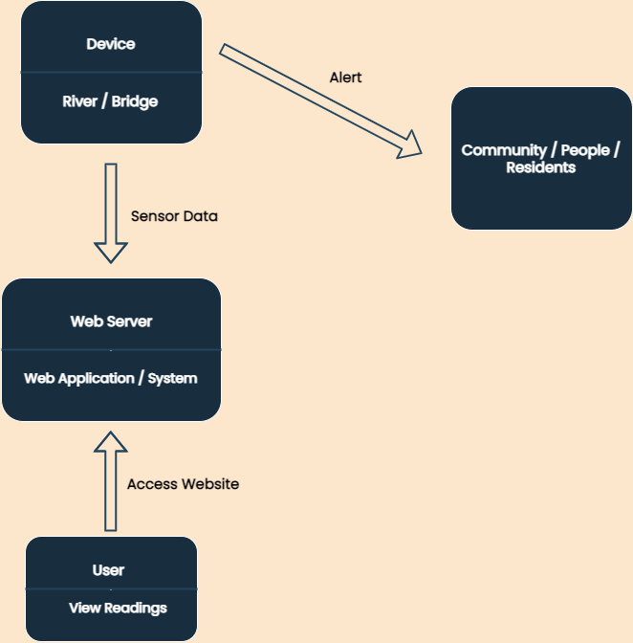

Figure 1. Project Design