**Chapter 2**

**REVIEW OF RELATED LITERATURE**

**Theoretical Framework of the Research**

This chapter tackles about the related research of the Smart Water Level Monitoring System. It discusses facts and principles to which present the research is related on foreign and local research that already exists.

**Internet of Things**

**Water Level Monitoring Technique**

**Smart Water Level Monitoring System**

Chart.js Library

P.A.D.I.S

Figure 3. Theoretical Framework of The Research

**Water Level Monitoring Technique**

Water level is one of the most commonly measured parameters, as accurate level data are essential for many applications. While climate change, pollution monitoring, and industrial water usage are broad reasons for monitoring water levels, more specific applications are discussed throughout this part of the research. Level is perceived as one of the most straightforward water parameters. In general, it is the level of water in a body of water, in groundwater, in a tank, etc. However, there’s a lot to unpack with this parameter. Not only are there very different water level applications and technologies used to measure it, but there are also a variety of terms used when describing water level, some of which have only subtle differences. These include:

* Water level: The height or elevation of water above (more common) or below (less common) a user-specified point. This term is used in many applications.
* Depth: When measuring in a groundwater well, this is the distance from the land surface to water in the well. In surface water, depth is the distance from the water’s surface to a specific point, typically the bottom of the water body or the location of a sensor.
* Gage height: Used to describe the water level of a river or stream. Level measurements in these applications are often collected at stream gage stations.
* Tide Gage: Describes a water level sensor used to monitor changes in sea level.
* Elevation: Used when describing the height of water above sea level.
* Hydraulic head: The height to which a column of water is above a reference elevation (e.g., sea level). Like elevation, this term is often used in groundwater applications.

Establishing a baseline of water level is also crucial for ponds, lakes, and reservoirs, as these data indicate when the volume of water is unusually low or high. Monitoring the water level in lakes and reservoirs is especially important, as they often serve as the source of drinking and irrigation water in many communities. In addition, these surface water bodies can generate electricity via a dam, help control floods, serve as a place for recreation, and as a habitat for wildlife.

There are two main types of water level indicators – contact and non-contact. Contact sensors are placed in the water when measuring water level. In contrast, non-contact sensors use a measurement that does not require any instrument components to be placed in the water.

**Contact Water Level Sensors**

These types of sensors have been around the longest. There is a wide range of contact sensors – from incredibly simple to high-tech – and some are designed for specific applications.

1. **Crest Stage Gages**
   1. 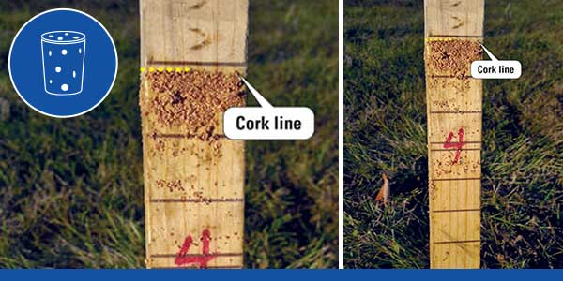A crest-stage gage is a simple way to measure water level, most often in streams and rivers. These gages consist of a metal pipe, wood staff, and a cork that’s been crushed up. Unlike modern level sensors, the crest-stage gage can only record the maximum water level. They are typically ‘reset’ before a high-water event occurs and checked by a technician after the event is over or when the water level has stopped rising.

Figure #. Crest-Stage gage

1. **Shaft Encoders**
   1. Shaft encoders are used to measure level in a stilling well as part of a stream gage station, hydrometeorological site, or flood warning system. However, they are also sometimes used in groundwater wells. Stilling wells are large vertical structures with a hollow center – many look like a giant tube – and are often installed along a riverbank. Water enters through pipes at the bottom of the well; this allows the water level in the well to be the same as that of the river.17 This design protects instrumentation inside the well and mitigates the impact of wind and turbulence on water level.

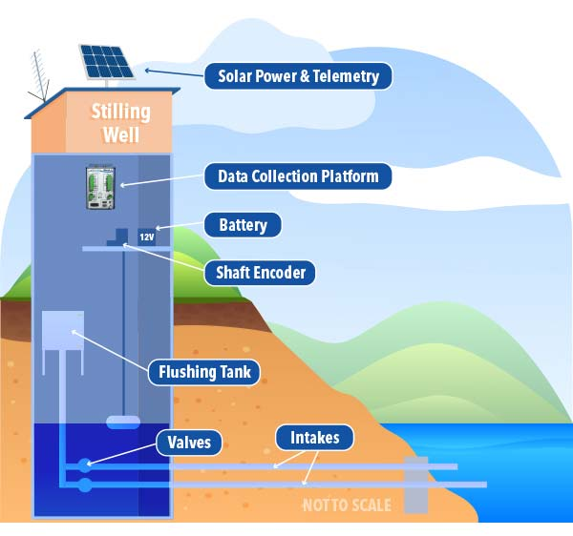

Figure #. Shaft Encoder

**Non-Contact Water Level Sensors**

Non-contact sensors have an advantage over contact sensors in some applications. They can be used when water may not always be present – bubblers can also be used in such an application – or when the sensor cannot be placed in the water due to other hazards. This also makes non-contact sensors safer for those that maintain them. Another advantage is there’s no concern of sensor damage due to debris and flood conditions. It is for these reasons that many professionals prefer non-contact sensors. It should be noted that non-contact sensors are susceptible to vandalism and damage from wind/severe weather events. They also need to be calibrated to measure the water level accurately and to eliminate interferences.

1. **Radar Sensors**
   1. Radar water level sensors like the YSI Nile Radar and the WL900 Radar Level Transmitter are “downward-looking” measuring systems that operate based on the time-of-flight method (ToF). They are typically attached to structures like bridges. Microwave impulses are emitted by an antenna, reflected off the target (water surface), and received by the radar system. Radars are popular because they provide stable, long-term monitoring with high accuracy and a low cost to service and operate.

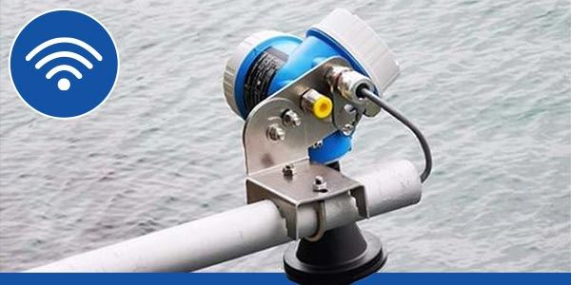

Figure #. YSI Nile Radar

1. **Ultrasonic Sensors**
   1. Ultrasonic sensors are similar to radars, as both sensors are typically installed above the water’s surface. However, ultrasonic sensors use ultrasonic sound waves – these require a medium to pass through, unlike microwaves – to determine the distance from the face of the sensor to the surface of the water by timing how long it takes the signal to return.

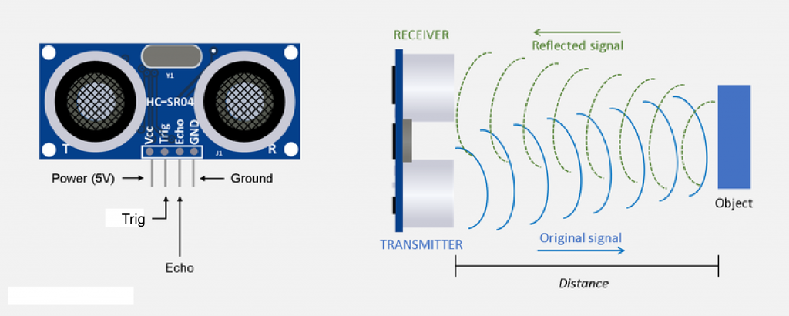

Figure #. Ultrasonic Sensor HC-SR04

**Internet of Things**

The internet of things, or IoT, is a networked system of interconnected computing devices, mechanical and digital machinery, items, animals, or people with unique identities (UIDs) and the capacity to transfer data without needing human-to-human or human-to-computer contact.

The Inter net of things (IoT) may assist this smart water level monitoring system by tracking water level fluctuations, producing results, and sending those data to a web server which then can be processed and thereafter viewed in a specific web site/page.

**How IoT works**

An IoT ecosystem is made up of web-enabled smart devices that employ embedded systems including processors, sensors, and communication gear to gather, send, and act on data from their surroundings. IoT devices exchange sensor data by connecting to an IoT gateway or other edge device, where data is either transferred to the cloud for analysis or examined locally. These gadgets occasionally interact with one another and act on the information they receive.

The gadgets conduct the majority of the work without human interaction, while individuals may engage with them to set them up, give them instructions, or view the data. The connection, networking, and communication protocols utilized with these web-enabled devices are heavily influenced by the IoT applications that are implemented. IoT may also leverage artificial intelligence (AI) and machine learning to make data collection easier and more dynamic.

**Chart.js Library**

Chart.js is a Javascript library that allows designers and developers to draw all kinds of charts using the HTML5 canvas element.

Chart.js offers a great array of simple, clean charts including animated and interactive versions. It's an easy way to include beautiful and engaging charts into your website for free.

**Features**

* Eight different chart types, all animated and customizable
* Mixed chart types provide a clear visual distinction between datasets
* Great rendering performance across all modern browsers (IE9+)
* Redraws charts on window resize for perfect scale granularity

Embedding Chart.js into the Web System the user can simply view the data readings as presented in various visualization features included. By fetching the data through PHP Script as backend and MySQL as a means for data storage and visualizing the fetched data through Chart.js. The user then can monitor water levels easily visualizing readings.

**Planning, Analysis, Design, Implementation and Sustainability**

**(P. A. D. I. S.)**

**Planning**

This phase requires study and analysis culminating in the full project management plan and that may lead to system development activities. This is where the research starts, planning is to aim the target of the research which is the online smart water level monitoring system. The system includes the ease of use, to provide early warnings through implementing the alert system and to increase awareness of possible flooding or overflowing in nearby rivers. In the planning phase, sufficient requirement detail is required to support development of the project’s management plan and permit outside validation of this deliverable.

**Analysis**

The Analysis Phase is where the project lifecycle begins. The Analysis Phase is also the part of the project where it will identify the overall direction that the project will take through the creation of the project strategy documents. Gathering requirements is the main attraction of the Analysis Phase. The process of gathering requirements is usually more than simply asking the users what they need and writing their answers down. Depending on the complexity of the application, the process for gathering requirements has a clearly defined process of its own. This process consists of a group of repeatable processes that utilize certain techniques to capture, document, communicate, and manage requirements.

**Design**

The Design phase is when it will build the plan for how you will take your project through the rest of the SDL process—from implementation, to verification, to release. During the Design phase it will establish best practices to follow for this phase by way of functional and design specifications, and it will perform risk analysis to identify threats and vulnerabilities in your software and hardware.

**Implementation**

The Implementation Phase has one key activity: deploying the new system in its target environment. Supporting actions include training end-users and preparing to turn the system over to maintenance personnel. After this phase, the system enters the Operations and Maintenance Phase for the remainder of the system’s operational life. Multiple-release projects require multiple iterations of the Implementation Phase – one for each release.

**Sustainability**

During the Operations and Maintenance Phase, the information system’s availability and performance in executing the work for which it was designed is maintained. The State realizes the largest value for the system during this phase. System operations continue until the system’s termination date, when the next phase, disposition, begins.

**Smart Water Level Monitoring System**

Smart Water Level Monitoring System is a simple and easy to build device assisted by a standalone system for the device using Arduino and a WIFI Module for data transmission, that can be built using a variety of sensors by adapting on which environment will the device is to be used. By building the device and implementing it further increases the safety and awareness of the residents in rural areas and possibly urban areas. In which are nearby unmonitored rivers and bridges, it can help passersby alert them of the rising and lowering of water levels under bridges and nearby rivers by sound and light (LED) indicators.

**Related Studies**

**WATER LEVEL MONITORING SYSTEM USING IOT**

**By: Priya J, Sailusha Chekuri**

**PG Student, Dept. of Computer Science and Engineering, RIT, Bengaluru, India**

Imagine the usefulness of being able to switch on the air conditioner system ten minutes before you get home on a hot afternoon. How about security system to detect smoke, burglary attempts alerted to you. These imaginations build the idea of Water Level Monitoring that has no end. The sophisticated Water Level Monitoring systems of course record the usage of water.

Technology nowadays has become an integrated part of people's lives. It has, and continues to influence many aspects of daily life and has allowed better social interaction, ease of transportation, the ability to indulge in entertainment and media and has helped in the development in medicine. The creation of many devices such as mobile phones and computers have caused many people to rely on technology to communicate with their friends, store information such as pictures, movies, documents, and music

The internet has become a common interface that many devices use in order to simplify the daily life of many people giving the ability to search for information, store their own information in the cloud while also giving them better ways of managing information. From the time of its introduction, the number of people that use mobile phones and the internet to communicate with other people has increased dramatically to become one of the major means of communication.

People with the help of smartphones can now connect to the internet without the need for a computer, while still offering the same functionality but through different means. With the introduction of advanced software and hardware devices, smartphones are now powerful devices and have become an important part of people’s daily lives. A major aspect is how the Smartphone is able to connect and communicate with other devices.

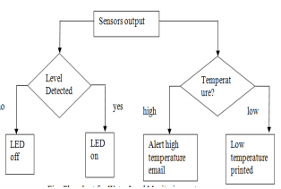A field that is recently gaining popularity is Water Level Monitoring which can also use smartphones as information or functionality hubs.

**Chart 1: Flowchart of the Proposed system**

The Internet has changed the dimensions of life involving virtual interaction. IOT has the potential to add new dimensions enabling smarter objects communications. The project proposes a simple water level monitoring system with different levels indicated. It also signifies when the water level is below and above then the requirement. System design and architecture is as discussed, thus being a cost effective and simple strategy to monitor the water level system.

Future Work can involve the analysis of water level in a particular area so that the wastage of water is prevented. We also include the GSM-based system where the message will be sent to the particular authorized person when the water level is below the required level.

WATER LE VEL MON ITORING SYSTEM

A Final Project

Presented to the Course Specialists of the

College of Engineering and Computing Sciences of

Batangas State University ARASOF Nasugbu

Nasugbu, Batangas

In Partial Fulfilment of the Requirements for

NTT 402 Internet of Things Cours

WATER LE VEL MON ITORING SYSTEM

A Final Project

Presented to the Course Specialists of the

College of Engineering and Computing Sciences of

Batangas State University ARASOF Nasugbu

Nasugbu, Batangas

In Partial Fulfilment of the Requirements for

NTT 402 Internet of Things Cours

WATER LE VEL MON ITORING SYSTEM

A Final Project

Presented to the Course Specialists of the

College of Engineering and Computing Sciences of

Batangas State University ARASOF Nasugbu

Nasugbu, Batangas

In Partial Fulfilment of the Requirements for

NTT 402 Internet of Things Cours

WATER LE VEL MON ITORING SYSTEM

A Final Project

Presented to the Course Specialists of the

College of Engineering and Computing Sciences of

Batangas State University ARASOF Nasugbu

Nasugbu, Batangas

In Partial Fulfilment of the Requirements for

NTT 402 Internet of Things Cours

WATER LE VEL MON ITORING SYSTEM

A Final Project

Presented to the Course Specialists of the

College of Engineering and Computing Sciences of

Batangas State University ARASOF Nasugbu

Nasugbu, Batangas

In Partial Fulfilment of the Requirements for

NTT 402 Internet of Things Cours

A Final Project

Presented to the Course Specialists of the

College of Engineering and Computing Sciences of

Batangas State University ARASOF Nasugbu

Nasugbu, Batanga

A Final Project

Presented to the Course Specialists of the

College of Engineering and Computing Sciences of

Batangas State University ARASOF Nasugbu

Nasugbu, Batanga

A Final Project

Presented to the Course Specialists of the

College of Engineering and Computing Sciences of

Batangas State University ARASOF Nasugbu

Nasugbu, Batanga

A Final Project

Presented to the Course Specialists of the

College of Engineering and Computing Sciences of

Batangas State University ARASOF Nasugbu

Nasugbu, Batanga

A Final Project

Presented to the Course Specialists of the

College of Engineering and Computing Sciences of

Batangas State University ARASOF Nasugbu

Nasugbu, Batanga

Presented to the Course Specialists of the

College of Engineering and Computing Sciences of

Batangas State University ARASOF Nasugbu

Nasugbu, Batanga

WATER LE VEL MON ITORING SYSTEM

A Final Project

Presented to the Course Specialists of the

College of Engineering and Computing Sciences of

Batangas State University ARASOF Nasugbu

Nasugbu, Batangas

In Partial Fulfilment of the Requirements for

NTT 402 Internet of Things Cours

WATER LE VEL MON ITORING SYSTEM

A Final Project

Presented to the Course Specialists of the

College of Engineering and Computing Sciences of

Batangas State University ARASOF Nasugbu

Nasugbu, Batangas

In Partial Fulfilment of the Requirements for

NTT 402 Internet of Things Cours

WATER LE VEL MON ITORING SYSTEM

A Final Project

Presented to the Course Specialists of the

College of Engineering and Computing Sciences of

Batangas State University ARASOF Nasugbu

Nasugbu, Batangas

In Partial Fulfilment of the Requirements for

NTT 402 Internet of Things Cours

WATER LE VEL MON ITORING SYSTEM

A Final Project

Presented to the Course Specialists of the

College of Engineering and Computing Sciences of

Batangas State University ARASOF Nasugbu

Nasugbu, Batangas

In Partial Fulfilment of the Requirements for

NTT 402 Internet of Things Cours

**WATER LEVEL MONITORING SYSTEM**

**Final Project Presented to the Course Specialists of the College of Engineering and Computing Sciences of Batangas State University ARASOF Nasugbu Nasugbu, Batangas**

**In Partial Fulfilment of the Requirements for NTT 402 Internet of Things Course By Calvin John V. Placio December 2020**

The Typhoons are a very dangerous natural phenomenon in our planet one snap and it can blew away

different structures like boats, houses and other that can be dangerous for us. Forecasting thru Television

watching can help us to be aware of the happening and state of our places (city, municipality or regional

channels) but this forecast is not enough to know what is happening soon or can happen soon in other words.

The forecasting of the weather or physical data aspect must be done on localize means, but what are the tools we

must have to attain this kind of community oriented system that will give the chance to the community to know

what is happening on their community such as high water level or storm surge this kind of event mostly happens

on fishing villages. Many boats has been destroyed by this events why? Because the user is not aware of this

event will happen to the seashore. Awareness must spread across the community. The internet of things became

a trend on the computing industry because it offers accessibility to the data set needed to perform specific tasks

like generating a temperature report on a specific timeframe and many more like remote controlled houses.

The Typhoons are a very dangerous natural phenomenon in our planet one snap and it can blew away

different structures like boats, houses and other that can be dangerous for us. Forecasting thru Television

watching can help us to be aware of the happening and state of our places (city, municipality or regional

channels) but this forecast is not enough to know what is happening soon or can happen soon in other words.

The forecasting of the weather or physical data aspect must be done on localize means, but what are the tools we

must have to attain this kind of community oriented system that will give the chance to the community to know

what is happening on their community such as high water level or storm surge this kind of event mostly happens

on fishing villages. Many boats has been destroyed by this events why? Because the user is not aware of this

event will happen to the seashore. Awareness must spread across the community. The internet of things became

a trend on the computing industry because it offers accessibility to the data set needed to perform specific tasks

like generating a temperature report on a specific timeframe and many more like remote controlled houses.

The Typhoons are a very dangerous natural phenomenon in our planet one snap and it can blew away

different structures like boats, houses and other that can be dangerous for us. Forecasting thru Television

watching can help us to be aware of the happening and state of our places (city, municipality or regional

channels) but this forecast is not enough to know what is happening soon or can happen soon in other words.

The forecasting of the weather or physical data aspect must be done on localize means, but what are the tools we

must have to attain this kind of community oriented system that will give the chance to the community to know

what is happening on their community such as high water level or storm surge this kind of event mostly happens

on fishing villages. Many boats has been destroyed by this events why? Because the user is not aware of this

event will happen to the seashore. Awareness must spread across the community. The internet of things became

a trend on the computing industry because it offers accessibility to the data set needed to perform specific tasks

like generating a temperature report on a specific timeframe and many more like remote controlled houses.

The Typhoons are a very dangerous natural phenomenon in our planet one snap and it can blew away

different structures like boats, houses and other that can be dangerous for us. Forecasting thru Television

watching can help us to be aware of the happening and state of our places (city, municipality or regional

channels) but this forecast is not enough to know what is happening soon or can happen soon in other words.

The forecasting of the weather or physical data aspect must be done on localize means, but what are the tools we

must have to attain this kind of community oriented system that will give the chance to the community to know

what is happening on their community such as high water level or storm surge this kind of event mostly happens

on fishing villages. Many boats has been destroyed by this events why? Because the user is not aware of this

event will happen to the seashore. Awareness must spread across the community. The internet of things became

a trend on the computing industry because it offers accessibility to the data set needed to perform specific tasks

like generating a temperature report on a specific timeframe and many more like remote controlled houses.

The Typhoons are a very dangerous natural phenomenon in our planet one snap and it can blew away

different structures like boats, houses and other that can be dangerous for us. Forecasting thru Television

watching can help us to be aware of the happening and state of our places (city, municipality or regional

channels) but this forecast is not enough to know what is happening soon or can happen soon in other words.

The forecasting of the weather or physical data aspect must be done on localize means, but what are the tools we

must have to attain this kind of community oriented system that will give the chance to the community to know

what is happening on their community such as high water level or storm surge this kind of event mostly happens

on fishing villages. Many boats has been destroyed by this events why? Because the user is not aware of this

event will happen to the seashore. Awareness must spread across the community. The internet of things became

a trend on the computing industry because it offers accessibility to the data set needed to perform specific tasks

like generating a temperature report on a specific timeframe and many more like remote controlled houses.

The Typhoons are a very dangerous natural phenomenon in our planet one snap and it can blow away different structures like boats, houses and other that can be dangerous for us. Forecasting thru Television watching can help us to be aware of the happening and state of our places (city, municipality or regional channels) but this forecast is not enough to know what is happening soon or can happen soon in other words. The forecasting of the weather or physical data aspect must be done on localize means, but what are the tools we must have to attain this kind of community-oriented system that will give the chance to the community to know what is happening on their community such as high-water level or storm surge this kind of event mostly happens on fishing villages. Many boats had been destroyed by these events why? Because the user is not aware of this event will happen to the seashore. Awareness must spread across the community. The internet of things became a trend on the computing industry because it offers accessibility to the data set needed to perform specific tasks like generating a temperature report on a specific timeframe and many more like remote controlled houses.

This type of technology offers a lot that it can be used on forecasting different areas r field, in addition to

that it can be used from home to an enterprise type of function. Sensors plays a vital part on the internet of

things with this gathering data from the physical to digital data and storing it in some sort of repository like

database which can be used on later usage (generating reports or viewing data). The integration of different

technology can be a solution for all in a community. A sensor, modules like GSM for texting message and a

water level sensor that is attached to a micro controller (Arduino or Raspberry pie) connected to a Wi-Fi is a

good starting point on developing this project. Plus an ability to print a report is a must on this system example

is the brgy captain is accessing the website that is where the microcontroller uploads data and he need a daily

report then it will be a useful project so that we have a good input and applies the principle of IPO (input,

process and output).

This type of technology offers a lot that it can be used on forecasting different areas r field, in addition to that it can be used from home to an enterprise type of function. Sensors plays a vital part on the internet of things with this gathering data from the physical to digital data and storing it in some sort of repository like database which can be used on later usage (generating reports or viewing data). The integration of different technology can be a solution for all in a community. A sensor, modules like GSM for texting message and a water level sensor that is attached to a micro controller (Arduino or Raspberry pie) connected to a Wi-Fi is a good starting point on developing this project. Additionally an ability to print a report is a must on this system example is the barangay captain is accessing the website that is where the microcontroller uploads data and he need a daily report then it will be a useful project so that we have a good input and applies the principle of IPO (input, process and output).

**Logical design of the project**

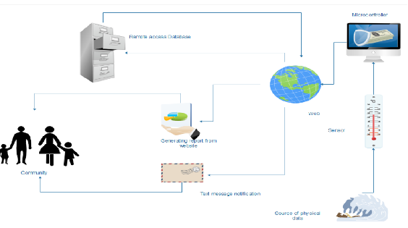

With the help of different modules that the system will be able to communicate to the end user using the GSM (Text message service) and Wi-Fi to connect to the web, uploading the physical data to the repository or in an online MySQL hosting website for storing of the physical data, then the data will be use soon for the report generation for the end user. The website also has advisory features like the GSM text notification. For reporting purpose for the system can also generate a printable report formats can be docs or pdf for a more secure report generation.

Presented to the Course Specialists of the

College of Engineering and Computing Sciences of

Batangas State University ARASOF Nasugbu

Nasugbu, Bat

**Related Prototypes**

**Prototype of Water Level Control System**

**By: K Karwati* and J Kustija**

K Karwati* and J Kustija

Department of Electrical Engineering Education, Universitas Pendidikan Indonesia,

Jl. Dr. Setiabudhi No. 207, Bandung 40154, Indonesia

**Department of Electrical Engineering Education, Universitas Pendidikan Indonesia, Jl. Dr. Setiabudhi No. 207, Bandung 40154, Indonesia**

Global climate and unpredictable rain circle may cause uncertainty of water availability. Recently, a very important problem from all over the world is the management of water resources. Water is commonly used in households, agriculture, and industry. Therefore, we need technology which can increase water distribution efficiency. In practice are known that many types of water level control system that can be done. Such system includes providing flood prediction, environmental protection, water discharge, power plant system, providing water control in industry, simple water level control in the home. The most efficiency of water distribution system to every aspect can be enhanced through dam automation. For that application can be done by designing open and close automatic water gate at the dam for a drainage system. The drainage system efficiency is not more than 40% if manually operated, through some automation, the drainage system efficiency can be enhanced to 50%. This paper design prototype water level control system by open and close automatically the water gate uses ultrasonic sensor. Open and close automatically the water gate becomes one of the means of service in an effort to control the distribution of more efficient drainage system to every aspect so as to minimalize the risk of the flood.

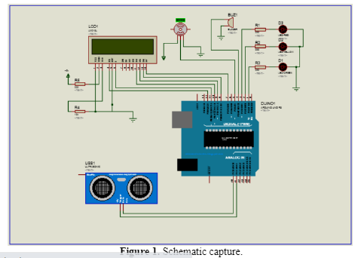2.1. Software design in this paper, the ultrasonic sensor reads the water level in the aquarium as input to the Arduino. As output, the servo would move the door aquarium, and water level conditions would be visible on LCD and led, as illustrated in the following schematic capture by Proteus (Figure 1).

The open and close automatically water gate operation is illustrated in block diagram system (Figure 2). The diagram contains several parts, that is, water level detected by the ultrasonic sensor, input data from ultrasonic sensor to Arduino, Arduino set servo motion, the servo for moving the water gate (the door aquarium), and the ultrasonic sensor for making feedback to Arduino. If the water level is low so the door would close.

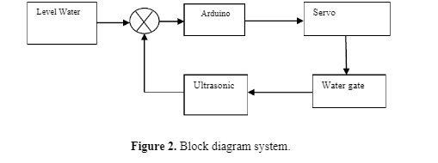

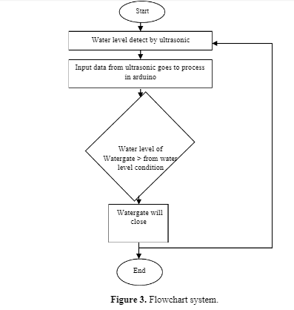

The flowchart of system is a follows (Figure 3).

The paper programs is set to 3 water level conditions, that is “AMAN” at water level ≤ 5 cm from ultrasonic sensor, “SIAGA” at 5 cm ≥ dist ≤ 10 cm from ultrasonic sensor, and “AWAS” at ≥ 10 cm from ultrasonic sensor. Designing software programs using Arduino software with C programming language.

Our design is in conformity with the intended purpose. The prototype of water level control system works well in distributing water in accordance with the water level, so it can be one of the contributors in the drainage system especially in the dam area to the surrounding environment. Based on the test results, the prototype can function well. From the sensor side, ultrasonic sensor is a good distance detection sensor with error 2.15% based on test results. Constraints in the use of 360 degree servo motors can be handled using the TIP 120, so the 360 servo motor can function as desired

Batangas State University ARASOF Nasugbu

Nasugbu, Batangas

In Partial Fulfilment of the Requirements for

NTT 402 Internet of Things Cours

A Final Project

Presented to the Course Specialists of the

College of Engineering and Computing Sciences of

Batangas State University ARASOF Nasugbu

Nasugbu, Batanga

A Final Project

Presented to the Course Specialists of the

College of Engineering and Computing Sciences of

Batangas State University ARASOF Nasugbu

Nasugbu, Batanga

A Final Project

Presented to the Course Specialists of the

College of Engineering and Computing Sciences of

Batangas State University ARASOF Nasugbu

Nasugbu, Batanga

A Final Project

Presented to the Course Specialists of the

College of Engineering and Computing Sciences of

Batangas State University ARASOF Nasugbu

Nasugbu, Batanga

A Final Project

Presented to the Course Specialists of the

College of Engineering and Computing Sciences of

Batangas State University ARASOF Nasugbu

Nasugbu, Batanga

Presented to the Course Specialists of the

College of Engineering and Computing Sciences of

Batangas State University ARASOF Nasugbu

Nasugbu, Batanga

WATER LE VEL MON ITORING SYSTEM

A Final Project

Presented to the Course Specialists of the

College of Engineering and Computing Sciences of

Batangas State University ARASOF Nasugbu

Nasugbu, Batangas

In Partial Fulfilment of the Requirements for

NTT 402 Internet of Things Cours

WATER LE VEL MON ITORING SYSTEM

A Final Project

Presented to the Course Specialists of the

College of Engineering and Computing Sciences of

Batangas State University ARASOF Nasugbu

Nasugbu, Batangas

In Partial Fulfilment of the Requirements for

NTT 402 Internet of Things Cours

WATER LE VEL MON ITORING SYSTEM

A Final Project

Presented to the Course Specialists of the

College of Engineering and Computing Sciences of

Batangas State University ARASOF Nasugbu

Nasugbu, Batangas

In Partial Fulfilment of the Requirements for

NTT 402 Internet of Things Cours

WATER LE VEL MON ITORING SYSTEM

A Final Project

Presented to the Course Specialists of the

College of Engineering and Computing Sciences of

Batangas State University ARASOF Nasugbu

Nasugbu, Batangas

In Partial Fulfilment of the Requirements for

NTT 402 Internet of Things Cour

The Typhoons are a very dangerous natural phenomenon in our planet one snap and it can blew away

different structures like boats, houses and other that can be dangerous for us. Forecasting thru Television

watching can help us to be aware of the happening and state of our places (city, municipality or regional

channels) but this forecast is not enough to know what is happening soon or can happen soon in other words.

The forecasting of the weather or physical data aspect must be done on localize means, but what are the tools we

must have to attain this kind of community oriented system that will give the chance to the community to know

what is happening on their community such as high water level or storm surge this kind of event mostly happens

on fishing villages. Many boats has been destroyed by this events why? Because the user is not aware of this

event will happen to the seashore. Awareness must spread across the community. The internet of things became

a trend on the computing industry because it offers accessibility to the data set needed to perform specific tasks

like generating a temperature report on a specific timeframe and many more like remote controlled houses.

The Typhoons are a very dangerous natural phenomenon in our planet one snap and it can blew away

different structures like boats, houses and other that can be dangerous for us. Forecasting thru Television

watching can help us to be aware of the happening and state of our places (city, municipality or regional

channels) but this forecast is not enough to know what is happening soon or can happen soon in other words.

The forecasting of the weather or physical data aspect must be done on localize means, but what are the tools we

must have to attain this kind of community oriented system that will give the chance to the community to know

what is happening on their community such as high water level or storm surge this kind of event mostly happens

on fishing villages. Many boats has been destroyed by this events why? Because the user is not aware of this

event will happen to the seashore. Awareness must spread across the community. The internet of things became

a trend on the computing industry because it offers accessibility to the data set needed to perform specific tasks

like generating a temperature report on a specific timeframe and many more like remote controlled houses.

The Typhoons are a very dangerous natural phenomenon in our planet one snap and it can blew away

different structures like boats, houses and other that can be dangerous for us. Forecasting thru Television

watching can help us to be aware of the happening and state of our places (city, municipality or regional

channels) but this forecast is not enough to know what is happening soon or can happen soon in other words.

The forecasting of the weather or physical data aspect must be done on localize means, but what are the tools we

must have to attain this kind of community oriented system that will give the chance to the community to know

what is happening on their community such as high water level or storm surge this kind of event mostly happens

on fishing villages. Many boats has been destroyed by this events why? Because the user is not aware of this

event will happen to the seashore. Awareness must spread across the community. The internet of things became

a trend on the computing industry because it offers accessibility to the data set needed to perform specific tasks

like generating a temperature report on a specific timeframe and many more like remote controlled houses.

The Typhoons are a very dangerous natural phenomenon in our planet one snap and it can blew away

different structures like boats, houses and other that can be dangerous for us. Forecasting thru Television

watching can help us to be aware of the happening and state of our places (city, municipality or regional

channels) but this forecast is not enough to know what is happening soon or can happen soon in other words.

The forecasting of the weather or physical data aspect must be done on localize means, but what are the tools we

must have to attain this kind of community oriented system that will give the chance to the community to know

what is happening on their community such as high water level or storm surge this kind of event mostly happens

on fishing villages. Many boats has been destroyed by this events why? Because the user is not aware of this

event will happen to the seashore. Awareness must spread across the community. The internet of things became

a trend on the computing industry because it offers accessibility to the data set needed to perform specific tasks

like generating a temperature report on a specific timeframe and many more like remote controlled houses.

The Typhoons are a very dangerous natural phenomenon in our planet one snap and it can blew away

different structures like boats, houses and other that can be dangerous for us. Forecasting thru Television

watching can help us to be aware of the happening and state of our places (city, municipality or regional

channels) but this forecast is not enough to know what is happening soon or can happen soon in other words.

The forecasting of the weather or physical data aspect must be done on localize means, but what are the tools we

must have to attain this kind of community oriented system that will give the chance to the community to know

what is happening on their community such as high water level or storm surge this kind of event mostly happens

on fishing villages. Many boats has been destroyed by this events why? Because the user is not aware of this

event will happen to the seashore. Awareness must spread across the community. The internet of things became

a trend on the computing industry because it offers accessibility to the data set needed to perform specific tasks

**Conceptual Framework of the Research**

**Output**

**Smart Water Level Monitoring System**

**Input**

1. **Knowledge – based requirements**
2. **Requirements specification**

Hardware Requirements

* Laptop / PC
* Smartphone / Cellphone

Software Requirements

1. Internet
2. Web Browser
3. HTML-CSS / JS / PHP / Mysql
4. XAMPP
5. Any applicable IDE / Code Editor

**OUTCOME**

**Functionality, Efficiency, Reliability, Sustainability, Usability**

**Process**

1. **Data Gathering**
2. **Planning**

* Observation
* Interview
* Review of Documents

1. **Analysis**

* System Planning
* Concept Modeling
* Data Modeling

1. **Design**

* System Designing

1. **Implementation**

* Coding
* Device Assembling
* Device Installation

1. **Sustainability**

Figure 6. Conceptual Framework

The hardware and software are located in the left side box. The input spectrum of the research also includes the Needs Specification. The middle box's core contains the development process used to create the system, which includes planning, analysis, design, implementation, and sustainability. The system's characteristics are listed in the right-side box, which is titled Smart Water Level Monitoring System. The box below provides the study's findings, which include the acceptability.