**Chapter 3**

**Research Methodology**

This chapter presents methodology processes and procedures required in the realization of this research study using the Planning, Analysis, Design, Implementation and Sustainability (PADIS) method.

**Development Research Method**

This project's objective was to create and implement a smart water level monitoring system that would track water level and volume, produce results, and send those data to the communities via a simple message system so they could take the appropriate safety precautions. The researcher employed the developmental research approach in establishing the problem, data gathering, software creation, testing, and proposal assessment to determine how the system works in areas of Functionality, Efficiency, Reliability, Usability, and Sustainability.

**Research Environment**

This research would conducted in the municipality of Kabasalan, which was located in the province of Zamboanga Sibugay, Philippines. The researchers in this research guarantee that the survey setting type they chose was acceptable for the number of respondents who may participate to the research. With a total size of 241.60 km2 (93.28 sq mi), the municipality of Kabasalan was perfect for the researcher to perform the survey on Brgy Calubihan, Kabasalan, Zamboanga Sibugay in order to collect findings. Theresearchers will conduct a survey on Smart Water Level System to assist riverfront residents in avoiding the hazard of rising water in the river.

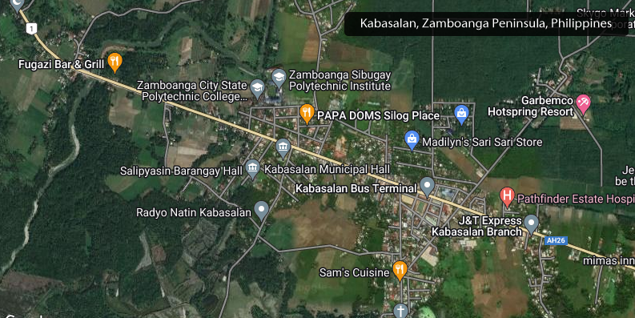

Figure 7. Kabasalan, Zamboanga Sibugay Map

**Research Respondents**

In the Municipality of Ipil, the researcher may conduct an interview among 50 respondents from various staff and residents who live close to a river.

|  |  |
| --- | --- |
| **Respondents** | **Number of Respondents** |
| Random residents | 20 |
| NDRMMC Staff | 10 |
| Residents near the bridge | 20 |
| **TOTAL** | **50** |

**Table 1. Research Respondents Table**

SURVEY QUESTIONAIRE

Name: Gender:

**Smart Water Level Monitoring System**

|  |  |  |  |  |  |
| --- | --- | --- | --- | --- | --- |
| CRITERIA | RATINGS | | | | |
| 1 | 2 | 3 | 4 | 5 |
| I. Functionality | | | | | |
| 1. Compliance of End Users needs |  |  |  |  |  |
| 2. Compatibility with the other systems |  |  |  |  |  |
| 3. Fitness of its intended use |  |  |  |  |  |
| 4. Protect all records inside the system |  |  |  |  |  |
| 5. The system provides useful time-savings and accurate |  |  |  |  |  |
| II. Efficiency | | | | | |
| 1. Support a minimum transaction of the system |  |  |  |  |  |
| 2. Support a number of system users at a time |  |  |  |  |  |
| 3. Increase system production at a quality |  |  |  |  |  |
| 4. Reduce the system development cost |  |  |  |  |  |
| 5. Cost Efficient |  |  |  |  |  |
| III. Reliability | | | | | |
| 1. Perform correct function |  |  |  |  |  |
| 2. Quick checking of requested information |  |  |  |  |  |
| 3. Accurate on data retrieval |  |  |  |  |  |
| 4. The reports that made by system are consistent without the documents |  |  |  |  |  |
| 5. Modify and correct wrong information |  |  |  |  |  |
| IV. Usability | | | | | |
| 1. User friendly |  |  |  |  |  |
| 2. The user is satisfied with the system outputs |  |  |  |  |  |
| 3. Simple driven program |  |  |  |  |  |
| 4. Easy to accomplish the basic task through graphical design |  |  |  |  |  |
| 5. Provide a detailed design to the user |  |  |  |  |  |
| V. Sustainability | | | | | |
| 1. It is easy to find a failure when it occurs |  |  |  |  |  |
| 2. Changes are easy to test |  |  |  |  |  |
| 3. It is easy to modify and adapt |  |  |  |  |  |

Directions: Please rate accordingly and check the box for your ratings:

_____ Recommended

_____ Not Recommended

**Research Instrument**

The research would be using the necessary parts for the device from Arduino Kit which would be mainly the water sensor as it is the most important part of the device as well as a part of the device that is used to send SMS and a Wi-fi module to connect to the internet to send live data from monitoring the water level, as for the IoT part, we would be using the HTML/CSS/JS for the platform for the frontend of website which shows the live updates for monitoring water levels and PHP for the backend scripting language and MySql to store the data being sent and shown from the device. As for how the device can sustain itself, supposed for the device to be isolated from electric power sources we proposed to use a solar powered source for the device to continue functioning in case of a power outage that results in the device becoming useless when sending real-time data to be monitored.

**Calendar Activities**

This graphically depicts the system's project timeline using a Gantt chart, which will assist us in determining how long this project should take, determining the resources required, and planning the order in which the researchers finish the project. This is a bar chart that illustrates the start and end dates of various project parts. The table on the next page displays the study's schedule of activities, which includes the project time period of the activities till they were completed. It will begin with planning in the third week of November.

During this step, the researcher initially gathers and searches the internet for information regarding irrigation and the problems it is experiencing. Second, they conduct interviews with study participants while maintaining social distance, and they solicit recommendations from various IT experts on how the system can run.

Data collection will take three (3) weeks until all relevant information is obtained. The researchers will also devote attention to the study's analytical phase during the third week of December. Analyzing the system's software needs will take more than a month. The researcher will develop a part of the system's structure as early as the first week of February, and it will take about 3 weeks to study the development part of the system's structure in project design, theoretical framework of the study, conceptual design, and the UML diagram of the proposed system.

The development of the study starts from the 1st week of February and it took eleven (11) weeks to create the foundation and structure of the system with the use of Visual Studio Code to create the program server. The system is also tested and evaluated by the researcher started from 4th week of March and ends on 3rd week of April; it took the researcher eighteen (18) weeks to finally finish the documentation of the proposed study.

While organizing the study's documents, obtaining data, assessing the requirements, developing the study, testing, and evaluating it, the researcher also keeps the system up to date by providing user trainings, which is part of maintaining the system until it is ready and done on April 4th.

|  |  |  |  |  |  |  |  |  |  |  |  |  |  |  |  |  |  |  |  |  |  |  |  |  |  |  |  |
| --- | --- | --- | --- | --- | --- | --- | --- | --- | --- | --- | --- | --- | --- | --- | --- | --- | --- | --- | --- | --- | --- | --- | --- | --- | --- | --- | --- |
| **Activities** | **November** | | | | **December** | | | | **January** | | | | | **February** | | | | | **March** | | | | | **April** | | | |
|  | 1 | 2 | 3 | 4 | 1 | 2 | 3 | 4 | 1 | 2 | 3 | 4 | 1 | | 2 | 3 | 4 | 1 | | 2 | 3 | 4 | 1 | | 2 | 3 | 4 |
| **Planning** |  |  |  |  |  |  |  |  |  |  |  |  |  | |  |  |  |  | |  |  |  |  | |  |  |  |
| **Analysis** |  |  |  |  |  |  |  |  |  |  |  |  |  | |  |  |  |  | |  |  |  |  | |  |  |  |
| **Design** |  |  |  |  |  |  |  |  |  |  |  |  |  | |  |  |  |  | |  |  |  |  | |  |  |  |
| **Implementation** |  |  |  |  |  |  |  |  |  |  |  |  |  | |  |  |  |  | |  |  |  |  | |  |  |  |
| **Sustainability** |  |  |  |  |  |  |  |  |  |  |  |  |  | |  |  |  |  | |  |  |  |  | |  |  |  |

**Table 2. Calendar of Activities**

**Development Methods and Approaches**

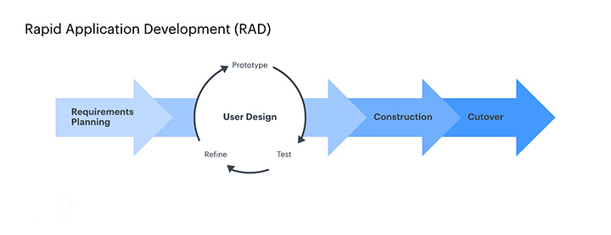This research would use Rapid Application Development in particular (RAD). In a RAD, the researcher will use a customized procedure in accordance with the demands and specifications of this project. The paradigm favors immediate feedback and functional prototypes over lengthy development and testing processes.

Figure 8. Rapid Application Development Model (RAD)

**Development Models and tools**

**UML Diagram**

In the figure below, it stands for how the system operates when interacting with humans. The user can be anyone who has access to the internet, and by accessing the system the user can monitor water levels on specific device by searching the device. The water levels are fetched from the database in which is stored by the device through requests from a live server.

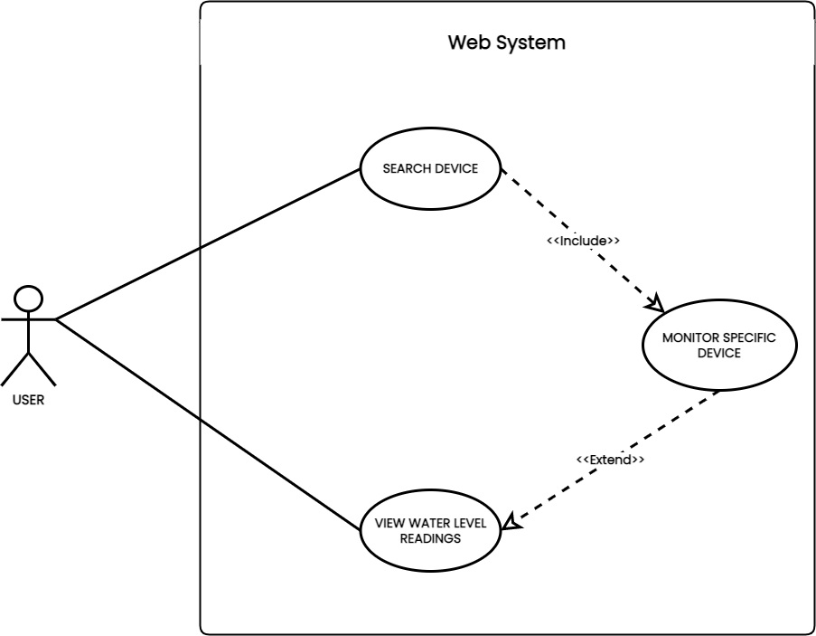

Figure 9. System Use Case Diagram

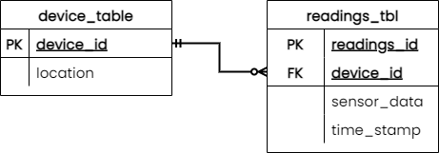

Figure 10. Entity Relationship Diagram

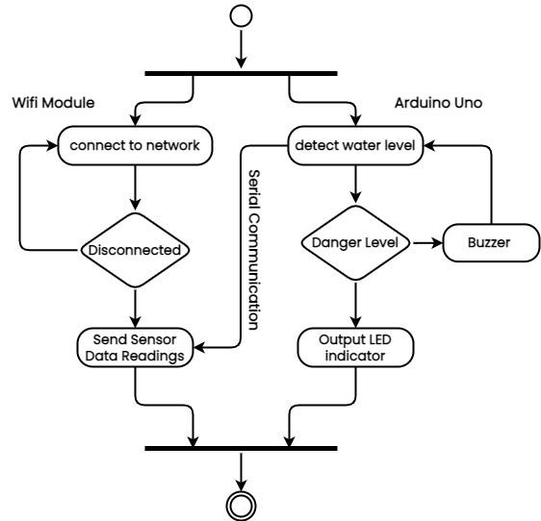

Figure 11. Device Activity Diagram

The Researcher will utilize the following as development models:

1. Web Technology. This technology shall serve as mediator to handle the implementation of the user and application web-based graphical user interfaces (GUI) as front-end.
2. Data Techonology. This technology shall handle the data repositories of the smart water level monitoring system.
3. Rapid Application Development(RAD). RAD shall be used in the development as technique to beat the time allocated for the development without sacrificing the quality of the proposed project.
4. Arduino Uno. The Arduino Uno is an open-source microcontroller board based on the Microchip ATmega328P microcontroller and developed by Arduino.cc. The board is equipped with sets of digital and analog input/output pins that may be interfaced to various expansion boards and other circuits.
5. Water Brick Sensor. Is designed for water detection, which can be widely used in sensing the rainfall, water level, even the liquate leakage.

Likewise, the researcher shall use as development tools to implement the development models mentioned, the following:

1. XAMPP(Apache, MySql). This will be utilized to create a local web server used for testing.
2. Navicat. A series of graphical database management and development software.
3. diagram.io. This application will be used to easily create UML diagram, Entity Relationship Diagram and etc.

**The Development Process**

When developing the research, the researcher would begin by evaluating the reasons for the need to construct a system. This stage assesses the researcher's future explanation plans, as well as the benefits, scope, risk, and resource needs. The creation of the research will begin with an initial planning session with Dr. Aurelio Mendoza Memorial Colleges, which will mark the start of the development. The development would be completed with graduation from Dr. Aurelio Mendoza Memorial Colleges.

Moreover, the researcher will be guided by the questions posed to the respondents, as well as the analysis of the data gathered, in order to resolve the challenges that exist in the current Smart Water Level System. The researcher will create the prototype to be used in the research after analyzing the data and determining the root cause of the problems. Specifications are broken down into precise new designs for the proposed system using Rapid Application Development (RAD) through extensive planning to solve software, interface, programming, data, and security challenges.