**How to use webapp on your localhost:**

**Note: You need to download WAMP (for Windows) for this!**

1). Unzip the folder [insert name here]

2). Place the folder directly under your localhost folder (www). So the folder should be under wamp64 🡪 www.

3). Make sure that the folder “app” is in the main folder.

4). To access the webapp, type <http://localhost/app> into your browser and it should open the application.

**How to deploy this webapp onto Amazon AWS Amplify (with screenshots):**

1). Zip the relevant files and rename the zip file to hungrymao

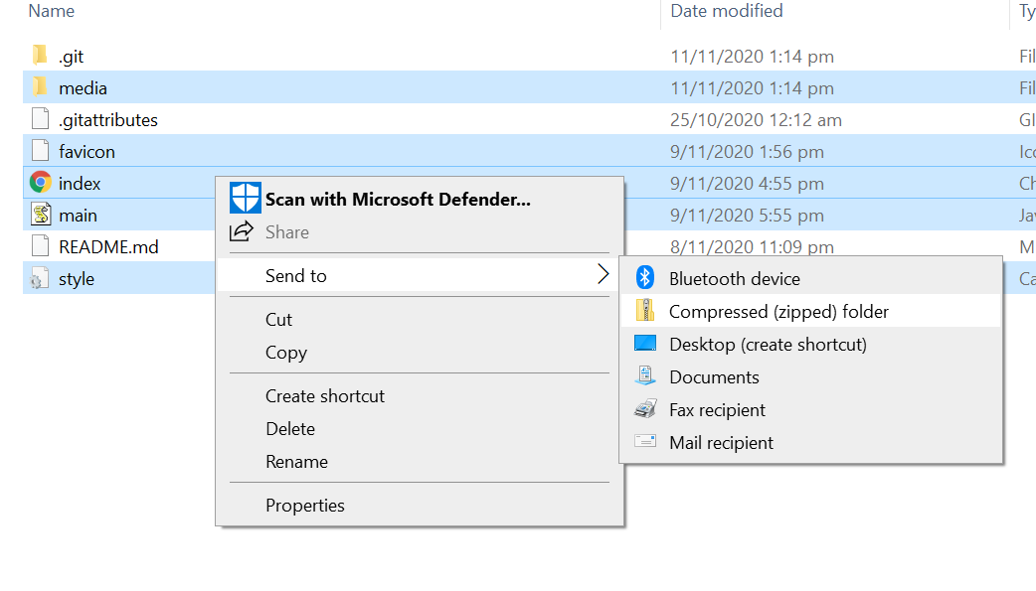



2). Go to <https://www.awseducate.com/signin/SiteLogin> and sign in

3). Click on My Classrooms, then click on ‘Go to classroom’ (box in red)

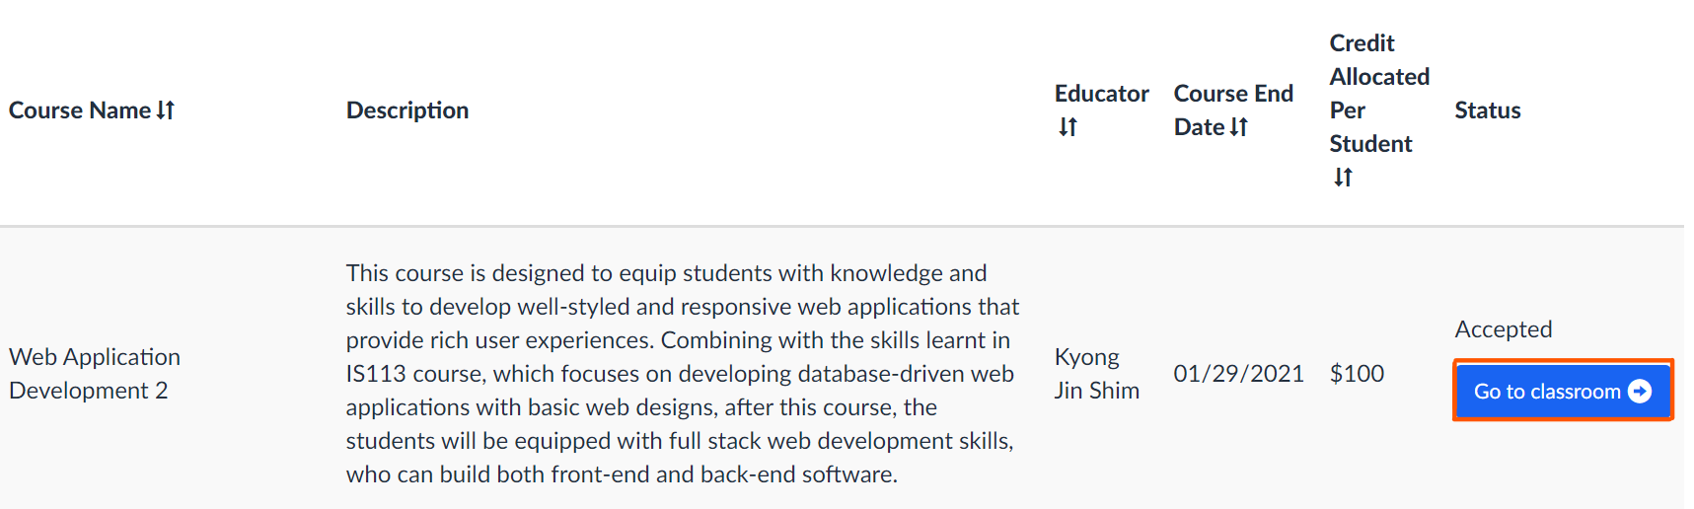

4). Click on AWS Console

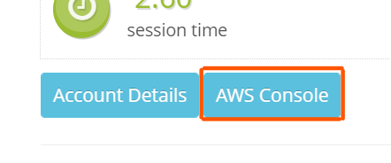

5). Search ‘AWS Amplify’ and you will reach this page

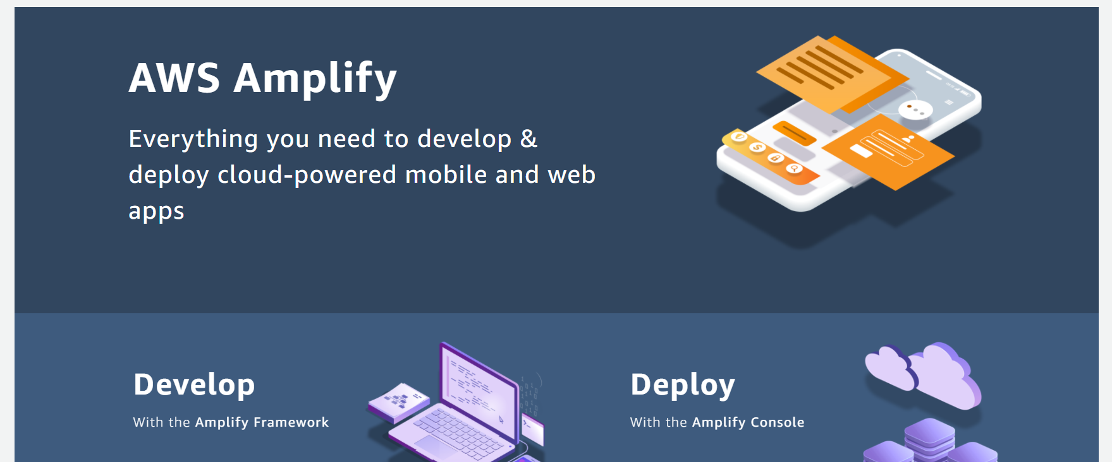

6). Under ‘Deploy’, Click ‘Get Started’

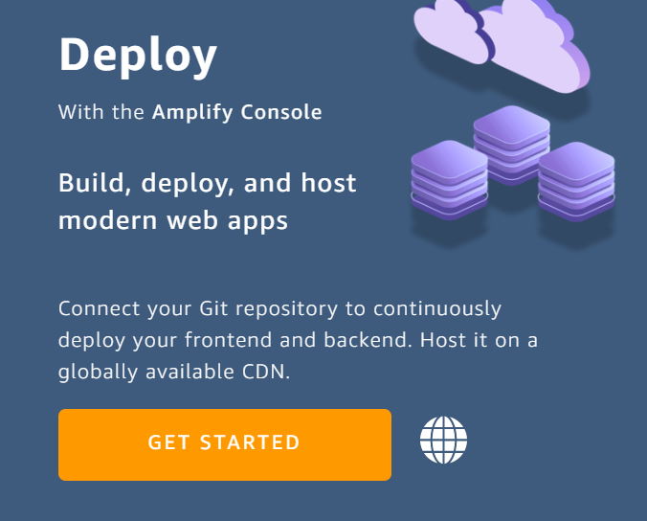

7). Choose ‘Deploy without Git provider’ and click continue

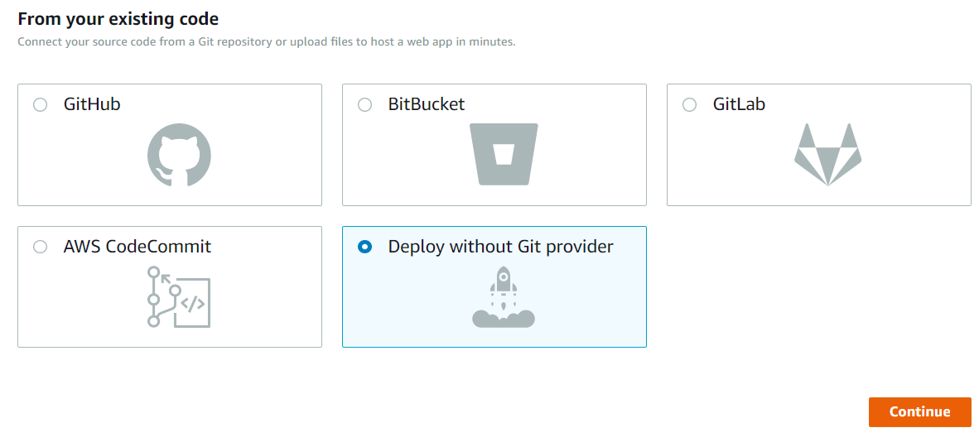

8). Fill in app name, environment name. Choose drag and drop method. Click choose files and choose hungrymao.zip

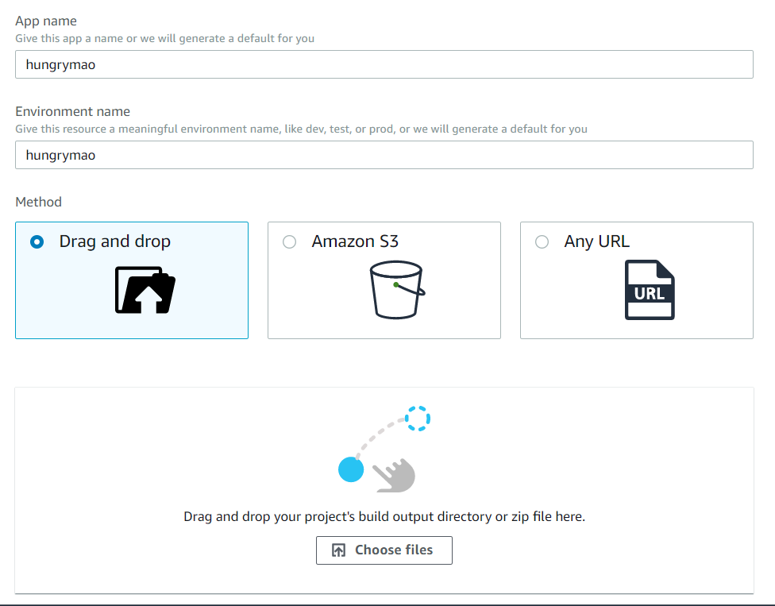

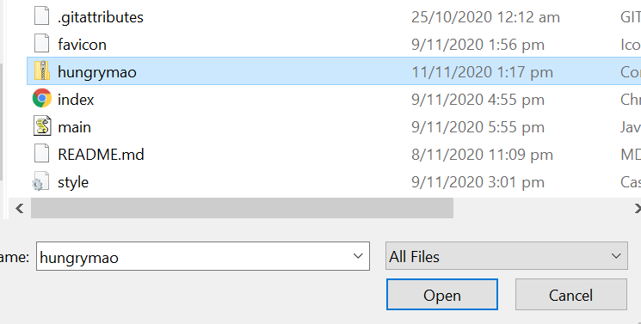

After choosing, click ‘Save and Deploy’

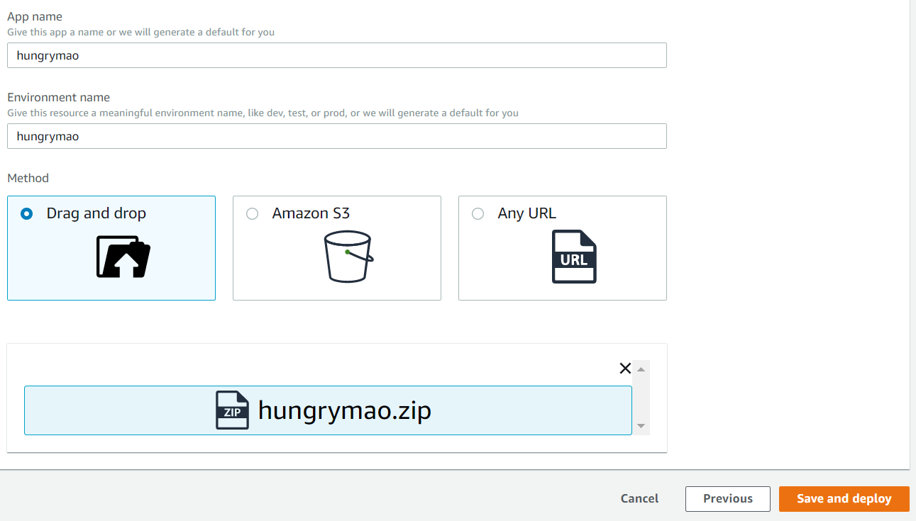

9). Wait for progress bar to reach 100%

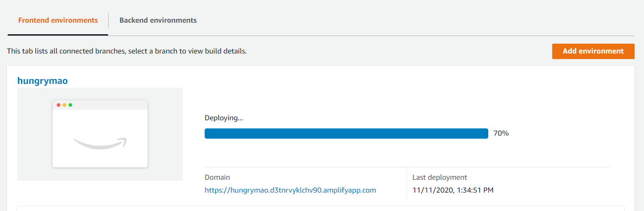

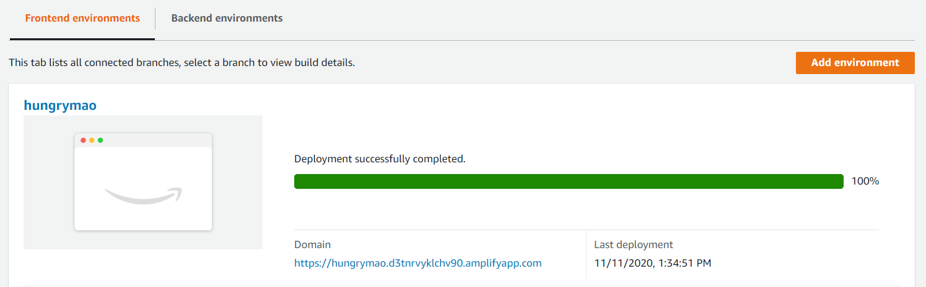

10). Click on Domain link to view your webapp

