Library Borrowing System - Project Requirements Specification

A. Programmer
John Prince Alonte

B. Project Title
Library Borrowing System

C. Description
A comprehensive library management system that allows users to borrow books using a slot-based system (10 slots per user), renew borrowed books with updated dates, return books with confirmation, and view all unreturned books with pagination. The system supports multiple user accounts (up to 10) with secure login.

D. Inputs

Main Menu Inputs
- Menu Selection: 1 (Login), 2 (Create New Account), or 3 (Exit)
- Username: Up to 20 characters
- Password: Up to 20 characters

Submenu Inputs
- Submenu Selection: 1 (Borrow), 2 (Renewal), 3 (Return), 4 (Read All), or 5 (Log Out)

Borrow Inputs
- Slot Number: 1-10 (user selects which slot to use)
- Author: Up to 50 characters
- Title: Up to 50 characters
- Publisher: Up to 50 characters
- Date Published: Up to 50 characters
- Date Borrowed: Up to 50 characters

Renewal Inputs
- Slot Number: 1-10 (ID of book to renew)
- New Date Borrowed: Up to 50 characters

Return Inputs
- Slot Number: 1-10 (ID of book to return)
- Confirmation: Y/N (confirm return action)

E. Processes

1. Main Menu
- Display header with programmer info, description, date, and project title
- Present three options: Login, Create New Account, Exit
- Process user selection and route to appropriate function

2. Create New Account
- Check if account limit (10 accounts) has been reached
- Accept username input (max 20 characters)
- Verify username doesn't already exist in system
- Accept password input (max 20 characters)
- Store username and password in arrays
- Increment account counter
- Display success message with username and password

3. Login
- Accept username input
- Search username array to verify existence
- If username not found, display error and return to main menu
- Accept password input
- Verify password matches stored password for that username
- If password incorrect, display error and return to main menu
- If successful, display welcome message and proceed to submenu

4. Submenu
- Display welcome message with username
- Present five options: Borrow, Renewal, Return, Read All, Log Out
- Process user selection and route to appropriate function

5. Borrow (Slot-Based System)
- Display all 10 slots with their status (EMPTY or OCCUPIED)
- For occupied slots, display the book title
- Accept slot number (1-10) from user
- Validate slot number is in range
- Check if selected slot is already occupied
- If occupied, display error and return to submenu
- If empty, prompt for book details (Author, Title, Publisher, Date Published, Date Borrowed)
- Store all book information in respective arrays indexed by user and slot
- Mark slot as occupied in status array
- Display success message

6. Renew
- Count user's borrowed books
- If no books borrowed, display message and return to submenu
- Display all occupied slots with: slot number, book title, author, and current date borrowed
- Accept slot number from user
- Validate slot number and check if occupied
- Display current book details including current date borrowed
- Accept new date borrowed
- Update date borrowed field in array
- Display success message

7. Return
- Count user's borrowed books
- If no books borrowed, display message and return to submenu
- Display all occupied slots with: slot number, title, and author
- Accept slot number from user
- Validate slot number and check if occupied
- Display full book details for confirmation
- Ask for Y/N confirmation
- If confirmed:
  - Clear all book data from arrays (all 5 fields)
  - Mark slot as empty in status array
  - Display success message
- If cancelled, return to submenu

8. Read All Unreturned Books (with Pagination)
- Count user's borrowed books
- If no books borrowed, display message and return to submenu
- Calculate total pages needed (2 books per page)
- Display books page by page:
  - Show page number (e.g., "Page 1 of 3")
  - Display up to 2 books per page with full details
  - Show: slot number, author, title, publisher, date published, date borrowed
  - After each page (except last), prompt "Press any key for next page..."
- After all books displayed, show total book count
- Wait for key press and return to submenu

9. Log Out
- Display logout message
- Reset current user index
- Return to main menu

F. Outputs

Header (shown on most screens)
Programmer: John Prince Alonte
Description: Library System
Date: November 28, 2025
Project Title: Final Project

Main Menu
===== MAIN MENU ====
1. Login
2. Create New Account
3. Exit

Choose option: _

Exit Message

Exiting, come back again!

Login Screen

===== LOGIN ====
Username: _
Password: _

Error Messages:
- "Invalid Username! Returning to Main Menu..."
- "Incorrect Password! Returning to Main Menu..."
Success:
- "Welcome [username]!"

Create Account Screen
===== CREATE NEW ACCOUNT ====
Username: _
Password: _

Error Messages:
- "Username already exists! Returning to Main Menu..."
- "Account limit reached! Maximum 10 accounts. Returning to Main Menu..."
Success:
- "Account created, hello [username]!"
- "Your password is [password]"

Submenu

Welcome [username]!
===== SUBMENU ====
1. Borrow
2. Renewal
3. Return
4. Read All
5. Log Out

Choose option: _

Borrow Screen

===== BORROW ====
Available Slots:
Slot 1: [EMPTY]
Slot 2: [OCCUPIED] [Title]
Slot 3: [EMPTY]
...
Slot 10: [EMPTY]

Choose slot to borrow (1-10): _

If slot occupied:
- "Slot already occupied! Returning to Submenu..."
If valid empty slot:

Enter book details:
Author: _
Title: _
Publisher: _
Date Published: _
Date Borrowed: _

Book Borrowed!
Returning to Submenu…

Renew Screen

===== RENEW ====
Your borrowed books:
------------------------
Slot 1: [Title] by [Author]
Current date borrowed: [Date]

Slot 3: [Title] by [Author]
Current date borrowed: [Date]
------------------------

Enter ID of book to Renew: _

Error Messages:
- "No books to renew. Returning to Submenu..."
- "Invalid ID! Returning to Submenu..."
- "Slot is empty! Cannot renew. Returning to Submenu..."
If valid:

Renewing this book:
Slot [X]: [Title] by [Author]
Current date borrowed: [Date]

Enter new Date Borrowed: _

Borrow Renewed!
Returning to Submenu…

Return Screen

===== RETURN ====
Your borrowed books:
------------------------
Slot 1: Title: [Title], Author: [Author]
Slot 3: Title: [Title], Author: [Author]
------------------------

Enter ID of book to Return: _

Error Messages:
- "No books to return. Returning to Submenu..."
- "Invalid ID! Returning to Submenu..."
- "Slot is empty! Cannot return. Returning to Submenu..."
If valid:

Returning this book:
Slot [X]:
Author: [Author]
Title: [Title]
Publisher: [Publisher]
Date Published: [Date Published]
Date Borrowed: [Date Borrowed]

Confirm return? (Y/N): _

If confirmed:
- "Book Returned! Returning to Submenu..."
If cancelled:
- "Return cancelled. Returning to Submenu..."

Read All Screen (Paginated)

===== UNRETURNED BOOKS ====
Page 1 of 3

------------------------
Slot 1:
Author: [Author]
Title: [Title]
Publisher: [Publisher]
Date Published: [Date Published]
Date Borrowed: [Date Borrowed]

------------------------
Slot 2:
Author: [Author]
Title: [Title]
Publisher: [Publisher]
Date Published: [Date Published]
Date Borrowed: [Date Borrowed]

------------------------

Press any key for next page…
After all pages:

End of book list.
Total books: [X] book(s)

Press any key to continue…

If no books:
- "No books borrowed."

Logout
Logging Out...
Returning to Main Menu…

G. Algorithm

Main Menu Flow
- Display header and main menu
- Get user input (1, 2, or 3)
- If 1: Call login function
- If 2: Call create_account function
- If 3: Display exit message and terminate
- If invalid: Redisplay main menu

Create Account Flow
- Display create account header
- Check if account_count >= 10
  - If yes: Display limit reached message, return to main menu
- Prompt for username
- Read username using DOS interrupt 3Fh
- Call check_username_exists function
  - If exists: Display error, return to main menu
- Prompt for password
- Read password using DOS interrupt 3Fh
- Call store_account function (stores in arrays, increments counter)
- Display success message with username and password
- Return to main menu

Login Flow
- Display login header
- Prompt for username
- Read username
- Call find_username_index function
  - If not found (returns -1): Display error, return to main menu
- Store user index in current_index variable
- Prompt for password
- Read password
- Call verify_password function
  - If incorrect: Display error, return to main menu
- Display welcome message with username
- Call submenu_main function

Submenu Flow
- Display welcome message with current username
- Display submenu options
- Get user input (1-5)
- If 1: Call borrow_book function
- If 2: Call renew_book function
- If 3: Call return_book function
- If 4: Call read_unreturned_books function
- If 5: Call logout function
- If invalid: Redisplay submenu

Borrow Function Flow
- Display borrow header
- Call display_simple_slot_status (shows all 10 slots)
  - For each slot 1-10:
    - Display slot number
    - Check book_status_array for user
    - If occupied: Display "[OCCUPIED]" and title
    - If empty: Display "[EMPTY]"
- Prompt for slot number (1-10)
- Read and parse slot number
- Validate range (1-10)
  - If invalid: Display error, return to submenu
- Check if slot is occupied
  - If occupied: Display error, return to submenu
- Convert to 0-based index and store in book_id
- Clear screen and prompt for book details
- For each field (Author, Title, Publisher, Date Published, Date Borrowed):
  - Display prompt
  - Read input into book_buffer
  - Call store_book_field_to_array (stores in appropriate array)
- Call mark_slot_occupied (sets status array byte to 1)
- Display success message
- Return to submenu

Renew Function Flow
- Display renew header
- Call count_user_books
  - If 0: Display no books message, return to submenu
- Call display_occupied_books_for_renew
  - Loop through all 10 slots
  - For each occupied slot:
    - Display slot number, title, author
    - Display current date borrowed
- Prompt for slot number
- Read and parse slot number
- Validate and check if occupied
  - If invalid/empty: Display error, return to submenu
- Store slot in renew_slot variable
- Clear screen and display book being renewed
- Prompt for new date borrowed
- Read new date into book_buffer
- Call update_date_borrowed
  - Calculates offset in date_borrow_array
  - Copies new date from buffer to array
- Display success message
- Return to submenu

Return Function Flow
- Display return header
- Call count_user_books
  - If 0: Display no books message, return to submenu
- Call display_occupied_books_for_return
  - Loop through all 10 slots
  - For each occupied slot:
    - Display slot number, title, author
- Prompt for slot number
- Read and parse slot number
- Validate and check if occupied
  - If invalid/empty: Display error, return to submenu
- Store slot in return_slot variable
- Clear screen and display full book details
- Display "Confirm return? (Y/N):"
- Read confirmation
- If Y or y:
  - Call clear_book_data (fills 250 bytes with '$')
  - Call mark_slot_empty (sets status byte to 0)
  - Display success message
- If N or n:
  - Display cancellation message
- Return to submenu

Read All Function Flow
- Display read header
- Call count_user_books
  - If 0: Display no books message, return to submenu
- Initialize pagination variables:
  - current_slot_display = 1
  - current_page = 1
  - Calculate total_pages_needed (total books ÷ 2, round up)
- For each page:
  - Clear screen
  - Display "Page X of Y"
  - Initialize books_displayed = 0
  - Loop through slots starting from current_slot_display:
    - If slot occupied:
      - Display separator line
      - Display slot number
      - Display all 5 fields (Author, Title, Publisher, Date Published, Date Borrowed)
      - Increment books_displayed
    - If books_displayed = 2: Break to next page
  - Update current_slot_display for next page
  - If more books exist: Display "Press any key for next page..."
- After all pages:
  - Display "End of book list."
  - Display "Total books: X book(s)"
- Return to submenu

Logout Flow
- Display logout message
- Set current_index = -1
- Return to main menu
H. Flow Chart Diagram
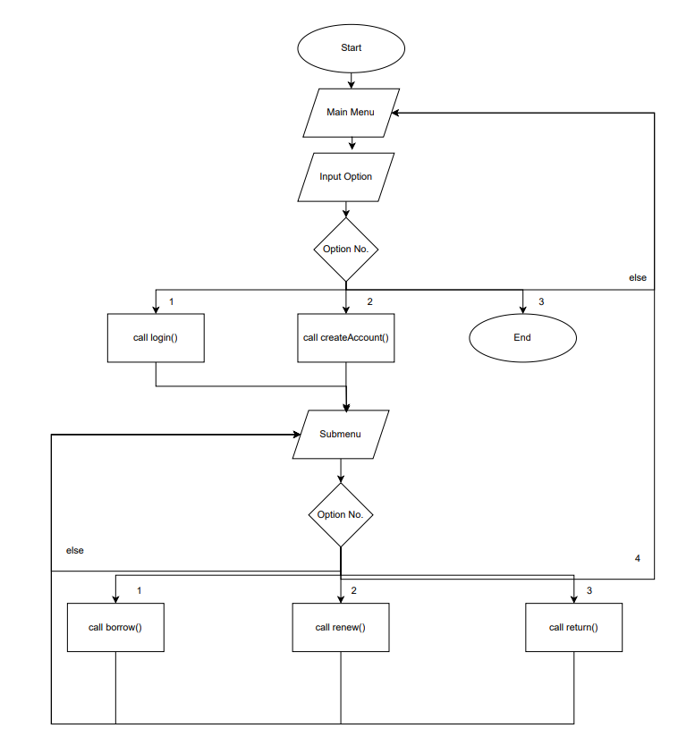

I. UI
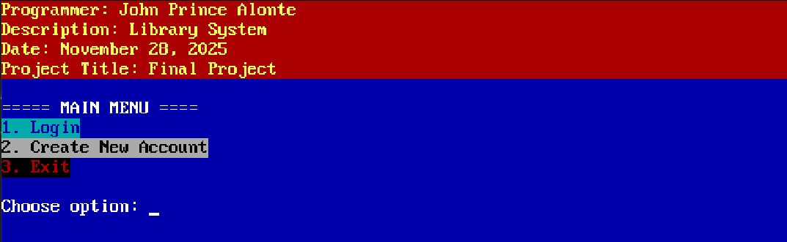
Main Menu
Login
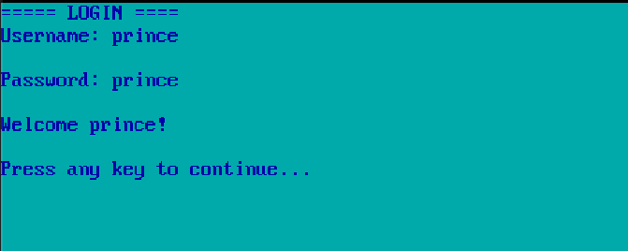
Create Account
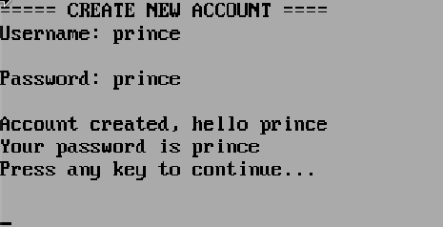

Exit
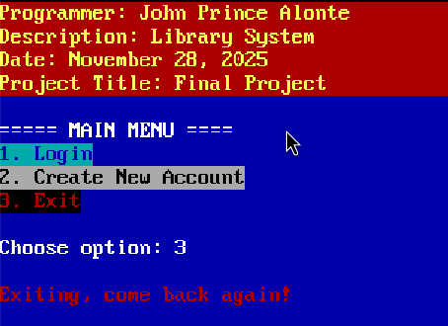
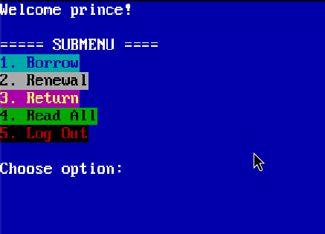
Submenu

Borrow
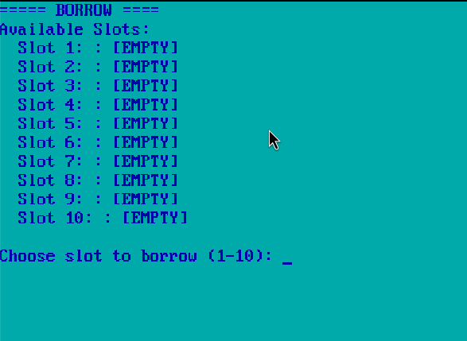
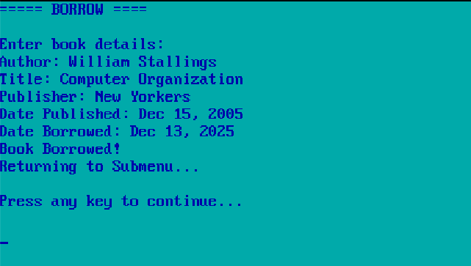
Renew
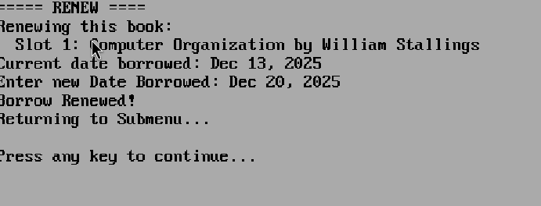
Return
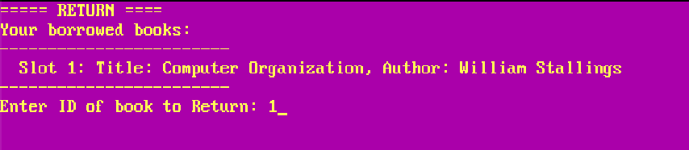
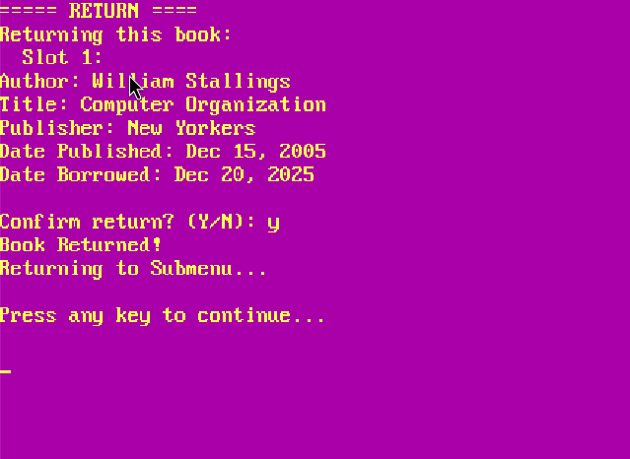
Read All
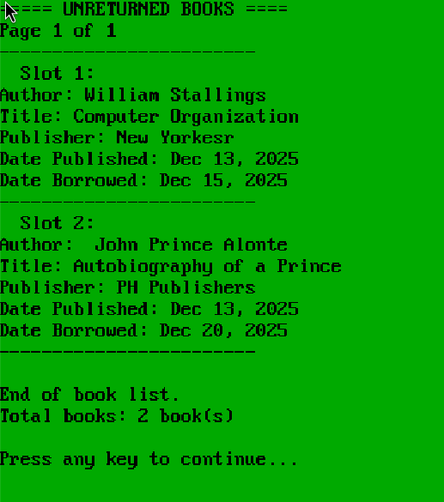
Log Out

