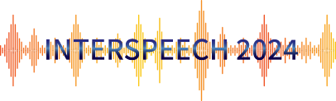
Special Session
Call for Paper & Hyporadise

“Large Language Model for
Speech and Audio Processing”

co-hosted with Nvidia, Google, CMU & Nanyang Tech

We welcome all submissions related to large language models and generative models for speech and audio processing, including but not limited to:

- In-context learning and generative models
- Adaptation and few-shot learning for speech and language processing
- Theory and parameter efficient tuning for large speech and language models
- Multimodal intelligence across audio, text, and vision





Hyporadise (NeurIPS 23) Whispering-LlaMA (EMNLP 23 oral)

Contact: huckiyang@gatech.edu / zhehuaic@nvidia.com

ASRU 23 Tutorial: http://www.asru2023.org/motion.asp?siteid=1007526&menuid=50053&postid=697777

NeurIPS 23 Code: https://github.com/Hypotheses-Paradise
EMNLP 23 Code: https://github.com/Srijith-rkr/Whispering-LLaMA

