Week 6 Deliverable Report
Team B: Project Management & AI Agent Team
王天宇, 夏佳嬣, 郭天智
Product Managed: AI-Powered Multi-Agent News Research & Analysis Platform
Development Platform: Dify
Underlying Model: Claude Sonnet 4
Week 6 Deliverables: AI Agent Architecture Design Doc v1.0 + WBS Decomposition Assistant Prototype
Current Progress: 3 of 4 agents completed (Requirements, Scheduling, Risk)

1. Deliverables Overview
According to the course schedule, Team B is required to complete two deliverables in Week 6:

Deliverable | Status | Notes
AI Agent Architecture Design Doc v1.0 | ✅ Complete | Separate Word document detailing the full 4-agent system design
WBS Decomposition Assistant Prototype | ✅ Complete | Built in Dify, includes Requirements Agent and Scheduling Agent
Risk Warning Agent Prototype (Week 9 task) | ✅ Completed early | Already integrated into current Dify workflow — 3 weeks ahead of schedule

Note: Team B has exceeded the Week 6 requirements. In addition to both required deliverables, the Risk Warning Agent prototype — originally due in Week 9 — has already been built and integrated into the current workflow. The Dify pipeline now contains three fully functional agent nodes.

2. Agent System Architecture

2.1 Overall Architecture
The system uses a sequential multi-agent pipeline architecture deployed on Dify. Each agent has a clearly defined role, and outputs are passed automatically from one agent to the next, forming a complete project management loop.

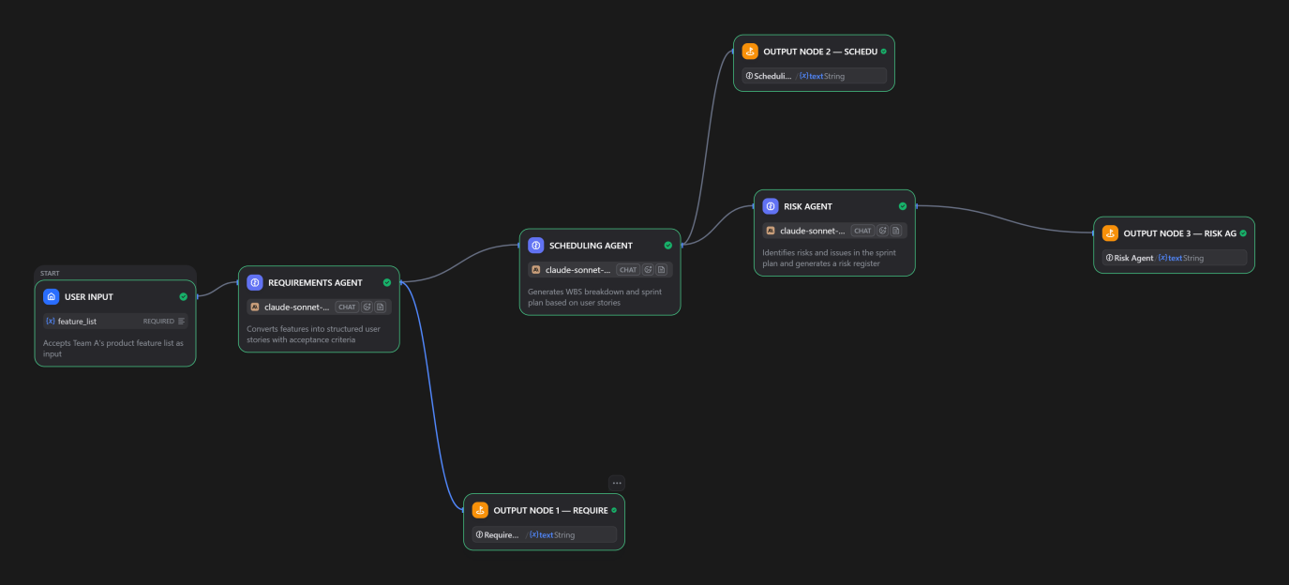

Agent | Role | Input | Output
Requirements Agent | Converts product features into structured user stories | Team A feature descriptions | User stories, acceptance criteria, priority ratings
Scheduling Agent | Generates WBS breakdown and sprint plan | User stories, team capacity | WBS, sprint plan, Gantt timeline
Risk Agent | Identifies risks and generates risk register | Sprint plan, progress updates | Risk register, alerts, mitigation strategies
Report Agent (Week 10) | Aggregates all agent outputs into project status report | All agent outputs | Project dashboard, burndown chart, weekly brief

2.2 Agent Collaboration Flow
- Step 1: Requirements Agent reads Team A's business plan (already available) and any subsequent feature updates, and outputs structured user stories.
- Step 2: Scheduling Agent receives the user stories and Team A's capacity (4 members x 10 hours/week = 40 person-hours/week) and generates a sprint plan and WBS.
- Step 3: Risk Agent analyzes the sprint plan, identifies potential risks, and outputs a risk register with mitigation strategies.
- Trigger rule: If Team A submits a requirement change, the Requirements Agent re-runs automatically, triggering the Scheduling Agent to re-plan, followed by the Risk Agent updating its assessment.

3. WBS Decomposition Assistant Prototype Demo

3.1 How the Workflow Runs
This prototype uses Team A's six core agent feature modules from the business plan as the initial input. The input passes through the Requirements Agent then the Scheduling Agent in sequence, producing a complete WBS breakdown and sprint plan as output.

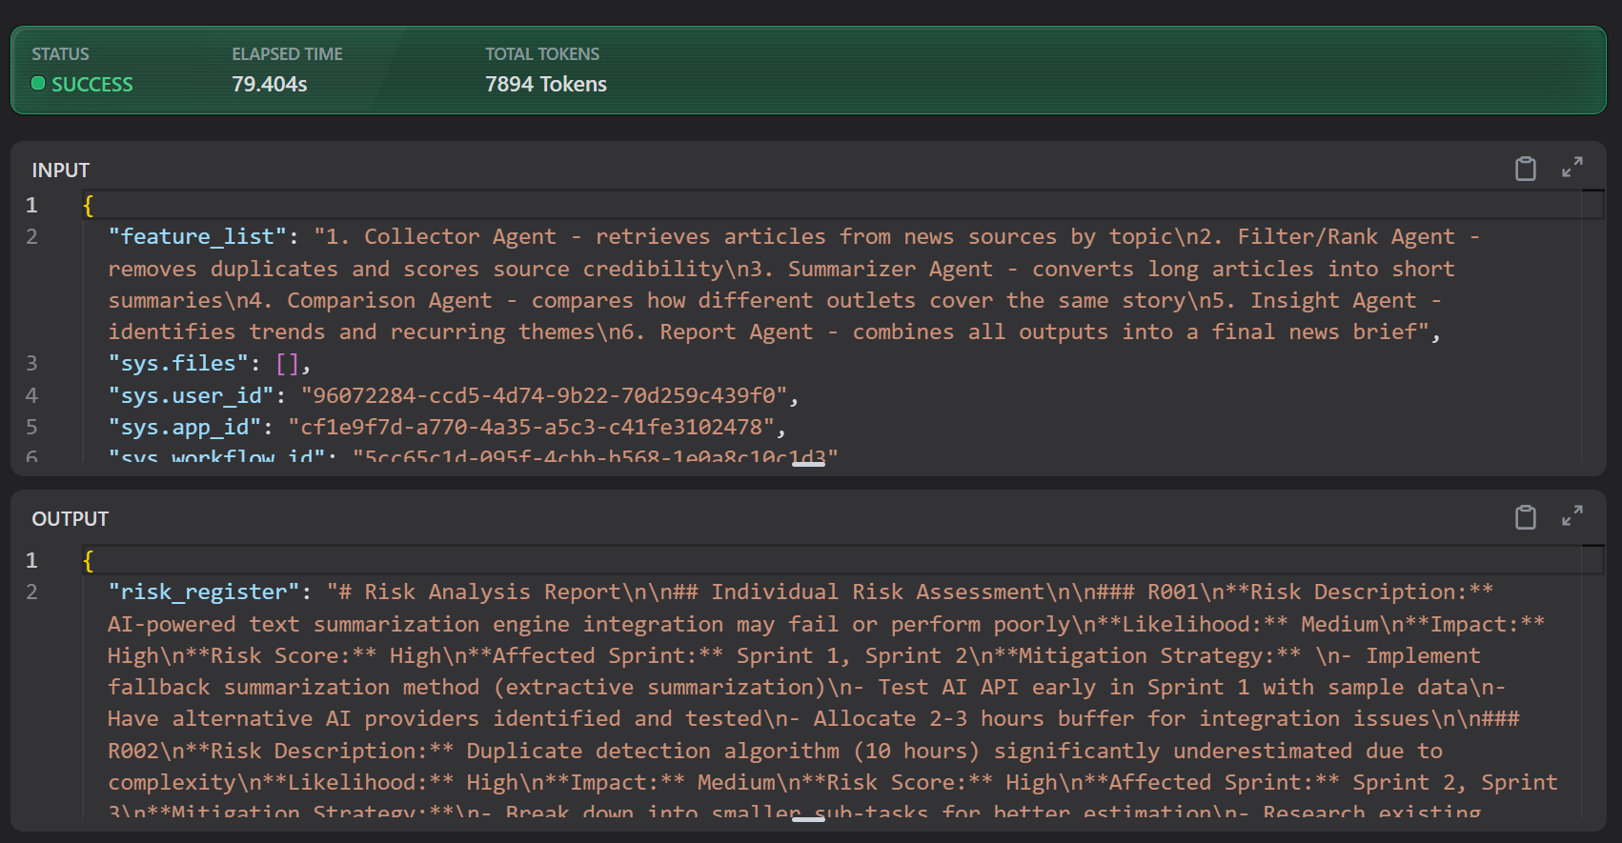
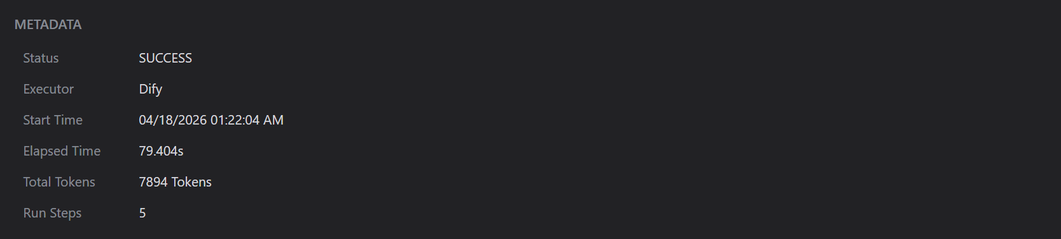

3.2 Requirements Agent Output Summary
Input: Team A's six core functional module descriptions
Output: Six structured user stories, each containing a user story statement, 3-5 acceptance criteria, priority rating (High/Medium/Low), and complexity estimate (Simple/Medium/Complex), plus a summary table.

Output quality highlights:
- All high-priority features (Collector, Filter/Rank, Report agents) were correctly identified and flagged as High priority.
- The Insight Agent was rated Low priority and High complexity — consistent with Team B's independent risk assessment that this feature is most likely to be descoped.
- Acceptance criteria for each story are specific and measurable, suitable for direct use in sprint management.

3.3 Scheduling Agent Output Summary
Input: User story list from the Requirements Agent
Output: 5-week sprint plan (Weeks 6-10), totalling 197 person-hours against 200 person-hours available capacity, with a 3-hour buffer (1.5%).

Key findings:
- High-priority features (Collector, Filter/Rank, Report agents) were correctly scheduled into earlier sprints.
- The high-complexity tasks of the Comparison and Insight agents were identified as likely to require deferral — consistent with real development risk.
- No sprint exceeded the 40 person-hour/week capacity limit.

3.4 Risk Agent Output Summary (Completed Early)
Input: Sprint plan from the Scheduling Agent
Output: 8 identified risks, overall project risk rating of 🟡 AMBER (moderate risk).

Key risks identified:
- R001: News API integration complexity risk (High likelihood × High impact = High risk)
- R002: Sprint 2 capacity overrun risk (High likelihood × Medium impact = High risk)
- R006: Integration testing gap risk (High likelihood × Medium impact = High risk)

Top 3 recommendations from Team B to Team A's PM: rebalance Sprint 2 task allocation, conduct early API proof-of-concept testing, and establish an integration testing strategy from the start.

4. PMBOK Framework Alignment
Each agent is designed to align with a core performance domain from PMBOK 8th Edition:

Agent | PMBOK Performance Domain | Specific Practices
Requirements Agent | Scope Performance Domain | Scope definition, requirements collection, WBS preparation
Scheduling Agent | Schedule Performance Domain | Activity sequencing, duration estimation, schedule development and control
Risk Agent | Uncertainty Performance Domain | Risk identification, qualitative risk analysis, risk response planning
Report Agent (to be built) | Stakeholder + Team Performance Domains | Project reporting, communication management, performance measurement

5. Upcoming Plan
Based on current progress, Team B's upcoming work is planned as follows:

Week | Deliverable | Content | Status
6 | Architecture Design v1.0 + WBS Prototype | This document + Dify 3-agent workflow | ✅ Done
7-8 | Team A sync + Dify development | Joint sync meetings, refine agent prompts, begin Report Agent design | In progress
9 | Risk Warning Agent Prototype | Already complete — will submit refined version with additional features | ✅ Early
10 | AI Agent System v2.0 + Demo Video | Full 4-agent integration + project dashboard frontend + demo video | Pending
15-17 | Final Roadshow & Defense | Joint roadshow, PM leads overall presentation and Q&A | Pending

6. Appendix Checklist
- Appendix 1: AI Agent Architecture Design Doc v1.0 (separate Word document)
- Appendix 2: Dify workflow canvas screenshot (3-agent pipeline)
- Appendix 3: Requirements Agent test output (full user story list)
- Appendix 4: Scheduling Agent test output (WBS breakdown and sprint plan)
- Appendix 5: Risk Agent test output (risk register and project risk rating)
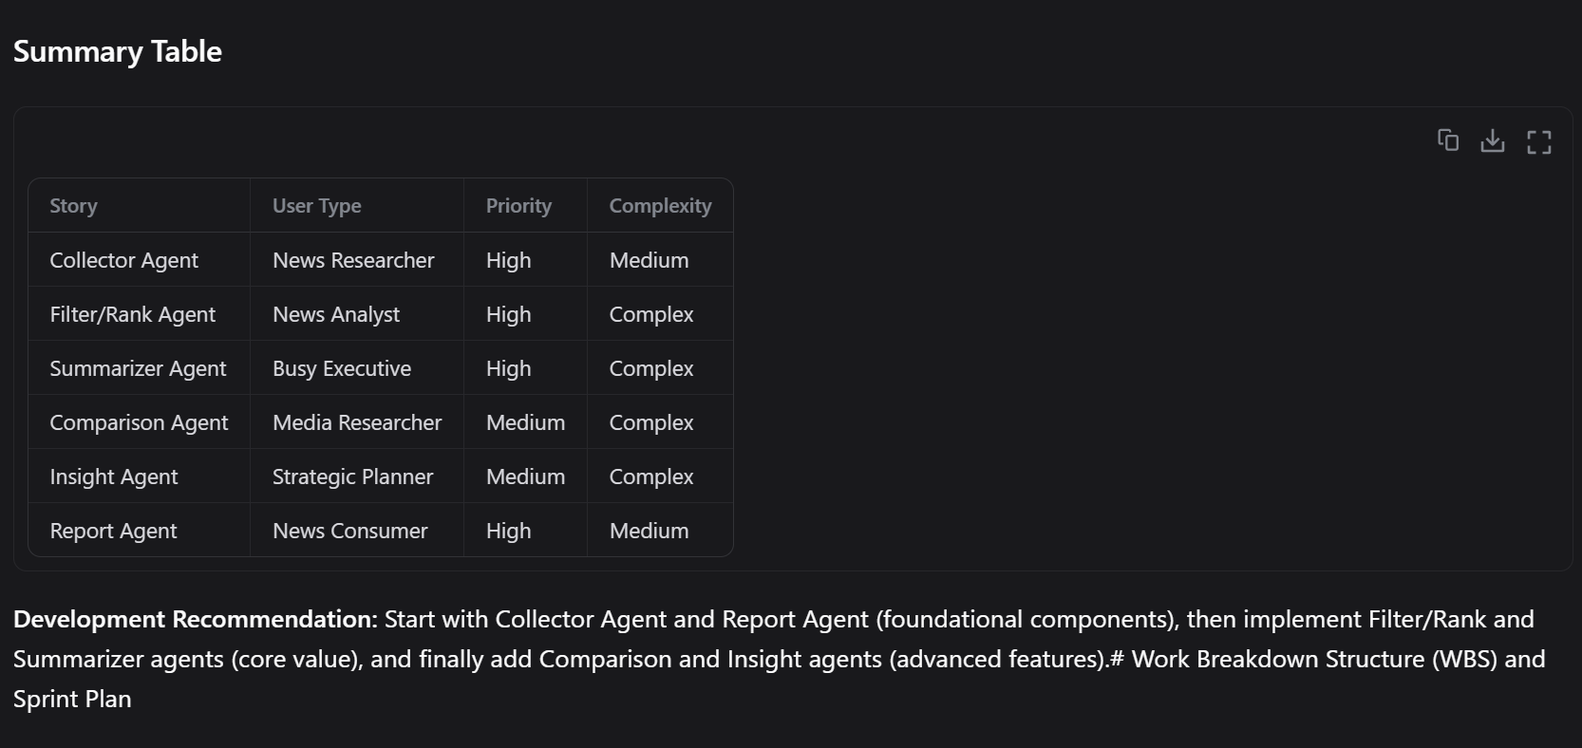
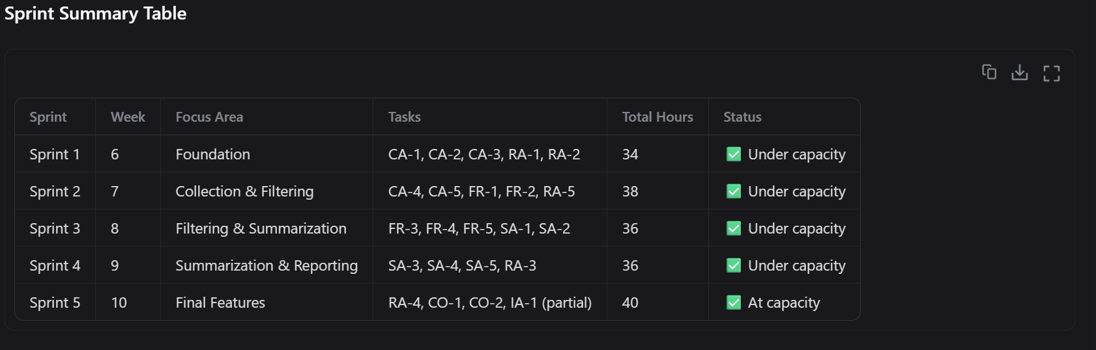
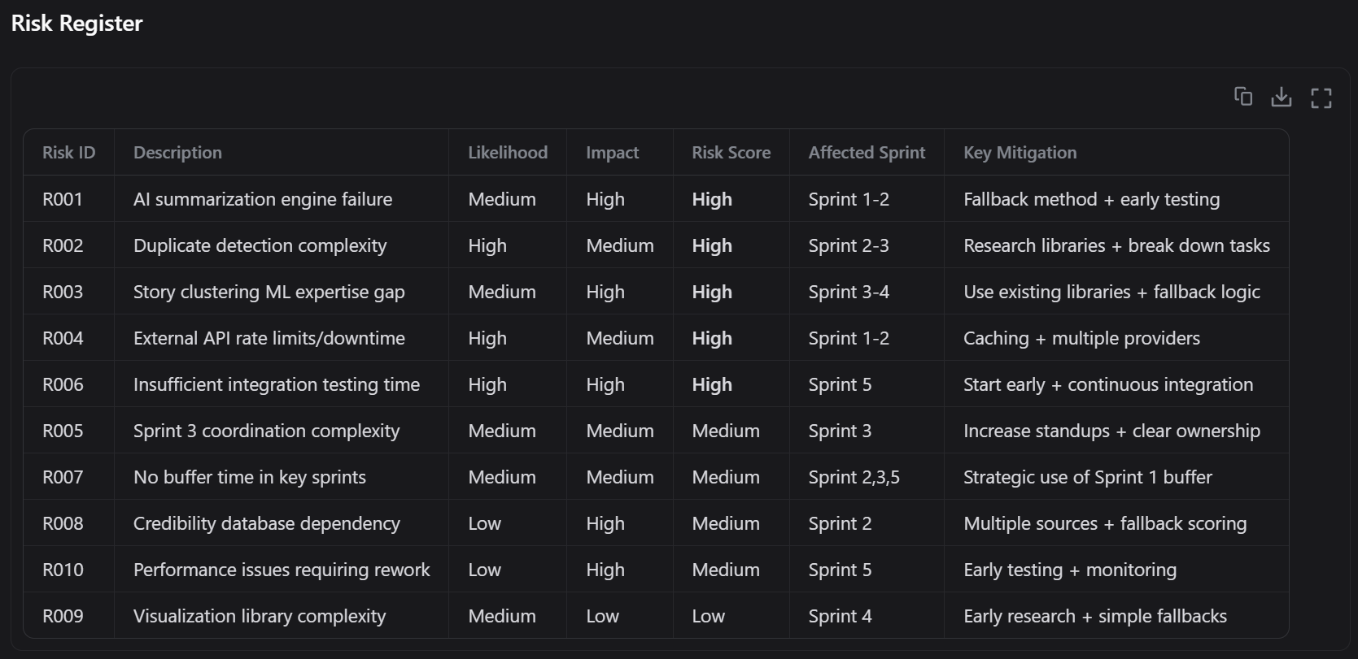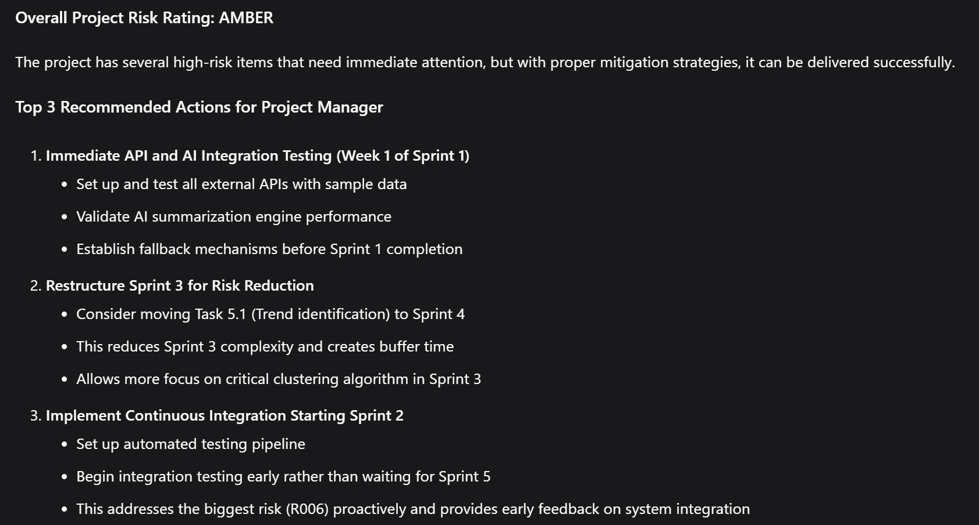
Team B — Project Management & AI Agent Team | Advanced Project Management: Value-Driven & AI-Enabled | 2026

