Weeks 9-15
F.R.I.D.A.Y Report Compilation

Team B: Project Management & AI Agent Team
王天宇, 夏佳嬣, 郭天智
Product Managed: AI-Powered Multi-Agent News Research & Analysis Platform

Item | Details
Reporting Scope | Retrospective weekly compilation for Weeks 9-15
Development Platform | Dify workflow + F.R.I.D.A.Y dashboard
Primary Inputs | Team A weekly product updates, generated reports, dashboard tests, GitHub repository documentation
Current Progress | F.R.I.D.A.Y dashboard verified with Team A data; later Dify/model timeout issues documented
Report Date Basis | Week 15 counted as of 14 June, per team convention
Prepared as a continuation of the Week 6 deliverable report format

1. Deliverables Overview
This document reconstructs the weekly F.R.I.D.A.Y reporting activity for Weeks 9-15. Because weekly reports were not formally compiled at the time, the entries below are organized from available Team A updates, generated Team A reports, F.R.I.D.A.Y dashboard outputs, Dify workflow tests, and the GitHub repository documentation.
Deliverable / Activity | Status | Notes
Weeks 9-15 F.R.I.D.A.Y report compilation | compiled | This document consolidates the reconstructed weekly outputs into one report.
Team A product verification | Complete | Team A News Intelligence Studio was checked through local runs and generated artifacts.
F.R.I.D.A.Y dashboard execution with Team A data | Complete / partial in latest rerun | Earlier runs completed all main tabs; latest rerun with new Dify account hit timeout at Report Agent.
Multi-topic Team A output testing | Complete | Topics included AI regulation in China, AI chip export controls, US-China semiconductor policy, and OpenAI copyright lawsuit.
Dashboard readability and Team A feedback polish | Partial | Layout problems were identified and a clearer feedback-card/table format was planned.
Dify/model workflow debugging | Partial | Model credit exhaustion, new Dify account setup, model configuration, and timeout issues were investigated.

2. Verified System Context

2.1 Team A Product Baseline
Repository documentation describes Team A final product as a local-first FastAPI news intelligence app that generates source-aware research reports from a single topic query. The app attempts trusted RSS retrieval first, uses Google News RSS as fallback, and can still generate deterministic local reports when model access is unavailable. It also saves local artifacts for Team B handoff.
- Core output includes executive summary, key facts, source comparison, insights, risk notes, and source evidence.
- Generated artifacts are saved under artifacts/<brief_id>/ and include brief.json, handoff.json, brief.html, and brief.md.
- Default local RBAC tokens include viewer-local-token, analyst-local-token, and admin-local-token for different access levels.
- Final product documentation positions the app as a modular research assistant with trusted direct RSS feeds, Google News fallback, hybrid generation, and HTML/Markdown/JSON handoff exports.

GitHub Source | What It Confirms
Team A MVP README | Confirms local FastAPI app, React/Vite/TypeScript frontend, trusted RSS + Google News fallback, RBAC tokens, output artifacts, and handoff route.
Team A final-product README | Confirms final product positioning: source-aware reports, structured sections, source evidence, hybrid generation, and demo path via team-a/mvp-v1.
Team B dashboard README | Confirms F.R.I.D.A.Y dashboard calls a 4-agent Dify pipeline and renders Requirements, Sprint Plan, Risk Register, and Status Report outputs.

2.2 Team B F.R.I.D.A.Y Dashboard Baseline
Repository documentation describes F.R.I.D.A.Y as a live project intelligence dashboard for Team B. It calls a 4-agent Dify workflow and renders project-management outputs for the project manager.

Agent / Output Area | Role in Dashboard
Requirements Agent | Generates requirements and user-story backlog from Team A product updates.
Scheduling Agent | Produces sprint plan and WBS breakdown.
Risk Agent | Generates risk register and overall project health rating.
Report Agent | Synthesizes a weekly status report from the other agent outputs.

3. Weekly F.R.I.D.A.Y Reporting Log
Week | Team A Input | Team B / F.R.I.D.A.Y Action | Main Finding | Status
Week 9 | Initial Team A product output / local product check | Ran Team A app locally; generated reports and artifacts; used product status as F.R.I.D.A.Y input. | Pipeline verified; main risks were fallback mode, topic relevance, and manual handoff. | Done
Week 10 | Multiple Team A generated report topics | Compared AI regulation in China, AI chip export controls, US-China semiconductor policy, and OpenAI copyright lawsuit. | Specific active-news topics worked better; broad policy topics had weaker topic fit. | Done
Week 11 | F.R.I.D.A.Y dashboard screenshots/PDF review | Reviewed generated dashboard outputs for readability and presentation quality. | Tables and long agent outputs were messy; dashboard needed Team A-facing polish. | Done
Week 12 | Dashboard polish planning / partial implementation | Planned feedback cards, test-summary table, improved table formatting, and print-friendly layout. | Better feedback structure designed for Team A to understand what to improve. | Partial
Week 13 | Team A latest product PPT update | Converted Team A product update PPT into concise F.R.I.D.A.Y input. | New Team A features identified: React UI, RBAC, 7 personas, 8 sections, trusted sources, confidence scoring, exports, and handoff. | Done
Week 14 | Dify/API/model workflow troubleshooting | Changed API keys, tried new Dify account, checked provider/model setup, investigated timeout errors. | Found model credit exhaustion and Report Agent timeout as current blockers. | Done
Week 15 | Compilation stage | Compiled reconstructed weekly reports and evidence into a single document. | Final report package prepared for PDF/Word submission. | In progress

3.1 Week 9 - Initial Team A Product Verification
In Week 9, the main task was to verify Team A latest app and confirm that its output could be used as input for Team B F.R.I.D.A.Y dashboard. Team A News Intelligence Studio was run locally from team-a/mvp-v1, and the local analyst token was used to generate reports.
- Confirmed Team A product could open locally and generate a report.
- Confirmed output artifacts such as brief.json, handoff.json, brief.html, and brief.md were created.
- Used the generated output as a Team A progress/update summary for F.R.I.D.A.Y.
- Identified early risks around topic relevance, fallback behavior, and manual Team A-to-Team B handoff.

3.2 Week 10 - Multi-topic Product Testing
In Week 10, several topics were tested to compare how Team A product behaved across different query types. The goal was to identify whether the product was stable only for narrow topics or also reliable for broader policy topics.

Test Topic | Observed Coverage / Quality | Finding for Team B
AI chip export controls | Live coverage; medium confidence; generally relevant sources. | Good candidate demo topic. Shows the pipeline works better for specific active-news topics.
OpenAI copyright lawsuit | Live coverage; medium confidence; relevant legal/news sources. | Good supporting validation topic. Shows live retrieval can work for active legal topics.
US-China semiconductor policy | Saved/fallback coverage; lower confidence; limited topic fit. | Shows broad geopolitical topics need better retrieval and fallback coverage.
AI regulation in China | Fallback/saved coverage; lower confidence; selected sources drifted toward chip export controls. | Shows topic-relevance risk for broad regulatory queries.

3.3 Week 11 - F.R.I.D.A.Y Dashboard Output Review

In Week 11, the generated F.R.I.D.A.Y outputs were reviewed for presentation quality. The dashboard successfully showed the major agent tabs, but the output was difficult to use as a Team A-facing feedback artifact.
- Long agent outputs were dense and difficult to scan.
- Markdown-style tables appeared misaligned or broken in exported/screenshotted dashboard views.
- Risk and sprint outputs were useful, but needed clearer visual grouping.
- Conclusion: the dashboard worked functionally but needed a more presentation-ready layout.

3.4 Week 12 - Dashboard Polish and Feedback Layout Planning

In Week 12, a dashboard polish plan was prepared to make F.R.I.D.A.Y more useful for Team A. The main design direction was to add a concise Team A feedback layer above the detailed agent outputs.

Planned UI Improvement | Purpose
Team A feedback cards | Show “What worked”, “What needs improvement”, and “Recommended next actions” in a simple format.
Team A test summary table | Compare multiple topics by coverage mode, confidence, result quality, and feedback.
Improved table styling | Prevent broken/misaligned tables and improve screenshot/PDF readability.
Print/screenshot-friendly formatting | Make dashboard outputs easier to include in reports and presentations.

3.5 Week 13 - Team A Latest Product PPT Processing

In Week 13, Team A sent a product update PPT. The update showed that News Intelligence Studio had advanced from the earlier MVP into a more complete research platform. The PPT content was converted into a short F.R.I.D.A.Y-compatible input summary because the Dify workflow input field had a strict word limit.
- Interface rebuilt with React 18, TypeScript, and Vite served by FastAPI.
- RBAC login roles introduced: Admin, Analyst, and Viewer.
- BriefComposer, BriefHistory, TrustedSourcesPage, and i18n language toggle added.
- Report output expanded from 4 sections to 8 sections.
- Personas expanded from 4 to 7, including Financial Analyst, Academic Researcher, and Risk Analyst.
- Trusted source management, direct RSS feeds, confidence scoring, source evidence, exports, GitHub Actions CI, and Team B handoff were reported as complete.

3.6 Week 14 - Dify/API and Model Troubleshooting

In Week 14, the Team A update was run through F.R.I.D.A.Y again, but several Dify workflow issues appeared. The workflow initially failed due to exhausted model credits or unconfigured model nodes. A new Dify account/API key was tested, which allowed the workflow to start, but timeout issues appeared later in the pipeline.

Issue | Observed Behavior | Planned / Attempted Fix
Model credits exhausted | Selected Dify model could not run due to unavailable credits. | Check provider settings; switch to a cheaper/faster available model or add provider API key.
Model not configured | Workflow completed Requirements Agent but failed at the next model node. | Configure every LLM node and republish workflow.
Dify API timeout 504 | Workflow started but timed out during later agents. | Shorten input and reduce agent output length.
Status Report node timeout | Workflow often stopped at the final Report Agent. | Limit Report Agent to short report format and avoid long tables.

3.7 Week 15 - Final Compilation

In Week 15, the focus shifted from running more experiments to compiling the reconstructed weekly work into a formal report. The final compilation is intended to show how Team B used F.R.I.D.A.Y to process Team A weekly updates, identify project-management risks, and prepare feedback for Team A.

4. Key Findings

Finding Area | Summary | Implication
Team A product functionality | Team A product can run locally and generate export artifacts. | Basic product and handoff pipeline are functional.
Retrieval quality | Specific news-active topics work better than broad policy topics. | Team A should test with focused demo topics and improve query expansion/fallback coverage.
F.R.I.D.A.Y dashboard | Dashboard can process Team A updates and generate project-management outputs. | Validates Team B system concept, but UI readability needs polish.
Dify workflow stability | Model configuration, credits, and timeout behavior remain practical constraints. | Report Agent and long WBS outputs should be shortened or moved to faster models.
Team A-to-Team B integration | Current flow is mostly manual: summarize Team A update and paste into F.R.I.D.A.Y. | Automatic handoff import remains a future improvement.

5. PMBOK Framework Alignment

The reconstructed Weeks 9-15 work continues the Week 6 agent design logic, but shifts from prototype design toward weekly project monitoring and stakeholder feedback.
Agent / Activity | PMBOK Alignment | How It Was Used in Weeks 9-15
Requirements Agent | Scope Performance Domain | Converted Team A product updates into feature requirements and improvement stories.
Scheduling Agent | Schedule Performance Domain | Generated sprint/WBS planning suggestions and revealed capacity pressure in improvement plans.
Risk Agent | Uncertainty Performance Domain | Identified retrieval quality, fallback dependency, source quality, Dify timeout, and manual handoff risks.
Report Agent | Stakeholder and Team Performance Domains | Generated status reports when workflow completed; later became the main timeout bottleneck.
Dashboard polish | Stakeholder Performance Domain | Improved how Team A could understand feedback and recommended next actions.

6. Current Status and Next Plan

Item | Current Status | Next Action
Team A weekly input process | Retrospectively reconstructed for Weeks 9-15. | Continue collecting Team A updates weekly instead of reconstructing later.
F.R.I.D.A.Y dashboard | Functional, with identified layout/readability issues. | Finalize feedback-card and summary-table layout.
Dify workflow | Works in earlier runs; latest new-account run hits timeout at Report Agent. | Shorten Report Agent prompt and enforce max-word output.
Team A handoff | Handoff JSON exists, but use is still manual. | Consider automatic import/upload or copy-paste summarizer workflow.
Final deliverable | Weeks 9-15 report compiled in this document. | Export as PDF and add selected screenshots/appendices.

7. Appendix Checklist

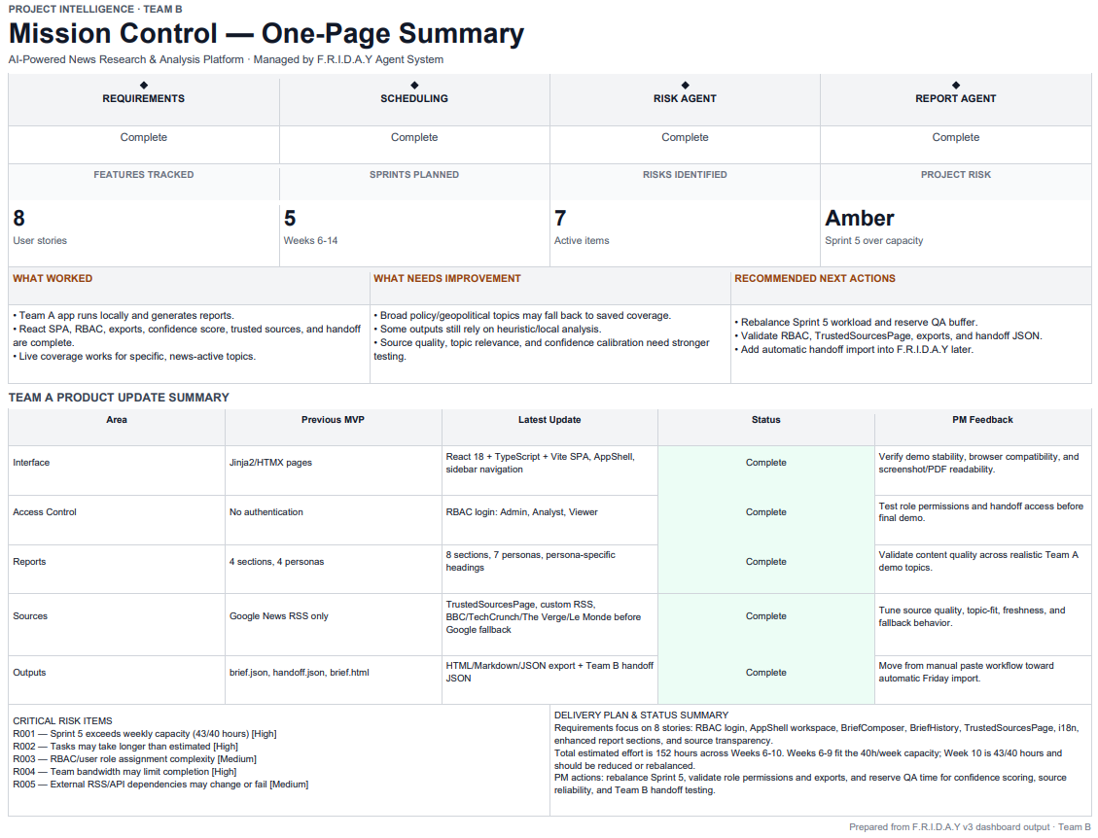
- Appendix 1: Team A generated report screenshots or exported HTML/Markdown files.

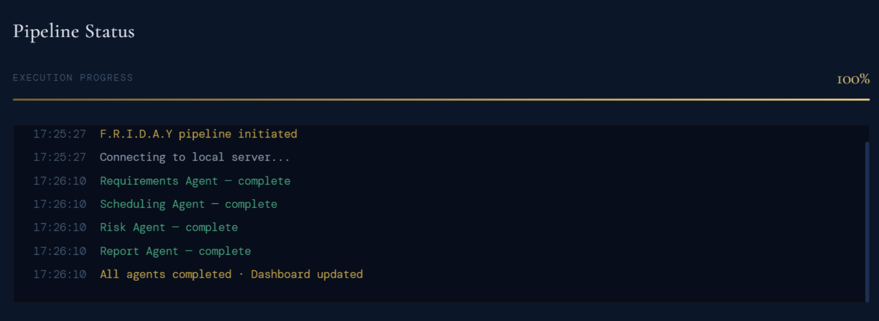
- Appendix 2: F.R.I.D.A.Y Status Report tab outputs where workflow completed.

- Appendix 3: Dify/API troubleshooting screenshots showing model/timeout issues.
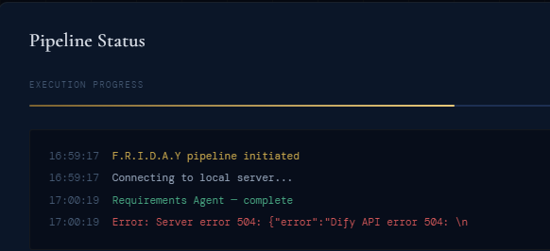
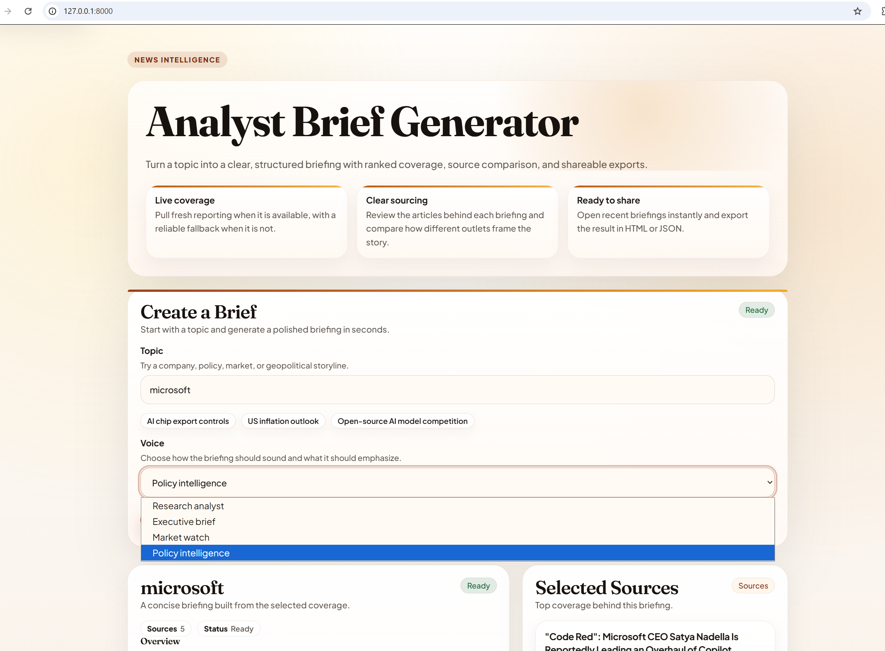
- Appendix 4: Dashboard polish screenshots showing improved Team A feedback layout.

