***Site: What’s My Weather?***

***“Whatever the Weather, Enjoy it Together”***

**Author: Hyrum J. Clark**

**Purpose:**

Display, in an easy to view format, the day to day weather for a few select cities. The weather information will be current and it will update as the weather changes. It will provide everything from the current temperature, daily highs and lows as well as a 10-day forecast to help users plan out their weekend camping trips.

**Audience:**

Anyone who likes to be outside and those who never leave their homes alike. If the weather in anyway effects their lives we want them to have access to the current weather and any weather warnings. Our hope is that even those who are computer illiterate can easily navigate through our site.

**Color Scheme:**

**Primary: Blue - 2899FF**

**Secondary: Yellow - FFF22A**

**Background: Grey - 7C7F7F**

Our default color scheme will be a mixture of light blue, yellow and grey. Ideally, we would like to have it so that the colors may change according to the weather but the logo will always have that light blue and yellow mixture. Text will almost always be black. Header and footer will be a similar color of blue. Main part of the page will have a grey background possibly with white text.

**Typography:**

Strictly Comic Sans and Papyrus. Papyrus will be in the header and footer with Comic sans throughout the main part of the body.

**Site Map:**

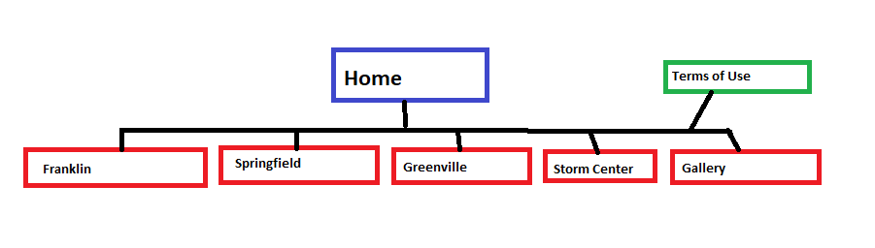

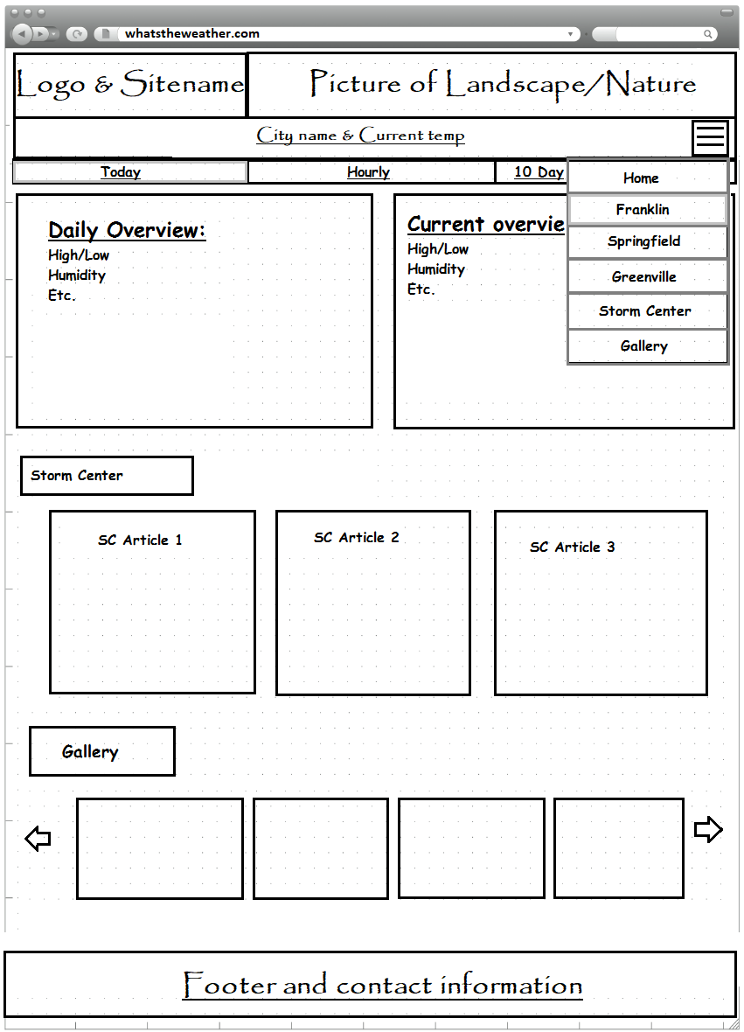**Wire-Frame Sketches:**

**Browser:**

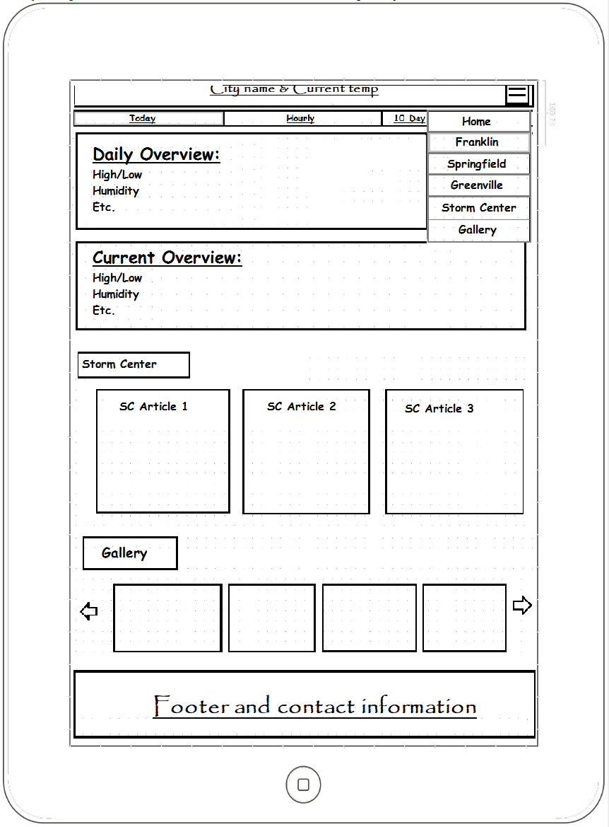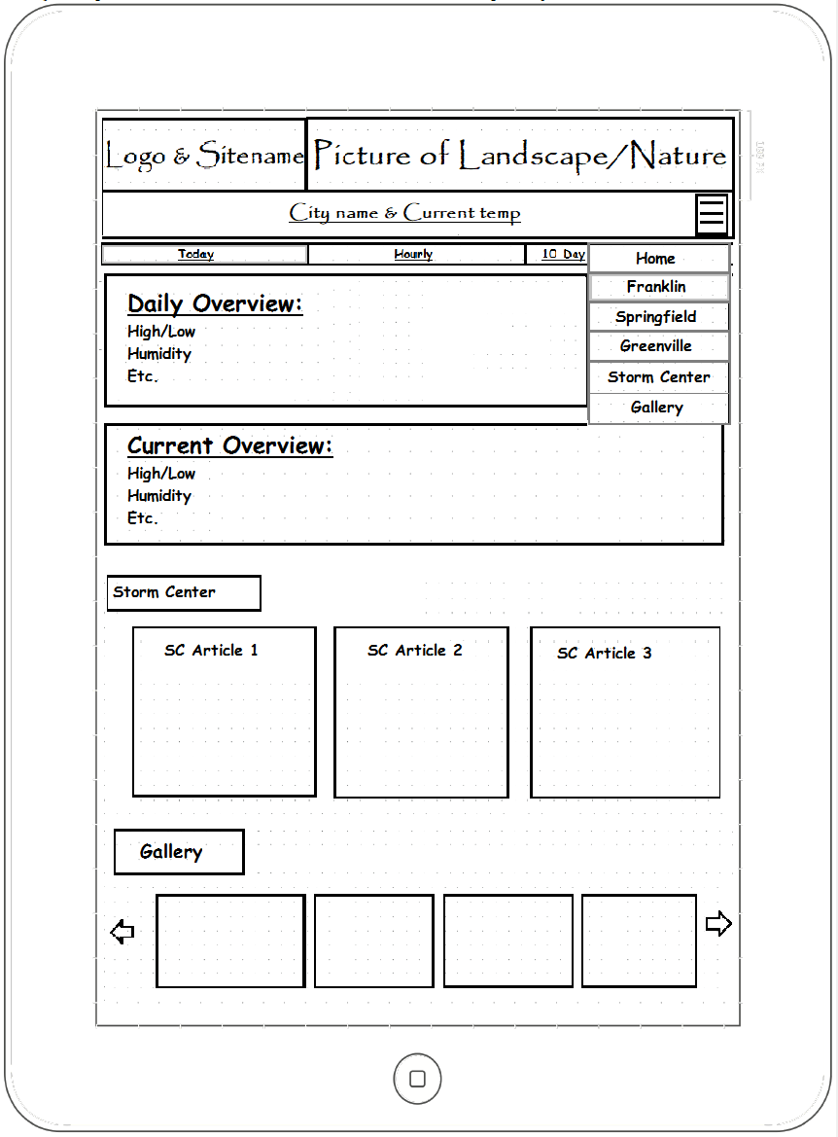**iPad:**

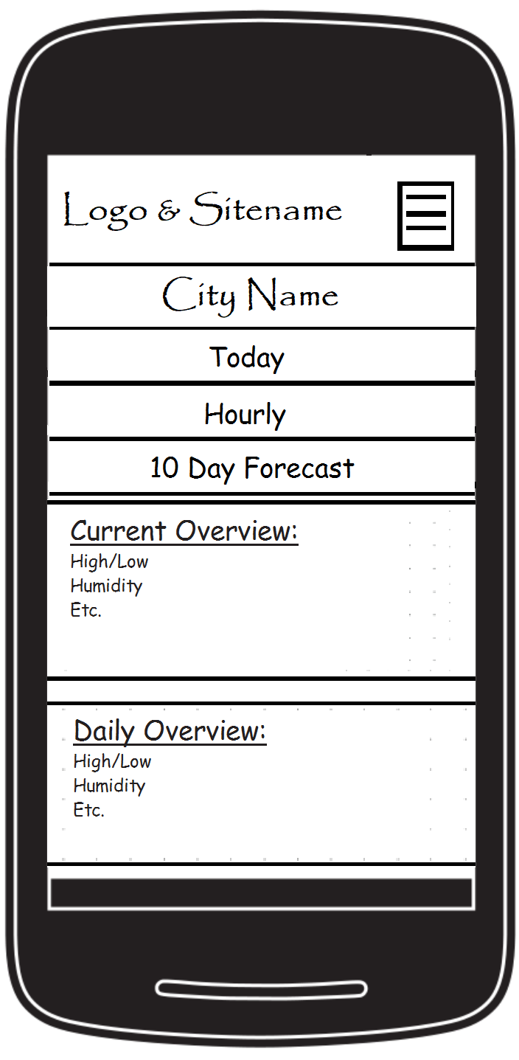 **Android Phone:**

