***Site:* The Mountain Spoke**

**Author: Hyrum J. Clark**

**Purpose:**

Provide a fresh new website experience for the clients, and potential clients, of The Mountain Spoke, that will reflect their culture of bicycle enthusiasm by advertising products, repair service, parts, and tour trips.

**Audience:**

Bicycle enthusiasts in the Bozeman, Montana region and serious bicyclists from around the world.

**Color Scheme:**

**Primary: Orange - FF570F**

**Secondary: Grey - A1A9AB**

Our default color scheme will be orange and grey. The background will be grey, and we’ll use mostly white text for the most part. Other than that, we may use some white and black in places if needed.

**Typography:**

Open Sans will be the default with Sans Serif as a backup incase open sans is not supported or doesn’t load from google fonts for some reason. 18px will be the default font size.

**Site Map:**

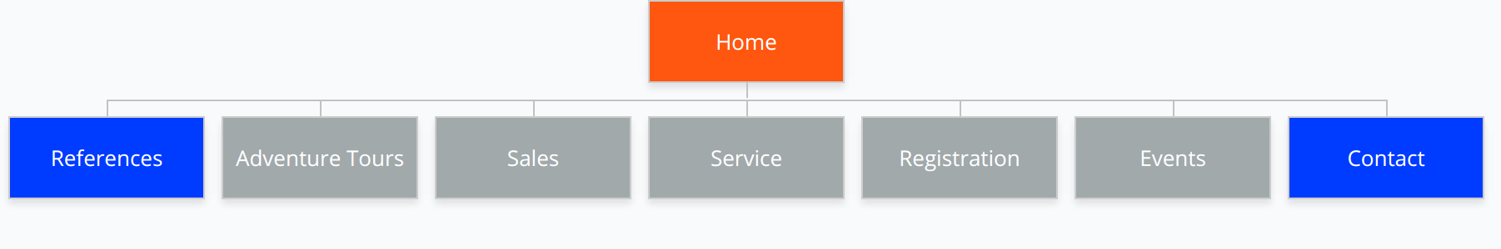

**Wire-Frame Sketches:**

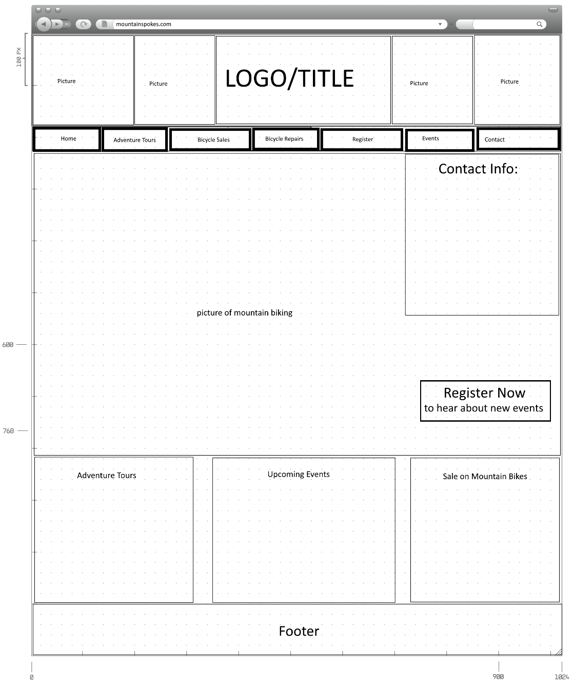**Browser:**

**iPad:**

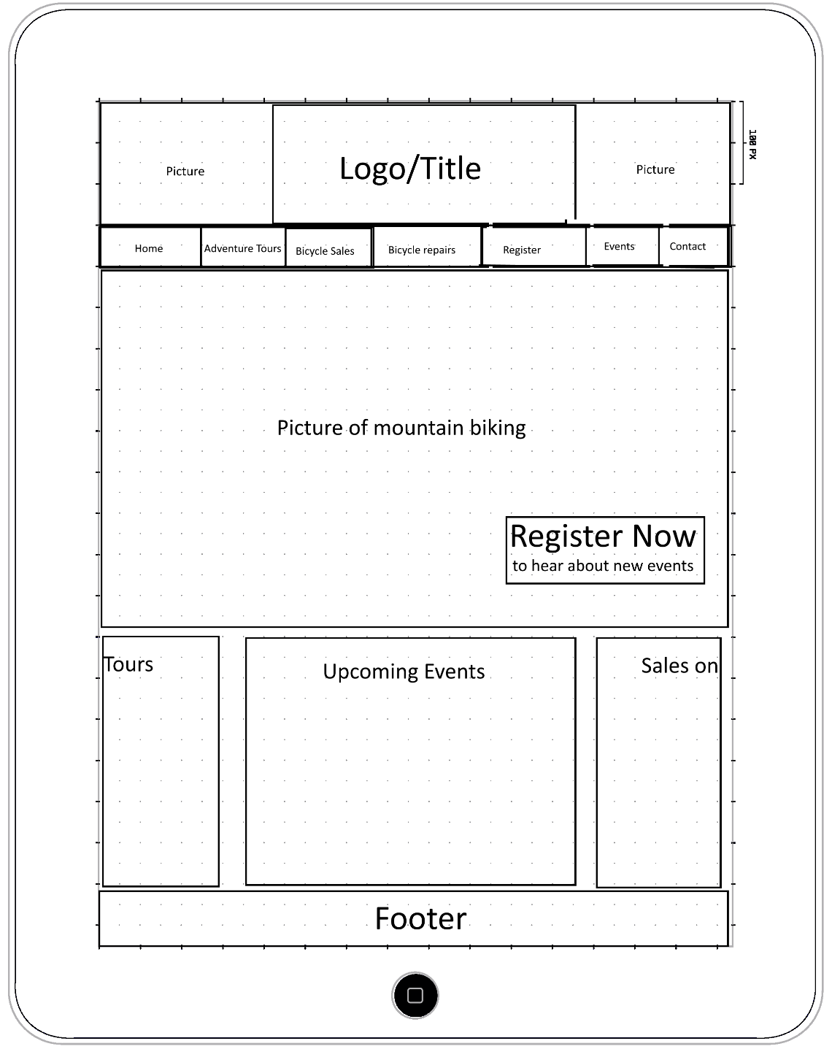

**Android Phone:**

