Kuka KR210 Pick and Place Project

Introduction
kuka arm is an industrial robot which is 6 degree of freedom serial robot arm which has a very high precision and able to lift very heavy weights.

Objective
My objective is to ably forward and inverse kinematics in the form of python script using Ros to simulate on rviz and gazebo the interaction of the robot arm with the surrounding environment.

Forward kinematics
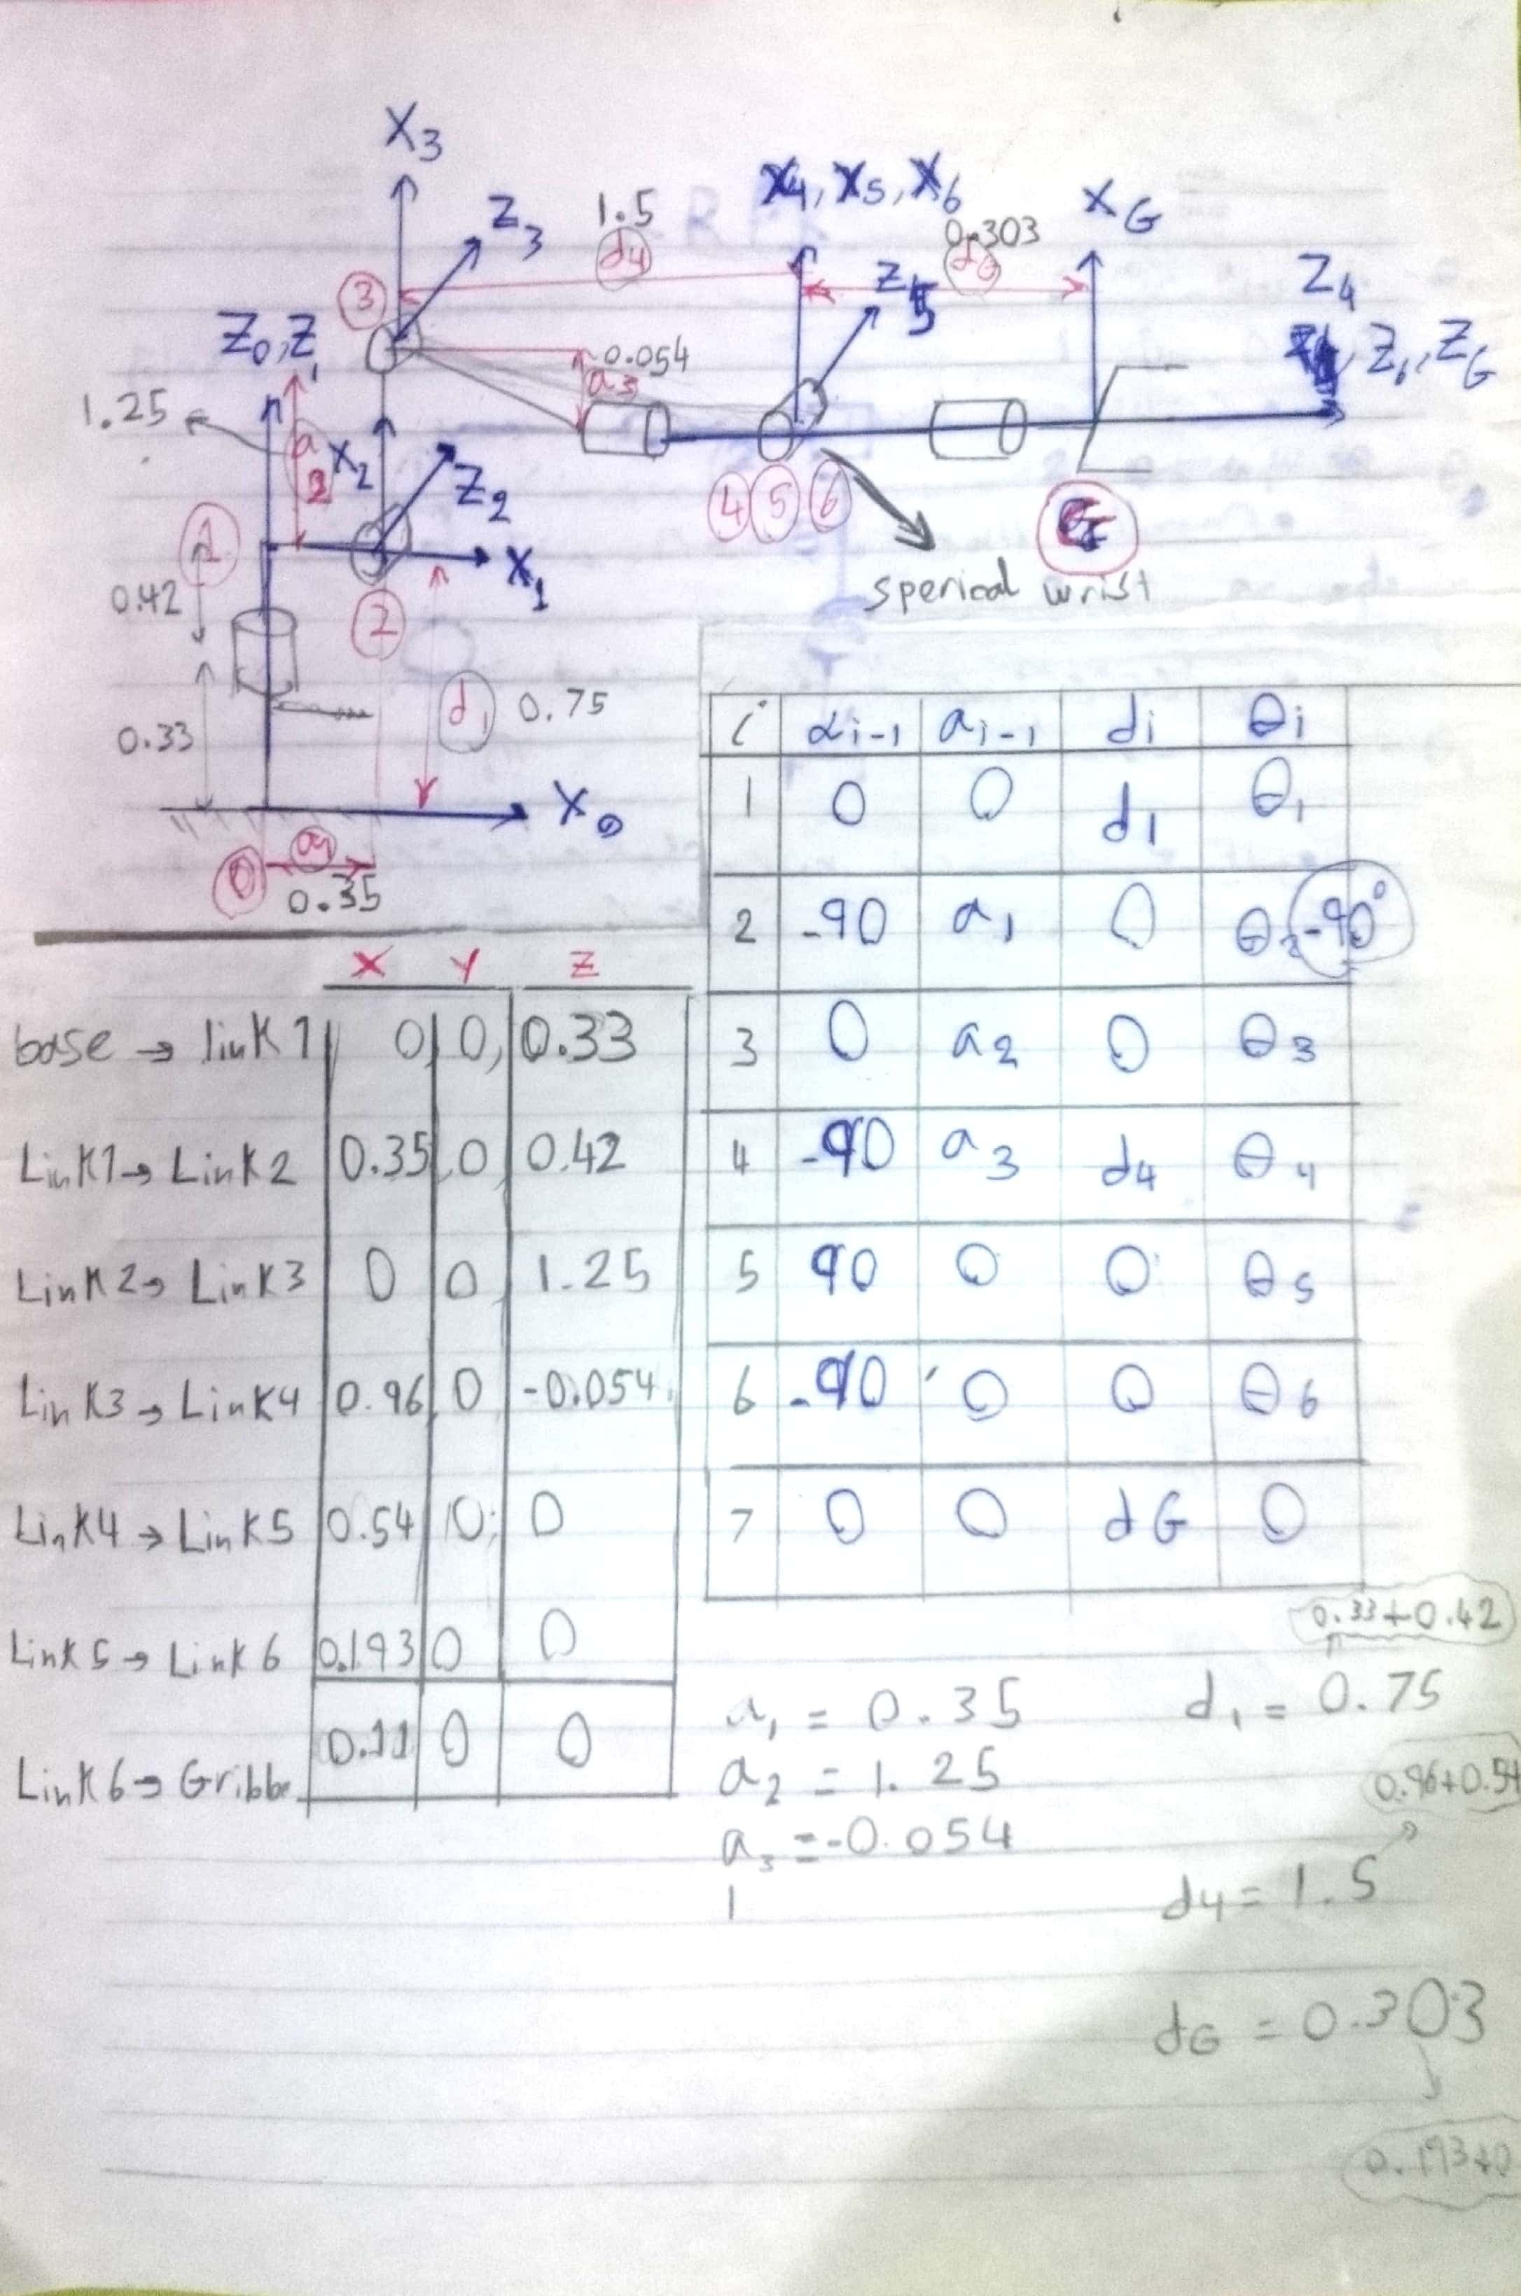

Inverse kinematics
Choosing Joint 5 as Wrist
Calculating theta 1,2,3

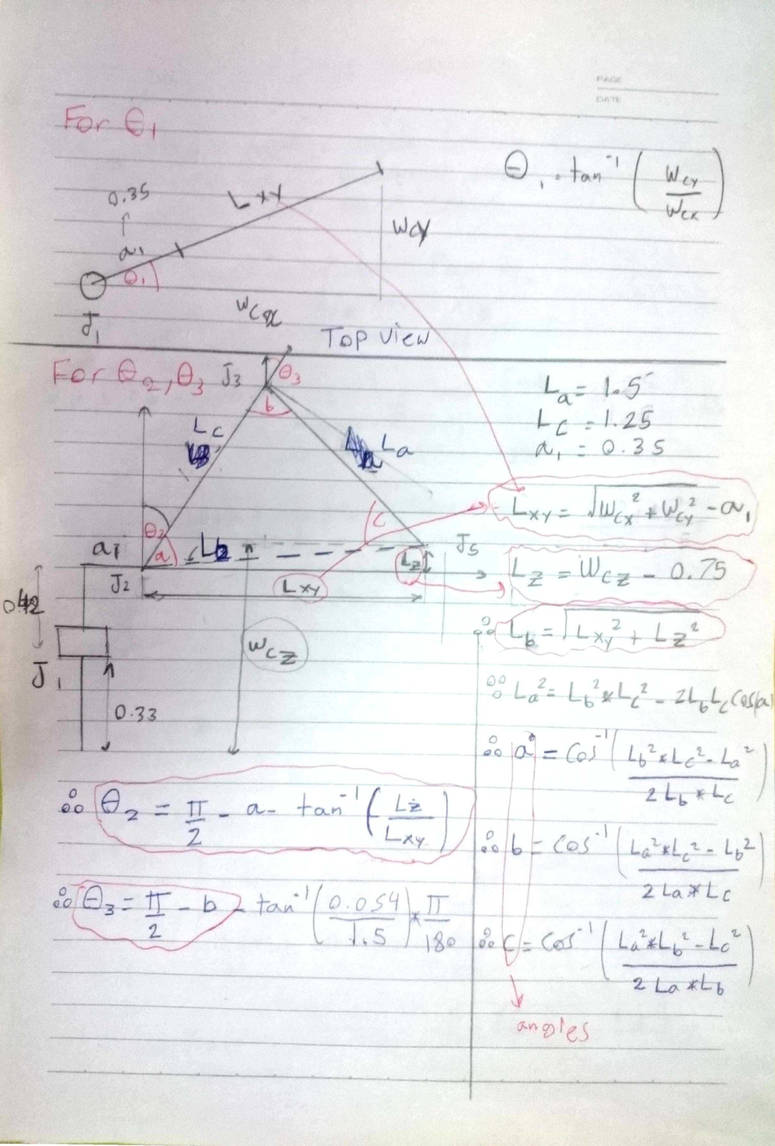

Calculating theta 4,5,6
R0_3 = (T0_1 * T1_2 * T2_3).evalf(subs={theta1: theta1,theta2:theta2, theta3: theta3})[0:3, 0:3]
R3_6 = R0_3.T * R_EE
theta4 = atan2(R3_6[2,2], -R3_6[0,2])
theta5 = atan2(sqrt(pow(R3_6[0,2], 2) + pow(R3_6[2,2], 2)), R3_6[1,2])
theta6 = atan2(-R3_6[1,1], R3_6[1,0])

setup the project
Make sure you are using robo-nd VM or have Ubuntu+ROS installed locally.

One time Gazebo setup step:
Check the version of gazebo installed on your system using a terminal:
$ gazebo --version
To run projects from this repository you need version 7.7.0+ If your gazebo version is not 7.7.0+, perform the update as follows:
$ sudo sh -c 'echo "deb http://packages.osrfoundation.org/gazebo/ubuntu-stable `lsb_release -cs` main" > /etc/apt/sources.list.d/gazebo-stable.list'
$ wget http://packages.osrfoundation.org/gazebo.key -O - | sudo apt-key add -
$ sudo apt-get update
$ sudo apt-get install gazebo7
Once again check if the correct version was installed:
$ gazebo --version

For the rest of this setup, catkin_ws is the name of active ROS Workspace, if your workspace name is different, change the commands accordingly
If you do not have an active ROS workspace, you can create one by:
$ mkdir -p ~/catkin_ws/src
$ cd ~/catkin_ws/
$ catkin_make
Now that you have a workspace, clone or download this repo into the src directory of your workspace:
$ cd ~/catkin_ws/src
$ git clone https://github.com/udacity/RoboND-Kinematics-Project.git
Now from a terminal window:
$ cd ~/catkin_ws
$ rosdep install --from-paths src --ignore-src --rosdistro=kinetic -y
$ cd ~/catkin_ws/src/RoboND-Kinematics-Project/kuka_arm/scripts
$ sudo chmod +x target_spawn.py
$ sudo chmod +x IK_server.py
$ sudo chmod +x safe_spawner.sh
Build the project:
$ cd ~/catkin_ws
$ catkin_make
Add following to your .bashrc file
export GAZEBO_MODEL_PATH=~/catkin_ws/src/RoboND-Kinematics-Project/kuka_arm/models

source ~/catkin_ws/devel/setup.bash
For demo mode make sure the demo flag is set to "true" in inverse_kinematics.launch file under /RoboND-Kinematics-Project/kuka_arm/launch
In addition, you can also control the spawn location of the target object in the shelf. To do this, modify the spawn_locationargument in target_description.launch file under /RoboND-Kinematics-Project/kuka_arm/launch. 0-9 are valid values for spawn_location with 0 being random mode.
You can launch the project by
$ cd ~/catkin_ws/src/RoboND-Kinematics-Project/kuka_arm/scripts
$ ./safe_spawner.sh
If you are running in demo mode, this is all you need. To run your own Inverse Kinematics code change the demo flag described above to "false" and run your code (once the project has successfully loaded) by:
$ cd ~/catkin_ws/src/RoboND-Kinematics-Project/kuka_arm/scripts
$ rosrun kuka_arm IK_server.py
Once Gazebo and rviz are up and running, make sure you see following in the gazebo world:
- Robot

- Shelf

- Blue cylindrical target in one of the shelves

- Dropbox right next to the robot
If any of these items are missing, report as an issue.
Once all these items are confirmed, open rviz window, hit Next button.
To view the complete demo keep hitting Next after previous action is completed successfully.
Since debugging is enabled, you should be able to see diagnostic output on various terminals that have popped up.
The demo ends when the robot arm reaches at the top of the drop location.
There is no loopback implemented yet, so you need to close all the terminal windows in order to restart.
In case the demo fails, close all three terminal windows and rerun the script.

