CISC7204 Revised Project Proposal

Course Code: CISC7204
Course Title: Data Science and Data Visualization
Coursework Item: Pair Project Proposal
Student Name: Tao Ao Ran He Ying Tong
Student ID: MC663520 MC660441

Project Topic
- Title: Multi-Sport Comparison of Athlete Injury Risks: A Clinical Biomechanics and Training Load Analysis
- Research Question: Do different sports exhibit statistically significant differences in their rates of severe injury risk, and how do factors such as training load and fatigue mediate these differences?
- Region & Domain: Global, Sports Medicine & Athlete Health

Project Purpose
2.1 Outcomes
This project deeply integrates the core learning outcomes of CISC7204. By transforming raw clinical data into actionable insights, it connects data auditing, statistical inference, and advanced visualization to real-world public health issues, directly aligning with our future career planning in data analytics and sports science.
2.2 Skills
We will practice essential data science skills, specifically: handling extreme class imbalances, encoding categorical variables, calculating confidence intervals, performing Chi-square tests, and building multivariate Logistic Regression models using Python (pandas, scipy.stats, statsmodels).
2.3 Knowledge
This project allows us to understand how biomechanical metrics (fatigue, previous injuries) interact with training loads, providing crucial knowledge for injury prevention in sports medicine.

Project Tasks
- Data Import & Audit: Load the multi-sport clinical dataset, check for missing values, and bin the injury_risk_level into a binary target (is_critical).
- Descriptive Statistics: Calculate the raw critical-risk rate and 95% confidence intervals (Wilson score interval) for each of the 10 sports.
- Hypothesis Testing: Perform a Chi-square test to determine if the observed differences in risk rates across sports are statistically significant.
- Feature Engineering & Multivariate Analysis: Build a Logistic Regression model to calculate the adjusted Odds Ratios (OR) for each sport, controlling for training_load, fatigue_score, and gender.
- Advanced Visualization: Generate four publication-ready plots:
- Dot plot with 95% CI for sport risk rates.
- Boxplot of training loads vs. risk status.
- Correlation heatmap of biomechanical features.
- Forest plot of the logistic regression coefficients.
- Documentation: Export the cleaned data, statistical results, and plots into a reproducible Jupyter Notebook.

Criteria for Success
- A fully reproducible Jupyter Notebook with relative file paths and clear markdown explanations.
- Clean, well-commented Python code using pandas, scipy.stats, statsmodels, and seaborn.
- A comprehensive statistical table showing the risk rates, confidence intervals, and p-values for the 10 sports.
- Visualizations must directly answer the research question, avoiding misleading axes (e.g., showing the zoomed-in differences accurately).
- Clear written interpretation explaining which sport has the highest risk and whether training load significantly impacts it.

Collaboration Issues (Pair Project)
This is a two-person project. The workload is divided equally (50/50) to ensure full reproducibility and quality.
- Roles & Division of Work:
- Member A (Tao MC663520): Leads project and schedules meetings. Responsible for data auditing, cleaning, handling missing values, calculating descriptive statistics, and generating the 95% CI dot plot. Drafts the Methodology section.
- Member B (He MC660441): Tracks deliverables. Responsible for hypothesis testing (Chi-square), building the Logistic Regression model, and generating advanced visualizations (Heatmap, Forest Plot). Drafts the Results & Discussion sections.
- Ground Rules:
- Version Control: Code and data will be shared via a private GitHub repository. Both members must commit regularly.
- Peer Review: Both members must review the final Jupyter Notebook to ensure it runs flawlessly with relative paths and no hardcoded local directories.
- Communication: Weekly synchronous meetings to review progress and address blockers, supplemented by daily asynchronous messaging.
- Joint Tasks: Both members will equally contribute to writing the Proposal, final report, and preparing the final presentation.

Dataset
- Primary dataset: 15,000 records across 10 sports with detailed biomechanical features:
https://www.kaggle.com/datasets/zayn1999/sports-injury-clinical-support-dataset
- Supplementary dataset used for cross-referencing session-level training loads):
https://www.kaggle.com/datasets/anjalibhegam/multimodal-sports-injury-dataset

Visualisation Justification
To address our research question, we engineered key predictors (e.g., workload_ratio, fatigue_score) and binarized the injury target (Critical vs. Non-Critical) to handle severe class imbalance. Since comparing raw injury rates alone ignores variance and confounding factors, we designed a two-step visual strategy:
- Baseline Risk Assessment:
To compare unadjusted critical risk rates, we generated a Dot Plot with 95% Confidence Intervals (Figure 1). The results show that risk rates across all 10 sports are remarkably close (86.0% to 87.5%). The extensive overlap of confidence intervals visually indicates that sport type alone is not the primary driver of injury, which is further confirmed by a preliminary Chi-square test (p = 0.9627).
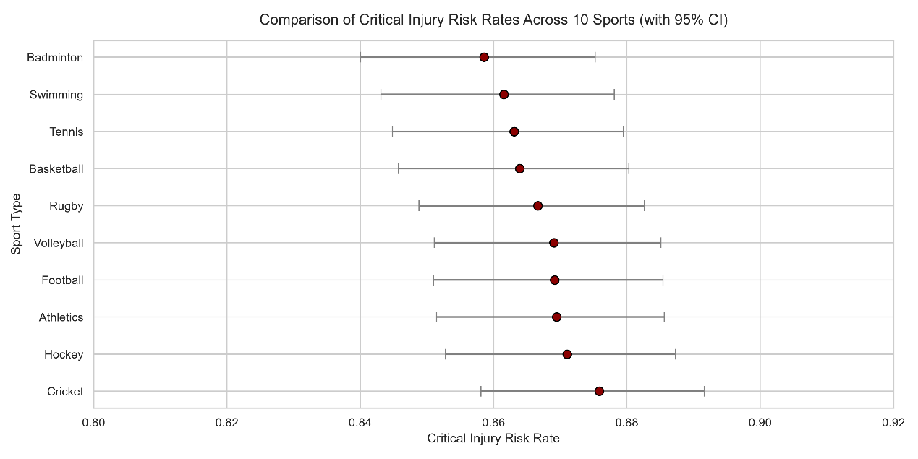
Figure 1: Comparison of baseline critical injury risk rates across 10 sports with 95% confidence intervals.
- Multivariate Risk Analysis (The Forest Plot)
To isolate true risk factors, we constructed a Multivariate Logistic Regression model controlling for clinical and biomechanical confounders. As shown in the Forest Plot (Figure 2), the Adjusted Odds Ratios (OR) for all sports hover around 1.0 and cross the baseline, indicating that sport type itself is not the primary risk driver. Instead, the plot reveals the true significant predictors: Training Workload Ratio (OR ≈ 3.8, p < 0.001), Previous Injury History (OR ≈ 1.6, p < 0.001), and Fatigue Score (OR ≈ 1.2, p < 0.001). This visual storytelling directly answers our research question, proving that injury prevention should prioritize training load management and recovery over the specific sport played.
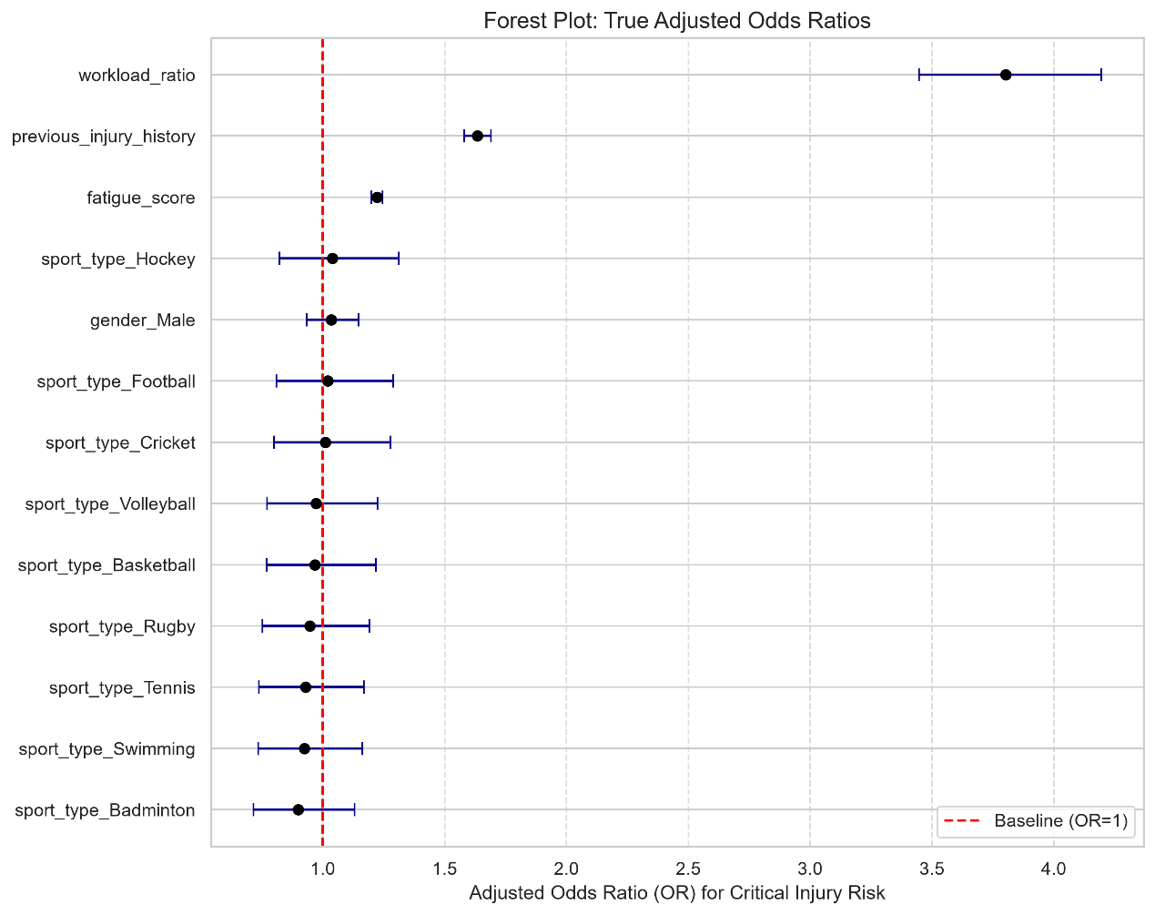
Figure 2: Forest Plot showing the Adjusted Odds Ratios (OR)
for critical injury risk after controlling for workload, fatigue, and injury history.

