BACHELOR IN PUBLIC ADMINISTRATION (BPA)
CURRICULUM
School Year 2026–2027 | CMO No. 18, Series of 2017
First Year – First Semester
Course Code | Term | Course Description | Credit Units |  |  | Pre-Requisite
 |  |  | Lec | Lab | Total
GE-101 | 1st | Purposive Communication | 3 |  | 3 | None
GE-103 | 1st | Mathematics in the Modern World | 3 |  | 3 | None
IR 1 | 1st | Basic Computer Operations with Laboratory | 2 | 1 | 3 | None
IR 4 | 1st | English for Professionals | 3 |  | 3 | None
GE-102 | 2nd | Readings in Philippine History | 3 |  | 3 | None
GE-104 | 2nd | Understanding the Self | 3 |  | 3 | None
IR 2 | 2nd | Values Education | 3 |  | 3 | None
NSTP 1 | Sem | National Service Training Program 1 (CWTS / LTS / ROTC) | 3 |  | 3 | None
PATHFIT 1 | Sem | Physical Activities Toward Health and Fitness 1 (Movement Competency Training) | 2 |  | 2 | None
Total |  |  | 25 | 1 | 26
1
First Year – Second Semester
Course Code | Term | Course Description | Credit Units |  |  | Pre-Requisite
 |  |  | Lec | Lab | Total
GE-105 | 1st | Science, Technology and Society | 3 |  | 3 | None
GE-Elect 3 | 1st | Environmental Science | 3 |  | 3 | None
GE-106 | 1st | Ethics | 3 |  | 3 | None
IR 5 | 1st | Introduction to Information Technology with Laboratory | 2 | 1 | 3 | IR 1
GE-109 | 2nd | Life and Works of Rizal | 3 |  | 3 | None
GE-108 | 2nd | The Contemporary World | 3 |  | 3 | None
GE-107 | 2nd | Art Appreciation | 3 |  | 3 | None
NSTP 2 | Sem | National Service Training Program 2 (CWTS / LTS / ROTC) | 3 |  | 3 | NSTP 1
PATHFIT 2 | Sem | Physical Activities Toward Health and Fitness 2 (Exercise-Based Fitness Activities) | 2 |  | 2 | PATHFIT 1
Total |  |  | 25 | 1 | 26

Second Year – First Semester
Course Code | Term | Course Description | Credit Units |  |  | Pre-Requisite
 |  |  | Lec | Lab | Total
Elective 1 | 1st | Project Development and Management | 3 |  | 3 | None
GE-Elect 1 | 1st | Gender and Society | 3 |  | 3 | None
IR 3 | 1st | Personal Growth and Career Education | 3 |  | 3 | None
PA 101 | 1st | Introduction to Public Administration 1 | 3 |  | 3 | None
PA Special Core 1 | 2nd | Basic Accounting | 3 |  | 3 | None
GE-Elect 2a | 2nd | Indigenous Creative Crafts | 3 |  | 3 | None
PA 102 | 2nd | Philippine Administrative Thought and Institutions | 3 |  | 3 | PA 101
PATHFIT 3 | Sem | Physical Activities Toward Health and Fitness 3 (Dance) | 2 |  | 2 | PATHFIT 2
Total |  |  | 23 |  | 23

Second Year – Second Semester
Course Code | Term | Course Description | Credit Units |  |  | Pre-Requisite
 |  |  | Lec | Lab | Total
PA 103 | 1st | Knowledge Management and ICT for Public Service | 3 |  | 3 | None
PA 104 | 1st | Organization and Management | 3 |  | 3 | PA 101
Elective 2 | 1st | Globalization and Public Administration | 3 |  | 3 | None
PA 105 | 1st | Local and Regional Governance | 3 |  | 3 | None
PA 106 | 2nd | Ethics and Accountability in the Public Service | 3 |  | 3 | None
PA 107 | 2nd | Public Accounting and Budgeting | 3 |  | 3 | PA 106
PSY 1 | 2nd | Psychology | 3 |  | 3 | None
PATHFIT 4 | Sem | Physical Activities Toward Health and Fitness 4 (Sports) | 2 |  | 2 | PATHFIT 3
Total |  |  | 23 |  | 23

Third Year – First Semester
Course Code | Term | Course Description | Credit Units |  |  | Pre-Requisite
 |  |  | Lec | Lab | Total
PA Special Core 2 | 1st | Elementary Statistics | 3 |  | 3 | GE- 103
RES 1 | 1st | Research Methods Applied in Public Administration 1 | 3 |  | 3 | None
PA 108 | 1st | Public Fiscal Administration | 3 |  | 3 | PA 107
Elective 3 | 2nd | Salary Standardization | 3 |  | 3 | Elective 2
PA 109 | 2nd | Office and System Management | 3 |  | 3 | None
PA 110 | 2nd | Administrative Law | 3 |  | 3 | PA 101
Total |  |  | 18 |  | 18

Third Year – Second Semester
Course Code | Term | Course Description | Credit Units |  |  | Pre-Requisite
 |  |  | Lec | Lab | Total
PA 111 | 1st | Public Policy and Program Administration | 3 |  | 3 | None
PA 112 | 1st | Public Personnel Administration | 3 |  | 3 | PA 101
RES 2 | 1st | Research Methods Applied in Public Administration 2 | 3 |  | 3 | RES 1
PA 113 | 2nd | Politics and Administration | 3 |  | 3 | PA 102
PA 114 | 2nd | Leadership and Decision Making | 3 |  | 3 | None
PA Special Core 3 | 2nd | Good Governance and Social Responsibility | 3 |  | 3 | PA Special Core 2
Total |  |  | 18 |  | 18
Fourth Year – First Semester
Course Code | Term | Course Description | Credit Units |  |  | Pre-Requisite
 |  |  | Lec | Lab | Total
Elective 4 | 1st | Records and Property Management | 3 |  | 3 | Elective 3
PA 115 | 1st | Human Behavior in Organization | 3 |  | 3 | None
PA 116 | 2nd | Governance and Development | 3 |  | 3 | None
PA 117 | 2nd | Special Topics in Public Administration with Seminar | 3 |  | 3 | Permission of Program Head
Total |  |  | 12 |  | 12

Fourth Year – Second Semester
Course Code | Term | Course Description | Credit Units |  |  | Pre-Requisite
 |  |  | Lec | Lab | Total
PRACT | Sem | Practicum / Work Integrated Learning for Public Administration (500 Hours) |  | 6 | 6 | CAR
Total |  |  |  | 6 | 6

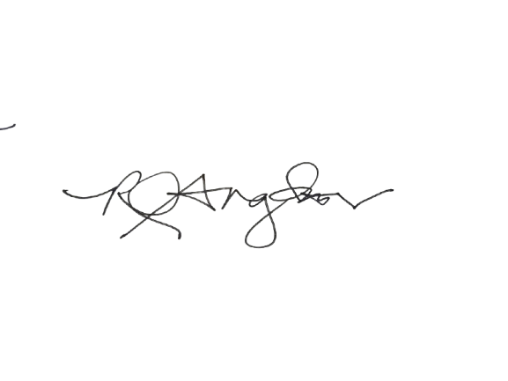
Total Curriculum Units: 155
Prepared By: | Curriculum sequencing verified:  • Year 1 contains only GE, institutional, PE, and NSTP courses.  • Prerequisite courses precede dependent courses.  • Year 2 major/professional load is minimized within total-unit and sequencing constraints.
RICKY Q. ANGWAS, MDMG
OIC- College Administrator

