## CSCI 6410 Advanced Database Design

## Linqiang Ge

Term Project Proposal

GSW Class Registration Application

1. February 27, 2017

# Janak Raj Chapagain

# Hyukpyo Hong

# Dongwen Qi

# Table of Contents

## 1 Summary

## 2 Introduction

## 3 Business Analysis

## 3-1 Functional Requirement

## 3-2 Data Requirement analysis

## 4 ER Diagram

## 4-1 Nomalization

## 4-2 ERD

## 4-3 Possible questions(Query)

## 5 Screenshot

## 6 Gantt Chart

# 1. Executive Summary

"This 'Registration helper' application is to make more convenient interface when GSW students do their register every semester. Main features of this application consist of three parts

1) Member Management

2) Class Registration

3) Class Review

First, every student and faculty of GSW can make their account with their school email(@radar.gsw.edu). Then, based on their basic information, such as major, and starting year, this application initialize with correspond information which is curriculum sheet and whole classes schedule of this semester.

Second, Application has two main screen, one is for curriculum sheet, and the other is class schedule. Curriculum sheet area shows that what classes are taken, and not. Also, it shows that what classes are available to enroll this semester. Since, students can select classes on the his/her curriculum sheet, and prerequisite sequence, it prevents from selecting classes unrelated with their degree. On the other hand, class schedule section shows whole list of classes of this semester, it basically shows same information with what GSW website is offering now. However, whenever students click the one part of their curriculum sheet(such as specific class name, Area A or selective course), class schedule screen turns to list of available classes.

Third, for more information, this application shows feedback of each classes from students, and everyone can read this feedback, if class has its feedback. To store this information, every students have to leave at least one feedback of what they took before, unless they are freshman.

Except above main functions, this application has minor features such as finding account, filtering schedule list, gpa calculator, and so on."

# 2. Introduction

Every semester, GSW students struggle with registering their classes. Although they have to meet their advisor before registration to make sure pursuing graduation, there are still possibility that student or advisor miss some information, since this is humans work. For example, computer science student can enroll in marketing management class, even this class can not be accepted for his degree. Moreover, current registration web site is not user friendly. Students have to open at least four screen, 1) curriculum sheet, 2) class schedule 3) Rain 4) Course Description. Separated information, and not unintuitive interface for registration can make mistake. This is time consuming and inefficient work for both student and advisor. So this application try to resolve this problem by combine these separate information, and linking each other with students information. Ultimately, this application may replace current Rain registration, with combining current school database in the future.

# 3 Business Analysis

# 3-1. Functional requirement

|  |  |  |
| --- | --- | --- |
| **No.** | **Description** | **Category** |
| 1 | Basic information section consists of 'Student name', 'Major', 'Acquired/required credits', 'GPA', 'Select Semester', 'Log out' | Basic Info |
| 2 | Major and start year added since there can be double major or minor. | Basic info |
| 3 | Basic info can be modified except email, name | Basic info |
| 4 | Current Class schedule is loaded right after the member logged in. | Class Schedule |
| 5 | Right side of each class there are review buttons, if it has more than one review. | Class Schedule |
| 6 | If review button at class schedule is clicked, then review contents appears on bottom section | Class Schedule |
| 7 | Retrieve the class schedule data of selected semester from GSW web whenever member logged in.(to know updated seat info) | Class Schedule |
| 8 | Class schedule can be sorted by criteria, such as Major, Credit, Time, Instructor, Class name/code, review rate, available seat | Class Schedule |
| 9 | Curriculum sheet is loaded right after the member logged in, | Curriculum sheet |
| 10 | You can check classes which already took before, then you can input GPA, review. | Curriculum sheet |
| 11 | Classes which already taken, are marked with special notation. | Curriculum sheet |
| 12 | Class which is not taken yet, has a button that make registration, if it is available at current semester with seat information | Curriculum sheet |
| 13 | Classes which can register this semester, are marked with special notation. | Curriculum sheet |
| 14 | If elective courses is clicked, then available class is displayed on the right section. | Curriculum sheet |
| 15 | Class which is not taken yet, has a button that make registration, if it is unavailable at current semester. with seat information | Curriculum sheet |
| 16 | Class which is not taken yet, and require prerequisite course, are marked with special notation. | Curriculum sheet |
| 17 | If classname is clicked at curriculum section, it's description is displayed on bottom section | Curriculum sheet |
| 18 | Classes are grouped by Area(e.g. Area A~F, Major, Electives) | Curriculum sheet |
| 19 | Curriculum sheet data require manual pre-process and stored in database, since its format is different each year, major | Curriculum sheet |
| 20 | If classname is clicked at class schedule section, it's description is displayed on bottom section | Detail Information |
| 21 | There is 'My schedule' button in bottom section, it shows time schedule, day by day. | Detail Information |
| 22 | Sign Up with student ID, email, major, start year | Membership |
| 23 | Student can find their ID or password with their email address by sending account information to their email | Membership |
| 24 | Initial screen of application is Log-in or Sign-up. It's located in top section. | Membership |
| 25 | After initial signup, student must leave at least one review of class that he took before (except freshman) | Review |
| 26 | Class review contains 'Rate of five stars', 'Semester', 'Class name', 'Class code', 'Instructor', 'Review contents' | Review |
| 27 | Class reviews are shown by anonymous to others. | Review |
| 28 | If one review receives more than 20 bad feed back from other students, his account will be lock until next semester. | Review |
| 29 | Students can see reviews relate to each class | Review |
| 30 | Student can leave feedback on each review, 'Helpful', 'Not helpful' | Review |
| 31 | Application consists of four section, Top - Basic Info, Left - Curriculum sheet, Right - Class Schedule, Bottom - Detail Info | Window |

# 3-2. Data requirement

|  |  |  |  |
| --- | --- | --- | --- |
| Table | Attribute | Data Example | Data Source |
| Member | mem_email | hhong@radar.gsw.edu | Student |
| mem_pw | P@ssw0rd |
| mem_startyear | 2016 |
| deg_level | undergraduate, graduate | <https://gsw.edu/academics/degrees> |
| deg_major | Computer Science |
| salt | !@#@!ADFAF |
| CourseList | cl_close | c | <https://gsw.edu/Academics/Registrars-Office/Schedule-of-Classes> |
| cl_year | 2017 |
| cl_semester | Spring |
| cl_CRN | 20397 |
| cl_SubjCode | CSCI |
| cl_CRSENo | 6410 |
| cl_title | Adv Database Design |
| cl_PTRM | 1 |
| cl_CredHours | 3 |
| cl_SeatAvail | 9 |
| cl_TotalSeats | 15 |
| cl_Days | MW |
| cl_start_time | 17:00 |
| cl_end_time | 18:15 |
| cl_Location | CWH 214 |
| cl_Instructor | Ge, L |
| cl_type | online, offline |
| curriculum | **curi_year** | 2016 |  |
| **deg_level** | undergraduate, graduate |
| **deg_major** | Computer Science |
| **cl_SubjCode** | CSCI |
| **cl_CRSENo** | 6410 |
| curi_area | A,b,c,m |
| curi_group | 0,1,2,3,4 |
| class_group | **curi_year** | 2016 |  |
| **deg_level** | undergraduate, graduate |
| **deg_major** | Computer Science |  |
| **curi_area** | A,b,c,m |  |
| **curi_group** | 0,1,2,3,4 |  |
| cg_credit | 12 |
| Prerequisite | cl_SubjCode | CSCI | <https://gsw.edu/academics/degrees> |
| cl_CRSENo | 6410 |
| pre_SubjCode | CSCI | <https://gsw.edu/academics/registrars-office/gsw-catalogbulletin> |
| pre_CRSENo | 4400 |
| Trascript | mem_email | hhong@radar.gsw.edu | Student |
| cl_SubjCode | CSCI |
| cl_CRSENo | 6410 |
| tran_GPA | A,B |
| Feedback | mem_id | hhong@radar.gsw.edu | Student |
| cl_CRN | 20397 |
| feed_content | "The instructor is very kind and make easy.." |
| Degree | deg_level | undergraduate, graduate | <https://gsw.edu/academics/degrees> |
| deg_major | Computer Science |
| course | cl_SubjCode | CSCI | <https://gsw.edu/academics/registrars-office/gsw-catalogbulletin> |
| cl_CRSENo | 6410 |
| cl_title | “Adv Database” |
| cl_credithours | 3 |
| cl_descripion | "This course covers advanced level database.." |

# 4. ERD

# 4-1 Nomalization

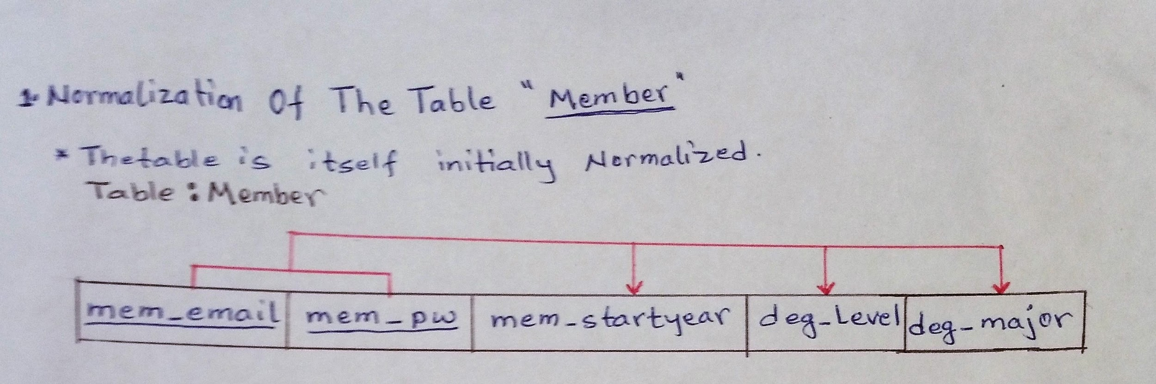

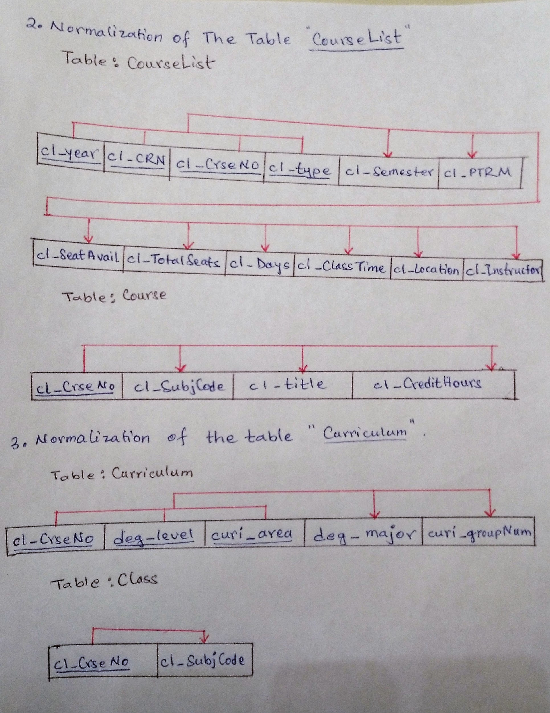

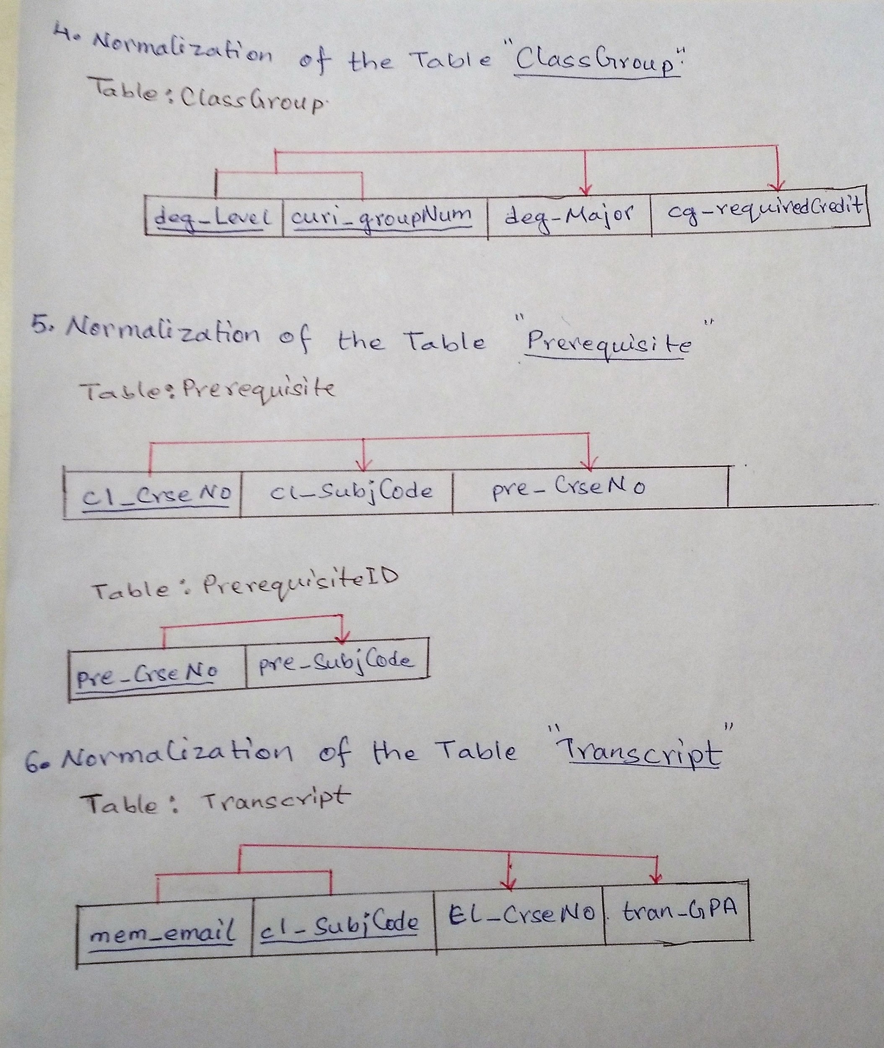

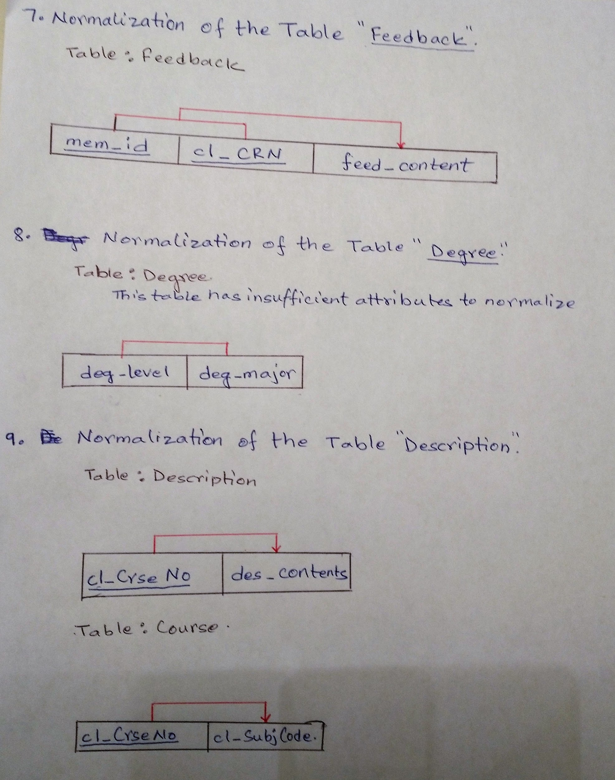

# 4-2 ERD

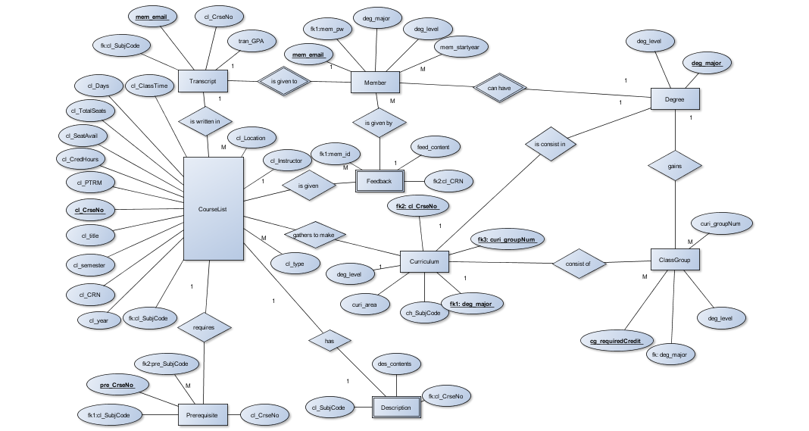

# 4-3 Possible questions(Query)

Show the list of classes which has available seats.

Show the list of classes which has reviews.

Show the list of classes which my major should take.

Show the classes which is on Thursday

Show the classes which is in my curriculum but not taken yet

Show the classes which is in my curriculum and already took

Show the time schedule which select to register at this semester

Show the class description of what I select from class schedule.

Compare user input id and password with account table

Load whole class schedule of current semester.

Sort the list of class schedule by name

Create new account of new member

Update user level from undergraduate into graduate

Insert my review contents into one class information.

Insert grade of the class into my curriculum information.

Remove the finish mark from the class which I checked by mistake.

# 5 Screenshot

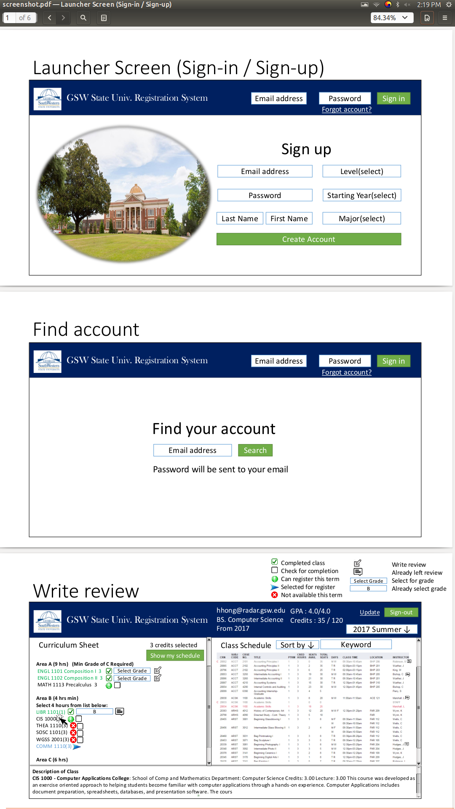

Register Screen

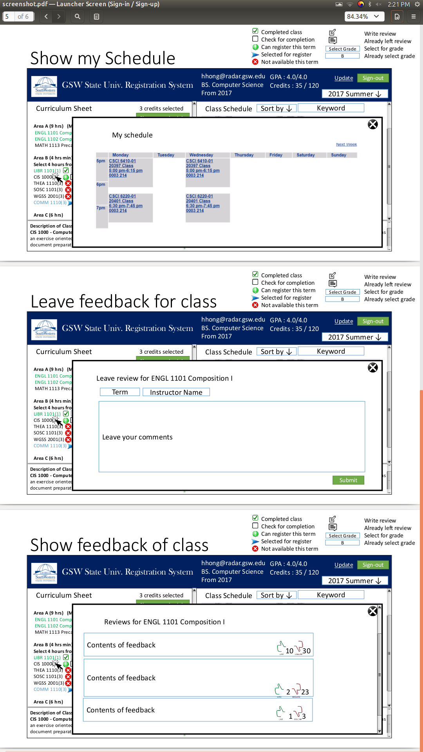

# 6 Gantt Chart

