R Notebook

This is an [R Markdown](http://rmarkdown.rstudio.com) Notebook. When you execute code within the notebook, the results appear beneath the code.

Try executing this chunk by clicking the *Run* button within the chunk or by placing your cursor inside it and pressing *Ctrl+Shift+Enter*.

plot(cars)

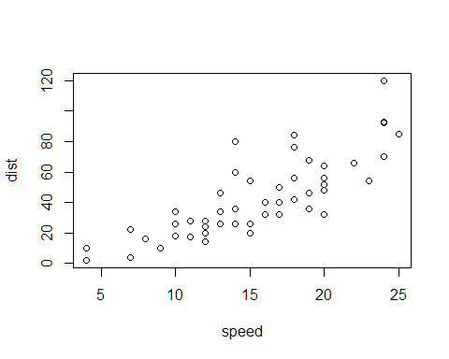

Add a new chunk by clicking the *Insert Chunk* button on the toolbar or by pressing *Ctrl+Alt+I*.

When you save the notebook, an HTML file containing the code and output will be saved alongside it (click the *Preview* button or press *Ctrl+Shift+K* to preview the HTML file).

pitch = c(233, 204, 242, 130, 112, 142)  
sex = c(rep("female", 3), rep("male", 3))  
my.df = data.frame(sex, pitch) # data frame of 6 informants  
my.df

## sex pitch  
## 1 female 233  
## 2 female 204  
## 3 female 242  
## 4 male 130  
## 5 male 112  
## 6 male 142

xmdl = lm(pitch ~ sex, my.df)  
summary(xmdl)

##   
## Call:  
## lm(formula = pitch ~ sex, data = my.df)  
##   
## Residuals:  
## 1 2 3 4 5 6   
## 6.667 -22.333 15.667 2.000 -16.000 14.000   
##   
## Coefficients:  
## Estimate Std. Error t value Pr(>|t|)   
## (Intercept) 226.33 10.18 22.224 2.43e-05 ***  
## sexmale -98.33 14.40 -6.827 0.00241 **   
## ---  
## Signif. codes: 0 '***' 0.001 '**' 0.01 '*' 0.05 '.' 0.1 ' ' 1  
##   
## Residual standard error: 17.64 on 4 degrees of freedom  
## Multiple R-squared: 0.921, Adjusted R-squared: 0.9012   
## F-statistic: 46.61 on 1 and 4 DF, p-value: 0.002407

2 + 2 = 4