|  |
| --- |
| SoftwareEngineering |
| Project Hw1 |
| A) 곽성은 김광채 김현범 윤아름 |

|  |
| --- |
| A 팀  2016-11-11 |

IR Class Diagram

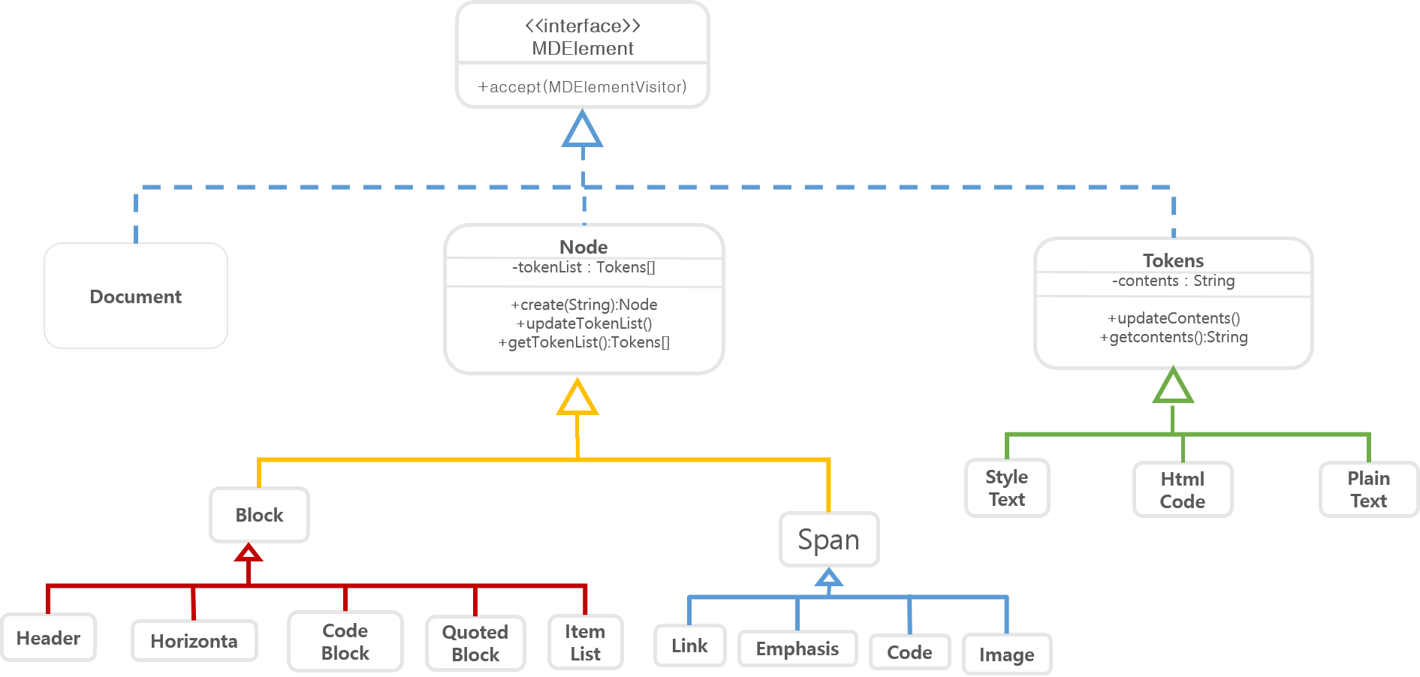

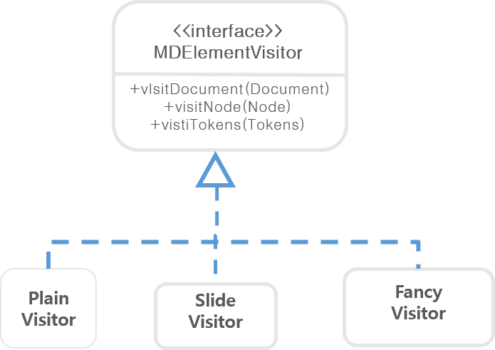

**Document Class**

* member variance
* - NodeList : Node[]

Nodelist makes up a document.

* member function
* +updateNodeList()

This function updates NodeList

* +getNodeList : Node[]

NodeList that is private data can be got by other class using this function.

**Node Class**

* member variance
* -tokenList : Tokens[]
* TokenList makes up a Node
* member function
* +updateTokenList()
* +getTokenList()
* member variance
* -contents : String

String variance that stores the text of Tokens’s contents

* +updateContents(String newString)

This function updates contents to newString

**We classify Classes that inherit Node Class into Block Class and Span Class**

1. Child Classes of Block Class

: Header Class, CodeBlock Class, QuotedBlock Class, ItemList Class, Horizonta Class

2. Child Classes of Span Class

: Link Class, Emphasis Class, Code Class, Image Class

Tokens Class

Design issues

**If there is no matched file to convert**

-Print error (file read error)

**If there is wrong option(can’t match contents, just form)**

-Print available contents of the option

**If there is wrong option(can’t match form, just contents)**

-Print several normal forms of the option

**If there are serious grammar error in original text**

-Ignore(believed in robustness)

-Give warning that there are problem in original text

**If the file size is so massive**

-Check file size before working

**If user didn’t specify output file name**

-Use default filename

**If there are multimarkdown**

-So far, do not support multimarkdown.(mmd)

Clarify grammar ambiguous

**When --- or === appear in series, it is ambiguous**

Markdown supports two styles of headers, “===” and “---”. When two headers are appeared consecutively, it is ambiguous.

**Image is only available with just its info. (Not available to change size, position)**

Image syntax looks like this: ![Alt text](/path/to/img.jpg ”Optional title”).  When an image is inserted, only Alt text and “Optional title” can be added as information. It is inconvenient when multiple images are uploaded. Because the multiple images cannot be arranged the positions by markdown. With this informations, the images cannot be sorted and specified the desired size.  If the images are sorted, it is possible to use ‘img’ tag of HTML.

**If there are both asterisks(*) and double asterisks(**) consecutively, it is ambiguous.**

Markdown cannot apply bold and italic at the same time. So if they are appeared consecutively, consider asterisks(*) first.

If there is a line-break between emphasis(asterisks(*) or double asterisks(**)), consider line-break as space.