|  |
| --- |
| SoftwareEngineering |
| Project Hw1 |
| A) 곽성은21400026 김광채21100055 김현범21100187 윤아름21100453 |

|  |
| --- |
| A조  2016-11-25 |

The way of Including a ‘Jtidy’ library

Firstly, We made this project named converter, set ‘javadoc’ as default and the java project directory as base directory for this project. Next, we set up each directory and the main class as directory property . Also we set up the directory that contains the jar file using <path> to include ‘Jtidy JAR file’. <fileset> tag in <classpath>  is used when specified the compressed file such as jar. Thus, <fileset> specifies the file format as jar in ${lib.dir}.

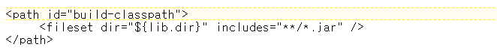

we initialized class, jar and doc directories for this project, after that we cleared the directories applied. we compiled the java files in ${src.dir} with Jtidy JAR file and then put class file in class directory.

To make a runnable JAR file, we made a manifest firstly and then made a runnable JAR file including the class files in class.dir on the basis of manifest .

Finally, this xml file executes program and code that makes some java documents.

What we have implemented since 2 weeks ago

* Exception handling when command parameter is empty.
* Draw up a code determining nodes and tokens.(on-going)
* Formalize classes to implement visitor pattern. For example, MDElement, Document, MDElementVisitor, SlideVisitor, PlainVisitor.