**>> 출력문과 메인메소드가 다음과 같이 되도록 필요한 클래스와 메소드를 작성하시오. 모든 멤버변수(필드는 private)**

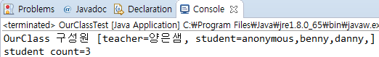

|  |
| --- |
| **public class OurClassTest {**  **public static void main(String[] args) {**  **Student std[] = new Student[3];**  **std[0] = new Student();**  **std[1] = new Student("benny");**  **std[2] = new Student("danny");**  **OurClass oca = new OurClass("양은샘", std);**  **System.out.println(oca);**  **System.out.println("student count=" + Student.getCount());**  **}**  **}** |

import java.util.*;

class OurClass {

private String teacher;

private Student[] std;

public OurClass(String teacher, Student[] std) {

this.teacher = teacher;

this.std = std;

}

public String toString() {

String result = "OurClass 구성원 [teacher=" + this.teacher + ", student=";

for (int i = 0; i < this.std.length; i++) {

result += this.std[i].getStu() + ",";

}

result += "]";

return result;

}

public int getCount() {

return std.length;

}

}

public class Student {

private String stu;

private static int count;

Student() {

this.stu = "anonymous";

count++;

}

Student(String a) {

this.stu = a;

count++;

}

public static int getCount() {

return count;

}

public String getStu() {

return this.stu;

}

}