|  |  |  |  |  |
| --- | --- | --- | --- | --- |
| 2021_1_WEB_14_과제 | 학번 : | 20165164 | 이름 : | 지현한 |

* 개념 활용

1. jQuery 속성 추가를 사용하여 이미지너비를 증가시켜 웹 브라우저로 출력하는 스크립트를 작성하시오.

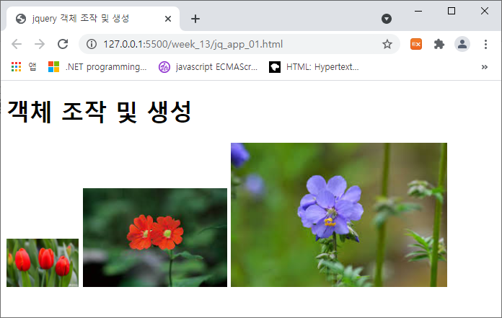

<body>

  <h1>객체 조작 및 생성</h1>

 <img src="flow4.jpg" alt="">

 <img src="flow6.jpg" alt="">

 <img src="flow7.jpg" alt="">

</body>

|  |
| --- |
| [소스]  <!DOCTYPE html>  <html>  <head>      <script src="https://code.jquery.com/jquery-3.6.0.js"></script>      <script>          $(function(){              $('img').attr('width',function(index){                  return (index+1)*100;              });          });      </script>  </head>  <body>      <body>          <h1>객체 조작 및 생성</h1>         <img src="image/flow4.jpg" alt="">         <img src="image/flow6.jpg" alt="">         <img src="image/flow7.jpg" alt="">        </body>    </body>  </html> |
| [실행결과] |

1. jQuery를 사용하여 1초 간격으로 랜덤한 크기의 글자를 제시된 결과처럼 출력하는 스크립트를 작성하시오. 단, 글자크기는 10px~40px

   <body>

   <div id="panel">난수로 생성된 숫자 추가</div>

</body>

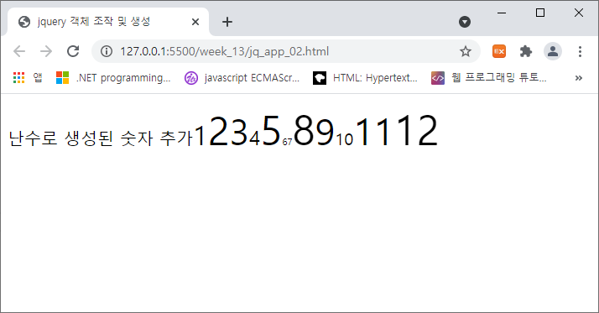

|  |
| --- |
| [소스]  <!DOCTYPE html>  <html>  <head>      <script src="https://code.jquery.com/jquery-3.6.0.js"></script>      <script>          $(function () {              let $panel = $('#panel');              let count = 0;              setInterval(function () {                  let $span = $('<span></span>');                  let fontSize = (Math.floor(Math.random() * 40) + 10) + 'px';                  $span.css({                      fontSize:fontSize,                      display: 'inline - block'                  });                  $span.html(++count);                  $panel.append($span);              }, 500);          });      </script>      <style>          #panel{              width:600px;              overflow:visible;              border:1px dottoed #ccc;              font-size: 20px;          }      </style>  </head>  <body>      <div id="panel">난수로 생성된 숫자 추가</div>  </body>  </html> |
| [실행결과] |

1. jQuery 이벤트를 사용하여 제시된 결과처럼 실행되는 펼침 메뉴를 구현하시오. 단, 메인메뉴는 3가지이고 서브메뉴의 개수와 내용은 본인이 임의로 결정할 것.

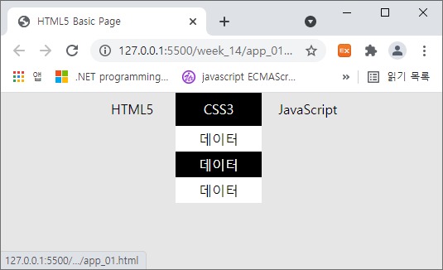

|  |
| --- |
| [소스]  <!DOCTYPE html>  <html>  <head>      <style>          * {              padding: 0;          }          ul {              width: 100px;              margin: auto;          }          li {              list-style: none;              width: 100%;          }          body {              background: #E6E6E6;          }          .outer-menu {              display: flex;              width: 60vw;          }          .outer-menu-item {              position: relative;          }          .outer-menu-item:hover {              background: black;              color: white;          }          .menu-title {              display: block;              height: 30px;              line-height: 30px;              text-align: center;              padding: 5px 20px;          }          .inner-menu {              display: none;              position: absolute;              top: 40px;              left: 0;              width: 100%;              background: white;              text-align: center;          }          .inner-menu-item>a {              display: block;              padding: 5px 10px;              color: black;          }          .inner-menu-item>a:hover {              background: black;              color: white;          }      </style>      <script src="https://code.jquery.com/jquery-3.6.0.js"></script>      <script>          $(document).ready(function () {              $('.outer-menu-item').hover(function () {                  $(this).find('.inner-menu').show();              }, function () {                  $(this).find('.inner-menu').hide();              });          });      </script>  </head>  <body>      <div>          <ul class="outer-menu">              <li class="outer-menu-item">                  <span class="menu-title">HTML5</span>                  <ul class="inner-menu">                      <li class="inner-menu-item"><a href="#">데이터</a></li>                      <li class="inner-menu-item"><a href="#">데이터</a></li>                  </ul>              </li>              <li class="outer-menu-item">                  <span class="menu-title">CSS3</span>                  <ul class="inner-menu">                      <li class="inner-menu-item"><a href="#">데이터</a></li>                      <li class="inner-menu-item"><a href="#">데이터</a></li>                      <li class="inner-menu-item"><a href="#">데이터</a></li>                  </ul>              </li>              <li class="outer-menu-item">                  <span class="menu-title">JavaScript</span>                  <ul class="inner-menu">                      <li class="inner-menu-item"><a href="#">데이터</a></li>                      <li class="inner-menu-item"><a href="#">데이터</a></li>                      <li class="inner-menu-item"><a href="#">데이터</a></li>                      <li class="inner-menu-item"><a href="#">데이터</a></li>                      <li class="inner-menu-item"><a href="#">데이터</a></li>                      <li class="inner-menu-item"><a href="#">데이터</a></li>                      <li class="inner-menu-item"><a href="#">데이터</a></li>                      <li class="inner-menu-item"><a href="#">데이터</a></li>                  </ul>              </li>          </ul>      </div>  </body>  </html> |
| [실행결과] |

1. ‘14주 수업자료’ 슬라이드 번호 3번

|  |
| --- |
| [소스]  <!DOCTYPE html>  <html>  <head>      <title>jquery 이벤트 - 이벤트 연결 메소드</title>      <script src="https://code.jquery.com/jquery-3.6.0.js"></script>      <script>          $(document).ready(function () {              // 이벤트를 연결합니다.              $('h1').hover(function () {                  $(this).css({ // 색상 변경                      background: 'red',                      color: 'white'                  });              }, function () {                  $(this).css({ // 색상 제거                      background: '',                      color: ''                  });              });          });      </script>  </head>  <body>      <h1>Header-0</h1>      <h1>Header-1</h1>      <h1>Header-2</h1>  </body>  </html> |
| [실행결과] |

1. ‘14주 수업자료’ 슬라이드 번호 23번

|  |
| --- |
| [소스]  <!DOCTYPE html>  <html>  <head>      <title>시각 효과</title>      <script src="https://code.jquery.com/jquery-3.6.0.js"></script>      <script>          $(document).ready(function () {              $("#btn1").on("click", function () {                  $("h1").slideUp(1000);              });              $("#btn2").on("click", function () {                  $("h1").slideDown("slow");              });              $("#btn3").on("click", function () {                  $("h1").slideToggle("fast");              });          });      </script>      <style type="text/css">          h1 {              width: 200px;              height: 200px;              background-color: #FF0;          }      </style>  </head>  <body>      <button id="btn1">slideUp</button>      <button id="btn2">slideDown</button>      <button id="btn3">slideToggle</button>      <h1>내용</h1>  </body>  </html> |
| [실행결과] |