|  |  |
| --- | --- |
|  |  |
| Problem2 Report |  |
|  |  |
|  | Student NO: 20183784Student Name: 노현진 |
|  |  |

**[Environment]**

* **CPU**

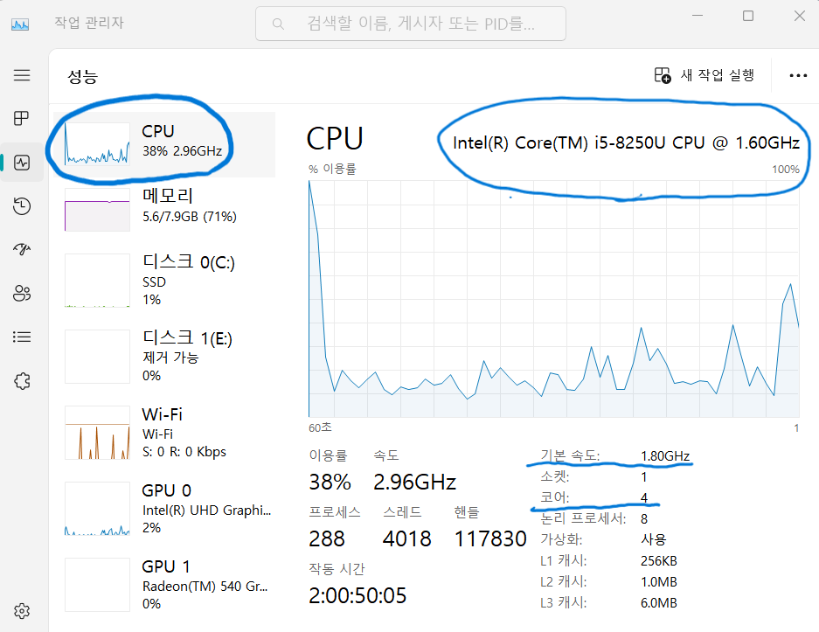

**CPU type: Intel® Core™ i5-8250U CPU**

**Clock Speed: 1.80GHz**

**Number of cores: 4**

* **Memory**

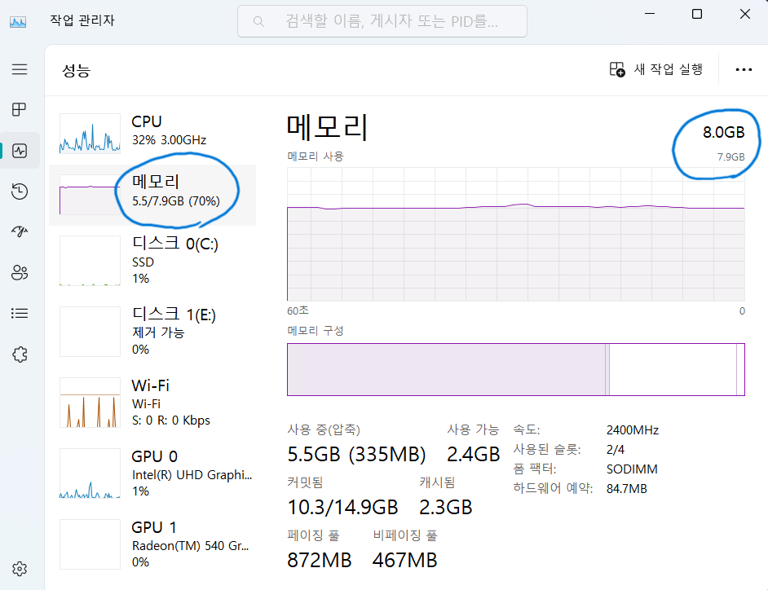

**Memory size: 8.0GB**

* **OS**

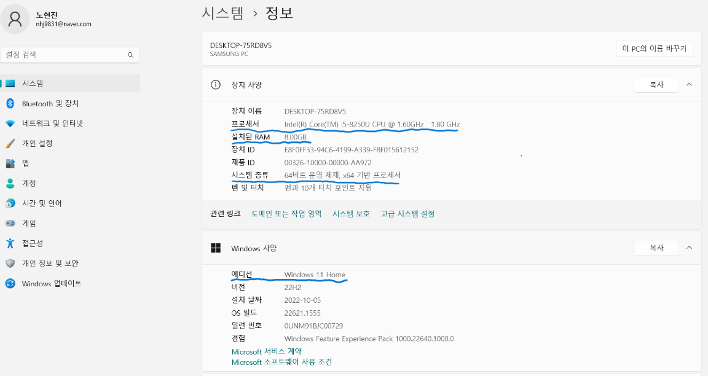

**OS type: Windows 11**

**[Source Code]**

* **prob2.c**

#include <omp.h>

#include <stdio.h>

#include <stdlib.h>

#define NUM_STEPS 10000000

void main(int argc, char *argv[]) {

if (argc == 4) {

/*

* argv[1]: scheduling type number

* 1: static

* 2: dynamic

* 3: guided

*

* argv[2]: chunk size

* => 1, 5, 10, 100

*

* argv[3]: number of threads

* => 1, 2, 4, 6, 8, 10, 12, 14, 16

*/

int scheduling_type_number = atoi(argv[1]);

int chunk_size = atoi(argv[2]);

int num_threads = atoi(argv[3]);

long i;

double step = 1.0 / (double) NUM_STEPS;

double x, pi, sum = 0.0;

double start_time, end_time;

omp_set_num_threads(num_threads);

start_time = omp_get_wtime();

printf("Chunk size: %d\n", chunk_size);

printf("The number of threads: %d\n", num_threads);

switch (scheduling_type_number) {

case 1:

// static

#pragma omp parallel for reduction (+:sum) schedule(static, chunk_size)

for (i = 0; i < NUM_STEPS; i++) {

x = (i + 0.5) * step;

sum = sum + 4.0 / (1.0 + x * x);

}

pi = step * sum;

end_time = omp_get_wtime();

printf("pi = %.24lf\n", pi);

printf("The execution Time : %lfms\n", end_time - start_time);

break;

case 2:

// dynamic

#pragma omp parallel for reduction (+:sum) schedule(dynamic, chunk_size)

for (i = 0; i < NUM_STEPS; i++) {

x = (i + 0.5) * step;

sum = sum + 4.0 / (1.0 + x * x);

}

pi = step * sum;

end_time = omp_get_wtime();

printf("pi = %.24lf\n", pi);

printf("The execution Time : %lfms\n", end_time - start_time);

break;

case 3:

// guided

#pragma omp parallel for reduction (+:sum) schedule(guided, chunk_size)

for (i = 0; i < NUM_STEPS; i++) {

x = (i + 0.5) * step;

sum = sum + 4.0 / (1.0 + x * x);

}

pi = step * sum;

end_time = omp_get_wtime();

printf("pi = %.24lf\n", pi);

printf("The execution Time : %lfms\n", end_time - start_time);

break;

default:

printf("Scheduling type number should be 1, 2, or 3.\n");

}

}

else {

printf("This program needs only three parameters.\n");

}

}

**[Results]**

* **Execution Time**

|  |  |  |  |  |  |  |  |  |  |  |
| --- | --- | --- | --- | --- | --- | --- | --- | --- | --- | --- |
| Execution time  (unit:ms) | Chunk  Size | 1 | 2 | 4 | 6 | 8 | 10 | 12 | 14 | 16 |
| static | 1 | 157.067 | 170.750 | 168.986 | 163.036 | 165.700 | 160.453 | 154.240 | 107.360 | 154.205 |
| dynamic | 275.678 | 311.475 | 283.562 | 276.219 | 285.548 | 290.200 | 286.356 | 305.809 | 291.712 |
| guided | 156.082 | 155.518 | 152.983 | 69.365 | 138.948 | 141.760 | 139.852 | 137.328 | 73.376 |
| static | 5 | 153.831 | 151.390 | 163.514 | 81.618 | 148.711 | 157.879 | 138.867 | 96.669 | 75.383 |
| dynamic | 163.591 | 178.118 | 142.086 | 136.382 | 179.642 | 176.504 | 180.392 | 173.991 | 173.116 |
| guided | 162.227 | 166.489 | 68.382 | 153.407 | 63.442 | 143.503 | 73.706 | 81.758 | 143.466 |
| static | 10 | 152.197 | 125.826 | 101.642 | 157.581 | 144.886 | 145.253 | 142.720 | 145.110 | 78.191 |
| dynamic | 168.866 | 146.063 | 164.891 | 135.730 | 172.622 | 138.050 | 129.074 | 165.337 | 134.013 |
| guided | 155.563 | 162.643 | 73.493 | 148.954 | 79.336 | 138.563 | 71.383 | 74.665 | 141.155 |
| static | 100 | 156.729 | 157.113 | 91.888 | 148.284 | 161.303 | 149.346 | 142.994 | 70.031 | 141.759 |
| dynamic | 161.240 | 153.951 | 98.794 | 154.846 | 72.815 | 145.257 | 152.219 | 61.015 | 145.712 |
| guided | 156.982 | 92.811 | 95.677 | 154.687 | 81.936 | 145.880 | 76.031 | 64.153 | 142.605 |

* **Performance**

|  |  |  |  |  |  |  |  |  |  |  |
| --- | --- | --- | --- | --- | --- | --- | --- | --- | --- | --- |
| performance  (1/exec time) | Chunk  Size | 1 | 2 | 4 | 6 | 8 | 10 | 12 | 14 | 16 |
| static | 1 | 6.36e-3 | 5.85e-3 | 5.91e-3 | 6.13e-3 | 6.04e-3 | 6.23e-3 | 6.48e-3 | 9.31e-3 | 6.48e-3 |
| dynamic | 3.62e-3 | 3.21e-3 | 3.52e-3 | 3.62e-3 | 3.50e-3 | 3.44e-3 | 3.49e-3 | 3.27e-3 | 3.42e-3 |
| guided | 6.40e-3 | 6.43e-3 | 6.53e-3 | 1.44e-2 | 7.19e-3 | 7.05e-3 | 7.15e-3 | 7.28e-3 | 1.36e-2 |
| static | 5 | 6.50e-3 | 6.60e-3 | 6.11e-3 | 1.22e-2 | 6.72e-3 | 6.33e-3 | 7.20e-3 | 1.03e-2 | 1.32e-2 |
| dynamic | 6.11e-3 | 5.61e-3 | 7.03e-3 | 7.33e-3 | 5.56e-3 | 5.66e-3 | 5.54e-3 | 5.74e-3 | 5.77e-3 |
| guided | 6.16e-3 | 6.00e-3 | 1.46e-2 | 6.51e-3 | 1.57e-2 | 6.96e-3 | 1.35e-2 | 1.22e-2 | 6.97e-3 |
| static | 10 | 6.57e-3 | 7.94e-3 | 9.83e-3 | 6.34e-3 | 6.90e-3 | 6.88e-3 | 7.00e-3 | 6.89e-3 | 1.27e-2 |
| dynamic | 5.92e-3 | 6.84e-3 | 6.06e-3 | 7.46e-3 | 5.79e-3 | 7.24e-3 | 7.74e-3 | 6.04e-3 | 7.46e-3 |
| guided | 6.42e-3 | 6.14e-3 | 1.36e-2 | 6.71e-3 | 1.26e-2 | 7.21e-3 | 1.40e-2 | 1.33e-2 | 7.08e-3 |
| static | 100 | 6.38e-3 | 6.36e-3 | 1.08e-2 | 6.74e-3 | 6.19e-3 | 6.69e-3 | 6.99e-3 | 1.42e-2 | 7.05e-3 |
| dynamic | 6.20e-3 | 6.49e-3 | 1.01e-2 | 6.45e-3 | 1.37e-2 | 6.88e-3 | 6.56e-3 | 1.63e-2 | 6.86e-3 |
| guided | 6.37e-3 | 1.07e-2 | 1.04e-2 | 6.46e-3 | 1.22e-2 | 6.85e-3 | 1.31e-2 | 1.55e-2 | 7.01e-3 |

**[Explanation/Analysis on the Results]**

The above results show that the guided approach is the best approach among all the methods. The execution of time and performance of guided approach is the best. Also, in case of small chunk size, dynamic approach is worst. If chunk size get larger, dynamic approach may be best approach.