<santa rosa local whether dataset>

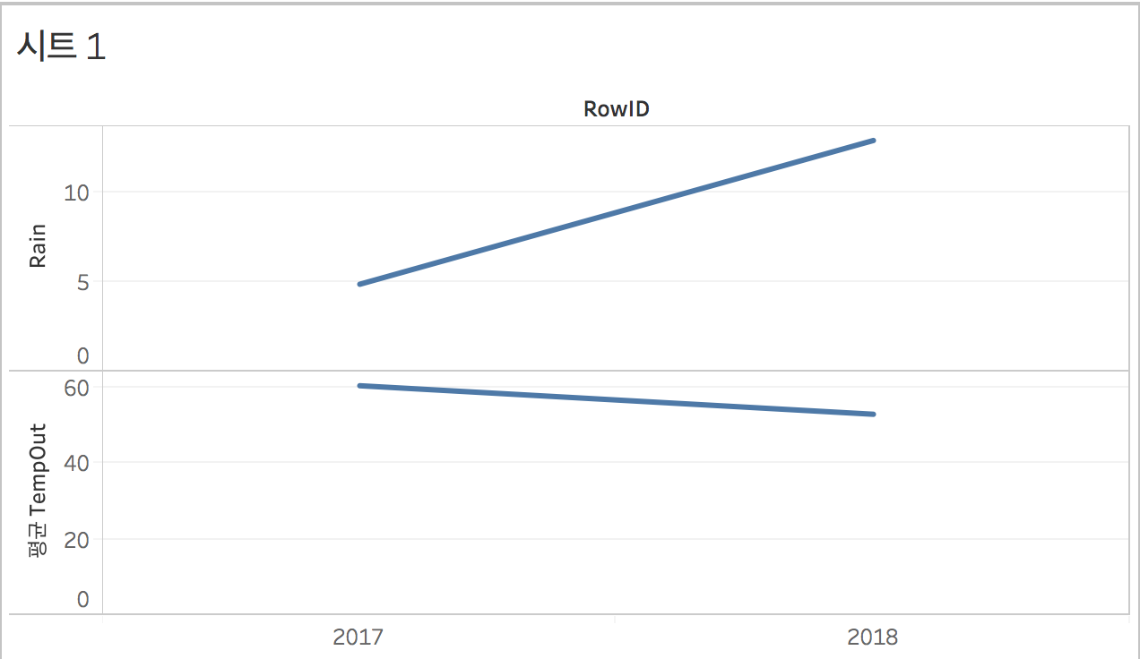

I judged that there was a connection between rain and temperature. Therefore, set RowID (year) as Xaxis and set Yaxis as Rain and average TempOut. As a result of vsualization, the average tempOut was lower in rainy year than in rainy year.

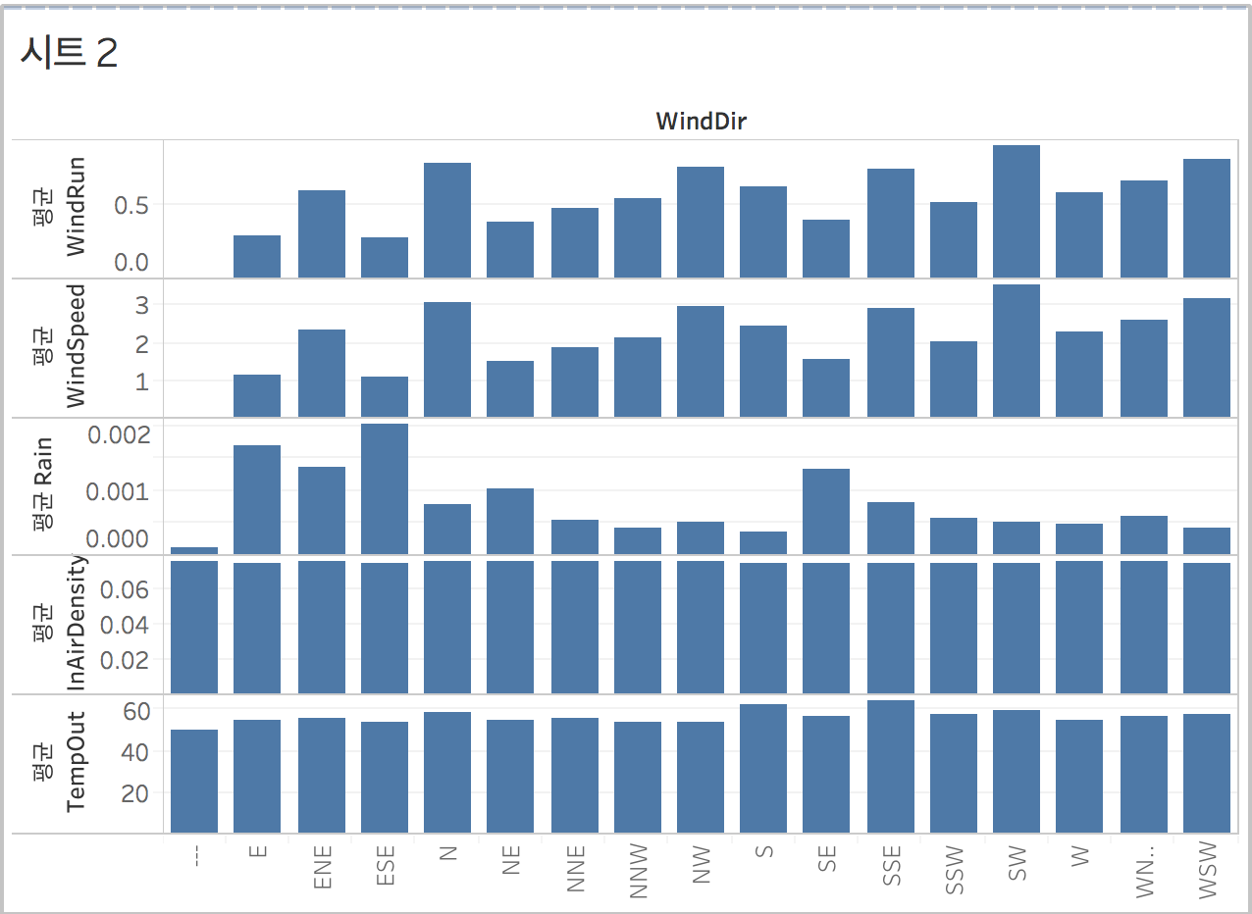

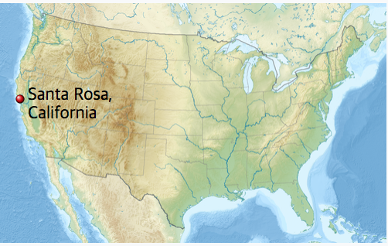

I thought there would be a mass of air. Therefore, i tried to correlate the various measures (windRun, windSpeed, windRain, inAi .ensity, tempOut) for the windDir. WindRun and windSpeed were the highest when the wind direction was SW. The SW direction of the santa rosa is from the sea. Therefore, it was windy. In the East direction, the wind was weakest because the east direction of the santa rosa was inland.

For the average rain, the wind direction was highest with the EAST direction and ESE direction. East direction of wind means the wind blows inland from the sea. Therefore, the average ratio of rain is greatest because wind comes from the sea.

The air density had nothing to do with the direction of the wind.

For the average temperature out, it was highest when the direction of wind was in south and sse. The wind direction is south, meaning it is blowing in areas with lower latitudes. This result is correct because lower latitude is usually hotter.

next page exist

< warn Missouri Dataset >

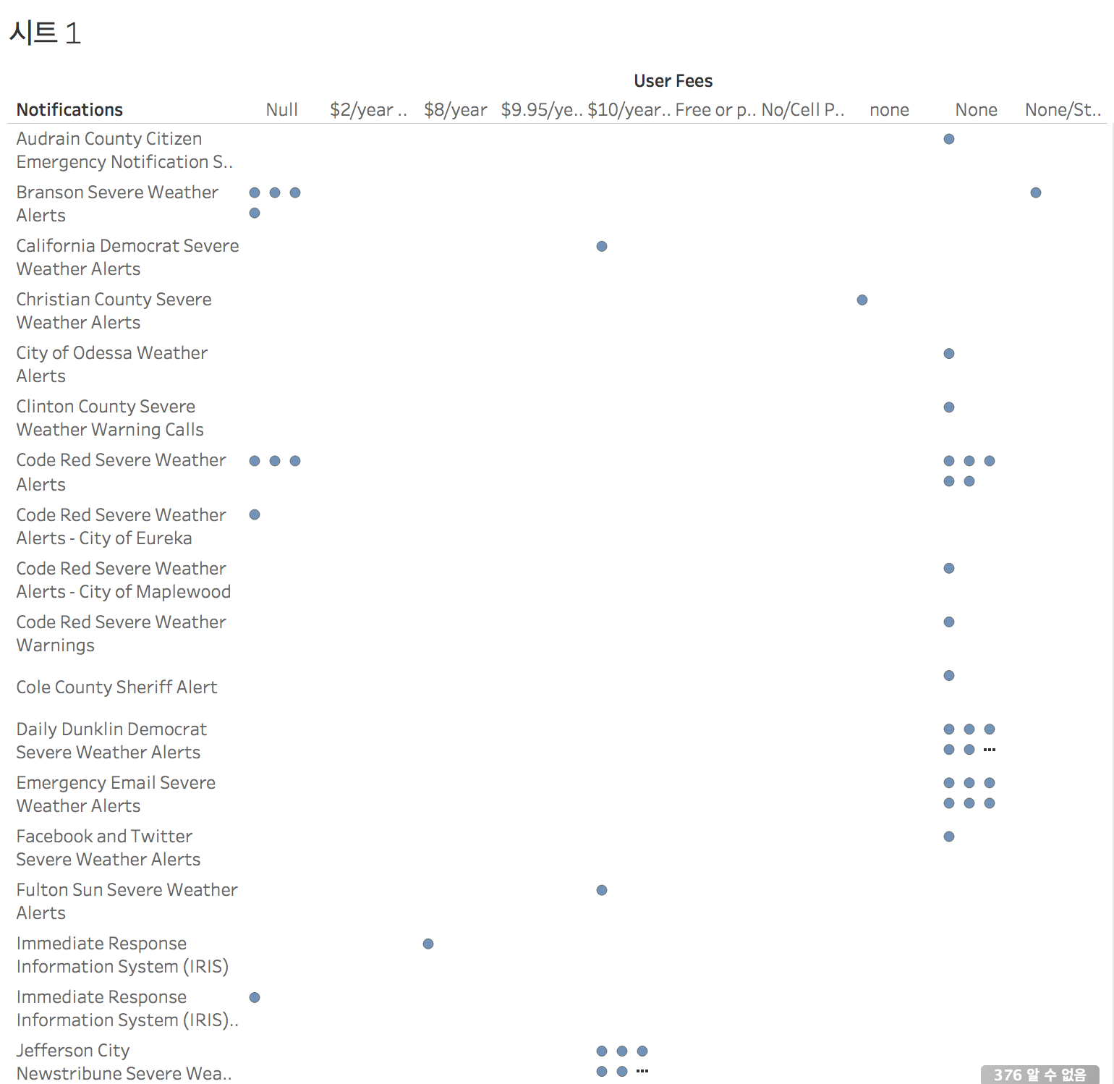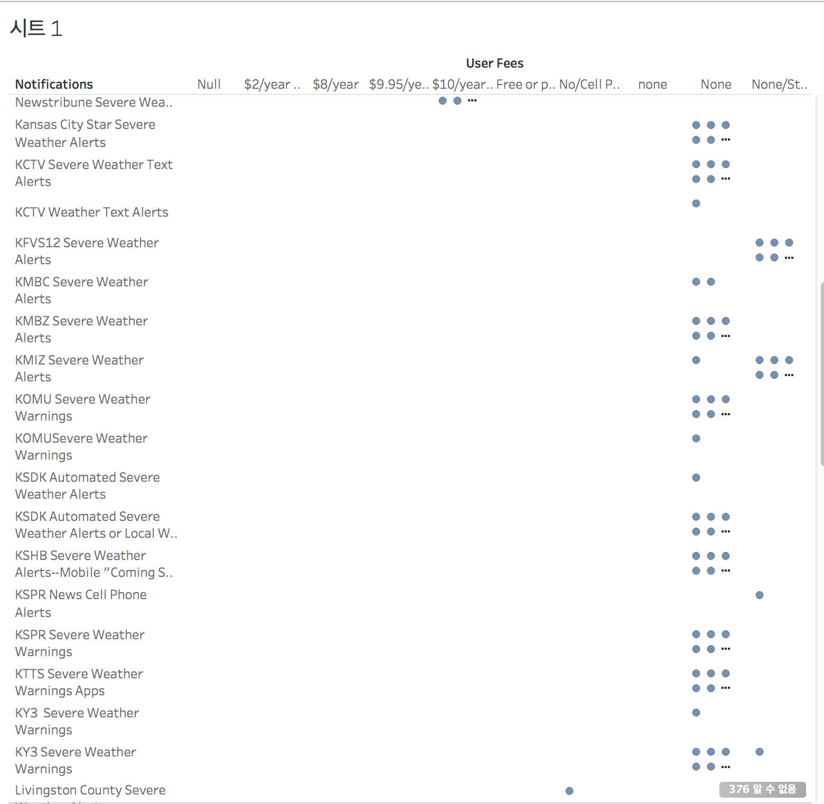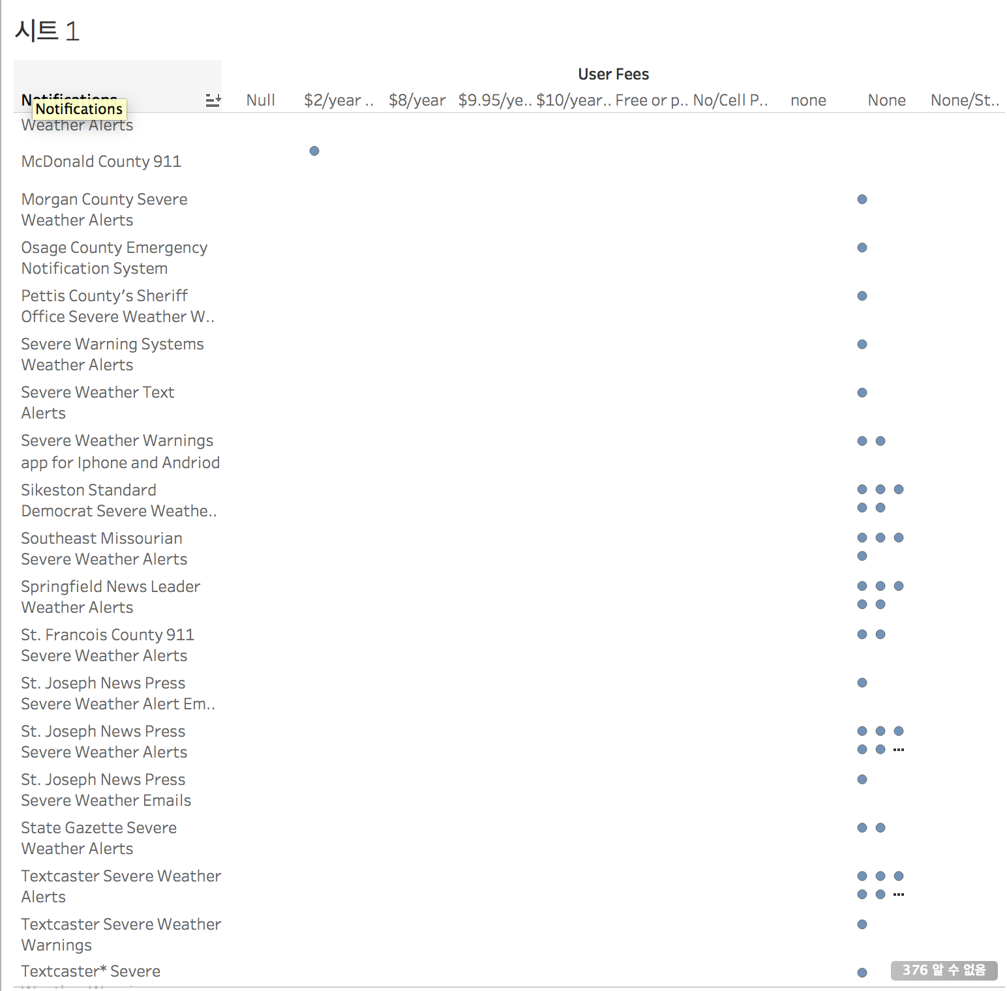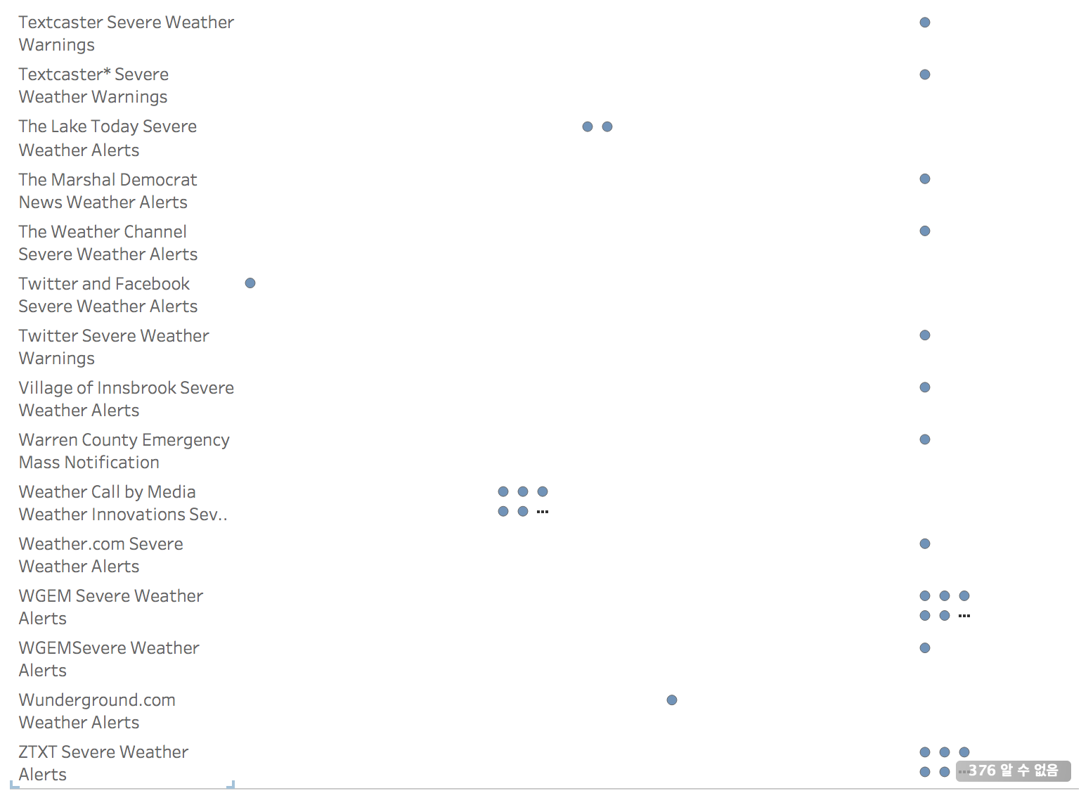

This is relationship between notification type and users fee.

For most notifications users fee is free. In some cases, however, they usually pay $ 10 a year. Users are usually get notification of severe information when they are large. This seems to mean that people can pay for important services.

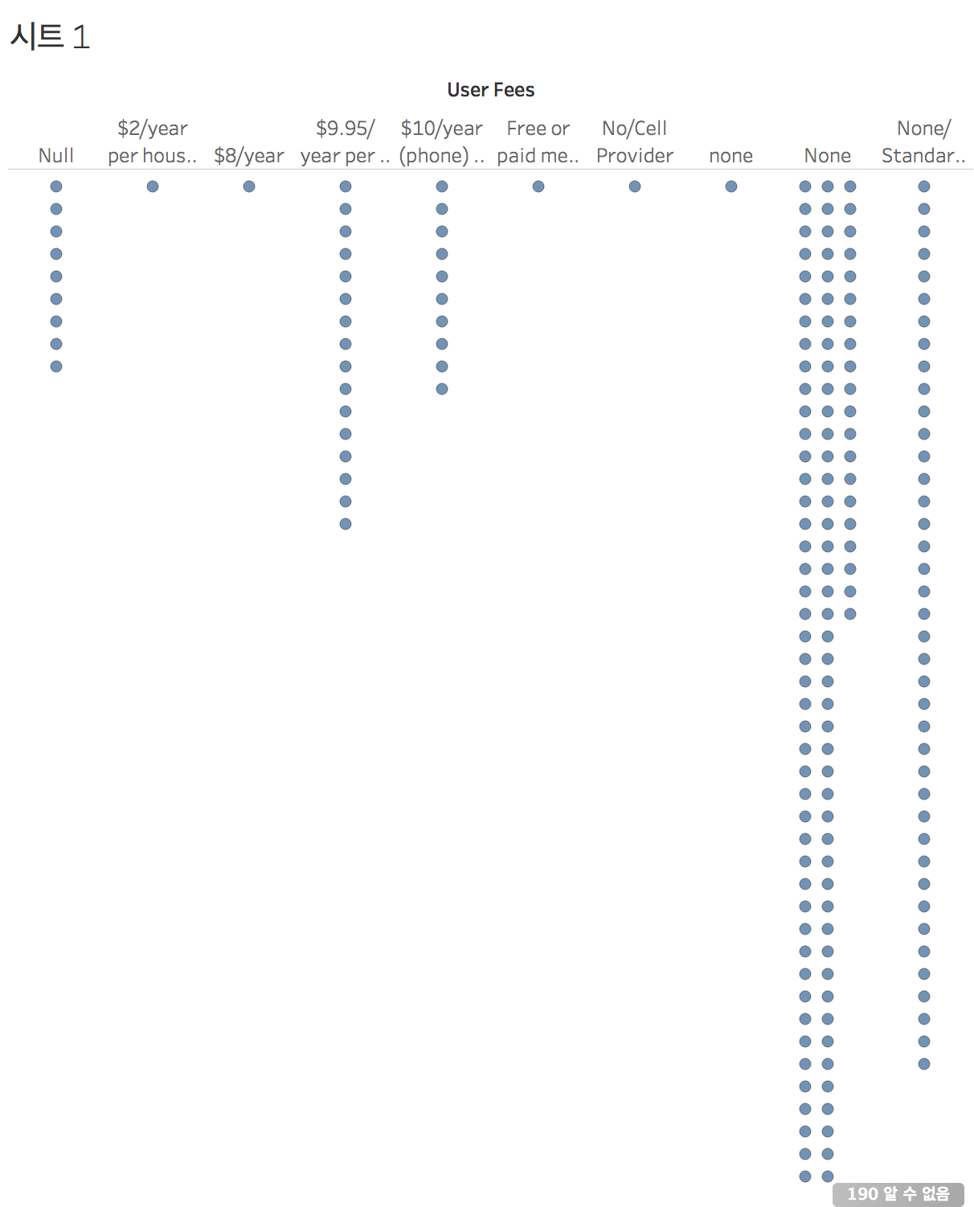

This is a distribution chart of user sensors. In most cases, the service is free, but there are many services where the user's offerings are $ 9.95 per year and $ 10 per year. It is judged that there are many such services because people pay for services that are valuable even if they are expensive.