**EXAM 3**

1. **See the tTEMP table**

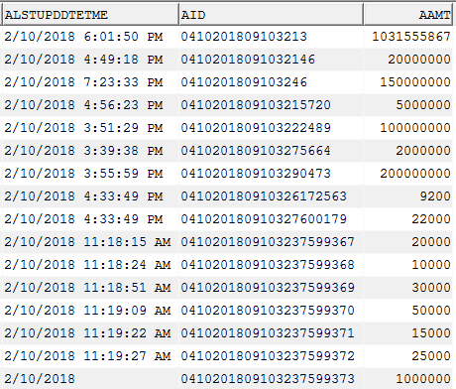

Write a **best query** to display all information that is updated on 02-Oct-2018

Select t.alstupddtetme,t.aid,t.aamt

from tTEMP t

where t.alstupddtetme = ‘02-Oct-2018’

1. **There are three tables: tTableA, tTableB, tTableC**



Write **best query** to insert data from tTableA, tTableB, tTableC into tTableD

Insert into tTableD

select * from tTableA

union all

select * from tTableB

union all

select * from tTableC;

1. **Which SQL command performs best (results is very large)**



1. Select * from temployees where aempid in (select aempid from tdepartments);
2. Select * from temployees a where exists (select 1 from tdepartments b where a.aempid =b.aempid);
3. Select distinct a.* from temployees a, tdepartments b where a.aempid = b.aempid;
4. **In this practice, you examine and write executable statements.**

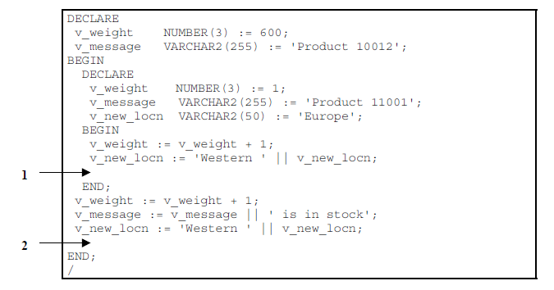

Evaluate the preceding PL/SQL block and determine the data type and value of each of the following variables, according to the rules of scoping.

a) The value of v_weight at position 1 is: 2

b) The value of v_new_locn at position 1 is: Western Europe

c) The value of v_weight at position 2 is: 3

d) The value of v_message at position 2 is: Product 11001 is in stock

e) The value of v_new_locn at position 2 is: Western Western Europe

1. **See tDepartments table**



Declare a cursour c_dept to retrieve adepid and adepname for those departments with adepid less than 100. Order by adepid

**DECLARE**

**CURSOR** c_dept **IS**

**SELECT** t.adepid, t.adepname

**FROM** tdepartments t

**WHERE** t.adepid < 100

**ORDER** **BY** t.adepid;

v_adepid tdepartments.adepid%**TYPE**;

v_adepname tdepartments.adepname%**TYPE**;

**BEGIN**

**OPEN** c_dept;

**LOOP**

**FETCH** c_dept **INTO** v_adepid, v_adepname;

EXIT **WHEN** c_dept%**NOTFOUND**;

DBMS_OUTPUT.PUT_LINE('Department ID: ' || v_adepid || ', Department Name: ' || v_adepname);

**END** **LOOP**;

**CLOSE** c_dept;

**END**;

1. See temployees table



In the executable section, get all information from the temployees table by v_aempname. Display selected information about employee. The sample output is as followes:

Employee ID: 1 Employee Name: Joseph

**DECLARE**

v_empid temployees.emp_id%**TYPE**;

v_empname temployees.emp_name%**TYPE**;

**BEGIN**

-- lay in4

**SELECT** emp_id, emp_name

**INTO** v_empid, v_empname

**FROM** temployees

**WHERE** emp_name = v_aempname;

DBMS_OUTPUT.PUT_LINE('Employee ID: ' || v_empid || ' Employee Name: ' || v_empname);

**END**;

1. See tEmployees table:



1. In the declarative section, declare two variable: v_aempname of type tEmployees.aempname and v_aempsal of tEmployees.aempsal. Initialize the latter to 1500.

**DECLARE**

v_aempname tEmployees.aempname;

v_aempsal tEmployees.aempsal := 1500;

1. In the executable section, retrieve the names of employees whose salaries are equal to the values in v_aempsal.

* If the salary entered returns only one row, insert into the tMessage table the employee’s name and the salary amount.

Note: Do not use explicit cursors.

* If the salary entered does not return any rows, handle the exception with an appropriate exception handler and insert the tMessage the message “No employee with salary of <salary>.”
* If the salary entered returns multiple rows, handle the exception with an appropriate exception handler and insert into the tMessage table the message “More than one employee with a salary of <salary>.”

**DECLARE**

v_employee_count **NUMBER**;

v_aempsal **number** := 2000;

v_aempname **varchar2**(20);

**BEGIN**

**SELECT** **COUNT**(*)

**INTO** v_employee_count

**FROM** tEmployees

**WHERE** aempsal = v_aempsal;

**IF** v_employee_count = 1 **THEN**

**SELECT** aempname **INTO** v_aempname

**FROM** tEmployees

**WHERE** aempsal = v_aempsal;

**INSERT** **INTO** tMessage **VALUES** (v_aempname,v_aempsal);

**END** **IF**;

**EXCEPTION**

**WHEN** NO_DATA_FOUND **THEN**

**INSERT** **INTO** tMessage **VALUES** ('No employee with salary of '|| v_aempsal,v_aempsal);

--DBMS_OUTPUT.PUT_LINE('No employee with salary of '|| v_aempsal);

**WHEN** TOO_MANY_ROWS **THEN**

**INSERT** **INTO** tMessage **VALUES** ('More than one employee with a salary of '|| v_aempsal,v_aempsal);

--DBMS_OUTPUT.PUT_LINE('More than one employee with a salary of '|| v_aempsal);

* **END**;

1. See tRegions table:



1. Create procedure sptregions_i to insert information according to template.

CREATE OR REPLACE PROCEDURE sptregions_i(

p_regname IN tRegions.aregname%TYPE

)

AS

v_next_id tRegions.aregid%TYPE;

SELECT MAX(aregid) + 1

INTO v_next_id

FROM tRegions;

INSERT INTO tRegions(aregid, aregname)

VALUES (v_next_id, p_regname);

DBMS_OUTPUT.PUT_LINE('Record inserted successfully');

END;

1. Create and execute an anonymous block to invoke the sptregions_i procedure with parameter value.

DECLARE

v_regname tRegions.aregname%TYPE := 'Region X';

BEGIN

sptregions_i(v_regname);

END;

1. Drop the sptregions_i procedure by issuing the following command.

Drop procedure sptregions_i;

1. Rename sptregions_i to sptregions_insert.

ALTER PROCEDURE sptregions_i RENAME TO sptregions_insert;