Homework 3
Your student #

Homework Guidance

To ensure the integrity and educational value of your work, please adhere to the following guidelines as you complete Homework 1:

1) Originality and Collaboration: You are encouraged to work independently and ensure that the submissions are your own. While collaboration with your peers for understanding concepts and discussing problems is allowed, directly copying work from your colleagues is strictly prohibited. Your submission should reflect your understanding and your ability to apply what you have learned.

2) Use of GPT-like Platforms: You are permitted to use GPT-like platforms for assistance with your homework. However, this tool should only be used when you fully understand the answers it provides. The purpose of using such platforms is to enhance your learning, not to bypass the learning process. Keep in mind that midterm and final exams will be conducted without internet access. If there is a significant discrepancy between the code you submit for homework and your ability to write similar code during an exam, it will be considered cheating. Such instances will result in a score of zero for the involved exam component.

3) Submission Quality: Your focus should be on submitting code that you comprehend thoroughly. Fancy or complex code that goes beyond your level of understanding is not the goal. We value honesty and genuine effort. Make sure that you can explain and justify every line of code you submit. This approach will not only help you in your homework but also prepare you for the no-internet exams.

Your coding HWs (check week03 pdf files) from 1 to 4 should be answered here:

1.

2.

3.

4.

5. Arsenic levels (measured in parts per billion) have been documented in the groundwater of southeastern New Hampshire. Based on the data provided below, create the following:

A. A boxplot
B. A probability plot

Based on these them, analyze the distribution shape of the data. What kind of transformation, if applicable, would render this data more symmetrical?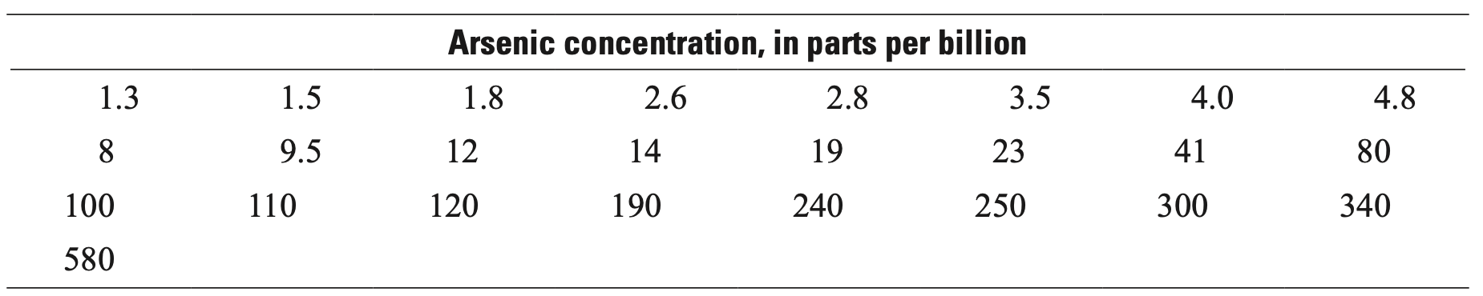

6. Feth et al (1964) analyzed the chemical compositions of water from springs flowing through various types of rocks. Compare the chloride concentrations from two of these rock types using a Q-Q plot. Additionally, construct another type of diagram. Discuss the similarities and distinctions in chloride levels between these two rock types. What features are noticeable in each diagram?
