**2024 Spring EN5423 Project Guide**

**Project Goal:** Compare drought conditions in North and South Korea using various drought indices and land cover types with 73 years of extensive data.

**Methodology (10 Points)**

1. Read the GWP_Handbook_of_Drought_Indicators_and_Indices_2016.pdf file.
2. In the "Ease of Use" section, there are three categories: (1) Green, (2) Yellow, and (3) Red for different drought indices. For this project, we will use SPI and SPEI, which are categorized as green and yellow in "Ease of Use."

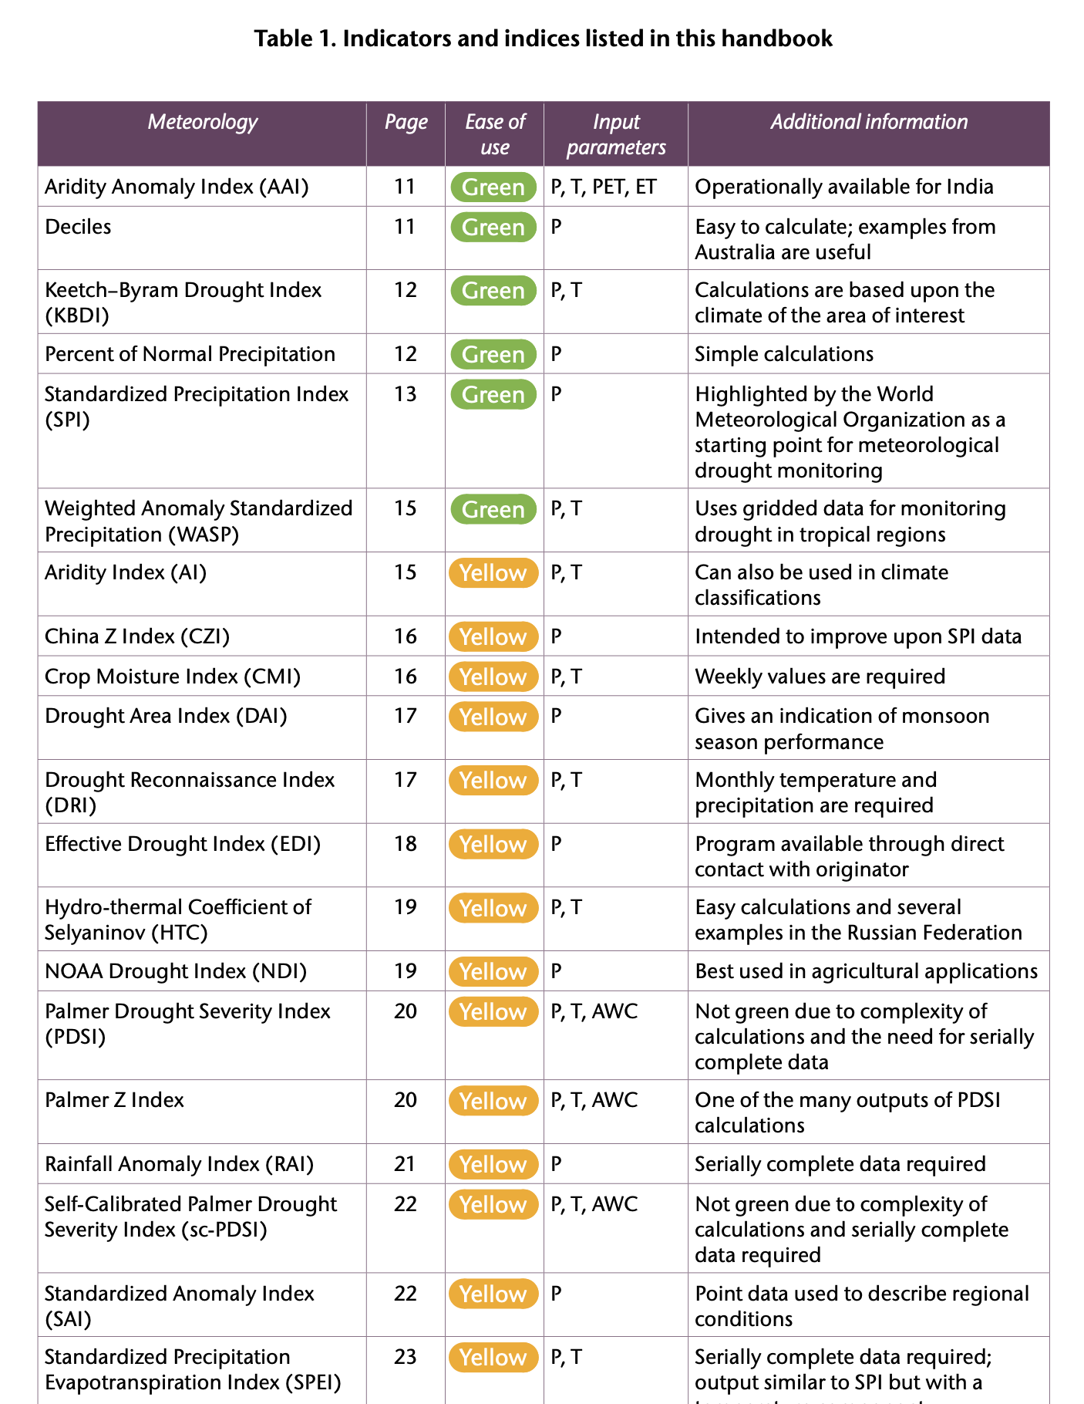

1. Review resources for calculating SPI and SPEI.
2. Read references for SPI and SPEI. There is one reference for SPEI and multiple references for SPI. Select one reference for SPI.

1. Submit a two-page summary for SPI and SPEI, including the calculation methods for both indices, by ***May 22 (Wednesday)***.

**Data Analysis and Final Report (30 Points + Bonus)**

1. You will be given 73 years of monthly data for Korea to calculate SPI and SPEI.
2. Compare SPI and SPEI across different land cover types, the severity of drought in Pyongyang and Seoul, trends in drought severity over 73 years, etc. Bonus points (10 points) will be awarded for any additional analysis.
3. Submit a 10-page final report:
   * (1) Abstract: half-page
   * (2) Introduction: 3 pages
   * (3) Methodology: 1 page
   * (4) Results: 3 pages
   * (5) Discussion: 2 pages
   * (6) Conclusion: half-page

The report is due by the end of the semester. Only one report per team is required (10 points). However, peer-review scores (20 points) will be more significant than the final report.

1. Do not worry about data processing – I will provide the Python code needed for this project on May 22 (Wednesday).