Database Assignment

01

정보통신공학과 2017112207 이건우

정보통신공학과 2017112200 신현호

1. Visit the homepage of the company/agency you selected.
2. Show their webpage

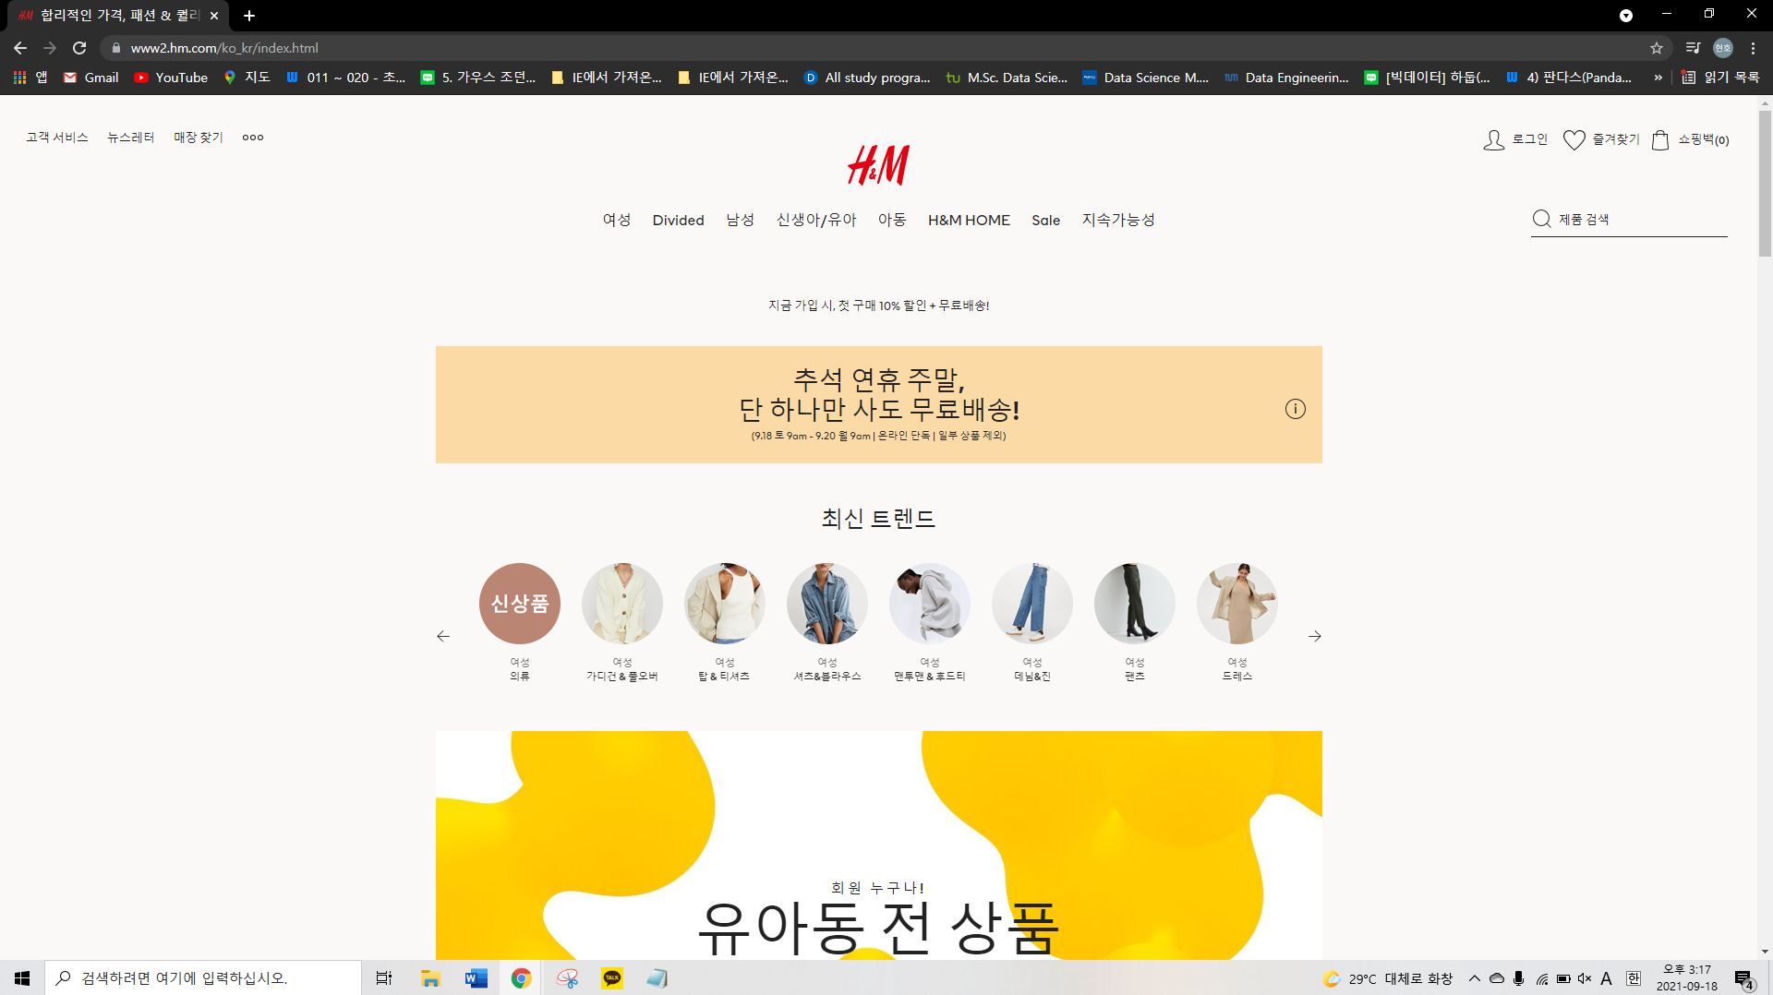

1. Describe briefly what kind of tasks they are doing.

* H&M is one of the fashion brands in the world. Consumers can buy clothes, shoes, and accessories on the website. There are a lot of categories in a toolbar on the top of the webpage for selecting a certain type of clothes. On the right side of the top of the webpage, there is a log-on button, favorites, and shopping cart section. Consumers can make their membership if they do not have one.

1. Explain some typical scenarios of the process/job of the company/agency.

* Let's assume that we want to buy a jacket for the autumn. First of all, we should make a membership. Then, we should select the 'Male' section, and go to the 'Jacket & Suit' section for choosing the jacket we want. We can put the product into the shopping cart and keep searching for the other jacket or buy it directly. Before the payment, we should enter the address we want and register the debit/credit card that we want to use for the payment. Finally, we should wait for the arrival of the product.

1. Assume that you are going to implement a small portion of the tasks at the organization.
2. Show the specific web page(s) you are going to implement. Or maybe you can come up with and draw your own web page.

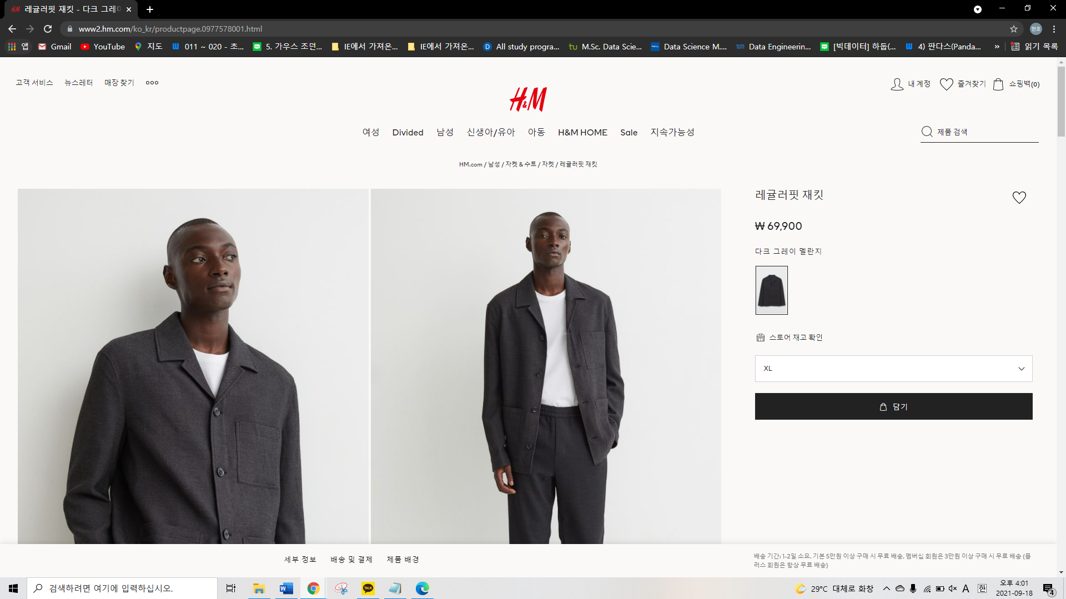

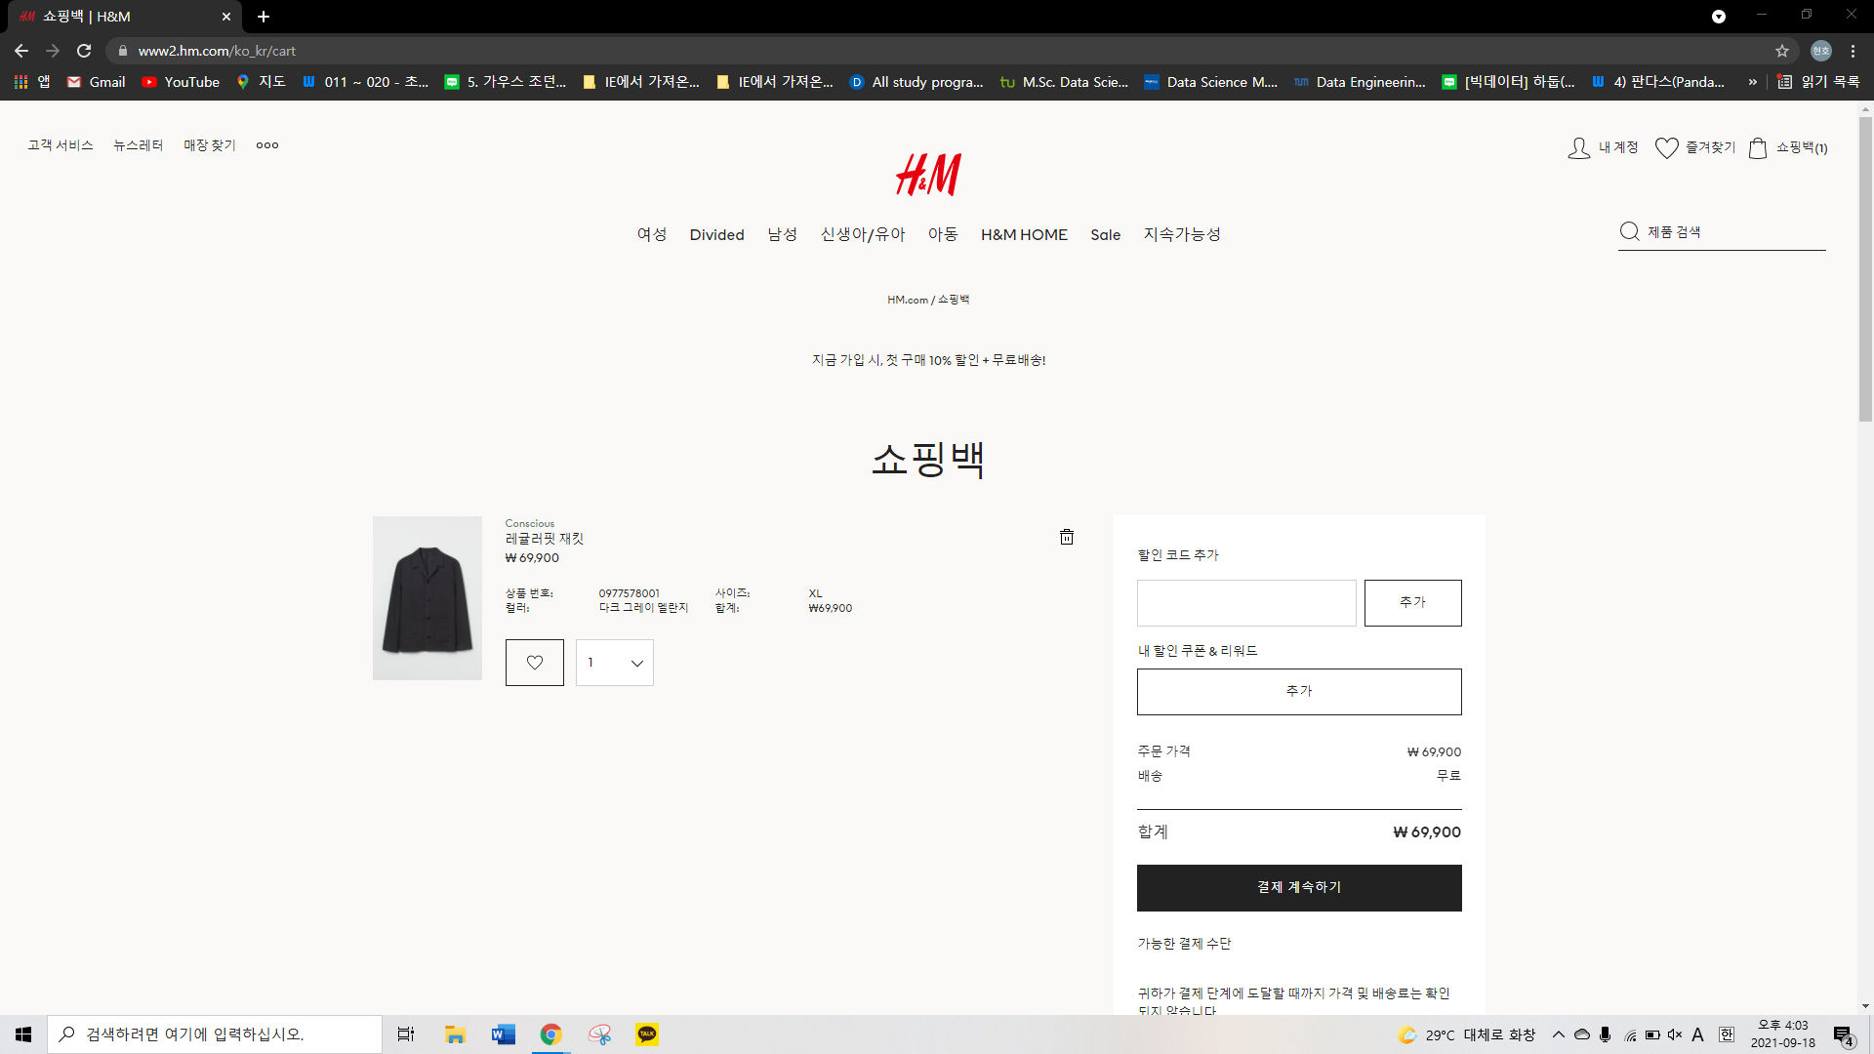

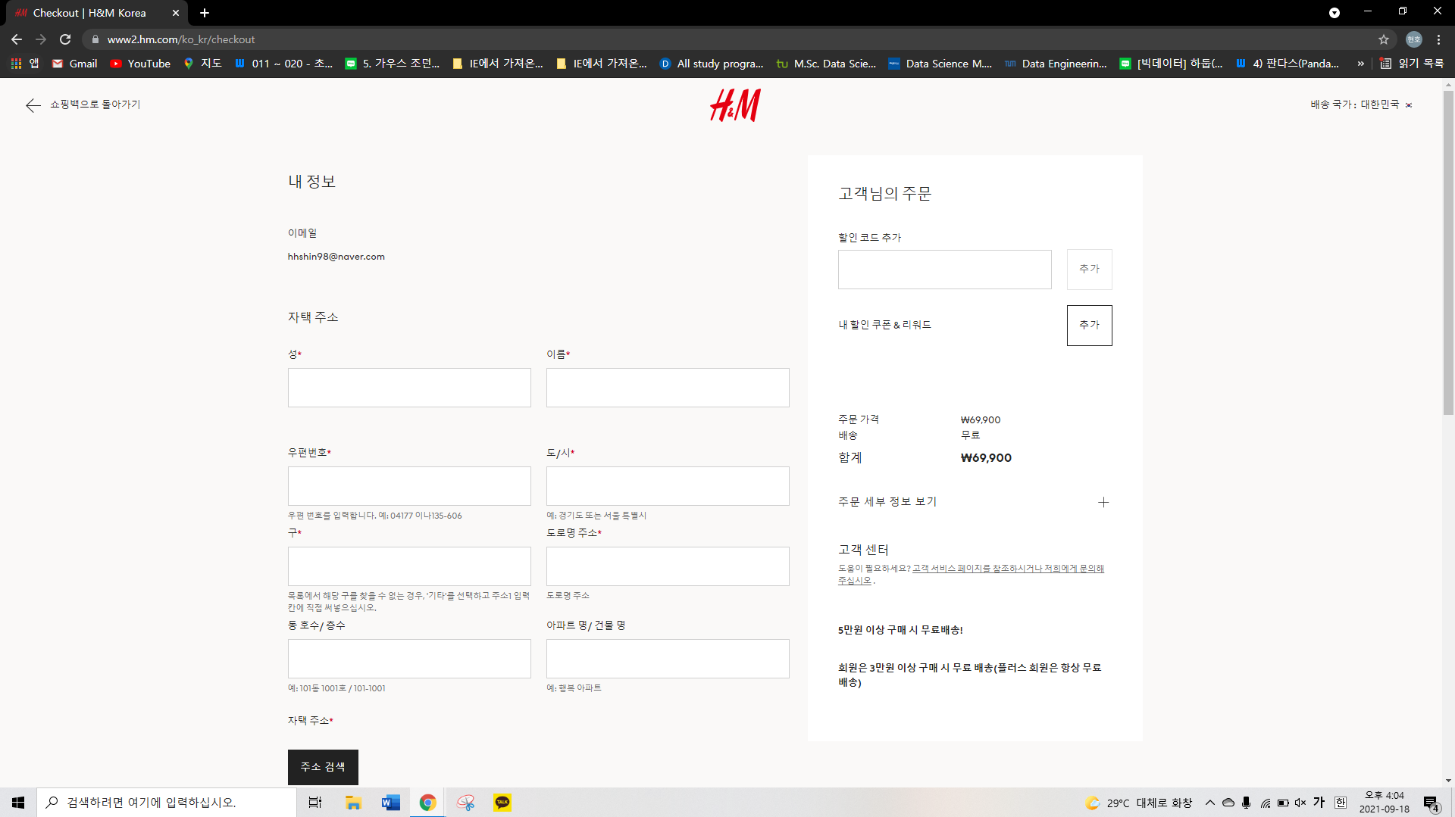

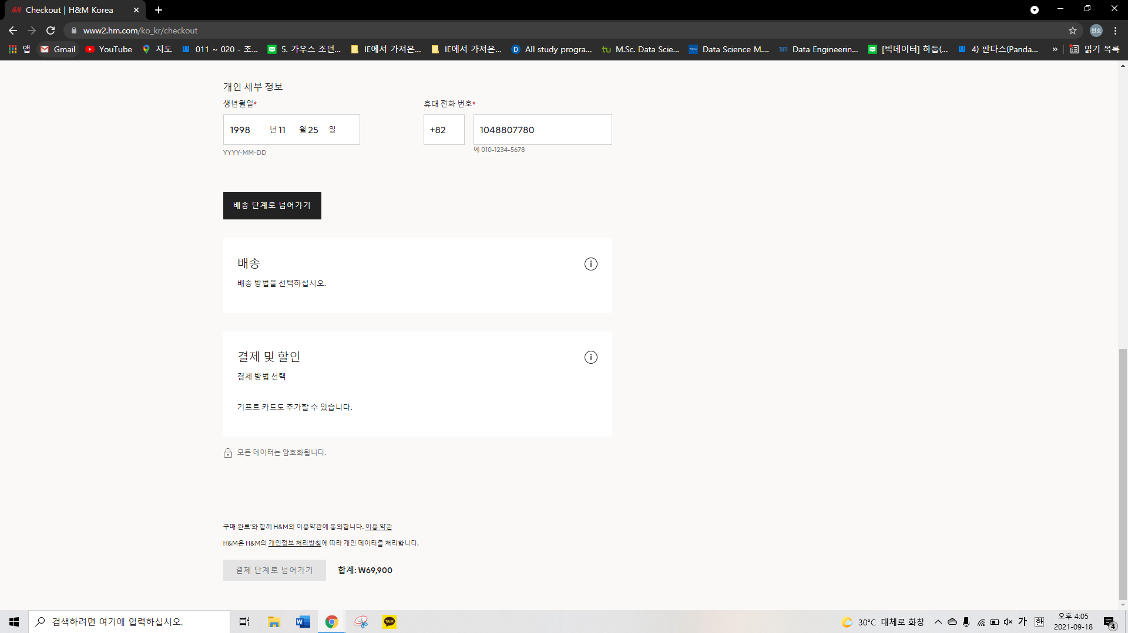

1. Explain the web page. For instance, if you are implementing the purchasing/selling task in Amazon(you don't have to be as fancy as Amazon), you should explain how the process of purchasing/selling will be done through this web page.

* In the first screenshot of the previous question, we selected the jacket we want and selected the size as XL. When we pressed the 'add' button, it was automatically put into the shopping cart. Then, we moved on to the payment section. We should enter the address precisely and if we have any coupon for a discount, we could enter the code of it.

1. Describe the job you will implement with this web page(or your own web page) in great detail. You should be very specific and provide every detail of the tasks, including what your team is going to do, what the boundary of the job you are dealing with is, what components/resources are involved in these jobs, etc.

|  |  |
| --- | --- |
| Entity | Attribute |
| User | User_id, Username, Password, Name, Gender, Address, Telephone_number |
| Order_items | Order_items_id, Product_id, Order_id |
| Order_details | Order_id, Product_number, Total_price, User_id, Payment_id |
| Payment_details | Payment_id, Amount, Provider, Status, Receipt, Order_id |
| Discount | Discount_id, Discount_percent, Desc |
| Product | Product_id, Name, Price, Category, Desc, SKU, Discount_id |
| Item_cart | Item_cart_Id, Quantity, Product_id |

* We would like to present steps for buying clothes on H&M online store. First of all, the user should sign up for using the services. Its entity contains id. password, and some personal information for signing up and login steps. In addition, we made Order_items, Order_details, and Payment_details for the payment and the order. The discount entity has some discount information. We need the information of the product so that is why we added a Product entity for checking the information of the product. Lastly, through Item_cart, we could check what we added in the item cart so that we can add or delete the item in the item cart section. This is how our ER diagram consists of.

1. Describe some Business Rules that are necessary for creating E-R diagram. Business Rules are the assumptions you can make to draw the E-R diagram. For example, co-owner of bank account is allowed/or not, same customer names are (or not) allowed, etc. These are especially needed when you do cardinality check in E-R.

* same names are allowed
* same usernames(nicknames) are not allowed
* same telephone_numbers are not allowed to prevent duplicate subscription
* same discount_ids (coupons’ PIN) are not allowed
* same product names are not allowed

1. Draw an E-R diagram using ERWin. When you draw the E-R, don't make the diagram too complicate. Limit the number of nodes less than 10. Probably 6-8 nodes will be a reasonable choice.

