Machine Learning Report

01

학번: 2017112200

이름: 신현호

1. Write a Python program to count the number of strings where the string length is 3 or more and the first and last character are different from a given list of strings.

Input List : ['cabc', 'xyza', 'abbc', '13221', 'xyzk'] Output : 3

<Program Code>

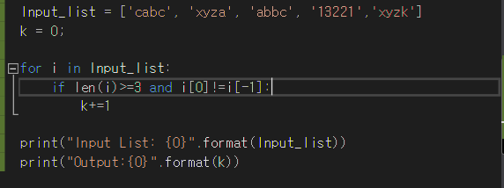

<Result>

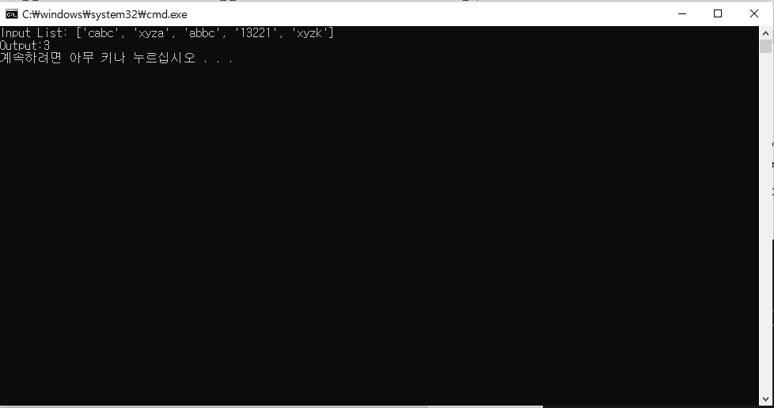

1. Write a Python program to get a list, sorted in decreasing order by the second element in each inner list from a list, using a 'lambda' function.

Input List : [[2, 6], [1, 2], [3, 4], [5, 3], [4, 1]] Output : [[2, 6], [3, 4], [5, 3], [1, 2], [4, 1]]

<Program Code>

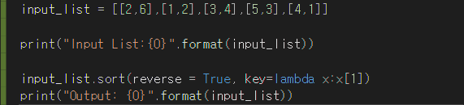

<Result>

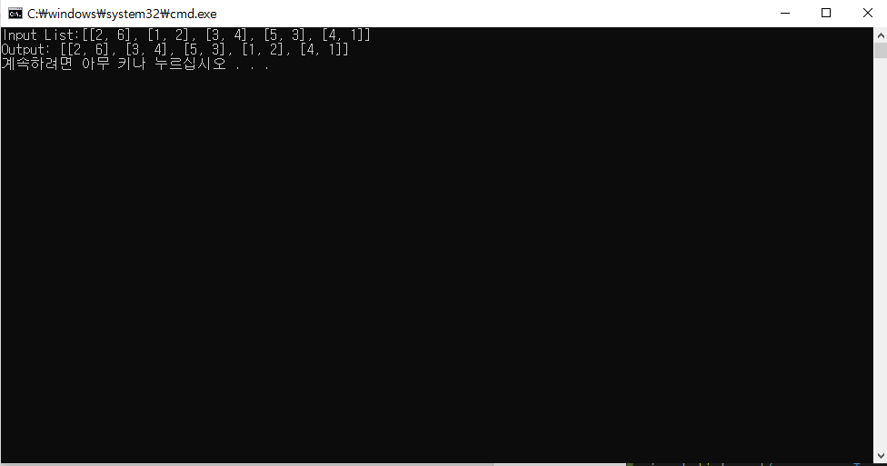

1. Write Python code for the following tasks
2. read csvfile into a two dimension list (called “a_list”) using ‘csv’ module.

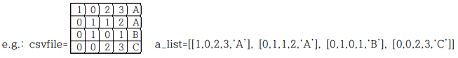

<Program Code>

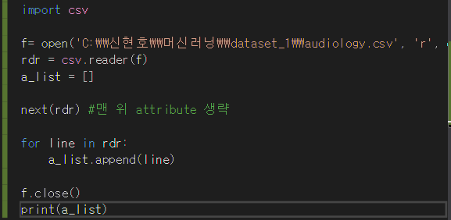

<Result>

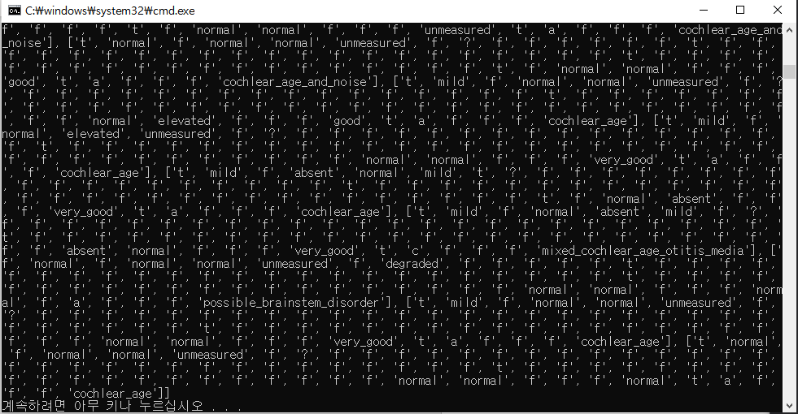

1. show the number of columns(attributes), number of rows(records) and number of classes (label), respectively.

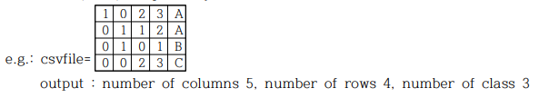

<Program Code>

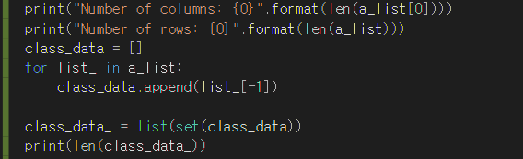

<Result>

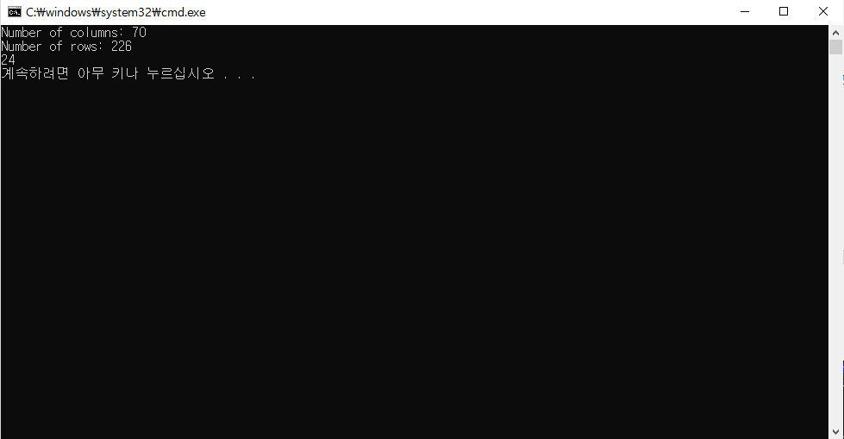

1. write a Python program that shows the first 2 rows per class from the “a_list”

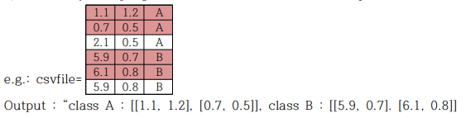

<Program Code>

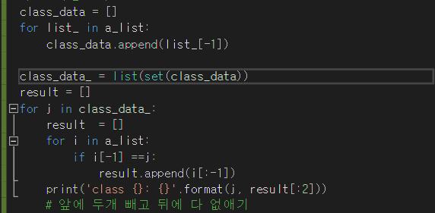

<Result>

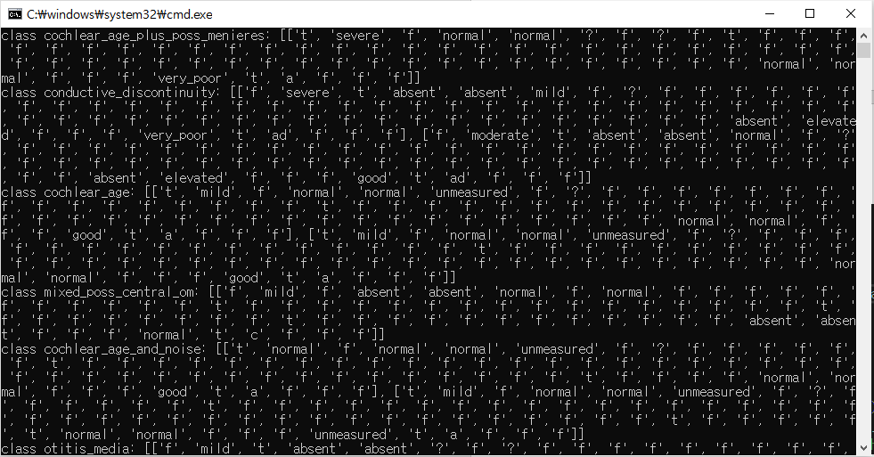

1. write a Python program which randomly shuffles ‘a_list’ data using 'random' module.

<Program Code>

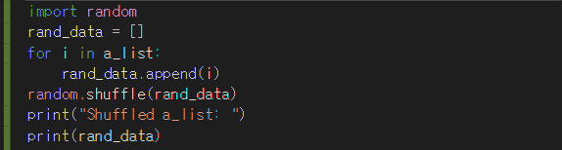

<Result>

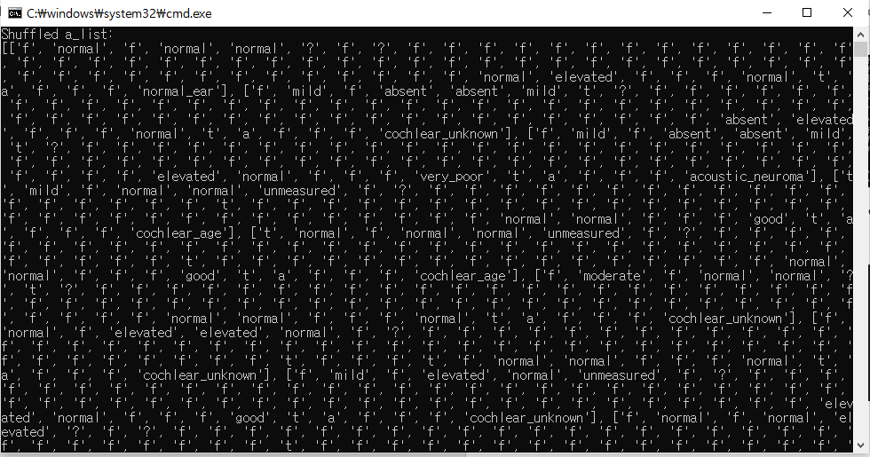

1. Using the “a_list” in question 3. write Python code for the following tasks
   1. given two column(attribute) index numbers, write a function that return a two-dimensional list that have the values of the columns

<Program code>

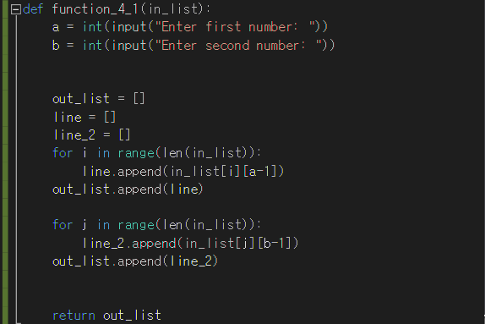

* 1. show the reversed elements of each list of q. 1) result. (We don’t actually change the values a_list)

ex) q.1) output = [[0,1,2,0], [3,4,5,6]] q.2) output = [[0,2,1,0], [6,5,4,3]]

<Program Code>

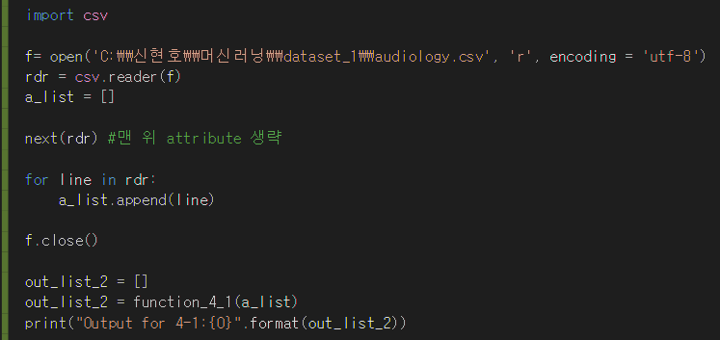

<Result>

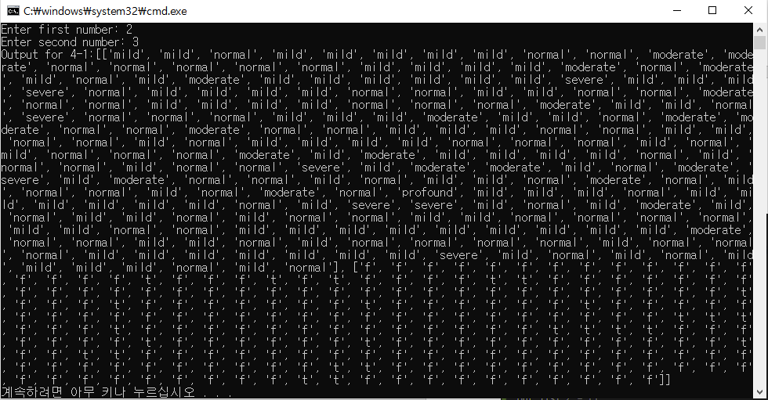

1. Using the “a_list”, write Python code for the following tasks
   1. define a function “divide_train_test(in_list, prop)” function where

input: 1) in_list: a 2D list, 2) prop: proportion of training data

output: train_data (first “prop” percent of in_list), test_data (the rest of in_list)

<Program Code>

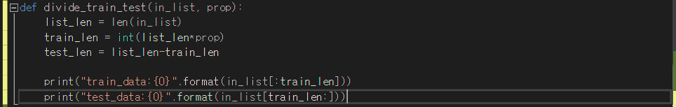

* 1. run divide_train_test(a_list, prop) TWO times using prop=0.7, 0.9, respectively, and show the result.



<Program Code>

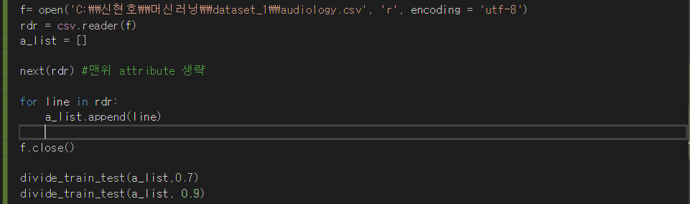

<Result>

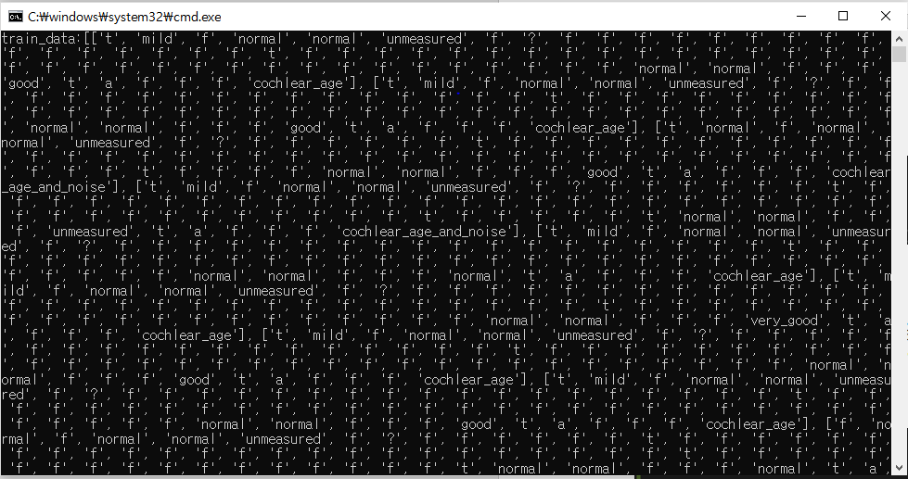

1. Write Python code for the tasks.
   1. define a function “min_max_avg_med” which takes a list of numbers and returns [minimum, maximum, average, median] of the list. (don't use any modules such as 'import statistics') e.g.: def min_max_avg_med(in_list):
   2. Using ‘random’ module, randomly generate 9 integer numbers (the numbers are more than -10 and less than 10) and, calculate the minimum, maximum, average and median values of generated numbers using above “min_max_avg_med” function.

e.g.: min_max_avg_med([-9,2,1,3,7,2,3,-7,-4]) returns [-9, 7, -0.222, 2]

<Program Code>

#6-1~6-2

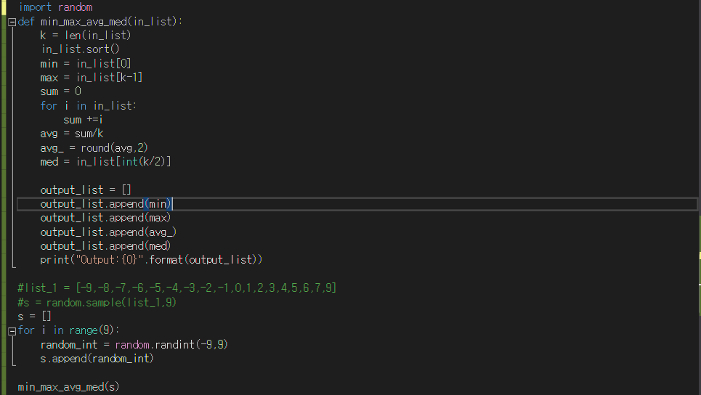

<Result>

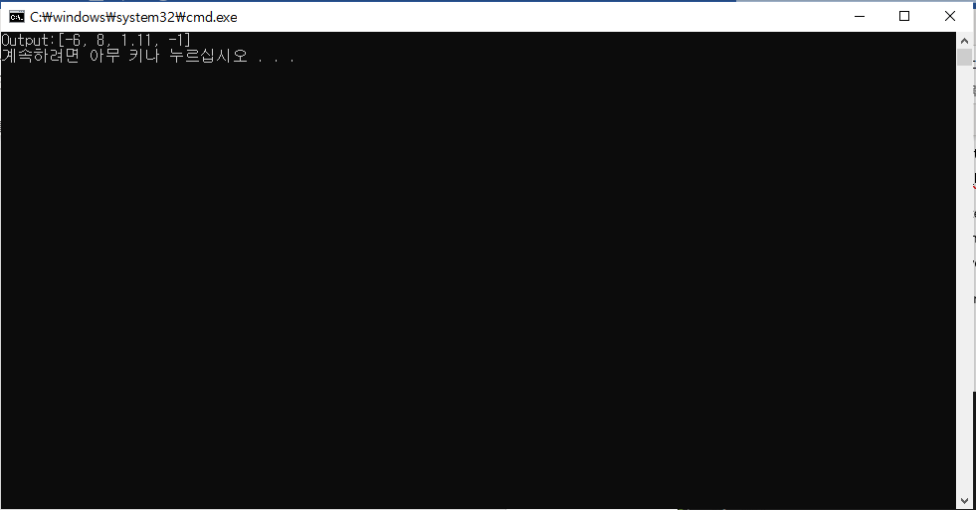

* 1. define a function “equ_interval” which divides a value range into n equal intervals.

input: 1) list [min, max] of range, 2) number of intervals

output: list of (equal distance) intervals

e.g.: equ_interval([-4, 8], 3) returns [[-4,0], [0,4], [4,8]]

4) run equ_interval 2 times by using different values of list and number of intervals.

<Program Code>

#6-3~6-4

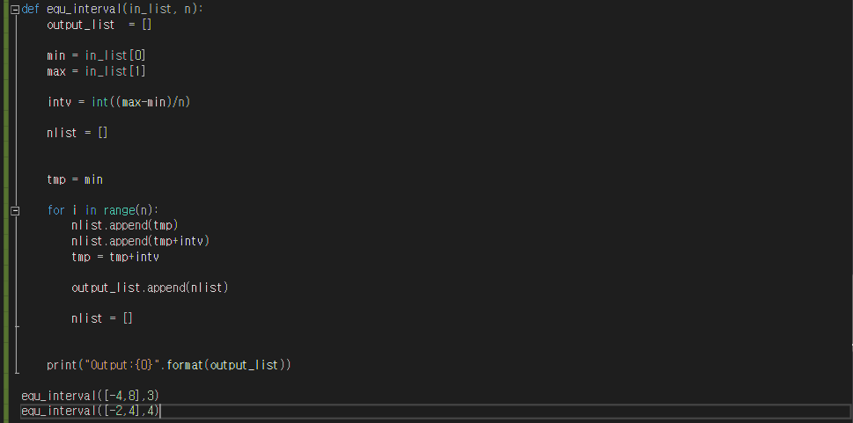

<Result>

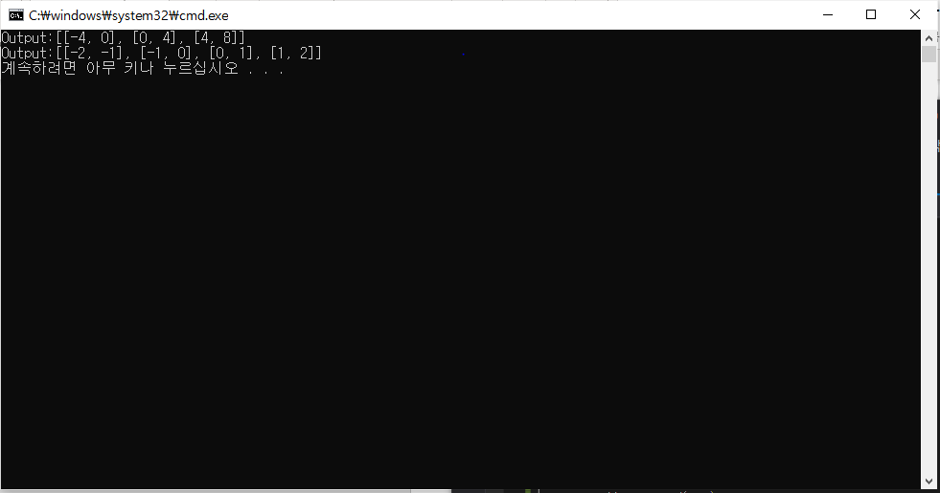

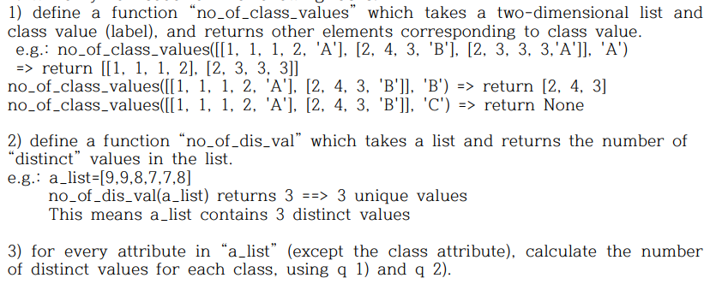

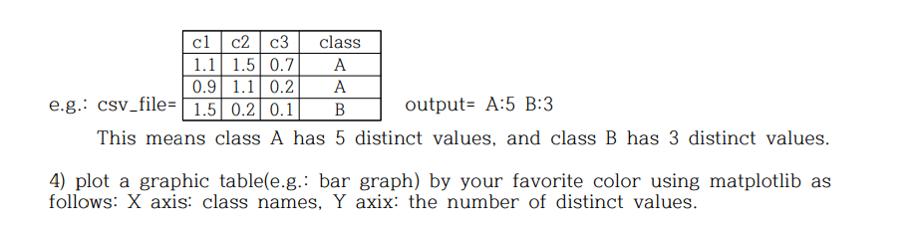

<Program Code>

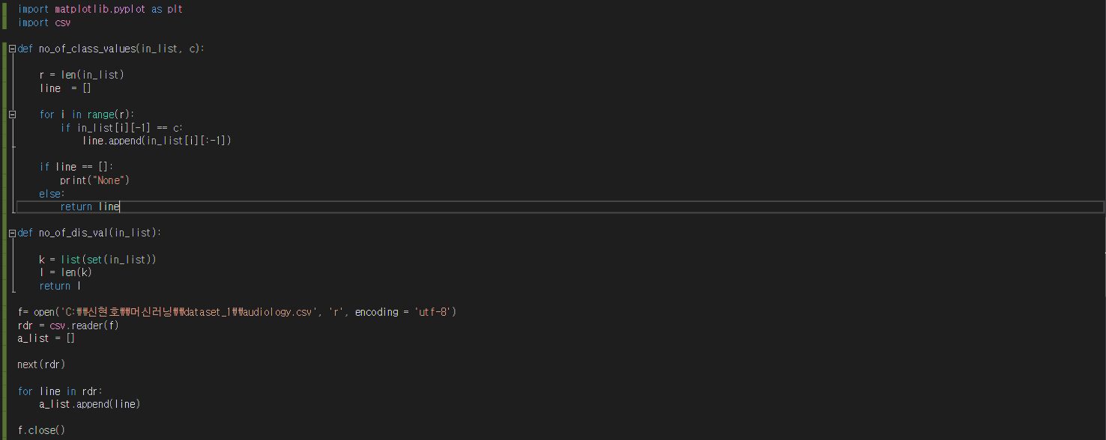

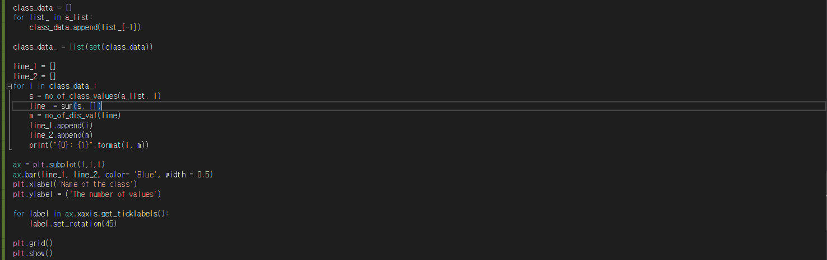

<Result>

